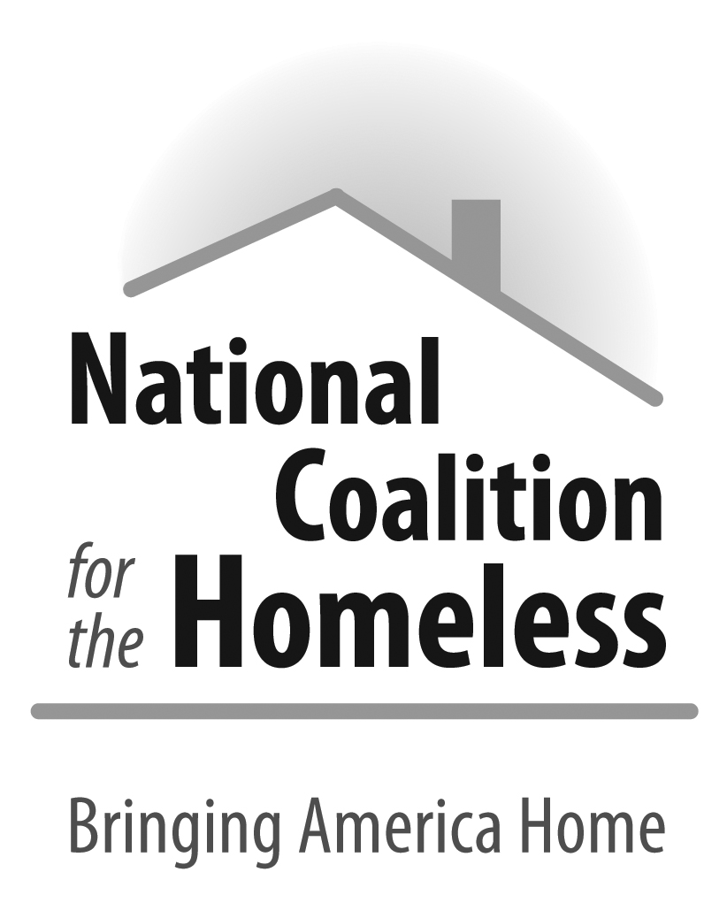

The History of the National Coalition for the Homeless

When modern homelessness first emerged in the late 1970s, hundreds of thousands of homeless were forced to fend for themselves with little emergency assistance from governments and communities. The roots of the National Coalition for the Homeless (NCH) begin in 1981 when the founder, Robert Hayes, filed a lawsuit on behalf of a man experiencing homelessness in New York City. The lawsuit was settled out of court, and people experiencing homelessness won the right to shelter in New York City. The Coalition for the Homeless in New York City formed as one of the early community-based coalitions. With the development of other local and statewide homeless coalitions, the National Coalition for the Homeless was formed in 1982 and incorporated in 1984, and was recognized as a tax-exempt, not for profit organization under the 501(c) (3) internal revenue code in 1988.
Over the last 30 years, NCH has been a leader on the forefront of emerging issues relating to poverty and homelessness. NCH was the first national advocacy organization to involve homeless/formerly homeless people in leadership positions, take on the issues of the educational needs/rights of homeless children and veteran homelessness, first to convene a national homelessness conference, and the first to have a website. NCH staff has helped to draft federal, state and local legislation, like the McKinney-Vento Homeless Assistance Act of 1987. The organization has long advocated for addressing the root causes of homelessness, including the lack of affordable housing, through policy advocacy (supporting efforts like the Bringing America Home Act), grassroots organizing (building a national movement led by people who have been un-housed), and public education (dispelling negative stereotypes and preserving civil rights of people experiencing homelessness).

Since its inception, NCH unlike other national agencies incorporates people experiencing homelessness in its governance, advocacy and education. NCH supports homeless and formerly homeless individuals by providing stipends through our speakers’ bureau. The speakers’ bureau members earn an average of $600 per year which supplements their incomes, introduces them to potential employers and assists them with improving their self-esteem through the healing that comes through sharing their amazing stories of resilience and their struggles and lessons learned as they worked to have a home again.

NCH trains homeless individuals in leadership development and public speaking. Many speakers have become regular visitors to capitol hill utilizing their newly found voices to educate congressional members on the realities of homelessness.

NCH is developing a curriculum to train people experiencing homelessness as mentors to provide peer support to currently homeless individuals as well as to become certified to be paid to provide support services to people experiencing homelessness as a Personal Care Assistant (PCA) and or Independent Living Skills staff. NCH will also work with our local and state grass root organizations, coalitions and service providers to register 100,000 homeless and formerly homeless individuals to vote.

To achieve and sustain our mission, NCH is seeking General Community Support.

The purpose of this campaign is general operating support, to increase the knowledge and awareness of the localize impact of homelessness via our Speakers Bureau and public education. It will help us to increase our capacity to assist people experiencing home to use their voice and power through education, advocacy and peer support. It will also be used to implement our National Technical Assistance Center for Peer Support and the You Don’t Need a Home to Vote Campaign.

