**The Educate, Equip & Empower (EEE) Project**

The Educate, Equip & Empower (EEE) project is a strategic initiative aimed at addressing critical challenges faced by women and girls in Nigeria, particularly in the areas of poverty alleviation, school retention, enrollment, and the completion of girl-child education. The project also facilitates networking and mentorship opportunities between female students and women professionals globally, while providing access to academic, professional, and financial opportunities for women and girls. This report provides an update on the activities carried out between December 2023 and February 2024.

**December 2023 – February 2024 Update**

EWEI Online, our vibrant online community, continues to foster a strong network for learning, mentorship, and collaboration. This quarter, our focus was on increasing awareness and access to funding opportunities for women and girls, in alignment with our mission to support long-term economic empowerment and educational advancement.

The central theme for this quarter was "Unlocking Access: Funding Opportunities for Women and Girls". The following sub-topics were explored in depth:

* **Understanding Grant and Scholarship Applications**
* **Spotlight on Local and International Funding Opportunities**
* **Building Competitive Proposals and Business Plans**
* **Connecting with Donors, Partners, and Crowdfunding Platforms**

Throughout this period, participants were introduced to real-time opportunities and guided through the processes of identifying, applying for, and maximizing various forms of financial support, including grants, scholarships, and business funding.

The following set of visuals showcases highlights from discussions, resources shared, and key moments between **December 2023 and February 2024**.

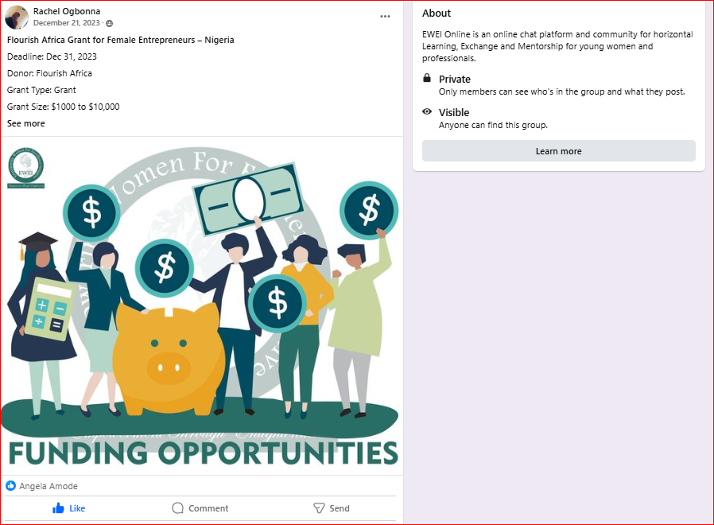

### 

### ****Challenges****

While EWEI Online made key strides in content delivery this quarter, the following challenges were identified:

* **Low Member Engagement:** Posts received minimal reactions or comments, reflecting a lack of active participation among members.
* **Limited Post Visibility:** Facebook’s algorithm, coupled with the closed nature of the group, may have reduced the reach and visibility of updates.
* **Slow Membership Growth:** As a closed group, organic discovery and join requests remained limited, affecting overall group expansion.
* **Possible Content Misalignment:** Engagement patterns suggest that some content may not be aligned with the immediate needs or preferences of the community.

### ****Mitigation Strategies****

To address these challenges, the following strategies were introduced during the quarter:

#### **Enhancing Engagement**

* Developed more interactive posts, including funding-related polls, quizzes, and open-ended prompts.
* Encouraged members to introduce themselves, share personal funding goals, or comment on resource posts.
* Highlighted success stories from members who have received scholarships or grants to inspire others.
* Maintained a regular posting schedule with varied content formats such as infographics, videos, and spotlight features.

#### **Expanding Reach and Visibility**

* Shared group content through EWEI’s public-facing social media platforms to attract new interest.
* Collaborated with grant consultants and women-focused influencers for live sessions and reposts.
* Updated the group description and pinned a welcome post to clearly articulate the group’s purpose and benefits.
* Encouraged existing members to invite peers and participate in a referral drive.

### ****Next Steps****

To further strengthen community participation and growth, the following next steps will be prioritized:

1. **Reintroduce the Group:** Launch a pinned reintroduction post highlighting the group’s goals, theme, and how members can benefit and contribute.
2. **Run a Reactivation Campaign:** Initiate a 2-week "Back to Life" campaign with member introductions, polls, and a live Q&A session on funding opportunities.
3. **Launch a Referral Challenge:** Encourage existing members to invite peers by offering recognition for top inviters and highlighting benefits of joining.
4. **Promote Across Channels:** Expand awareness of the group through EWEI’s social media pages, partner networks, and community newsletters.
5. **Engagement Ambassadors:** Assign active volunteers or interns to help stir conversations, comment on posts, and encourage interaction in real-time.
6. **Conduct a Member Needs Survey:** Understand member interests better through a short poll to refine content focus (e.g., more local grants, business loans, or education-specific opportunities).