EDUCATE, EQUIP AND EMPOWER 230 WOMEN AND GIRLS
The Educate, Equip & Empower (EEE) project is designed to tackle poverty, retention, enrollment and completion of girl child education, enable networking and mentoring between female students and women professionals around the world and provide access to opportunities for women and girls in Nigeria.

June 2021 – August 2021 Update
EWEI Online, our online community for horizontal learning, exchange and mentorship, has in the last quarter carried out activities online.
In June 2021, we engaged in discussions around Drug and Drug Use under the following sub-themes:
- What are drugs and different types of drugs commonly used?
- Disadvantages of drug abuse and its adverse effects
- What can to do to prevent and stop drug abuse?
- Menstrual Cramps and drug abuse and what can be done

In July 2021, we had interactive discussions around trending topics. Each week we discussed a different issue. They were movie reviews, relationship highlights and book discussions. These topics covered precisely are:
- Movie review for the movie: Citation
- Relationships, boundaries and deal breakers
- Book discussion on the book titled; Dear Ijeawele: A feminist manifesto in 15 Suggestions, by Chimamanda Ngozi Adichie

In August 2021, we discussed Human Trafficking under the following sub-topics:
- What is trafficking and the types of human trafficking?
- Human trafficking statistics in Nigeria and globally
- Video Stories of women who had been trafficked
- What to do and how to fight against human trafficking
- Oloture: A movie focused on human trafficking, sex work and Gender-Based Violence

The following set of visuals highlight the different topics and sub topics discussed in the month of June 2021- August 2021.

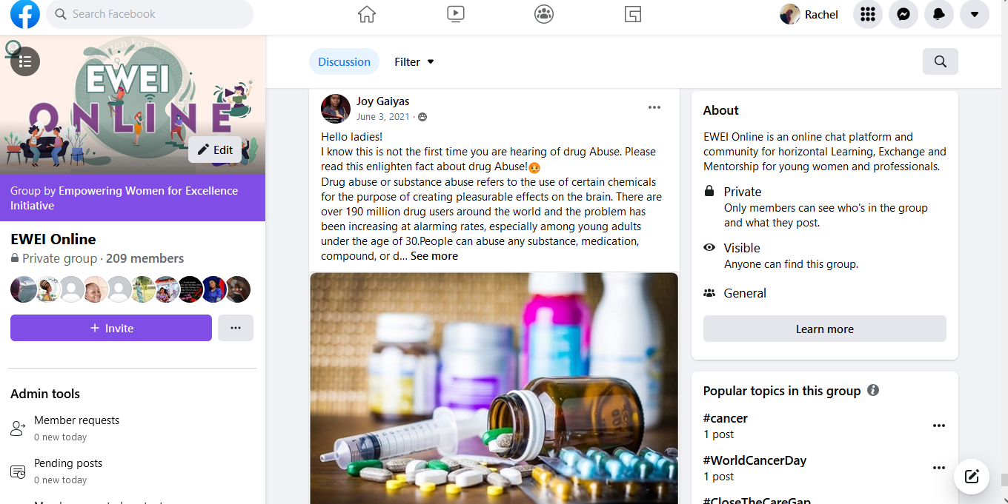
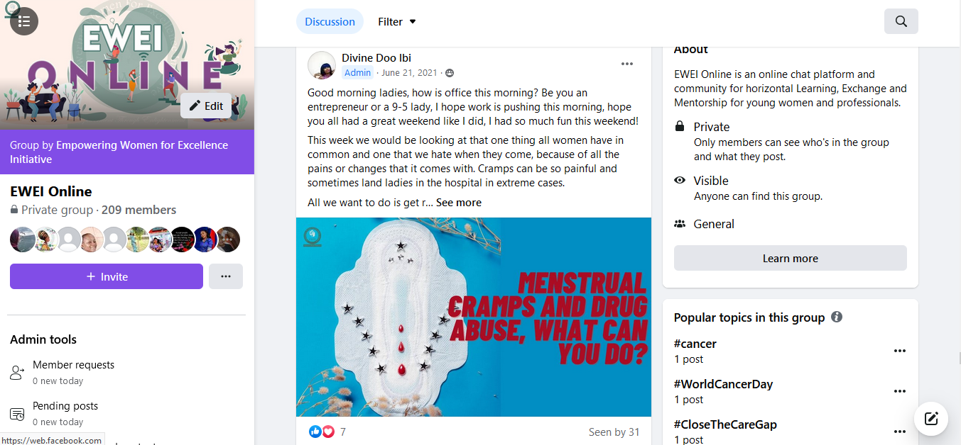
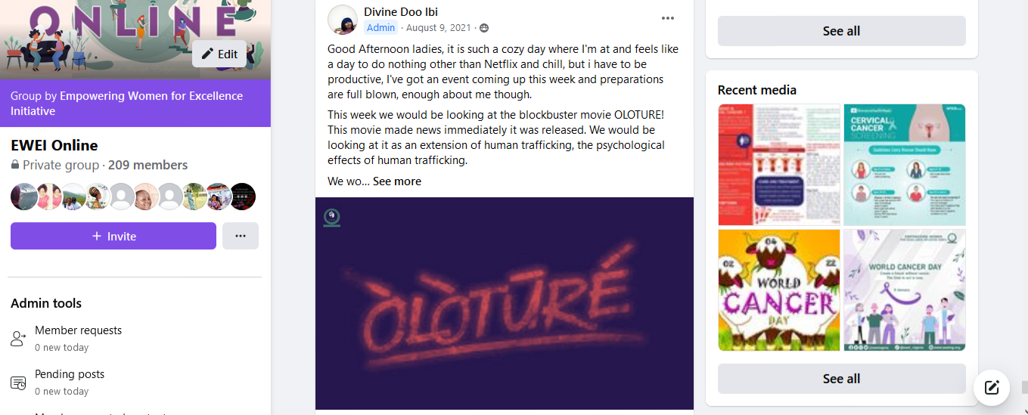
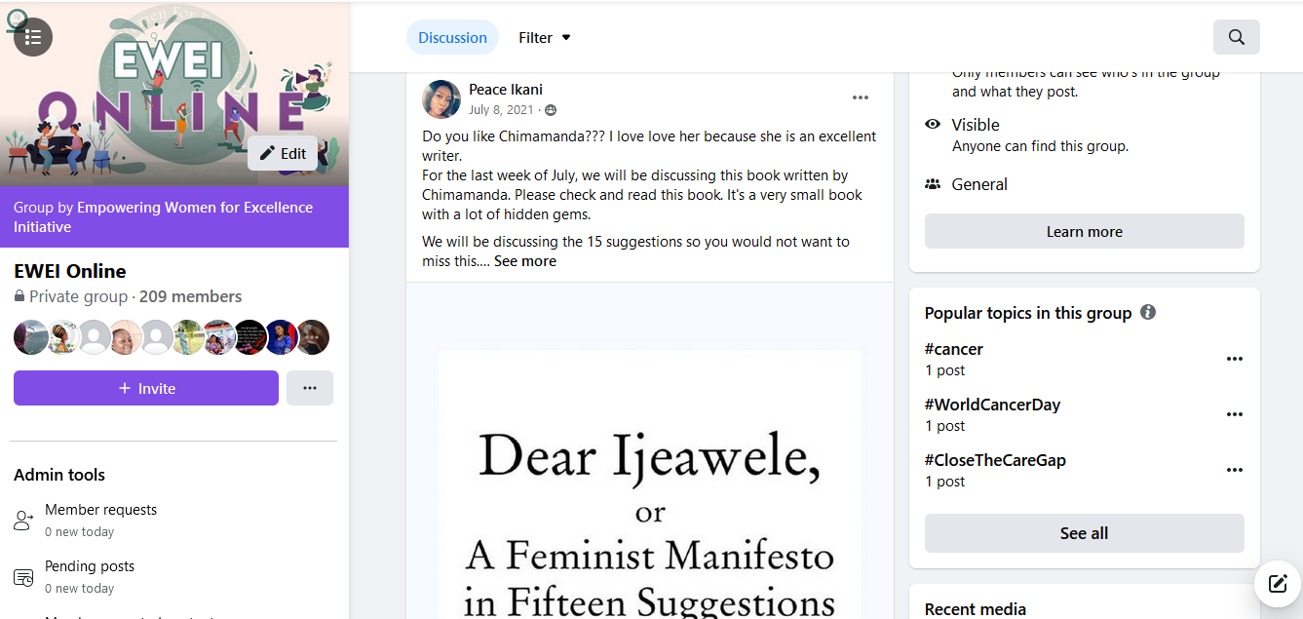
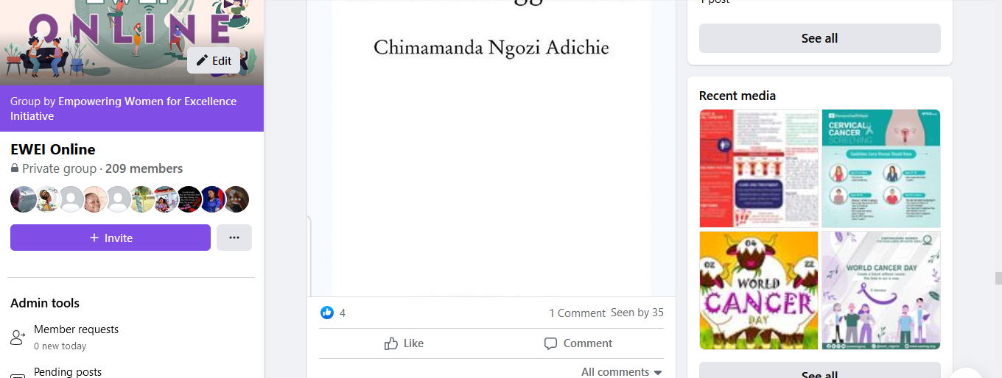
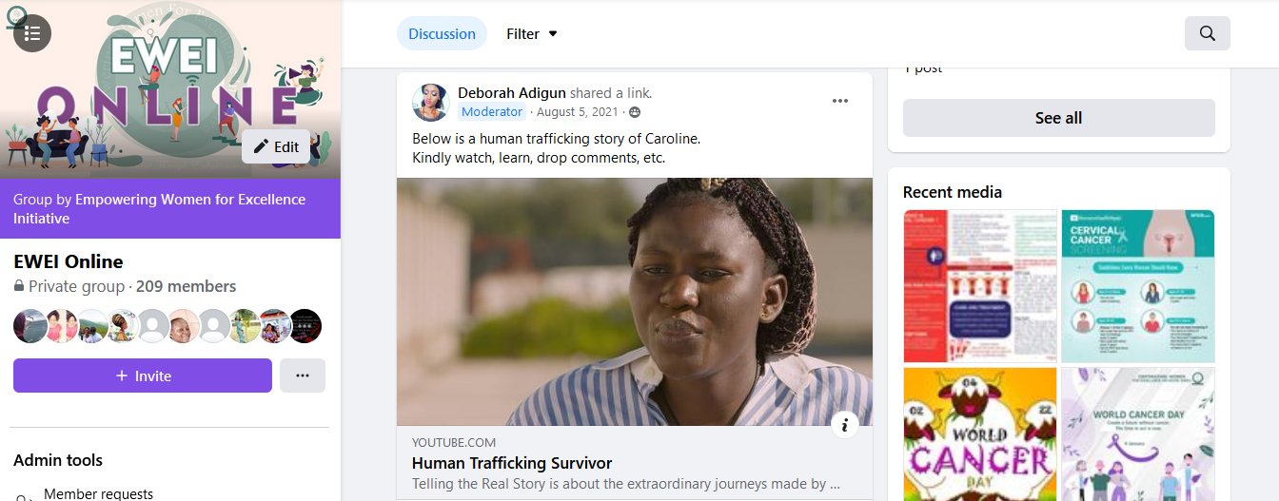
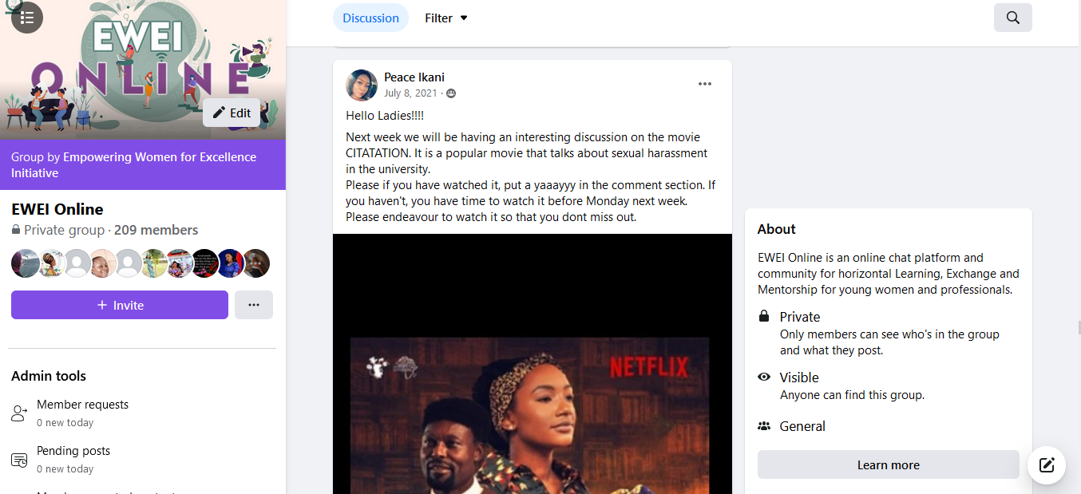
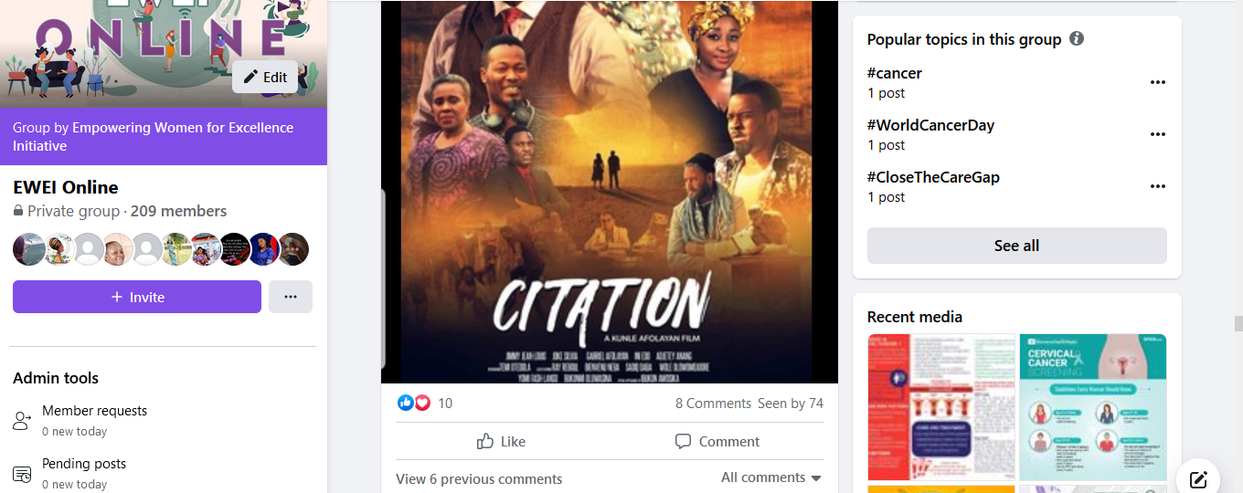
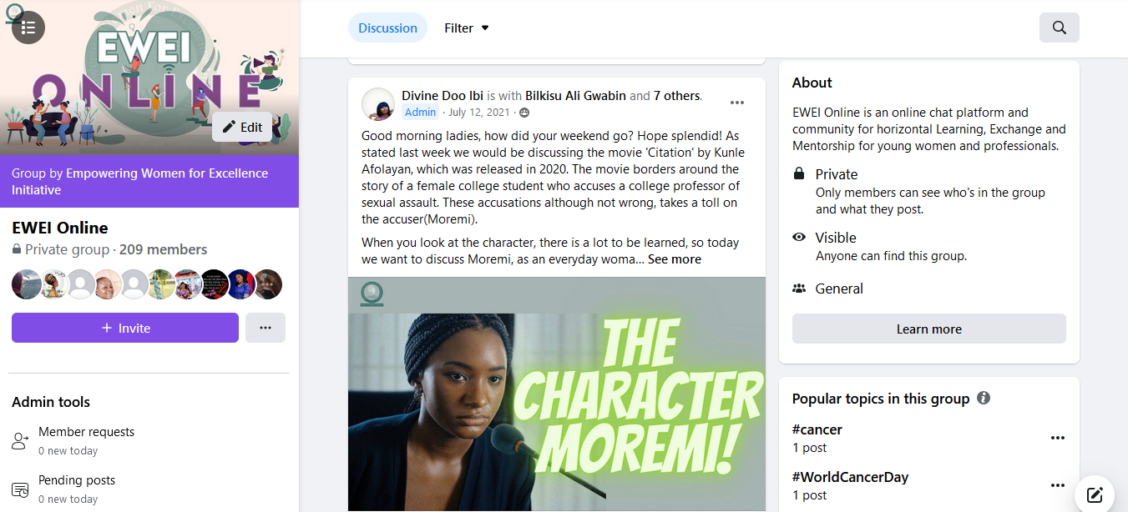

The following set of visuals highlight metrics of membership and engagement from June 2021 – August 2021.

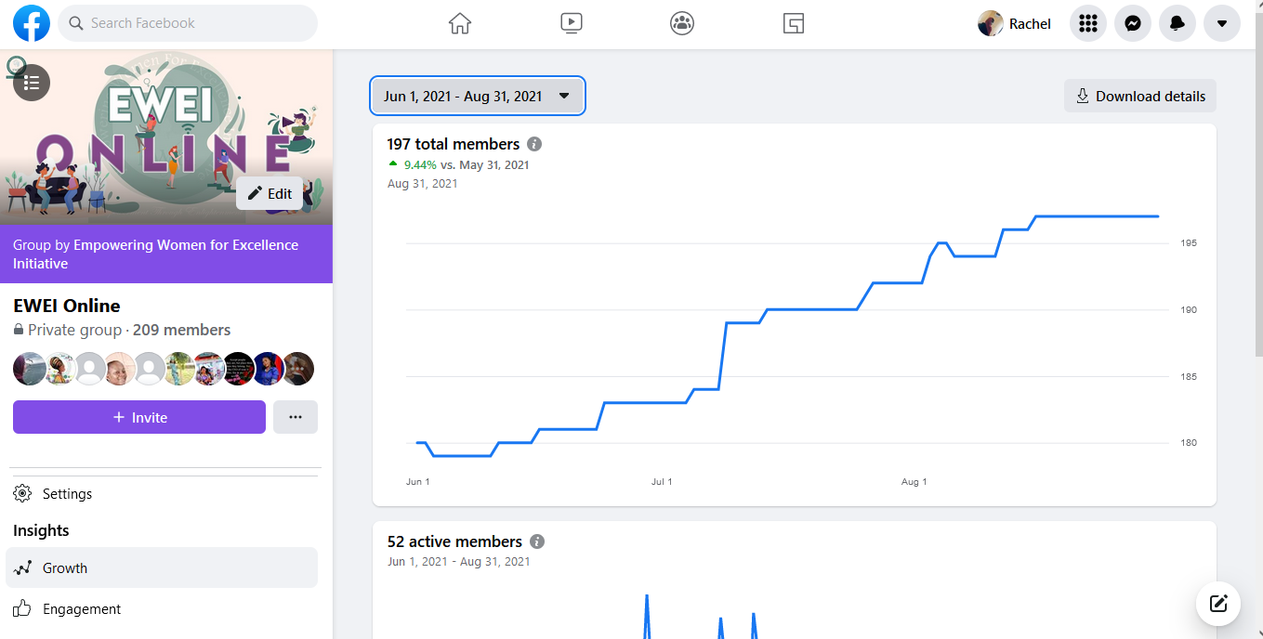
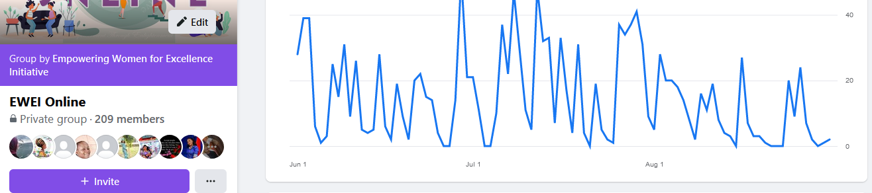

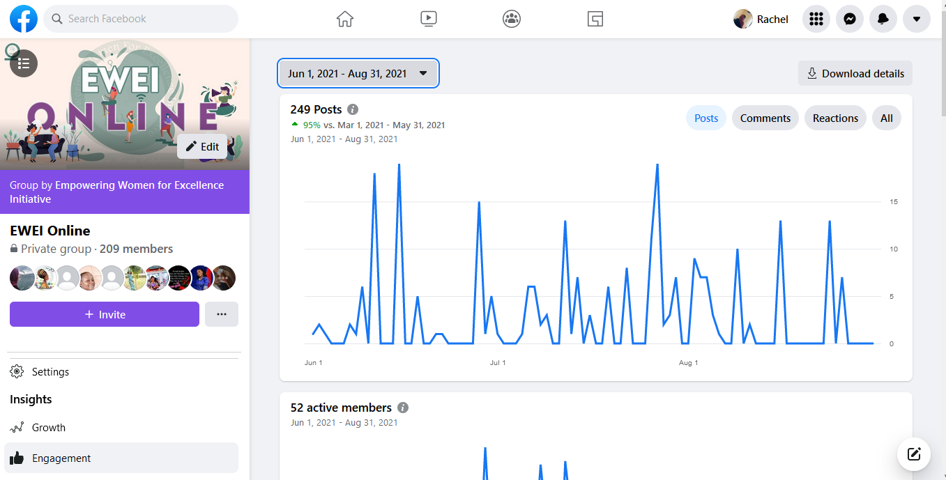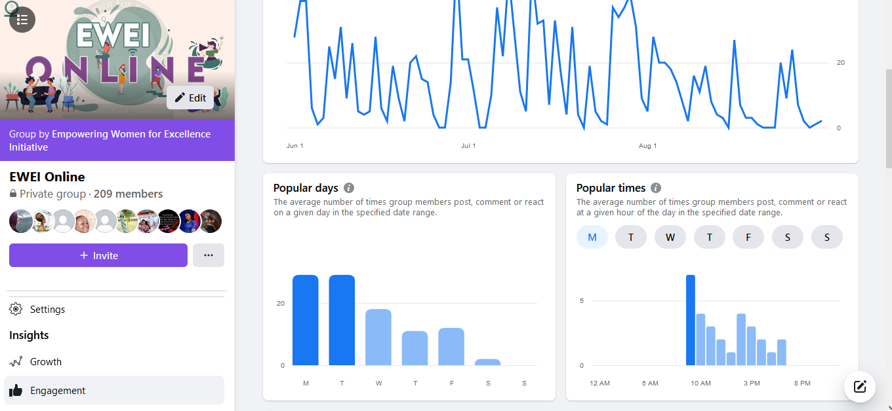

Members of EWEI online were invited to participate in our project called The Women’s Parliament, which models the ideals of democracy and participatory governance.

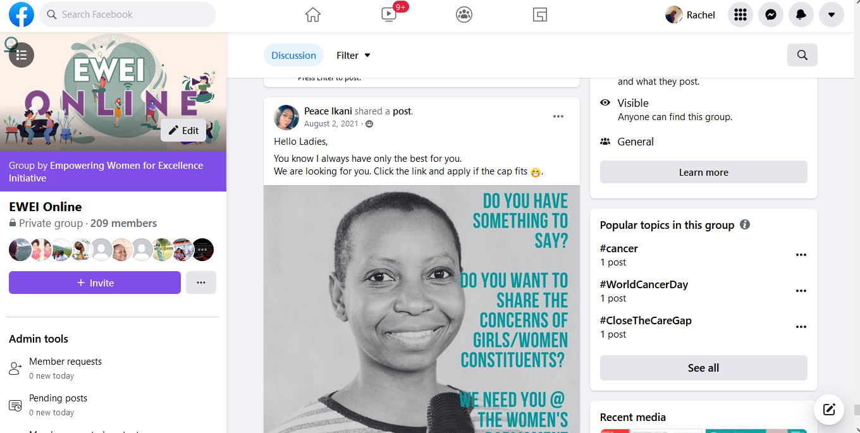
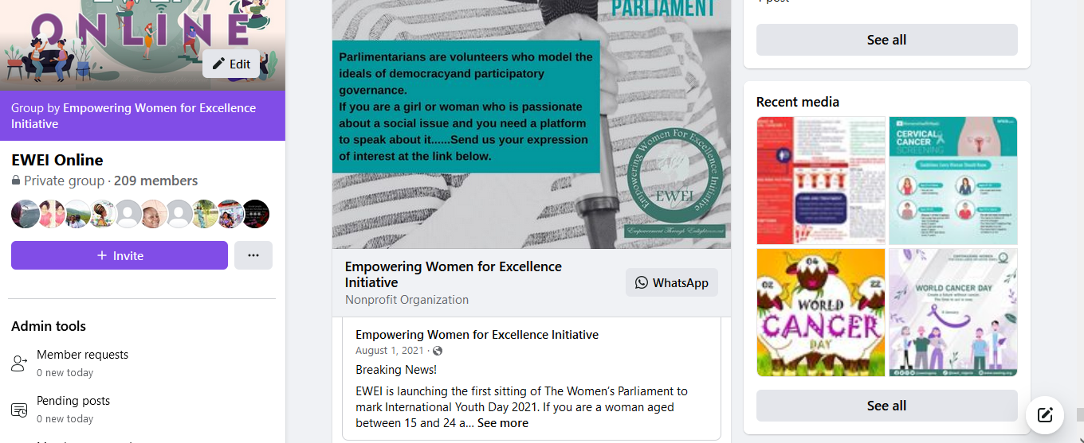
Global and local funding opportunities were also shared on the platform to give members visibility about professional, academic and financial opportunities.
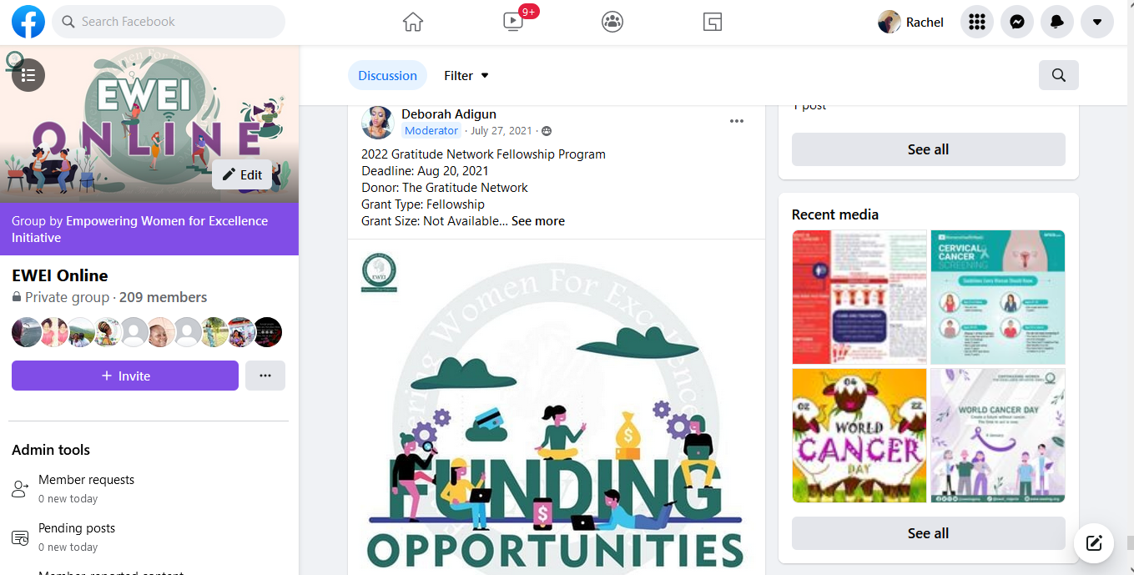
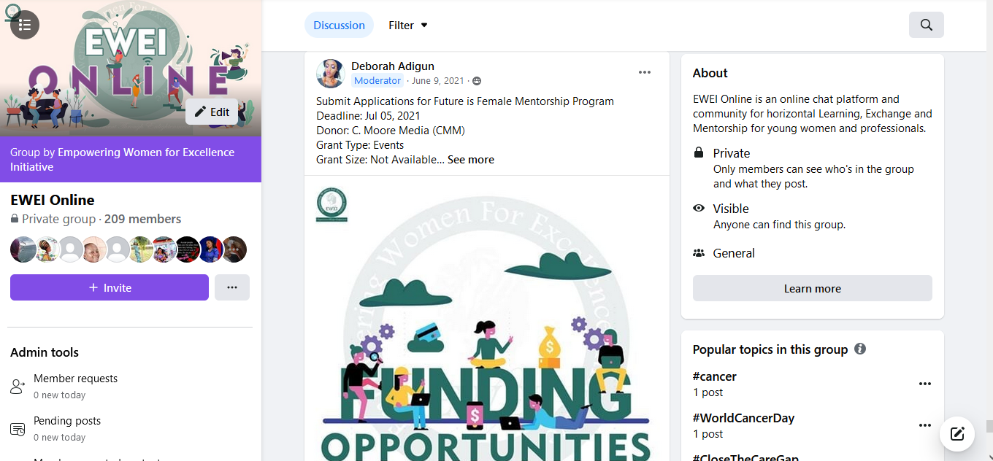
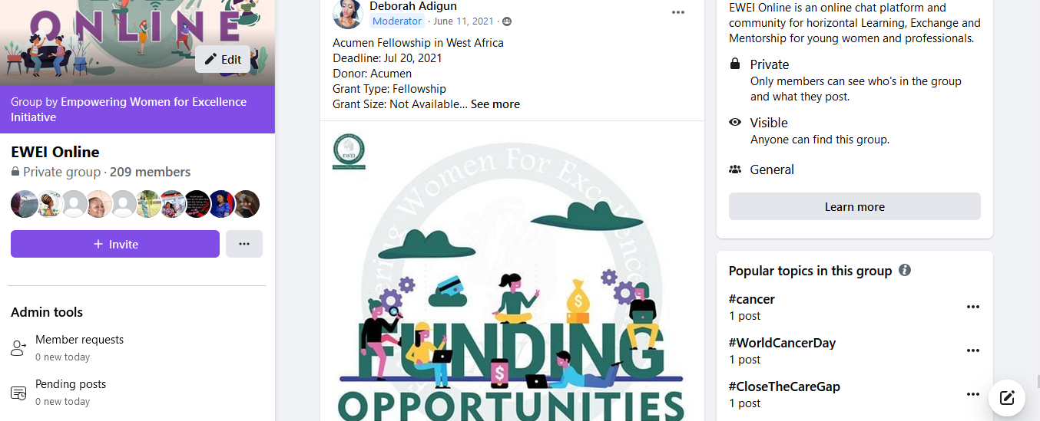

CHALLENGES
The major challenge is low engagement by members on the page. In addition, we are still yet to reach our target number of memberships on the page (300 members).
MITIGATION
To address the challenge of low engagement, we continued sharing educational resources to engage the EWEI Online members, alongside funding opportunities. We also tried to diversify out content on the page to include videos, articles images and puzzle games for interactivity. To address the challenge of low membership, we shared the link to the page continuously on EWEI’s social media handles for publicity and physically make membership invites.

NEXT STEPS
Moving forward, we will continue to adopt the cross-posting methods. That is, we will regularly post information regarding EWEI Online on all EWEI's social media platforms encouraging ladies to join the page, hold our monthly E-Chat video chat to engage members and equally publicise our events on EWEI online to get the participation of the members.
We will also organise facebook live events to discuss with members and engage in educative and fun activities, and get their opinions on topics and content they are interested in engaging with.

