HEALTH FOR ALL (HFA)  The death rate in rural Nigeria is high, much higher than it should be.  The organized public healthcare system is often utilized very late in a disease process, and when people are near death.  In 2012, the life expectancy of the population of Nigeria was 53 years.  The estimated per capita GDP in these communities is less than $1,000, much less than the low $6,082 in Nigeria as a whole.  There is limited access to trained health workers, as well as little knowledge of common chronic diseases and the strategies to manage them. |  |  | Who We Are  About Us  HFA is a non-profit organization that provides free health care to communities in rural Nigeria. HFA provides health screenings, medical exams, health education, diagnostic tests, and medications.  Contact Us  Phone: 415-420-8132  Email: healthforallglobal@yahoo.com  Web:  HEALTH FOR ALL (HFA)  21 Thrift Street  San Francisco, CA 94112. |  |  | HEALTH FOR ALL (HFA)  - … because everyone deserves a chance at life.

Mission statement  The mission of HFA is to bring healthcare to all in these communities because everyone deserves a chance at life.  The vision of Health For All (HFA) is that screening clinics will spread throughout the town, one village at a time. HFA will introduce the concept of health promotion and health maintenance to manage and prevent diseases in these communities.  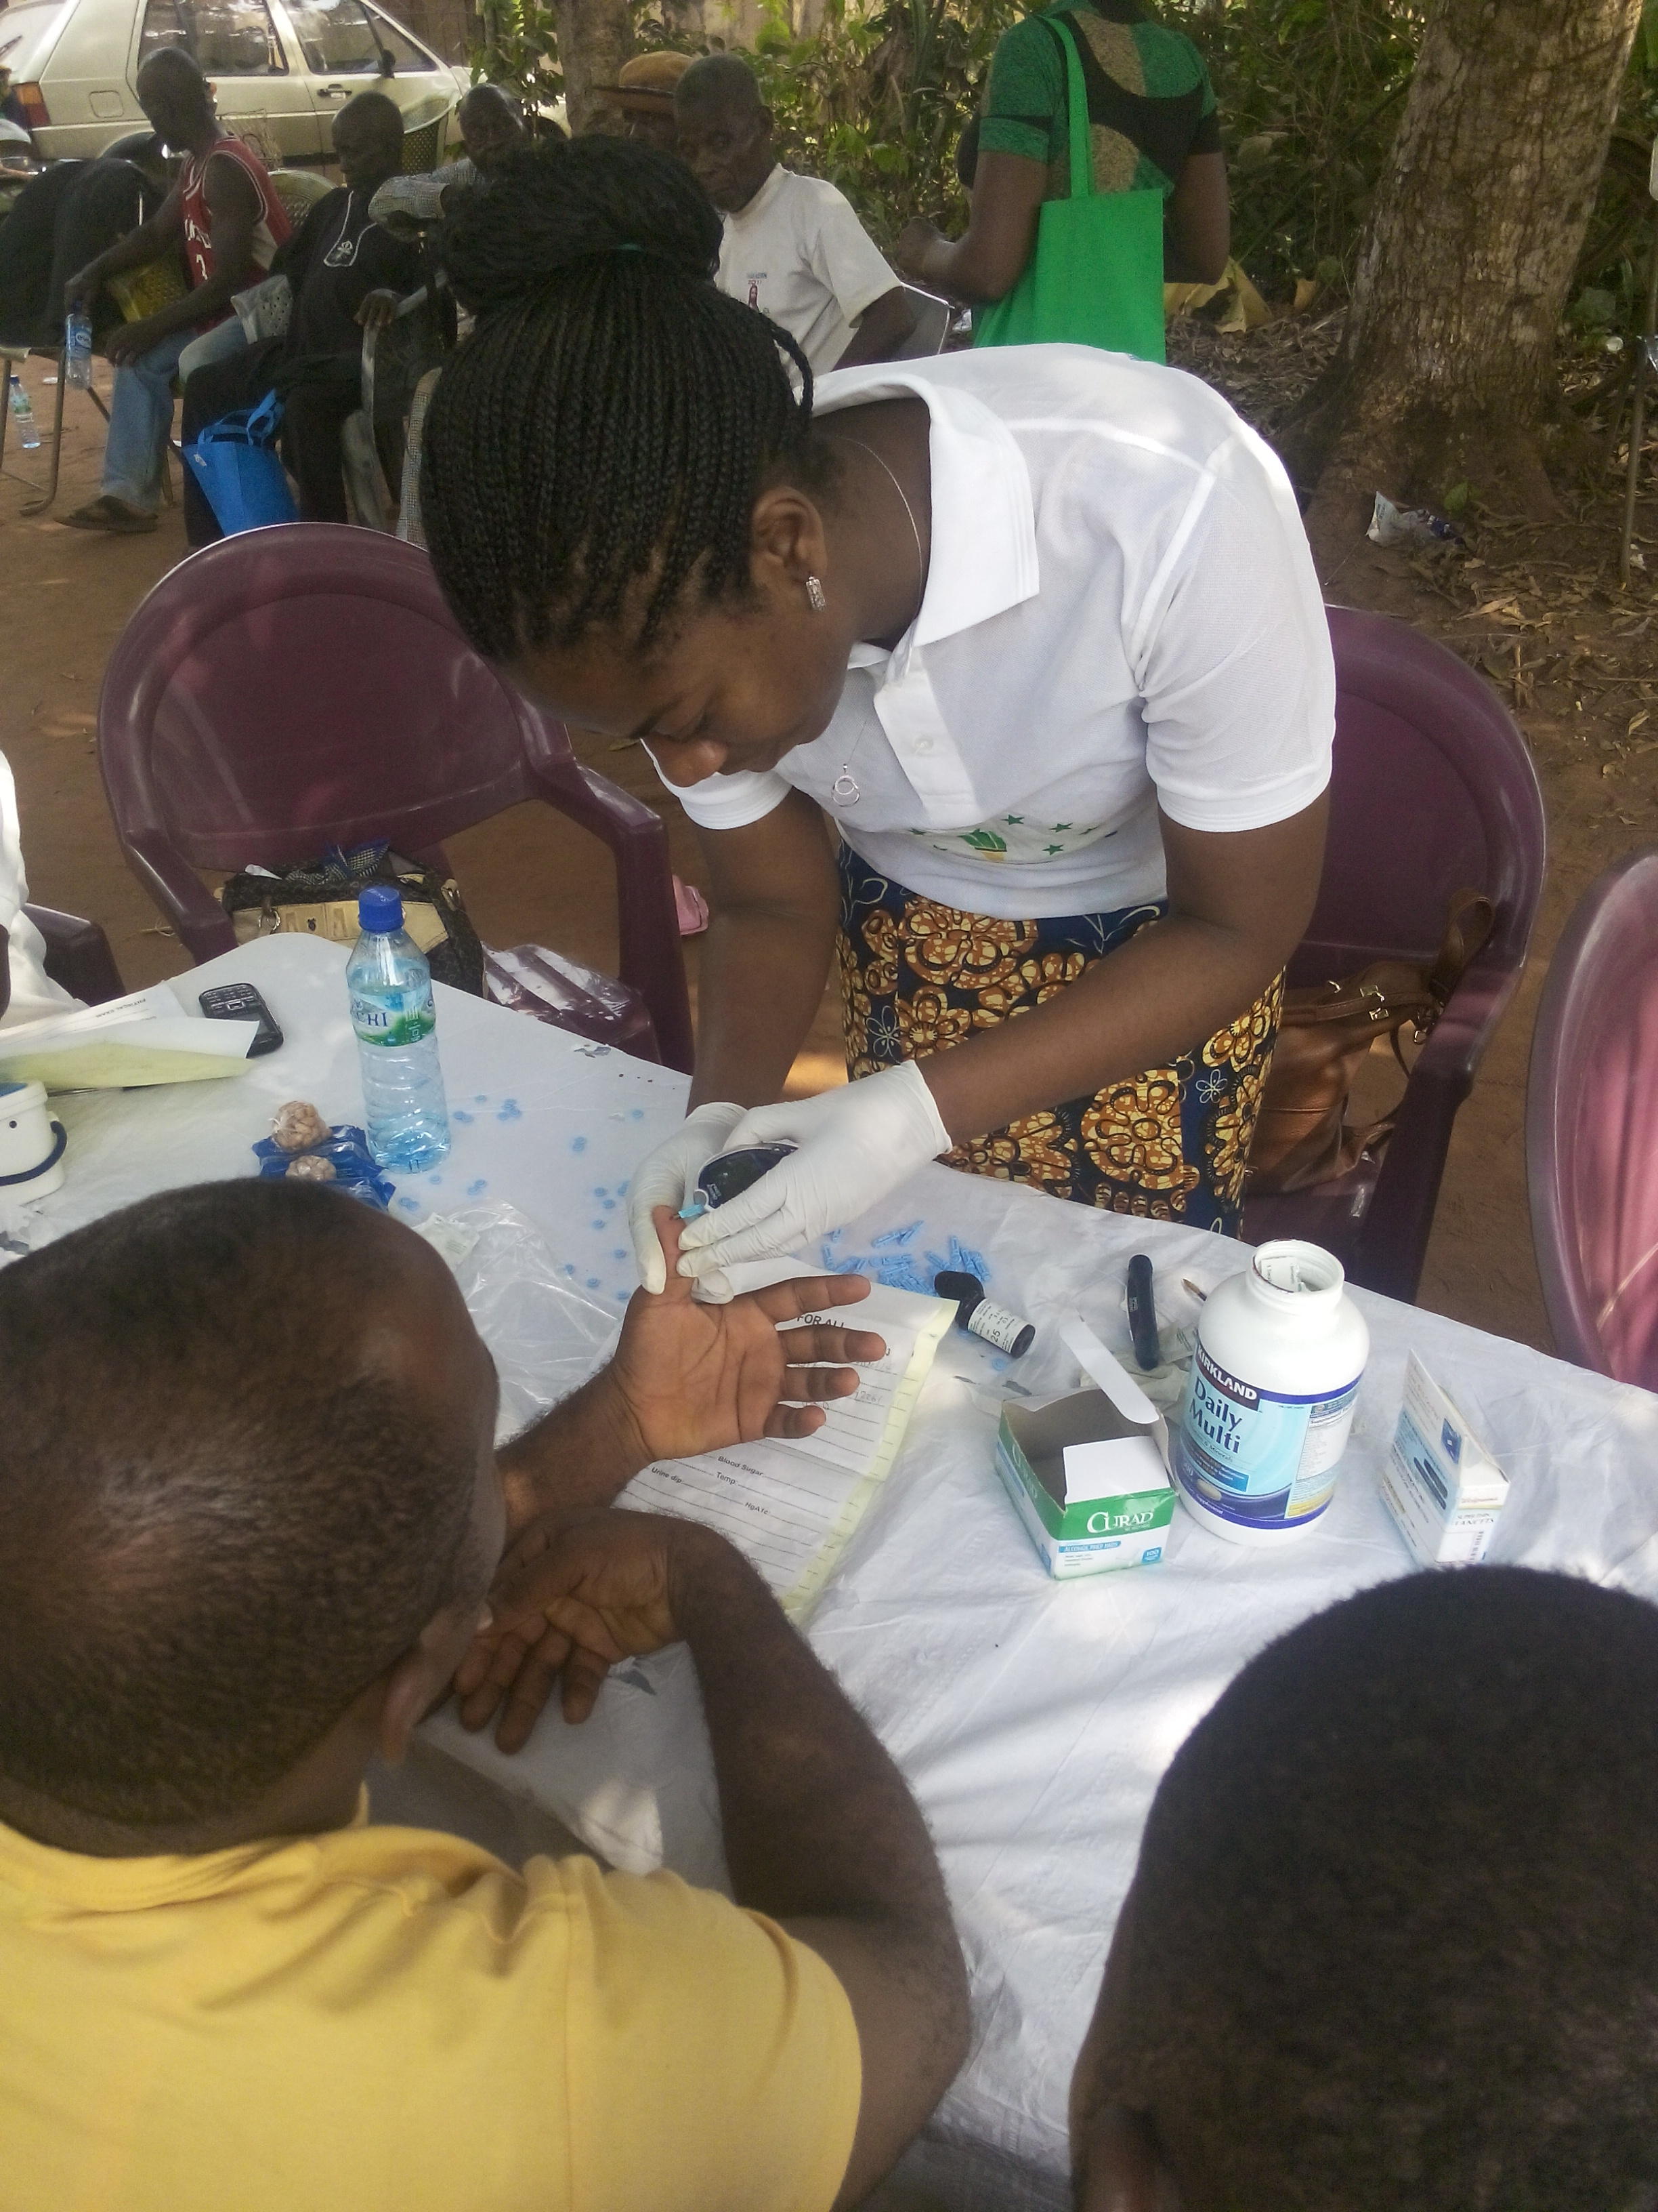 |  |  | Health For All (HFA) is a free healthcare, wellness initiative formed with the objective of providing free basic medical care to the people of rural communities in Nigeria. Health For All was created to change the reality of death due to untreated chronic diseases. Through health screenings, hypertension and diabetes, among many other diseases can be identified, and treated.  In its debut, HFA reached over 200 people for screening and provided additional one-on-one clinical exams and counselling for 80 of them, all despite limited resources.  One person served was a 46 year old father of six with a pregnant wife. He had no specific complaints, but came along with his wife because she hasn’t received any prenatal care at 4 months pregnant. He was diagnosed with both hypertension and diabetes, with a hemoglobin A1c of higher than 10. After a clinical exam, he was given appropriate medications for hypertension and diabetes, along with vitamins. His wife received prenatal vitamins, and related medication. Chances are high that he did not continue his medications after his initial supply was used up, a common problem in these communities.  More than 50% of adults over 30 years old screened, had a diagnosis of hypertension and 13 people had a diagnosis of diabetes with hemoglobin A1c greater than 7.  These numbers are alarming since many are at high risk for not treating these conditions either with medication or dietary changes. |  |  | Health Education  The services provided by HFA are aimed at health promotion and disease prevention through early detection by health screenings, medication management of chronic diseases, and health education and coaching to promote healthful behaviors.  Part of the health education was provision of seeds to improve gardening success and promote increased vegetables in the diet  HFA offers monthly follow up blood pressure and blood sugar screenings, in addition to a more comprehensive health screenings and clinical exam two or more times a year,  The monthly follow up aims to maintain close monitoring and prevent breaks in the medication regimen, an important component in chronic disease management.

