Period of festivities and celebrations for our children

The past three to four months has been a period of several festivals and celebrations across India. The country has celebrated its Independence day, Diwali, Ganesh Chaturthi, Navratri, etc. and several other festivals during this period.

Our children have also taken to these several festivals with a lot of enthusiasm and spirit. Firstly our children at our Balmandir Centre in Panvel actively and with a lot of patriotism celebrated the independence day of India by hoisting the Indian Flag along with the national anthem.

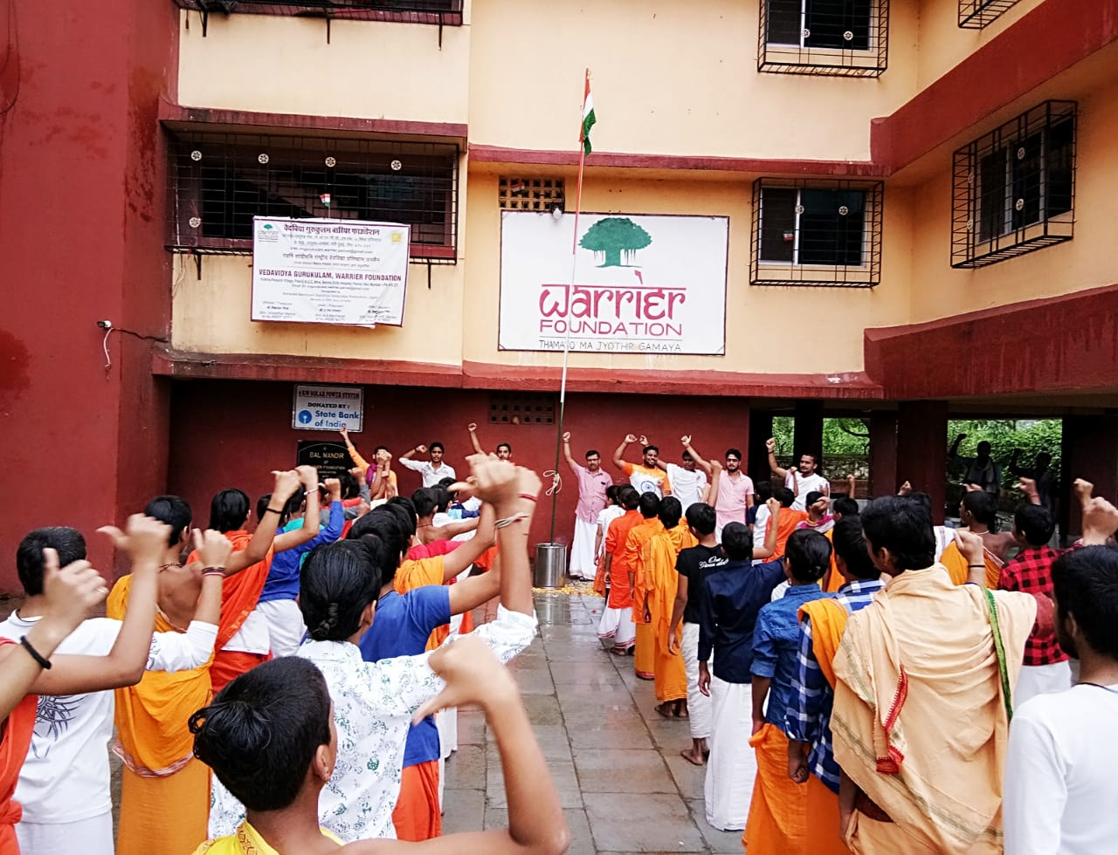
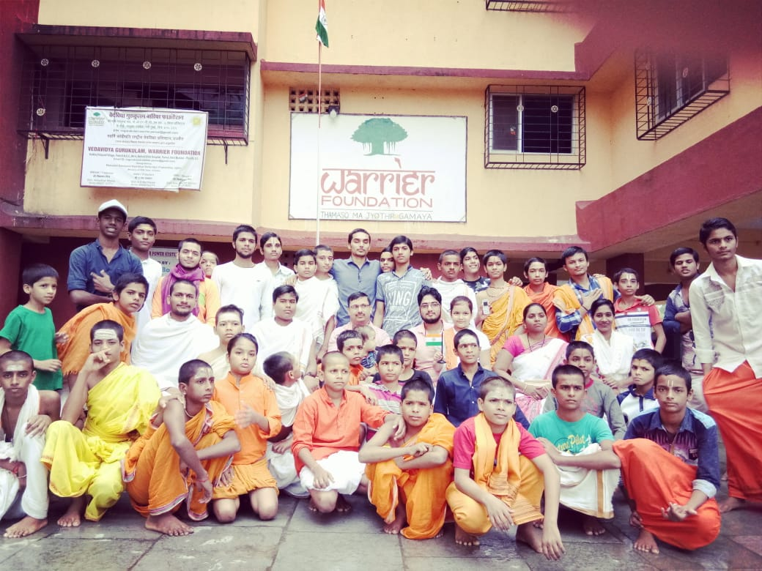

The Children from our Balmandir at Ernakulam Kerala took part in a drawing and other cultural competition during the festival of Onam that is celebrated very actively in Kerala.

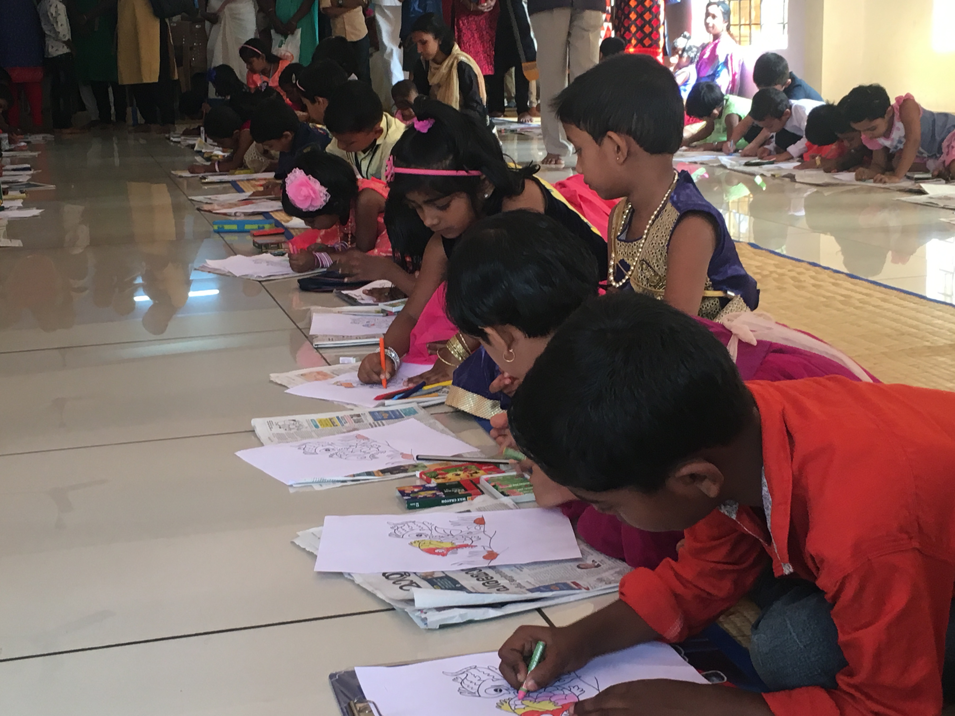
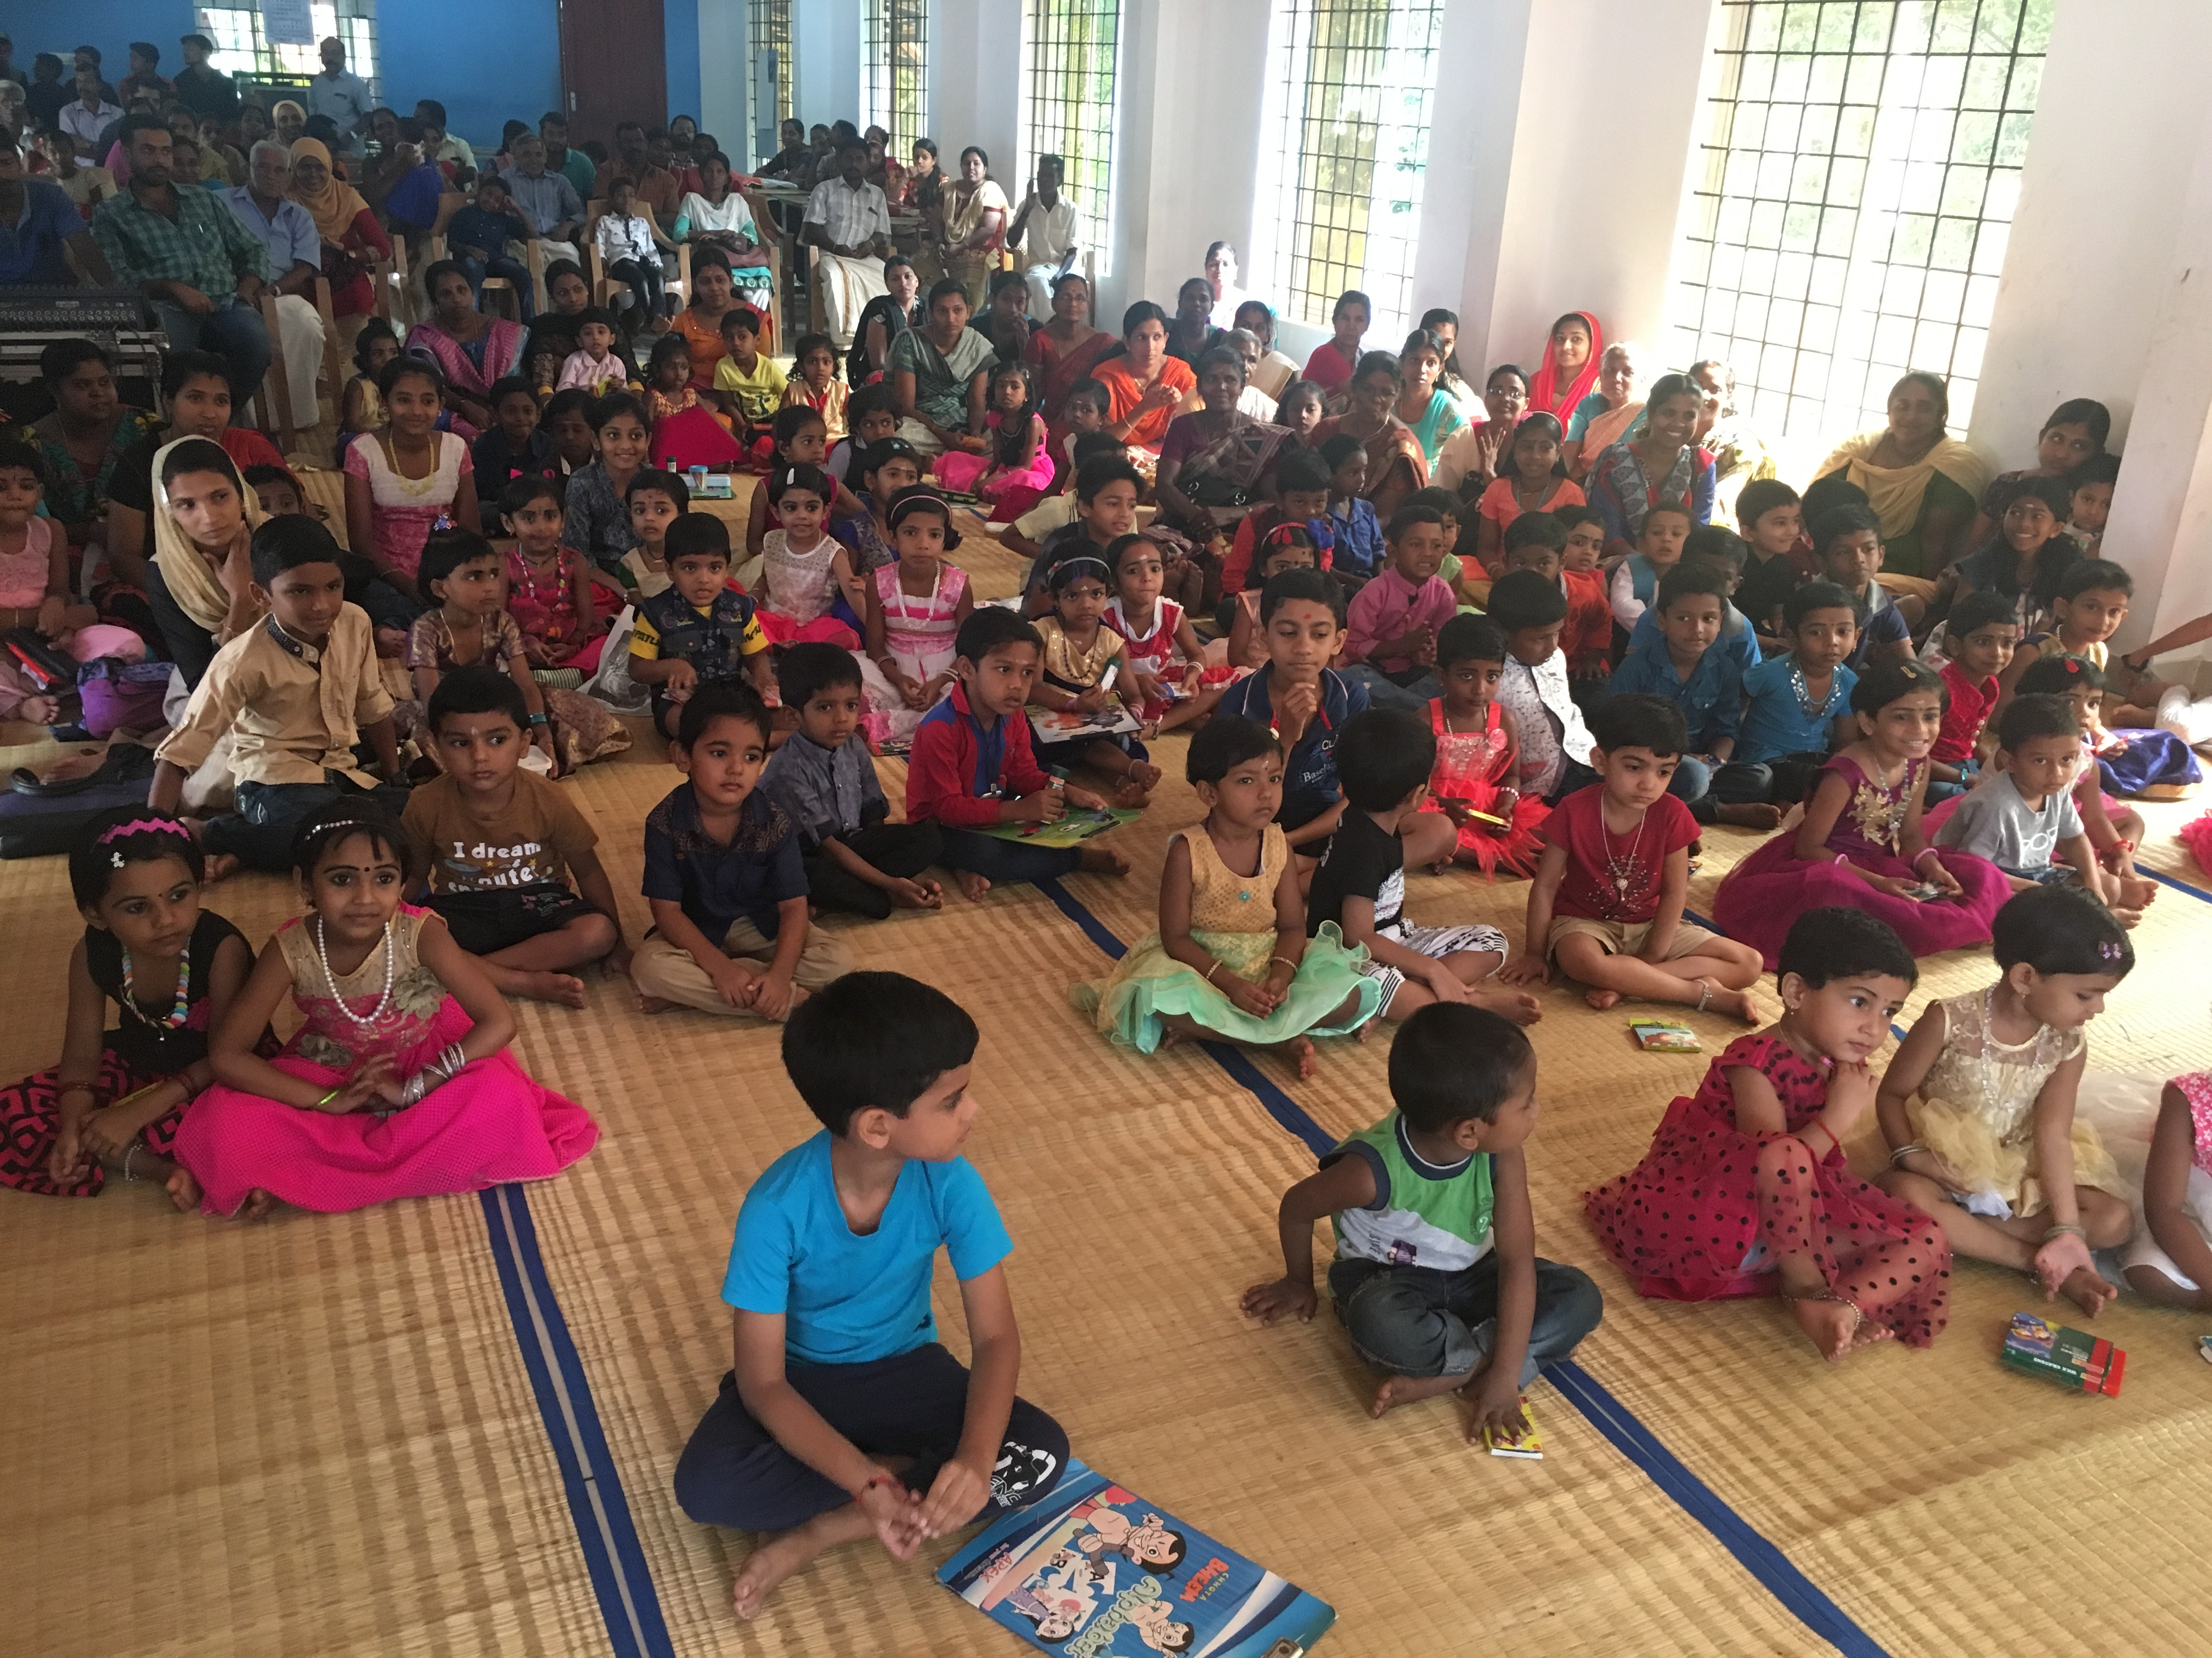

Our children from Balmandir Thirunavaya, Kerala, eagerly awaiting for guests to come before the celebrations for the navratri could begin.

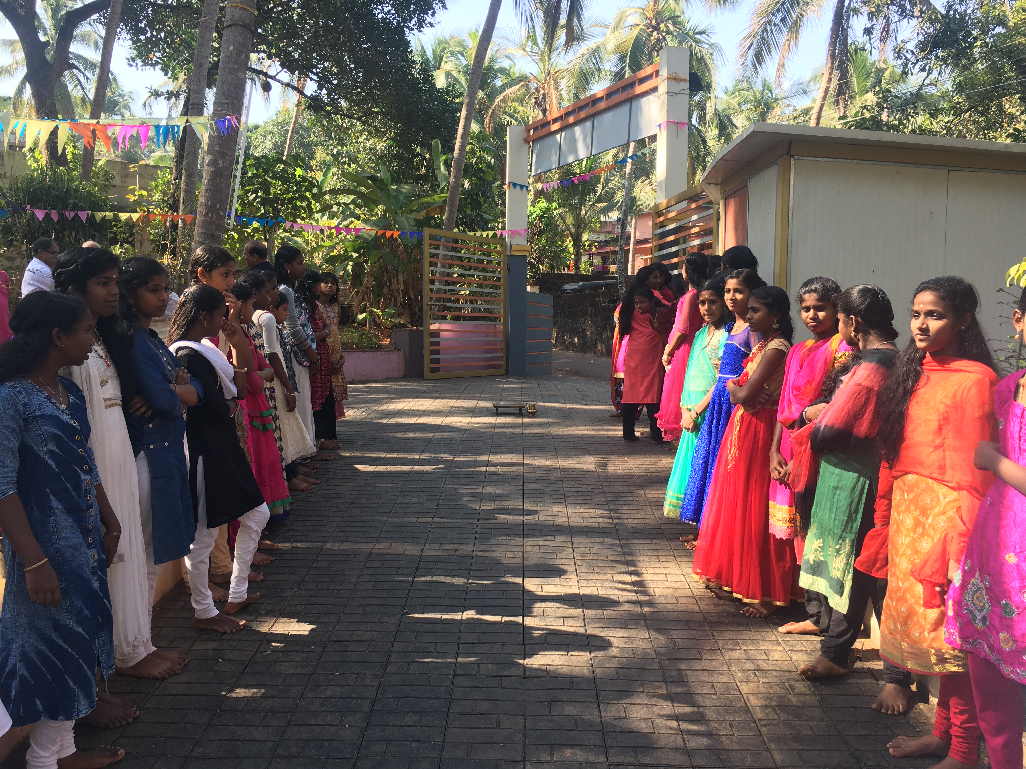

Last but not the least our kids taking part in extra curricular learning before Diwali in our Panvel Balmandir Centre where they are learning to skillfully make beautiful lamps and lanterns to light up the entire Centre with lots of lights and happiness.

