June 30, 2020

Global Giving Report April - June 2020

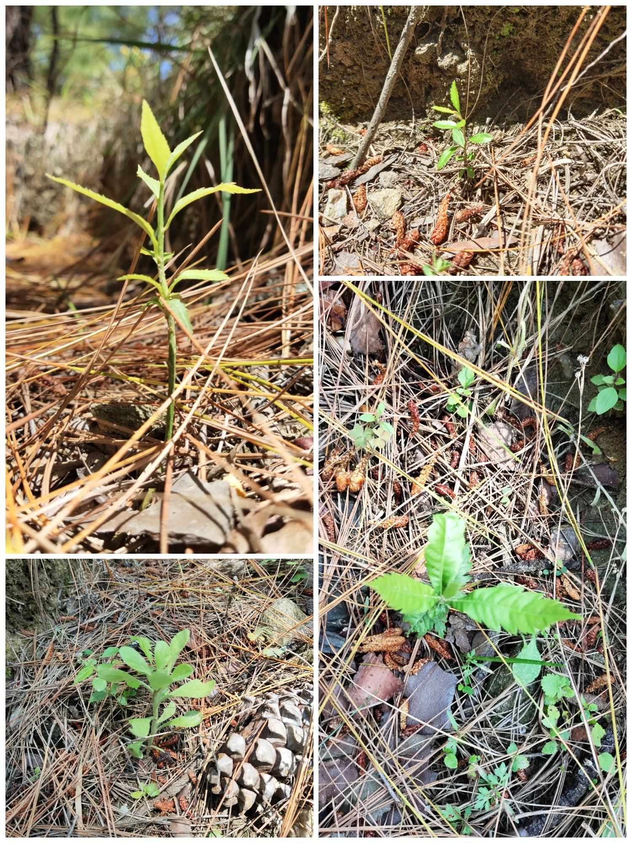

From Seed Bombs to Seedlings!
As a result of an eco-fun activity of seed bombing conducted prior to monsoons last year, some of the seeds underwent germination successfully. Various native seeds of kumaon were used in making seed bombs. Some of them were- Chamlai, Bhatoola, Sakina, Ghadi, Kilmaadu, Kathua aadu, Chuaru, Padam, Hisaloo and Kachnaar (these are local tree species). This activity also aimed at growing more native trees near the school premises to protect the pine forests from forest fires. During, the upcoming monsoons, efforts will be made to nurture these young plants into sturdy trees for the future.

Contextualized content for rural mountain children

As an attempt to make education more meaningful and experiential for the rural mountain kids, Aarohi, with the support of donations through Global Giving’s School Farm project and Duleep Matthai Conservation Trust initiated development of contextualised learning material using natural resource management methodology. The content designed for the upper primary section aims at achieving the learning goals defined by the Ministry of Human Resource and Development, GoI. These learning goals are the same for schools in both rural and urban areas. Keeping these goals as base, our content provides a context to learning making it more relevant and relatable to the immediate environment.
Through contextualisation of education with farming and ecology, we think parents from the local rural communities will be able to contribute to their child’s learning and the concepts taught under various disciplines will become more relatable to a child, bringing them closer to their local environment. Content has been designed to include the Himalayas, local biodiversity, folk stories, beliefs, traditions, cultures of Kumaon, history and geographical importance of this region, and traditional farming practices.

