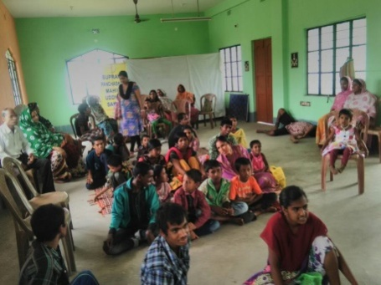SUPRAVA PANCHASHILA MAHILA UDDYOG SAMITY

CHETANA- Special School of Mentally Retarded children

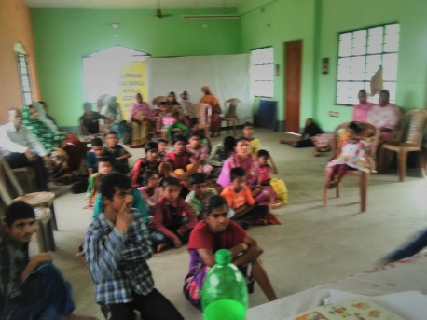SupravaPanchashilaMahilaUddyogSamity(SPMUS) is a registered under the society’s registration act 1961, FCRA. It has been doing different social welfare program for the women and child since 1993.

The organization has been running a special school for mentally retarded children namely ‘CHETANA’ giving facilities to 50 MR children without any financial support. It was academically recognized in 2nd March, 2001-No. 242/1(3 MEE).

The institutional special education has been imparting to the 45 Nos. mentally retarded children. Integrated approaches have been adopted for the prevention of it with protection of the children by the organization through different campaign program in different blocks of the District. The organization has been working with strong support of National Trust of Government of India, State level authority and Dept. of Mass Education Extension Dept.

Objective:-

* Integrated education and social inclusion of differently able children and their families.
* Imparting education to the mentally retarded children in formal education system
* Involvement of community to social and economic rehabilitation of the children at family level and community level.
* Sensitization of the people about prevention and protection of the children.

Approach:-To overcome the challenges with the participation of family members and their concern community.

Activities:-

* Teaching in special education
* Vocational training
* Sports and cultural activities
* Linkage with schemes of the government
* Parent counseling

Achievement:-

|  |  |  |
| --- | --- | --- |
| Issues | Target | Achievement |
| No of children | 50 | 45 |
| Nos. of children gets facility dress and teaching& learning materials. | 45 | 45 |
| Nos. of children linkage with social security schemes. | 15 | 12 |
| Nos. of guardian meeting conducted. | Monthly | Monthly |

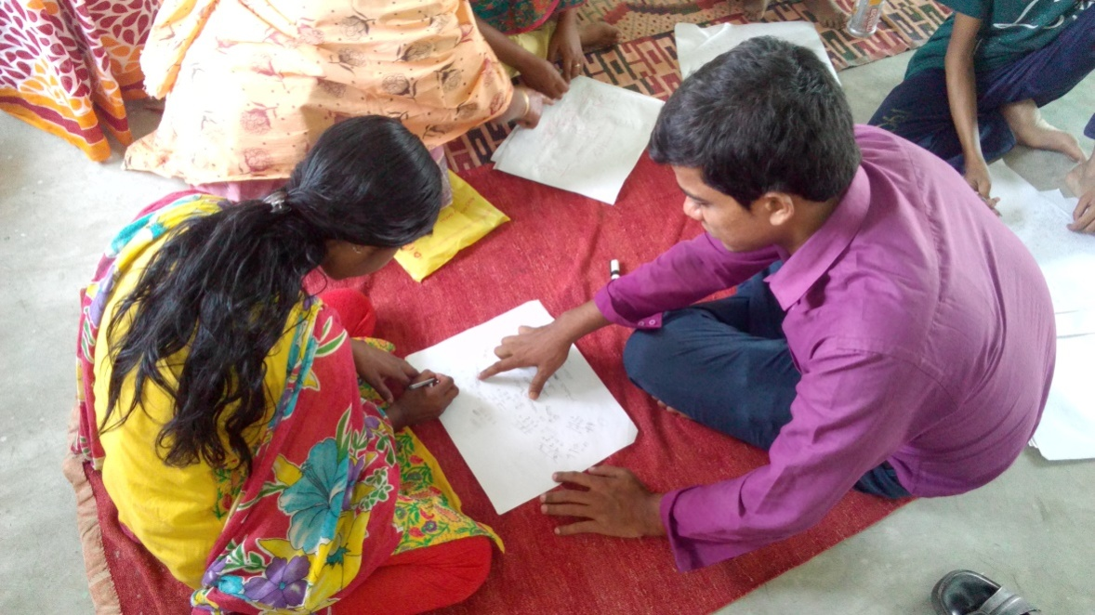

|  |  |  |
| --- | --- | --- |
| ইস্যু | লক্ষ্য | অর্জন |
| শিশুদের সংখ্যা  15 12 | ৫০ | ৪৫ |
| বাচ্চাদের সংখ্যা যোগ্যতা পোষাক এবং শিক্ষণ ও শেখার উপকরণ পায় | ৪৫ | ৪৫ |
| সামাজিক নিরাপত্তামূলক স্কিমগুলির সাথে শিশুদের সংযোগের সংখ্যা | ১৫ | ১২ |
| অভিভাবক বৈঠক মাসিক মাসিক | মাসিক | মাসিক |

ক্রিয়াকলাপ

• বিশেষ শিক্ষায় শিক্ষাদান

•বৃত্তিমূলক প্রশিক্ষণ

• ক্রীড়া এবং সাংস্কৃতিক কার্যক্রম

• সরকারের পরিকল্পনার সাথে সংযোগ স্থাপন

• পিতামাতাদের পরামর্শ

