NARRATIVE REPORT | December 31  2017
Presented by Mr M Matemera (Project Coordinator) |  | KUWADZANA SKILLS TRAINING CENTRE (KSTC) formally YET

INTRODUCTION
2017 marked a momentous year in which we embarked on our ambitious journey to become the best community based skills provider. In order to achieve this, there was an all-out transformation of KSTC. Looking back on 2017, I would like to emphasize not only our achievement in reaching our management goals but also the way we demonstrated the operational versatility to improvise our strategic direction, adapt to the constantly shifting industry environment, and collectively overcome the obstacles that stood before us. Going forward we have made innovation an integral part of our operations by focusing on four strategic agendas: the introduction of new courses, fundraising projects, and improvements in our financial structure and staff development. Below is a summary of major highlights of the year 2017 in a tabular format.

Activity | Achievements | Challenges | Way forward
Technical Skills Training
Programme Marketing | Programme Marketing was successful. KSTC held two sessions January and March 2017. It was centered on road-show method. Theater performances were done during the road show. Fliers were also distributed to Granary, Kuwadzana Extension, Dzivarasekwa 3 and 4, Kuwadzana 4, 5, 6, 7, Corobrough North, Kuwadzana phase 3 and White House shopping centers were visited during the road show. One of KSTC board member Mrs O Mavhunga distributed fliers to Churches in our community where she was invited to preach. | Other advertising media was not used to extend marketing efforts such as social platforms i.e face-book and whatsapp and website. | - To continue road shows.  - Advertise on Websites, Facebook and whatsapp.  - To print t-shirts written, “I made this at KSTC” at the back.  - To increase banners for display at townships.
Enrolment | 2017 enrolment statistics is as tabled below. We started with 12 new students and 8 proceeded from 2016 in February of 2018. At the end of the year we recorded 44 new students plus 8 from 2016 to a total of 52 students. Of the 52 students, 25 completed their courses and graduated and 10 drop out while 17 have proceeded to finish their courses in 2018. | - Low turnout during the first months.  - There is no wider range of courses on offer.  - 10 students’ dropout. | - To advertise early in 2018.  - Diversify and introduce short courses with high impact.  - Encourage students to finish their training before they could start other or new programmes.
ENROLLMENT STATISTICS AS AT 31 DECEMBER 2017
NARRATION | REG | FEB | MAR | APR | MAY | JUN | JUL | AUG | SEP | OCT | NOV | DEC | MALE | FEMALE | TOTAL
Enrolled 2017 / month | 0 | 12 | 5 | 2 | 5 | 5 | 2 | 0 | 7 | 2 | 3 | 1 | 8 | 36 | 44
Enrolled 2016 / month | 8 | 0 | 0 | 0 | 0 | 0 | 0 | 0 | 0 | 0 | 0 | 0 | 1 | 7 | 8
Dropout | 0 | 0 | 2 | 2 | 0 | 4 | 0 | 0 | 0 | 2 | 0 | 0 |  | 10 | 10
Completed Course | 0 | 0 | 0 | 0 | 2 | 2 | 0 | 0 | 0 | 1 | 2 | 18 | 7 | 18 | 25
TOTAL NUMBER OF STUDENTS from 2017 class. |  |  |  |  |  |  |  |  |  |  |  |  |  |  | 17

Technical Courses | The trainings went on well for all the 3 departments as per their respective syllabi and 85% of the trainees managed to complete their trainings. | - Students often bring their training materials late, citing delays by parents to release money for the materials. | - Students need to be encouraged to seek training material funds early to compliment the effort of Instructors.  - KSTC should consider incorporating training material cost on monthly fees.
Machines, Service and Repairs | - All the three departments managed to service and repair their respective machines.  - Dressmaking Department and Interior Decorations has got 12 straight machines and 2 over-locking machine all together.  - 6 sawing machine motors were rewound.  - Accessories for the machines for all the 3 departments were also bought. | - Sawing machines breakdown more often than anticipated, resulting in high machine service and repairs cost. | - Instructors to closely monitor machines during and after use.  - To buy new machine/s in 2018 to easy work load on old machines.
Training Materials Purchased | All departments managed to procure adequate training materials. |  | All instructors must use training materials economically.
Bursary /  Course Subsidy | All students were informed about the bursary scheme. 16 applications were received during the year and approved as follows:  - Dressmaking Department 8.  - Interior Décor approved 5.  - Welding Department 3.  Bursary scheme was extended to student debts in 2016. Students on the bursary scheme are expressing happiness and satisfaction. Letters have been received from students who have their lives changed with the scheme and shall be forwarded to Fepa. | - Bursary scheme age limit.  - Some parents with deserving children are too shy to benefit from the skim hence are not accepting the offer. | - To review the bursary conditions.  - To keep on engaging the parents regarding the scheme.
Non-Technical Skills Training
Life Skills Training | As per the table below 6 out of 6 sessions were held during the year as per the Activity Calendar. Topics covered were as follows:  - Visionary Leadership.  - Creative thinking.  - Team Building.  - Communication.  - Problem solving.  - Decision Making.  Attendance was at an average of 24 youth members per session in first half of the year and 30 in the last half. Only 9 youth from the community came to participate too. Mrs Chambara a Harare Polytechnic lecturer was the facilitated all the sessions. Life Skills had a high and positive impact. Students participated very well and expressed satisfaction after the training. | Youth from the community are reluctant to come in big numbers to participate. | To engage all responsible offices of social clubs, schools and churches in our community and invite them.
Center Peer Education | 3 sessions of Peer Education were successfully held and peers discussed the following topics:  - Love and sex,  - Peer pressure,  - Personal vision for the next 5 years.  The average attendance was 24. Youth from the community were only 6. Students were highly motivated after the events. They resolved that no sex before marriage and that no one should be given pressure to do things that he or she wouldn’t do under normal circumstances, in as much as they encouraged one another to have a vision. | The majority of students find it taboo to discuss openly about sex. | To encourage students to discuss about sex openly so that they are knowledgeable and can learn from each other`s experiences.
Theater training | All 3 sessions scheduled for the 1st and 2nd quarter were done. The themes were as follows:  - Importance of Education  - Education & Poverty.  - Xenophobia.  Mr M Nyandebvu facilitated the trainings. Students’ participation was super. The attendance was at an average of 22 pupils. 4 of them were Graduates of 2015 and 2 from the community.  Theater performance was done during the sports tournament. |  | Theatre is a powerful message deliver and creates jobs as well as helps make people assertive hence should be done regularly.
Reproductive Health Education | 3 sessions were held during the year. The topics covered were as follows:  - HIV & AIDS  - Female & Male Reproductive Systems.  - Consequences of early sex indulgences.  National Aids Council (NAC) facilitated HIV & AIDS while Ms Tshuma a Registered General Nurse at Parirenyatwa Hospital facilitated Fe/male Reproductive System. NAC held the event at Kuwadzana 4 Shopping Centre hence the reason for over 200 people from the community attended. | Lack of demonstration equipment such as a projector. | A projector should be bought for future use as it improves presentations.
Lobby & Advocacy & Training | All sessions were conducted. The first topic was Approaches to Lobby & Advocacy and the last was an assignment to the trainees to engage their parents on issues affecting them and lobby to solve it with them, so as to have harmony at home. Both trainees and KSTC enjoyed the exercise. KSTC students attended and only 1 from the community. Mr D Muzondo facilitated. | Youth from the community did not attend as expected. Lake of refreshments was their reason. | - Keep on inviting more youth through churches, schools and social clubs.  - KSTC to organize refreshments where necessary.
Day of the African Child | The event was hosted by City Council at Warren Park Magamba Hall. The event was held under the theme “The 2030 Agenda for Sustainable Development for Children in Africa: Accelerating protection, empowerment and equal opportunity”. This event pulled most of the youth in the community to one place, hence the reason for high turnout of the youth in the community. 17 of our students participated on the day. They composed a song for the event. This event had a high impact on the community since there was a high turnout. |  | To always attend this event every year.
Consultation Days | Parents’ attendance was pleasing. This platform was also used to advise parents about other programmes at the school including bursary. Parents showed satisfaction with work of their children. About 70% of the parents attended. | On the contrary parents were not happy about using the back entrance. | City Council has since been engaged to create entrance from the front office. KSTC is still waiting for their response.
Counseling | Counseling should be part of the Activity Calendar events. 10 students came for one on one counseling. They had personal issues that can be summarized as follows:  - Family issues  - Relationships  - Prayer  - Education and  - Peer pressure.  Counseling has great impact since it helps motivate them and feel that they are cared for. | Most of the students seem to have problems but are too shy to discuss or open up. | Students are encouraged to continuously share their personal problems especially that the Coordinator is a qualified counselor.
MEGA Tournament | FEPA – Fund for Development and Partnership in Africa is branded the main donor for the tournament. FEPA provided funds for sports uniforms, tennis, balls prices and refreshments as well as planning and logistics for the event.  The event was finally held on the 4th November 2017 under the theme Spare a day and resources towards the environment. The following teams attended:  Netball, volleyball, netball, soccer, kick boxing, marathon, cycling, musical band and theatre and these teams contributed over 300 participants and we also had over 150 audiences. A top athlete we had was Innocent Kanopupa who is a Kick boxer and Sub-Saharan Africa Silver weight Championship silver medalist and also being former KSTC graduate of 2016.  The event was graced by Mr. Kadio from Harare City Council and social organizers from our district. Also in attendance was the M.Ps office and National Aids Council. These officials were happy for the program and promised to help KSTC in its future endeavors.  It was agreed that the tournament be an annual event. | Most of the corporate world we approached turned KSTC down sighting economic hardships hence the funds we had were inadequate. | Local donors and all other stakeholders should continuously be approached and engaged in the planning and implementation process of the tournament in time.
Sports Training | All session planned for the year was done. Students requested for more training sessions in preparation of the tournament after lessons on every Monday, Wednesday and Friday. More youth from the community and former graduates participated with KSTC students. 3 teams were set up as follows:  - Netball  - Volleyball and  - Soccer  All students and 14 community youth participated forming KSTC teams. | - Students found it difficult to train on both netball and volleyball grounds because; the grounds are tarred instead of required turf surface.  - On the other hand, sports training equipment such as balls, whistles and nets were not sufficient enough. | - To liaize with City Council for the renovation of sporting grounds.  - All training equipment must be procured earlier.
Sports Gear Manufacturing | Sports gear manufacturing was a successful program. Sports uniforms for both boys two soccer and girls two netball sets were manufactured according to plan. FEPA financed 100% of the sports uniforms manufacturing. |  | KSTC should put the uniforms into good use and use these uniforms to advertise their expertise in sport gear manufacturing. May FEPA help finance the other 2 departments with sports uniforms in 2018 for Basket and Volley ball teams.
Exposure visit | The industrial visit was successful. All trainees were taken to Archer Trading a clothing manufacturing company based in Bulawayo. The company has a workforce of 600 workers including those who do welding. The trainees had a chance to see the industrial processes on a larger scale and also ask question regarding production.  Both the trainees and staff were highly motivated by the trip. | The organization had little funds for the trip. It was a one day trip which was very tiresome since its long distance.  The trip was done late instead of being done earlier. | KSTC should continue to send students on industrial exposure visits as it has high impact on learning and preparation of graduates.
OTHER
Reports | The auditor was successfully engaged to audit the 2016 Financial year.  All 2017 financial and narrative reports for first 3 quarters were submitted to FEPA. | The 4th quarter unaudited Financial and Narrative report for the year ended 31 December 2016 were produced late as a result changes in human resources. It also delayed the Audit of the same period to be carried out. | All reports must be submitted to FEPA as per the agreed dates. Delays of such must be communicated forthwith.
Consultant Support | The consultant is continuously helping management to come up with refined various concept documents and many other issues. “Areas covered by the consultant and management are as follows: 2017 activity calendar, Review of 2016 end of year report, 2018-2020 funding proposal.  2017 board and staff exposure visit were also carried out to Young Africa in Chitungwiza and Silveira House Hopely Projects. KSTC board and staff were introduced to different models being used by the two non-profit making organizations. |  | The kind of support obtained from the consultant should be put into effective use.
Board Meetings | Board meetings were held as follows:  - 2 meetings in the 1st quarter.  - 1 meeting in the 2nd quarter.  The new board was appointed in the 2nd quarter. The new board members are as follows:  - Mr R Mukavhi (Legal)  - Mr C Mukungatu (Treasurer)  - Mr Chivhenge (Social Worker)  - Mrs O Mavhunga (Community)  - Mrs E Usayiwevhu (Community)  - Mrs C Nyandebvu (Founder)  - Mr M Matemera (Coordinator)  Ms Rusinehama, Mr Mawire and Mr Chitenga resigned following the lapse of their terms. |  | The board should meet according to scheduled dates.
Fundraising | KSTC managed to send funding proposal to the following organizations:  - Jesus College Sub-Saharan Africa Fund for Education Funding  - Australian Embassy  - Brazilian Embassy  - Canadian Embassy  - Global giving | Few funding proposals were sent to various donors in 2017. | KSTC should keep on writing effective proposals to different funding Organizations.
2017 Graduates Employment | As tabulated below 8 graduates of 2017 class are already employed in the informal sector. Of these 8 graduates 3 were on bursary. | Graduates indicated lake of capital to start their own initiatives in the community. | KSTC should continue to engage Fepa for graduates’ loan fund.
2017 GRADUATES EMPLOYMENT SUMMERY
 | Formal sector | Informal Sector | Department Total |  | Bursary
Dressmaking |  | 3 | 3 |  | 2
Interior Décor |  | 2 | 2
Welding |  | 3 | 3 |  | 1
TOTAL |  | 8 | 8 |  | 3

MARKETING – ROAD SHOW TEAM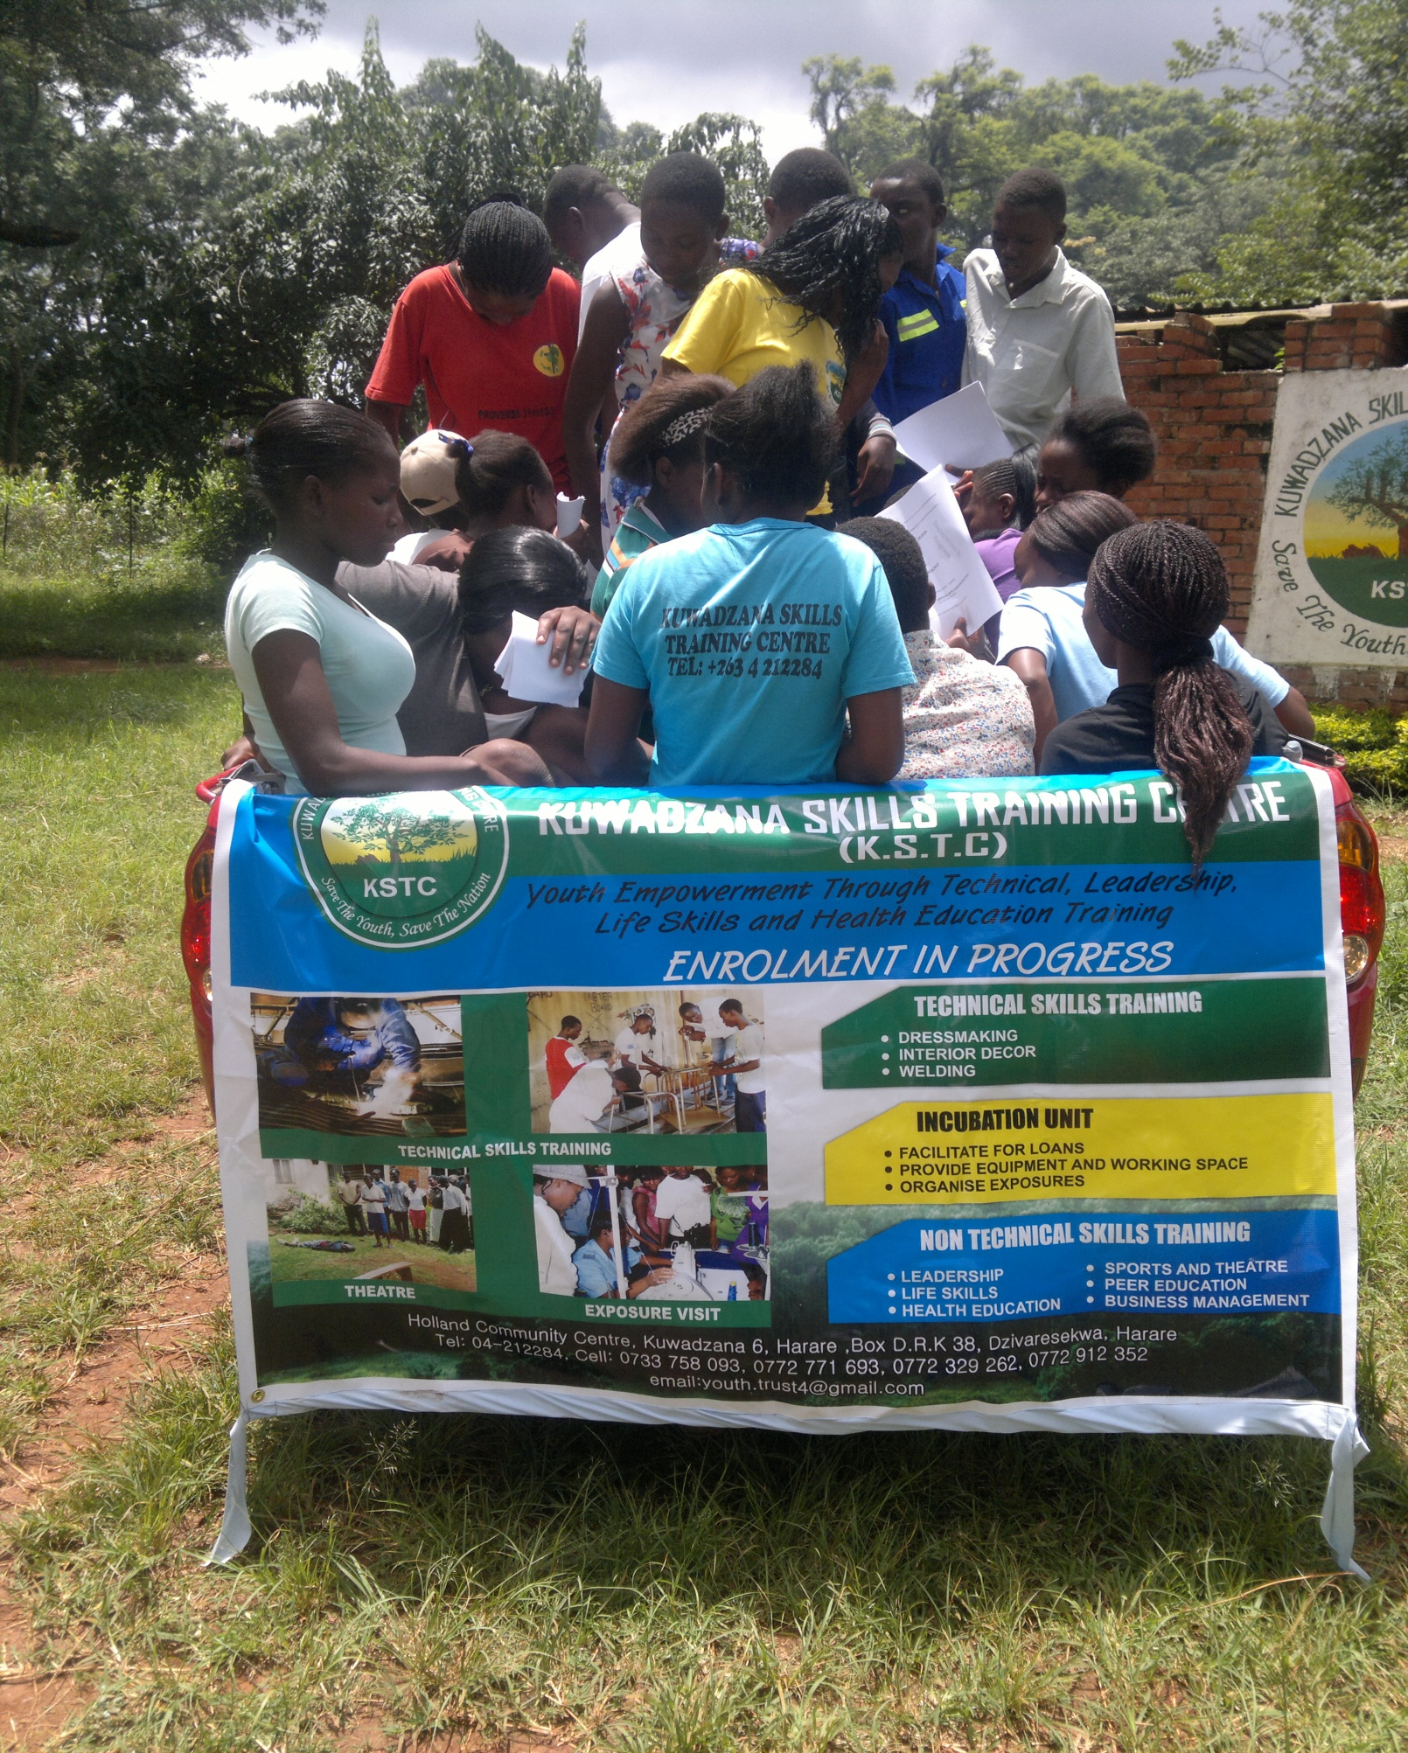
SPORTS GEAR MANUFACTURING
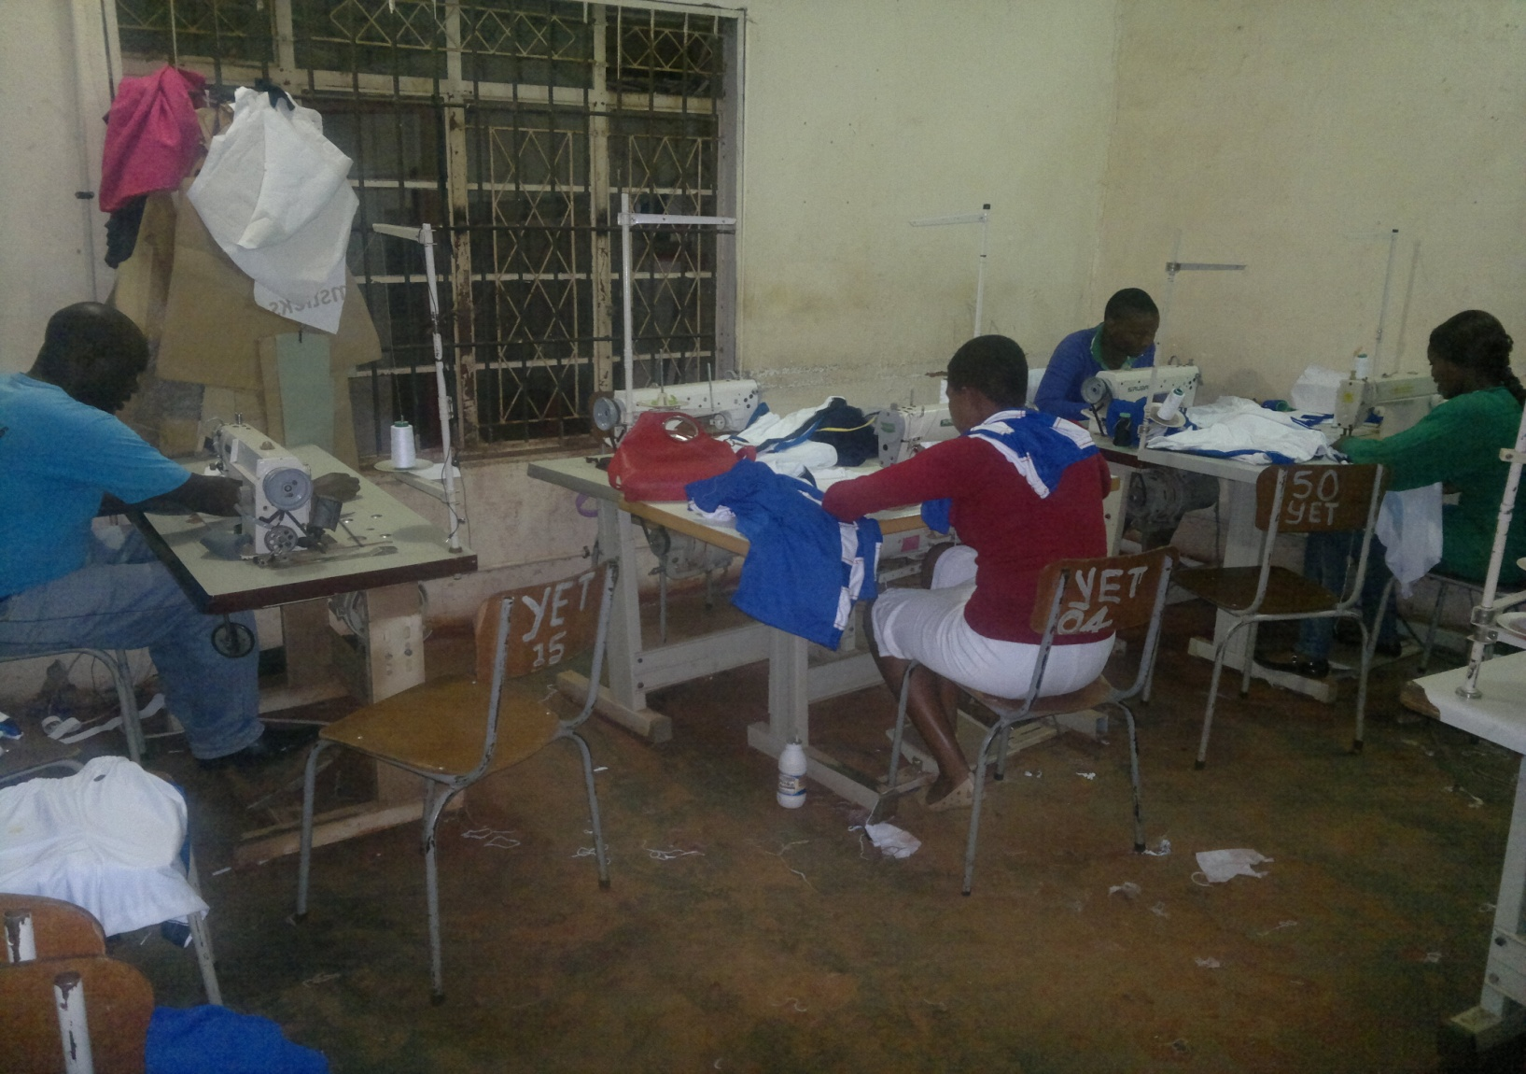

THEATER TRAINING SESSION WITH TALENT MAGATSI STANDING IN WHITE DRESS FORMAR GRADUATE 2011
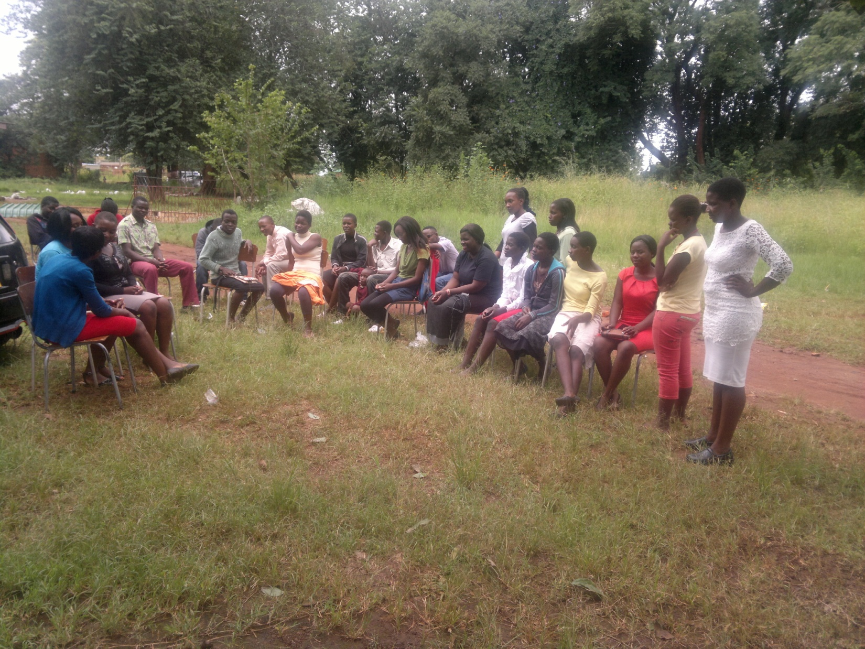

INDUSTRIAL EXPOSURE VISIT – ARCHER TRAING IN BULAWAYO
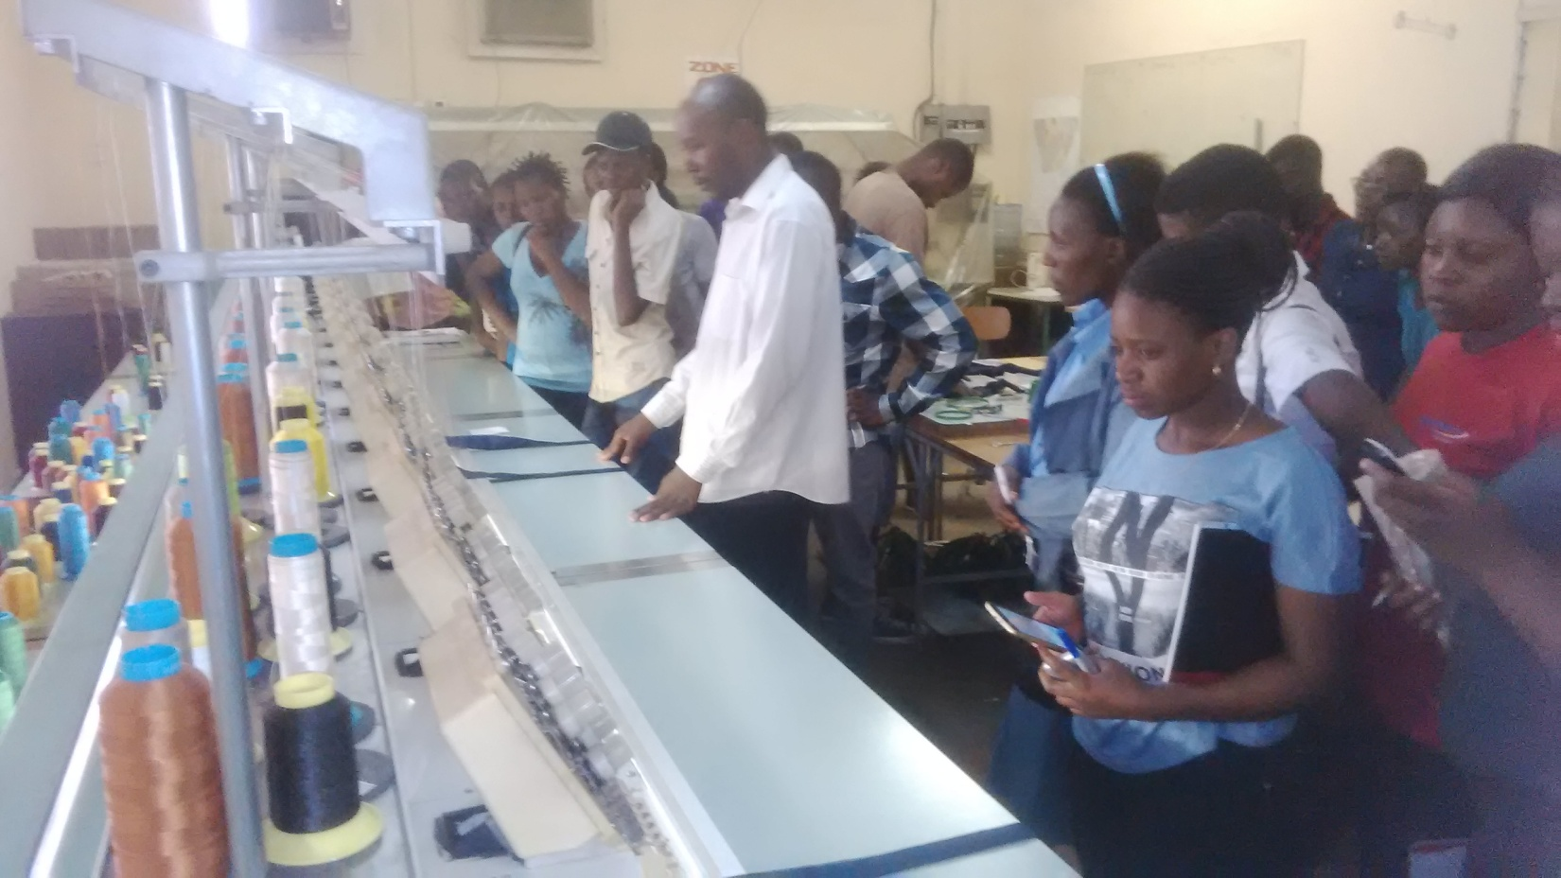

SPORTS TOURNAMENT – AMACHER CYCLIST COMPETITION (SENIOUR MALE CATEGORY)
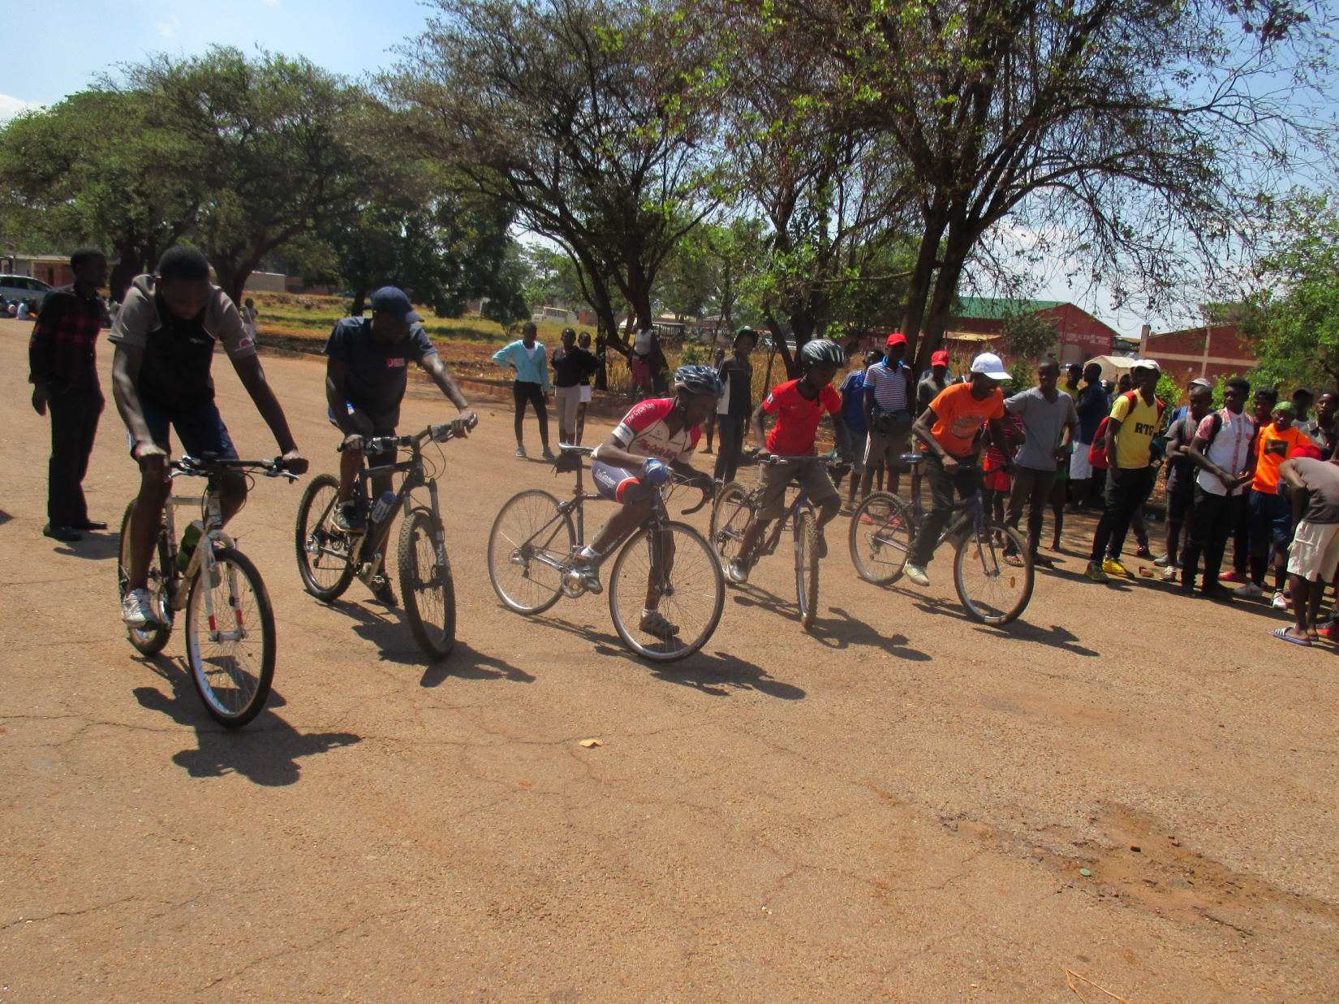

SPORTS TOURNAMENT – NETBALL COMPETITION (OPEN GIRLS)
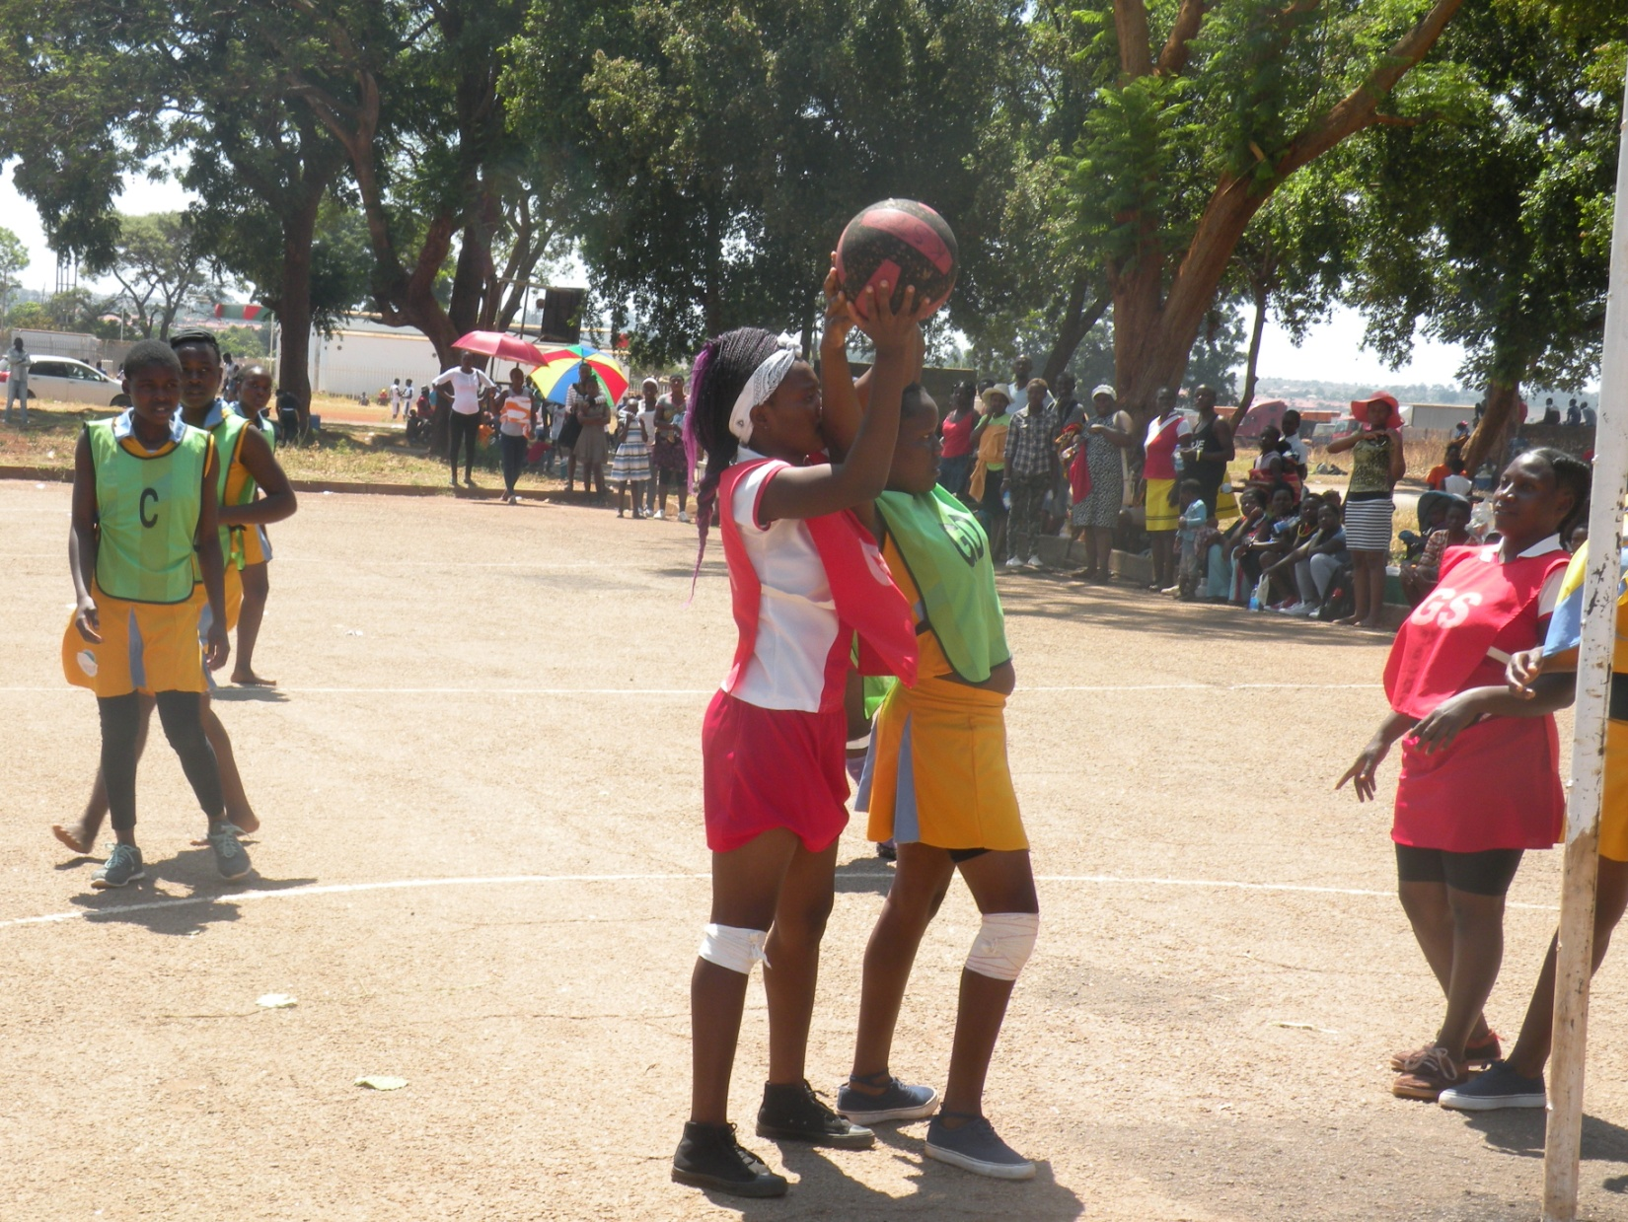

GRADUATION DAY – GRADUATES AND PARENTS
