Innovations in Peacemaking – Burundi/Healing and Rebuilding Our Communities
Elie Nahimana, Coordinator

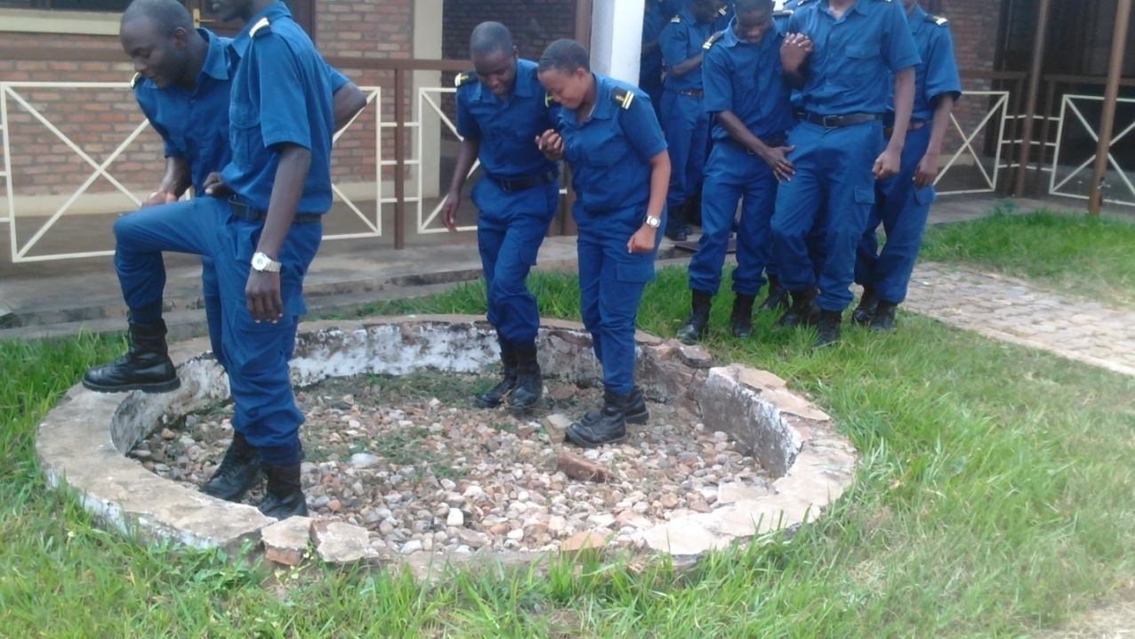
Trust walk with students from the Police University as part of a Healing and Rebuilding Our Communities workshop.
DONATE
To make a tax deductible (US) or gift aid eligible (UK) donation through Global Giving, click on goto.gg/33287

Testimony by Ndayizeye Jeanine
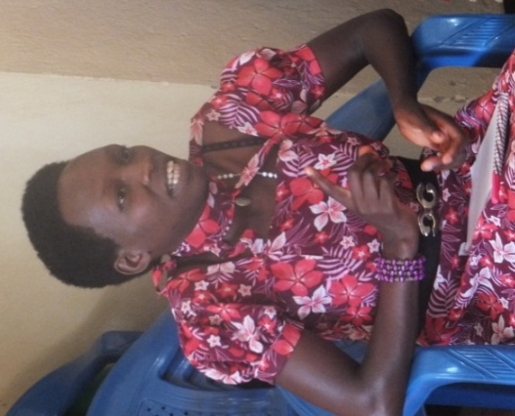
Before attending this workshop, I was having prejudices towards security agents. I have never imagined that there is among them anyone who can do something good, forgive or be a trustful person. From this time, I have completely changed my opinion due to the fact that among facilitators of IPB and HROC, there are courteous and wise policemen with a respectful look instead of fearful one. May our worthy God bless the ones who taught us and shared his testimony about forgiveness. This touched my heart and pushed me to change and to love policemen and soldiers.
I wish the organization to keep moving forward in its projects as the knowledge spread is useful and indispensable in the recovery process of trust among families, reconciliation, peace and sustainable development. This is true for me since we benefited from one student who participated in HROC peace activities who then he guided us from the bad cohabitation which characterized us in our campus to mutual forgiveness and reconciliation.
I am glad of the time you reserved for sharing and listening to us as the fact of speaking about ourselves was for us a way of being deeply released and healed.
2018 accomplishment

At the national level
- IPB educated and accompanied university students from different ethnicities and political parties in the same province through dialogues for peace, mutual tolerance, and national reconciliation. This included the military and police universities.
At the Bujumbura city
- IPB reconciled the youth and the security agents through peace dialogues and trauma healing sessions. These included local authorities and youth affiliated to the ruling political parties and its allies and those in the opposition.
- IPB met with students from the secondary schools who were abusing their teachers and supervisors by giving them psychological assistance utilizing the HROC methodology.

All these activities include refresher trainings, dialogues sessions on the current situation, participative development of common action plans, and identification of economic opportunities for youth to address poverty, a driver of political conflict in Burundi today.

- IPB succeeded to get all the parties to meet at the same table. This was the first step for all sides to overcome fear and to analyze the root causes of the violence and vengeance and propose ways to overcome them.
- IPB trained students at the army and police universities in peace making and trauma healing.
- Promoted peace clubs within community universities located in each province to sensitize students on trauma healing and social and economic resilience.
- Young who attended IPB peace activities in collaboration with IPB promoted peace initiatives in their own region.

What IPB hopes to experience in 2019
- Initiate a Peace Club in each community university in all provinces including the Burundi national army and police universities.
- Organize follow up activities to make the economic opportunities identified and action plans elaborated for this purpose.
- A HROC-in-Schools program in Bujumbura and up country.
- More peace dialogues to reconciling the youth and security agents.
- More female participation in IPB’s peace activities and making speeches in the public sphere.
- Work with handicapped students at universities.
- Community celebrations, organized to bring participants together with members of the community at large including local authorities in order to build awareness of healing initiatives taking place in their community and to reach lasting social cohesion.
- Playing football as a tool of mobilization and sensitization to bring different communities and identity groups together.

Thank you for your support for 2019.

