A New School Year and a Fresh Start

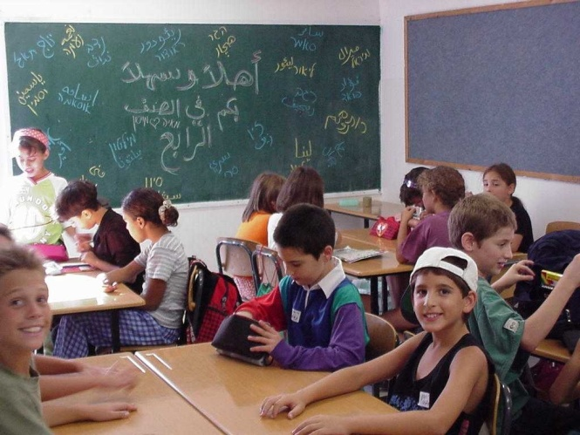
A new chapter begins at the Neve Shalom/Wahat al-Salam Primary School this September. As the school year begins students will also welcome a new Principal, Ms. Carmela Farber. The former principal of a primary school in Bat Yam, Ms. Farber, previously is excited and eager to tackle the challenges that lie ahead.
The Primary School recently received special status from the Israeli government allowing it to pave the way for future growth. Already, plans are under way to take on 100 additional students, and the School continues to gain recognition as a model across the region.
Last year at closing ceremonies, the Primary School said goodbye to Anwar Dawood, the beloved leader for many years. His wishes for the students at his departure were clear: “May you make many friends. May all your courses be interesting. May you always have your homework in on time!”

