ACTION PLAN

FOR

IMPACT YO'
(Improving Adolescents, Children , Teenagers & Youth Outcomes)
PROJECT

An Initiative of Good Samaritan Widows Support Foundation
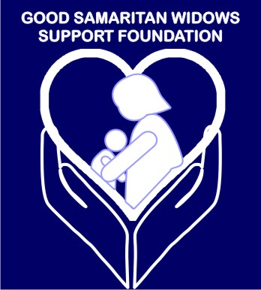

[FROM JUNE 2018- OCTOBER 2018]

MAY, 2018
LIST OF ABBREVIATIONS

AIDS - Acquired Immune Deficiency Syndrome
HIV - Immunodeficiency Virus Human
STD - Sexually Transmitted Disease
FHI - Family Health International
ARV - antiretroviral treatment through
NGO - Non Governmental Organisation
STI - Sexually Transmitted Infection
UNICEF - United Nations Children's Fund
USAID - United States Agency for International Development
PMTCT - Prevention of mother-to-child transmission (of HIV)
ART - Antiretroviral therapy
DART - Development of Antiretroviral Therapy (in Africa)
HIVDR - HIV drug resistance

CBO - Community Based Organisations

CAACP - COCIN Aids Awareness & Care Programme

CRUDAN - Christian Rural and Urban Development Association of Nigeria
TEAM - CIHDA - Community Integrated Health Development Advancement .
JNI - Jama'atu Nasir Islam
CAN - Christian Association of Nigeria

Project Overview
HIV and AIDS continues to ravage our economy up till this very moment. New infections are still rising, especially among children and young people. Deaths from AIDS related diseases are increasing rapidly, eventually peaking in 2005. Stigma is a huge problem for most people living with HIV. There are more than 15 million children orphaned by AIDS as well as having a devastating impact on families, these issues are also damaging to many countries' economies with Nigeria Inclusive.
Vision
A sustained Adolescent, Children, Teenagers and Youth response achieving a HIV/AIDS free world.
Mission
To build capacity of Adolescent, Children, Teenagers and Youth with adequate information and tools on HIV/AIDS through traditional bodies, religious bodies, schools and internet.
Challenge Statement
- Innovative, sustainable, low-cost and well-thought-out measurable strategies to reach 200,000 adolescents and young people with comprehensive HIV knowledge within 6 months.
- Innovative and sustainable ways to engage 100,000 adolescents and young people to participate in the HIV response at the Federal, State and Local Government level
- Innovative, sustainable, measurable referral and linkage strategies to ensure 3,000 adolescents and young people receive HIV tests, know their results, and are enrolled in treatment care and support.

The fight against HIV/AIDS is all inclusive across board. One of the major problems that hinder the fight against this disease are myths. IMPACT YO' (Improving Adolescent, Children, Teenagers & Youth Outcome) HIV/AIDS program in Nigeria has a goal super cede the challenge statement within 5 months. Our intensive focus areas are:

- HIV counseling and testing
- HIV/AIDS education
- Prevention of mother-to-child transmission
- Prevention of sexual transmission of HIV and other STIs
- Treatment, care and support
- Stigmatization and Discrimination
IMPACT YO' is an initiative located in Jos Plateau State that will encourage by enabling meaningful participation of adolescents and young people in the HIV response in Nigeria. There are over 90 million people in Nigeria below age 30 years making our population a very young one. This initiative will undertake sensitization seminars to educate Traditional and Religious Bodies, Primary, Secondary, Tertiary Schools in Plateau State targeting 1 million young people with adequate information on HIV/AIDS in 5 months. IMPACT YO' is a team of four young people: 1 Team Lead, 1 Logistics Director, 1 Finance Director , 1 Communications Director.

Our team targets to educate 1 million Adolescent, Children, Teenagers & Youth adequately on HIV/AIDS for the period of 5 months with the following resources: Vehicle, Projector, Handbills, Jotters, Pens, Folders, Banners, Posters, computer, smart phones ,pamphlets, social media and software. We will partner JNI, CAN, CRUDAN, - COCIN Aids Awareness & Care Programme (CAACP), Community Integrated Health Development Advancement (TEAM - CIHDA).
In order to have a better understanding of the target audience, we will carry out a physical and Online random research study to establish 2 main issues –
- What do these young ones need or expect to find from IMPACT YO' .
- How much they know with respect to the HIV/AIDS education.
Our team will do anything possible to:
Sensitize 1 million Adolescent, Children, Teenagers & Youth adequately in 5 months.
- Embrace a culture of continuous improvement.
- Aim at excellent support to alleviate young people from health related
challenges.
- Maximize the use of internet as over 20 million youths are active online in Nigeria.

Problem Statement and Solution
Correct and adequate information has not been passed across to a high percentage of Nigerians. Our team will address this issue adequately by sensitizing the young ones and involving them as stakeholders in the fight against this deadly scourge. The myths to address are:
MYTH 1:
‘HIV and AIDS are the same thing.’
REALITY: HIV is a virus that attacks people’s immune system. HIV can lead to AIDS, but not everyone with HIV has AIDS. When HIV weakens the immune system so much that the body becomes infected with a number of different infections and diseases, we call this condition AIDS. However, with antiretroviral therapy (ART), you can prevent HIV from developing into AIDS.
MYTH 2:
‘If you have HIV, you will die soon.’
REALITY: In the 1980s, the death rate from AIDS was very high. But now, with properly managed ART, HIV does not have to lead to AIDS. With ART, HIV-positive people can live long, productive and healthy lives. provide advice on how to do this.
MYTH 3:
‘You can only get HIV through risky sexual behaviour.’
REALITY: Although HIV can be transmitted through unprotected sex, there are other ways of contracting the virus. HIV can only be transmitted in the following ways:
having unprotected sex (anal, vaginal or, less commonly, oral) with someone who is HIV-positive, using non-sterile needles or blades that have been used on someone living with HIV – for example, when injecting drugs from mother to child during pregnancy, childbirth or breastfeeding through HIV-infected blood transfusions or blood products (check that the blood has been tested for HIV).
MYTH 4:
‘You can get HIV through kissing, hugging, sharing cups, sharing toilets or being bitten by mosquitoes.’
REALITY: HIV has to get inside another person to cause infection. It is not transmitted through the air or water, and does not survive for long outside the human body. Saliva, sweat and tears do not contain enough HIV to infect another person. HIV is not spread through hugging, sneezing, coughing, sharing toilets, sharing clothes, holding or shaking hands, sharing food and drink, or being bitten by a mosquito. Unless both partners have open sores or cuts in their mouths, there is no risk of HIV transmission from kissing.
MYTH 5:
‘There is no need to use a condom during sexual intercourse if both partners already have HIV.’
REALITY: There is more than one kind of HIV, and it is possible to be re-infected with another type of the virus. Even if both partners are living with HIV, they should make sure they protect themselves from re‑infection by always using a condom and using it correctly. A health worker can provide advice on how to do this.
MYTH 6:
‘If someone who is on ART feels better, they can stop taking their medication.’
REALITY: It is very important for people living with HIV to continue taking their medication even when they are feeling well. If they stop their ART, the amount of HIV in their bodies will increase again. The gap in treatment can also give the virus a chance to become resistant to the medicine, making it harder to treat.
MYTH 7:
‘HIV can be cured with traditional medicines, or through having sex with
a virgin.’
REALITY: These ideas are untrue and dangerous. There is currently no cure for HIV, but with ART it can be managed and controlled so that people can live healthy, productive lives. HIV

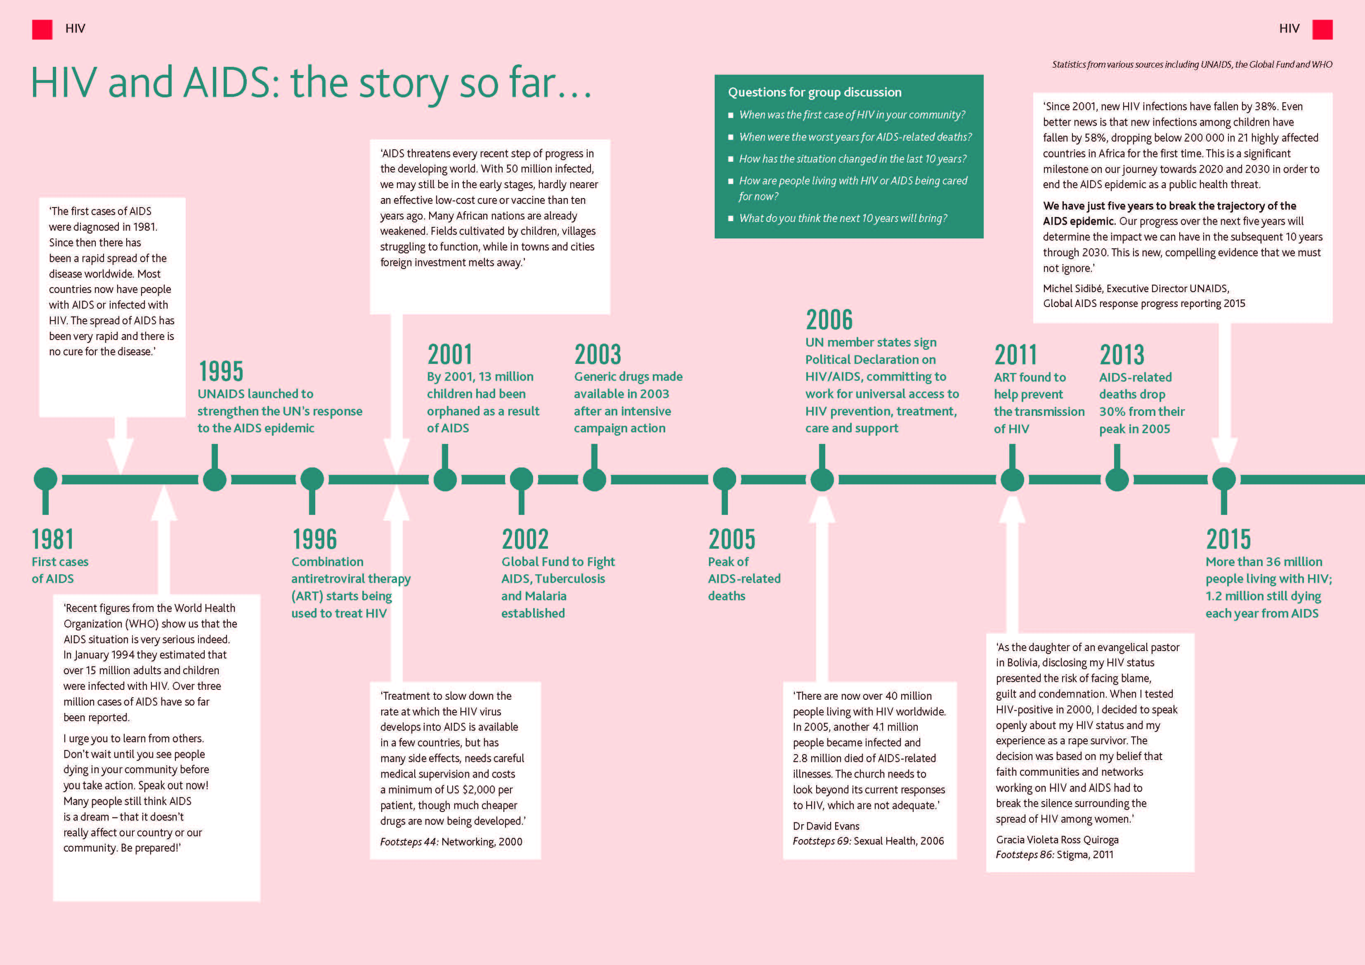

Making an IMPACT YO'
This is aimed to change the religious bodies from being part of the problem to becoming part of the solution. This strategy has been effective and has achieved some great results. A network of religious bodies will work together to change inaccurate knowledge, unhelpful attitudes and risky behaviours relating to HIV and sexuality. We will make partners in Jos (NGOs/CBOs) to help injecting drug users (IDUs) to protect themselves against HIV and to recover from drug addiction. We produced a tool the Think livelihoods! toolkit to help people living with HIV to develop sustainable livelihoods. Our partners will help to improve palliative care for people living with HIV. This will include helping people to access pain relief medication and providing spiritual and psychological support to individuals and their families. These will greatly impact our communities positively.

Protecting Children from HIV
One of our main priorities is preventing parent-to-child transmission of HIV. However, it soon became clear that even if HIV transmission was prevented, the mother or baby could die during pregnancy or in the first year after the birth. With the use of our approach called IMPACT YO' (Improving Adolescent, Children, Teenagers & Youth Outcome) we would achieve that. IMPACT YO' is aimed not only to prevent Adolescent, Children, Teenagers & Youth from HIV/AIDS but parents passing HIV on to their children, also to help reduce death and disease among mothers and babies.
The IMPACT YO' framework covers everything from family planning, through pregnancy and birth, to six months after the baby is born.

One of the main innovations of the IMPACT YO' approach is a scheme called ‘Mother Buddies’. Mother Buddies are trained volunteers who visit vulnerable pregnant women eight times, during pregnancy, after birth and up to six months after delivery. The Mother Buddies would be equipped with a Smartphone and software that guides them through the key questions to ask in each of the eight visits. The phones also store helpful training resources, and allow the Mother Buddies to collect data on the women they care for.
Promotion strategy
Youth & Adolescence Awareness : IMPACT YO' (Improving Adolescent, Children , Teenagers & Youth Outcomes) communication materials are brochures, hand bills and pamphlets, and also the use of our website/social media pages.

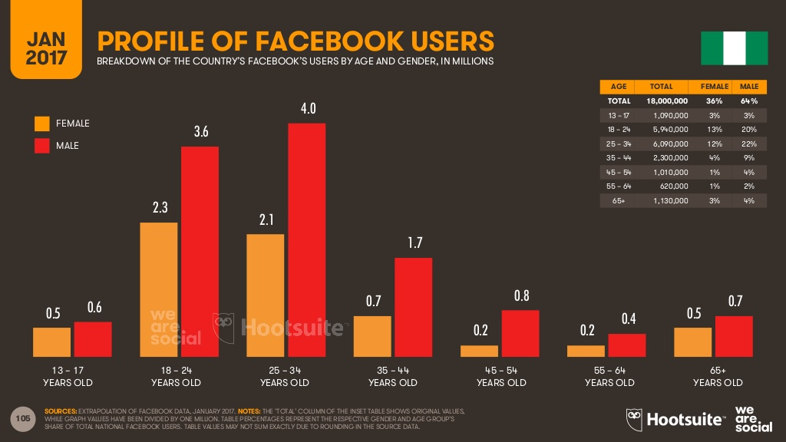
- Online Advocacy: IMPACT YO's website/social media pages will reach almost all its target corporate audience with key information and our concentrated social media campaigns can send targeted messages to our target audience. It’s also relatively affordable compared to other campaign options. We’ll use social media and our website to reach a millions of audience with little resources. IMPACT YO' will encourage its audience to engage healthy eating using tips and also friendly messages from our team all direct to our target audience.
We plan to implement other Social media advocacy through Twitter, YouTube, Instagram, LinkedIn and more. Mobile messaging platforms like WhatsApp and viber.

- Our Team:
1 Team Lead, 1 Logistics Director, 1 Finance Director, 1 Communications Director

S/N | NAME | AGE | SEX | ORGANISATION | ADDRESS | EMAIL | PHONE NUMBER
1. | Jemimah Kromtit | 26 | F | IMPACT YO' | No. 23 Old Barn Behind Corona School Jos | jemimahvoukwash@gmail.com | 08088695050
2. | Hanny Nymphas | 27 | F | IMPACT YO' | No. 23 Old Barn Behind Corona School Jos | nymphashanny@gmail.com | 07013492537
3. | Nanyi Noel Bature | 27 | F | IMPACT YO' | Rayfield Road Jos | Joynoel49@gmail.com | 08037718421
4. | Dogo Philemon Alhamdu | 24 | M | IMPACT YO' | No. 2 Church Street Rahwol Kanang Jos | philemondogo@gmail.com | 07038719012

Tactic/Activity Plan
Tactic/Activity | Planned date | Who is Responsible | Resources Needed | Budget (N) | Indicators of success | Means of Verification (MoV)
Sensitization seminars to 10 secondary schools in Jos | June 2018 | All Team Members | Vehicle, Projector, Handbills, Jotters, Pens, Folders, Pamphlets, Banners, Posters | N400,000 ($1108.04) | Reduction of HIV/AIDS transmission and deaths in Jos, Nigeria | Social Media Posts (Our Pages/ Website), Motion and Still Pictures
Sensitization seminars to 10 Primary schools in Jos | July 2018 | All Team Members | Vehicle, Projector, Handbills, Jotters, Pens, Folders, Pamphlets, Banners, Posters , | N400,000 ($1108.04) | Reduction of HIV/AIDS transmission and deaths in Jos, Nigeria | Social Media Posts (Our Pages/ Website), Motion and Still Pictures
Sensitization seminars to 20 religious bodies in Jos | August- September 2018 | All Team Members | Vehicle, Projector, Handbills, Jotters, Pens, Folders, Pamphlets, Banners, Posters | N800,000  ($2216.08) | Reduction of HIV/AIDS transmission and deaths in Jos, Nigeria | Social Media Posts (Our Pages/ Website), Motion and Still Pictures
Sensitization seminars to 5 Tertiary institutions in Jos | October  2018 | All Team Members | Vehicle, Projector, Handbills, Jotters, Pens, Folders, Pamphlets, Banners, Posters | N400,000 ($1108.04) | Reduction of HIV/AIDS transmission and deaths in Jos, Nigeria | Social Media Posts (Our Pages/ Website), Motion and Still Pictures

Project Budget:

Cost Item | Cost (Naira) | USD
Social Media Set up/Management | 300,000 | 831.02
Projector & Accessories | 300,000 | 831.02
Transportation | 100,000 | 277.01
Banners | 50,000 | 138.505
Pamphlets | 200,000 | 554,02
Posters/Handbills | 100,000 | 277.01
Jotter/Pen/Folder | 300,000 | 831.02
Smartphones/App. | 200,000 | 554.02
Drugs/Counselling/Treatment | 2,000,000 | 5,540.17
Other Costs
Promotion Plan Implementation | 50,000 | 138.505
Team Stipends | 400,000 | 1108.04
Total | N4,000,000 | $11,080.33

KEY CHALLENGES/RISKS/MITIGATION STRATEGY
Key Challenges

1. Financial constraints - HIV/AIDS programme should be well-funded in any country but this epidemic burdens the economy of many countries including Nigeria. Prevention makes treatment affordable and treatment can make prevention more effective. Adequate financial resource for HIV/AIDS prevention and treatment programme scale up is a great challenge because poverty is a key factor in propagation of the HIV epidemic. Many of the high risk behaviours that expose people to HIV are related to poverty.

2. Social and cultural challenges - Socio-cultural norms provide a formidable challenge to efforts to mitigate the impact of HIV/AIDS. AIDS is a social and cultural issue, dealing with sexual issues in the Nigerian society is an uphill task, it is regarded in most pplaces as 'disrespectful'. Sexual behaviour is not openly discussed in our society and talking sex is considered impolite. Parents and elders usually do not talk openly about sex with adolescents.

3. Stigma and discrimination - Stigma and discrimination are still the much talked about issues. HIV related stigma significantly impacts on uptake of HIV testing, negative attitude of services providers, and adherence to HIV treatment and follow up. This reinforces the social constraints of cultural acceptance of medical initiatives.

4. Limited coverage of prevention programme - For the over two decades of fighting the HIV/AIDS epidemic till date the health service has had limited success in addressing the need of the commercial/female sex workers; poor knowledge about safe sex and poor negotiation of condom use. Sexual transmission is a key driver of HIV transmission in Plateau state. Sex workers are both at high risk because of multiple sexual partners and highly vulnerable because of environmental and structural barriers that prevent them from accessing prevention services and having control over their activities.

Mitigation Strategy
1. Delivering effective prevention Education by addressing AIDS/HIV myths and realities adequately.
2. Increase access to Primary, Secondary and Tertiary Schools.
3. Increase access to religious and traditional bodies
4. Maintaining quality of education. We will absorb adequately informed victims of HIV/AIDS as stakeholders.
5. The culture problems can't easily addressed in a short time. It is necessary to continue to address through education programmes and different media in partnership with many key players.
6. Emphasize first and foremost access to quality education for all children and youth until the end of primary education and preferably beyond secondary level: educating the population is the best way to respond to HIV/AIDS epidemic.
7. Ensure that relevant sexual and health education teaching materials are distributed and are reaching the schools, brothels and the communities at large; monitor their availability and use through specific surveys; identify reasons why they might not be available, and take corrective measures.

