Date September 26/2020
Dear respected partner,
This is a project report on school support for 80 orphan children Addis Ababa.
Introduction
Yengat Birhan Charity Organization is an indigenous humanitarian organization established by a volunteer health professional, as an Ethiopian Residential Charity, in June 2016, and re-registered on May 24, 2019 with number 3645. Its mission is to empower poor and disadvantaged individuals, family and communities, by helping to actualizing their latent potential through integrated family development programs. The project was designed to respond to the problems of disadvantageous families’ especially single mother or child headed/orphan family by provides innovative and comprehensive support related to their economy, children education and health.
  - Currently, the organization works in Addis Ababa Yeka Sub City, woreda 08 slum. In this quarter our project called School support for 80 orphan children in Addis Ababa were implementing the ongoing activities of the project. In fact we were not providing or implemented as what we planned at the beginning of the year, because of the COVID – 19 Pandemic, but we could provide other kinds of timely support. We hope you know and will understand how the current pandemic affect every activities on the world at large.
The ongoing activities of the school support project tried to assist 135 very needy school children’s family by supporting some food items as part of the school support since they were in need of it.
Now a days the ongoing activities are more focused on supporting the school children’s family by strengthen their economic part mostly by giving regularly food times for them in order to feed their children.
Major activities performed during the quarter
As we all knows the educational empowerment program is to support school children to facilitate access to education and to perform better through providing education material and tutorial classes as the project objective is to improve access to education and to improve academic performance for school aged children
For the last four years the school support program provided support include school materials such as school uniform, school bag, Exercise book and tutorial class that focused on English language and Mathematics with snack. The tutorial classes were once per week (Saturday) from 9:00am to 12:00 noon mostly done by volunteers’ teachers.
In this quarter under this program as mention above we could not perform the usual support but could provide food items and related materials that helps for the prevention of the pandemic for 135 households, whom belongs to the needy schoolchildren. The support materials include the following: 2 litters of cooking oil, 4kg of Macaroni, 5 pieces of hand washing soap, 2 bag of Tea of 100gm.
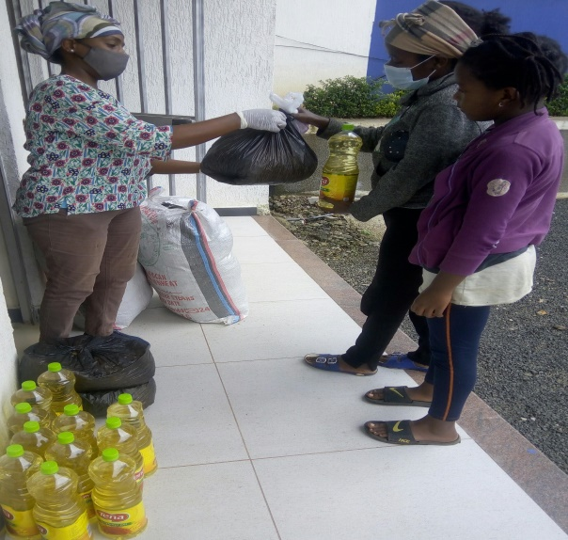

During the provision of school support to children family
Organizing additional donations
Currently our major work of the organization shifted to organizing resources both as in kind and financial both locally and internationally (through Global Giving) in order to give more timely support to our beneficiaries. In this quarter we received a donation both in the form of in kind and finance that gave us potential to support the needy timely to minimize the damage. We are also forming a partnership with some organization which found in Addis Ababa in order to get more resources to sustain the needy life.
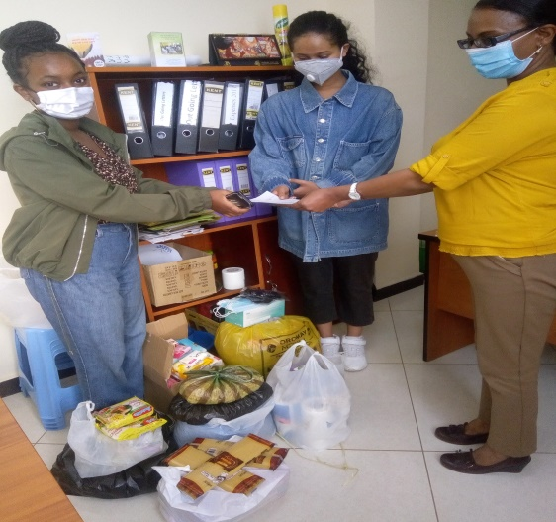
While we receiving donation
Obstacle / constraints
In this quarter, even though Yengat Birhan, faced major unexpected problem, COVID - 19 that affect the implementation of its activities, we are still doing our best in supporting the school children’s by all the means in spite of having small donation. This is because of almost all of the organization activities were managed by Par time and volunteers, from all professions but one thing we should share for you is we need additional support still to sustain the food items support to them if the pandemic persist since the children’s families are found in a very low economic states to feed their children.

Therefore we remind and encourage you to share our objective to your family and friends to sustain the very poor life during this COVID 19 pandemic.

We are very thankful, without your support we couldn’t have an opportunity of sustain others life in this pandemic.
Remain safe!
Meseret Tesfaye , Program leader
Yengat Birhan Charity Organization

