Date October 5, 2019
Dear our respected partners,
Hope all are well with you.
We are very thankful for your concern and support that made us to change needy school children’s performance and life.
Short description of the implementing organization:
Yengat Birhan is an indigenous humanitarian organization established by a volunteer health professional who envisioned bringing a long lasting change in the living standard of disadvantageous families especially headed by women with children through improving the socio-economic status situation and thereby building their self-esteem. The founder family has a history of supporting disadvantaged children and their family for over six years by sharing their own financial and material resources plus the rich experience in humanitarian service. Since September 2014, the founder approaches individuals who share her vision and able to get financial, material and technical support and continued operating in collaboration with Yeka Sub-city Woreda 08 community and local administration office.
Yengat Birhan is evolved based on the rapid situation assessment made in 2013, following the continuous demand. Both the rapid assessment and the founder observation revels that how a little support from a single family could change the condition of households through small business activity that encourages extending the support in a more structured and organized way. As a result, the organization is formally established, elects the board of directors. In June 2016, Yengat Birhan registered formally as a resident charity with registration number 3645. With the mission to empower poor and disadvantaged individuals, family and communities, by helping to actualizing their latent potential through a holistic and integrated development program.
Educational support program
The educational support program is to support school children to facilitate access, complete their education, and to perform better through providing education material and tutorial class.

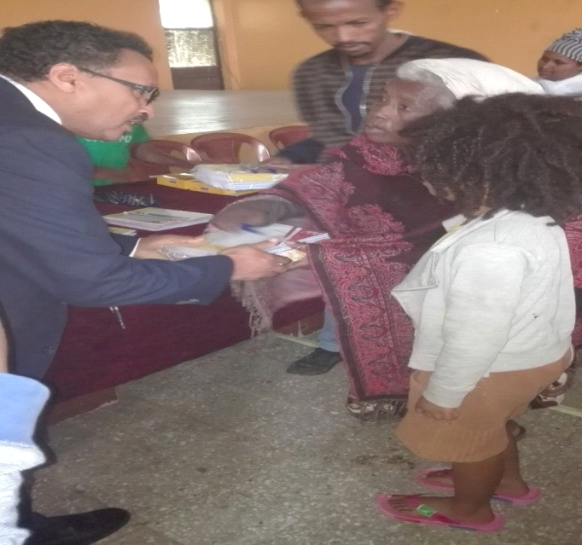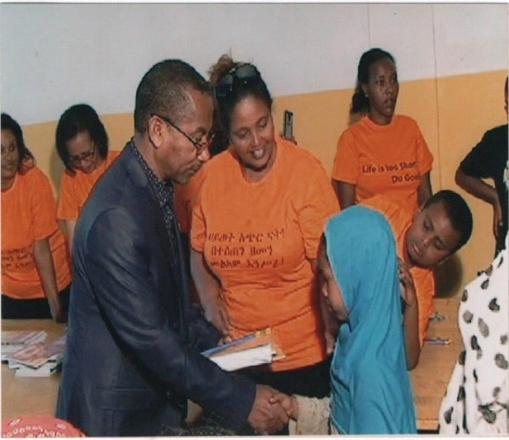
Our Objective: To improve access to education and to improve academic performance for school aged children
As the previous quarter, our ongoing activities of the school program of this quarter focused on providing tutorial classes on English and Mattes with snacks as a means to facilitate the performance of 135 (68 female and 67 male) of need children at Birhu Tesfa elementary school. It is one of the school which found at Yeka Sub City Woreda 08 in Addis Ababa and in which we are providing the tutorial classes to the school children by the permission of school officials. In this quarter especially in the month of August most of our school children spent their time by attending the tutorial classes which organized by the city administration of Addis Ababa, since it is vacation time for schools.
Regarding our school children performance, the performance of our children on this quarter is good when it compares with the previous one. We don’t have student who drop out or not promoted to the next level, as since June is the end month for Ethiopian school calendar year.
Therefore in this quarter under this program the organization able to provide tutor classes with snack for school children as we planned because of your support, in order to continue and to expand our reach the organization encouraging you to keep donating us.
We appreciate your support!
Meseret
Program leader
Yengat Birhan Charity Organization

