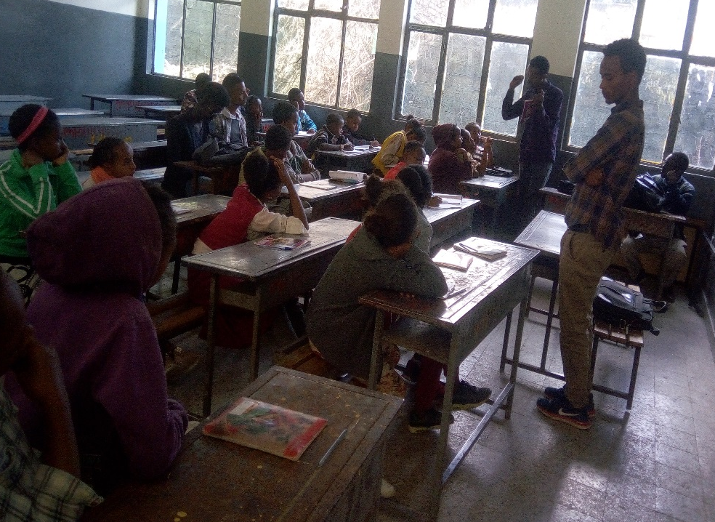
Our par timer teacher giving instruction to the school l children

