June 04, 2022
This is a quarterly project report of Yengat Birhan Charity Orgnaization on school support for 80 orphan children from Addis Ababa, Ethiopia
Report period from March-May, 2022
Dear our partner, thank you for supporting us in changing others life!
Introduction
Yenegat Birhan Charity organization is an indigenous humanitarian organization that works on child education, women empowerment and health since 2016. The main support areas includes supporting women in income generating activates and creating awareness on some important social and political issues, providing school materials and tutorial class with snack for school children in order to perform better and creating awareness on health related issues and help them to get health care in need of it.
For the last three months, the organization had performed different activities under the school support project related to school children. We could providing different school support for 130 (62female and 68 male) as the plan. Related with the service which we provided, we forced to provide different types of support for 85 sponsored children and for 45 none sponsored children because of limitation of budget.
For both group we could provide Ethics class for one hour every Monday and Tuesday for all school children with providing different types of snack like egg sandwich, lentil sandwich and pizza alternatively. It was by dividing 130 in to two groups in order to use our limited class room and instructor effectively. And for both group, we paid Birr100.00\child the tutorial services as the monthly fees and additional 100 birr for each grade 8 student for a total of 19 students for tutorial service 1\2 day on Saturday, to prepare ministry exam.
The additional support for 85 school children, for those who have individual sponsor were the following:
- Once per week we could provide them lentil sandwich, egg sandwich and pizza alternatively while they were attending boys and girls clubs for students whose age above 12 and for the students age below 12 provided it while they were attending music and art club. This helps them to bring behavioral change, character, and communication and express their feeling freely and to asking their question.

- We provided personal hygiene materials like sanitary pads for 24 female students per month and hair oil for 37 female students every three month.

- We also provided four laundry soap, big size and four life boy hand soap small size (70gm) for student every two months, stationery material: one exercise book and one pen quarterly and one surgical mask provided every week for all children.
- For three students, for those who need additional support from the organization received their monthly milk powder, food items and house rent fee according to their specific needs.
The remaining support in this quarter which we provided for 45 students was stationery and mask. As it is mentioned above, they don’t have sponsor as a sustainable way but in which the organization preferred to support them depending on the availability of additional money in general.
The organization also organized Easter event for all 130 school children on the month of May 2022 as part of Easter holyday celebration. The purpose of celebrating the holyday was to have a get together day with each grade level students including with all teachers and staffs too and to be the cause of children joyfulness, having unity with other students, and create awareness about humanity. On that day lunch and holyday gift had provided as a result children were very happy.
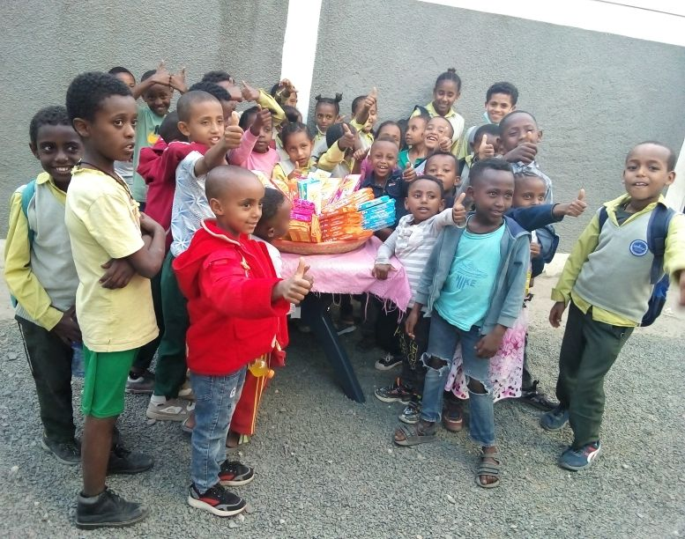
Part of student while celebrating Easter 2022
During the last three months, 76 Self Help Group or mothers of our children’s from 130 children assisted to save money in a group in order to start their own income generating activities. It is to support their children in a better and sustainable way. Each mother contributes birr from 5 birr to 20 weekly in order to engage in income generating activities. Most of the children mothers involved in small income generating activities currently, but because of the Ethiopian current situation and with their personal challenge with the depth of their poverty it is not easy to send the child to school without additional support.
Therefor don’t forget your money is doing a great work and you influencing much in changing others life for better tomorrow.
We want to thank all of you who participated in our charity work, your support made a difference in the work we do. Without you it is impossible to do this.
Keep sharing Yengat Birhan for others so that we can involve more in change others school children life.
Thank you again!
Meseret Tesfaye, Project Leader
Yengat Birhan Charity Organizati

