__________________________________________________
WEAVING PEACE NET IN THE MIDDLE OF CRISIS
Report from Kenya #482 – January 12, 2018
Update: Thanks to the good response all the students who I reported on last week have received sponsors and some additional funds have been collected to improve the primary school.
*****
Note: I have been able to change the name of the TCSC webpage to https://transformingcommunityforsocialchange.wordpress.com/. The old address with “communities” (my mistake) no longer works.
*****
Request: After a year-long effort, HROC facilitators, led by Innocent Hahirwa in Rwanda, have revised the English version of the manual for the HROC Basic workshop. Please contact me at davidzarembka@gmail.com if you would like a cyber copy. There has been a request from HROC facilitators in Kinshasa, Democratic Republic of the Congo, to have the manual translated into French. The cost of doing this is $250. If you would like to contribute towards this effort, please contact me and I’ll advise you on how to send the donation.
*****
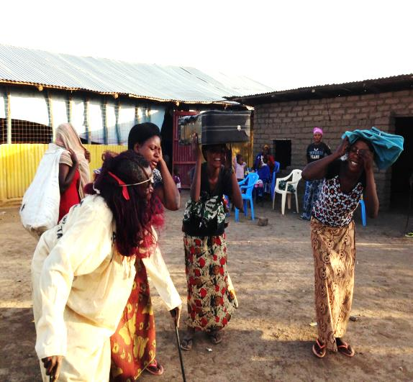
This is a picture of a role-play from our participants, depicting the challenges they are facing in the camp and how the skills they have learnt are going to help them transform.
TRANSFORMING COMMUNITY FOR SOCIAL CHANGE
(TCSC)
WEAVING PEACE NET IN THE MIDDLE OF CRISIS IN KAKUMA REFUGEE CAMP
By Peter Serete, Program Manager
This project consisting of four AVP workshops in the Kakuma Refugee Camp and six listening sessions in the new Kalobeyei Camp was sponsored by a grant from the African Great Lakes Peace Trust in England. Thanks so much for the support.
BACKGROUND
Kakuma Refugee Camp was established in 1991, originally hosting Sudanese and then Somali refugees and more recently between 2013 and 2017 welcoming an influx of South Sudanese. The civil war in South Sudan continues to cause mass displacement of civilians both internally and across borders to neighbouring countries including Kenya and Uganda. In Kakuma there are refugees from Congo, South Sudan, Sudan, Burundi, Uganda, Ethiopian and Somali. Kakuma remain a mirror of nearly all the conflicts that so deeply divide Africa today.
War does not stop when refugees cross into Kenyan biggest camp as they often bring with them the brutal histories of civil war, ethnic hatreds, genocide, prejudices and conflict plaguing their home countries. Listening to them carefully, the pain, poverty, loneliness, rage, guilt, shame and old wounds serves as a constant reminder of who they are and what they have lost. This situation is always overwhelming and a small provocation can be transformed into unspoken sorrow, forcing them, rather than grounds for reconnection, to become fuel for the ongoing violence and discrimination that makes life in the camps unbearable. Moreover, there have been tensions between poor locals living around the camps, who often suffer drought and hunger, and the refugees who receive free food, healthcare and education.
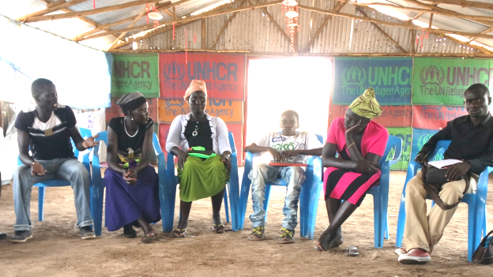
AVP participants at the Kakuma Friends Church.
As a consequence of the progressive closure of Dadaab refugee camp, the other big refugee camp in north-eastern Kenya, many new refugees of non-Somali ethnicity are arriving to a newly opened camp called Kalobeyei, 30 km (20 miles) to the north of Kakuma. This new camp opened due to overcrowding in Kakuma and a decision on the part of the Government of Kenya to move away from an encampment policy [where the refugees are separated from the local population] for the management of refugees. Kalobeyei, built by the UN refugee agency, UNHCR, in conjunction with the local Turkana county government, is an “integrated settlement”. That means it aims to provide economic benefits and services to host and refugee communities alike, including schools, hospitals, and marketplaces. For them to integrate well, they will need to embrace non-violence, which requires strength, courage, self-respect and respect of others.
In Kenya, according to UNHCR figures, the combined population of Kakuma and Kalobeyei refugee settlements in Turkana County has increased from 45,638 in 2009 to 184,938 refugees as of November 2017.
In this report, Transforming Community for Social Change (TSCS) in collaboration with Friends Church Peace Teams (FCPT) and Friends Church Kakuma (FCK) with support from African Great Lakes Peace Trust (AGLaPT) from England conducted four Alternative to Violence (AVP) workshops among the refugees in the middle of crisis in Kakuma Camp. 112 participants were reached including 42 Congolese, 37 South Sudanese, 21 Burundians, 2 Ugandans, 6 Ethiopians and 4 Somali. In addition six listening sessions were held with the new refugees in Kalobeyei in order to determine the next steps in promoting peacemaking there. The plan is to involve the newly arrived refugees with participants from the local Turkana population.
AVP participants in a small group discussion during the exercise on affirmation.
INTRODUCTION
Many young people grow up surrounded by violence and learn to see violence and abuse of power as normal and effective responses to conflict. Violence appears to be the only viable option for responding to conflict. The main objectives of AVP in these four basic trainings were
1. To raise awareness of the options young people have in a conflict in the refugee camp. AVP teaches that conflict does not need to be avoided and that it does not need to be met with violence. In the ideal world conflicts can be resolved with "win/win" solutions, ones in which everyone leaves with their needs met.
2. Non-violence is not just a state of mind or an attitude towards conflict. It is a commitment to actively seek to change the force or situation that degrade and oppress people. It is a commitment to address violence at its roots.
3. AVP teaches that the best way to overcome injustice is to come together as a community and turn to each other as resources for change. This grassroots approach to ending injustice emphasizes that change is possible if communities living in the refugee camp come together and that each one has an important role to play in the process. Finding win/win solutions to conflict and working as a community to end injustice is not easy.
4. They require skills that must be learned and practiced, skills that are intimately related to each other and that build on one another.
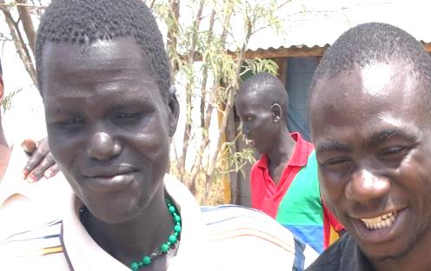
A South Sudanese with a Burundian participant during a cooperation exercise.
Following the lead of individual creative responses to conflict, AVP identifies four building blocks:
- Affirmation and self-esteem
- Cooperation and group decision-making
- Communication
- Conflict resolution.
In order to present these building blocks, it is important to understand their relationship. If a group of people in conflict want to resolve conflict peacefully, they need to have a foundation of good self-esteem. In situations where victims think it is self-diminishing to say something nice about perpetrators and one feels more powerful having a great "putdown," teaching affirmation is both a challenge and a necessity. The rewards are well worth the effort. Some young people sometimes have a difficult time identifying their feelings and do not always have permission or opportunity to share these feelings aloud. Inviting youth to express their feelings and creating a safe space in which to do that is basic to the AVP program.
It is the foundation on which participants are able to learn cooperation. In order to cooperate, they must make group decisions. In making group decisions, conflicts may arise and participants will need to use conflict resolution and communication skills. The ability of participants to state their own point of view in a way that does not alienate the other person, to listen to the other person's point of view without judgment or blame, and to notice the common ground are motivations for problem solving together. Thus the elements of the program are related to one another and should be taught in a way that embraces all of the elements.
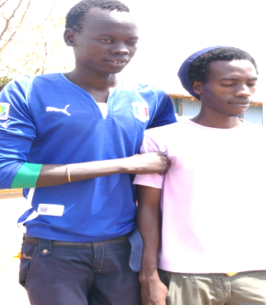
Two youth from two conflicting communities leading each other during a trust walk exercise.
CHALLENGES
- An overwheling numbers of participants: We could only manage a maximum of 20 but we were forced to train 25 participants per workshop. We turned away many participants who wanted to join the training.
- Laguage barrier: Most of Burundians and Somalis don’t understand English. We managed to get translators but translating was time consuming.
- The need of more trainings.
LESSONS LEARNT
1. Everyone has an inward goodness and if given safe space they can express themselves in a non-violent manner.
2. Youth, like their elders, are involved in conflicts. We can start out realizing a violent reaction is only one way of responding in a conflict. Somewhere in every conflict situation there is the possibility of for a non-violent solution.
3. Stereotypes and prejudice are common in all refugee communities. To change situations in positive ways, start with ourselves, our attitudes, beliefs, manner of speaking, tone of voice, and behavior.
4. Participants understand well when the training is participatory rather than lecture. Non-violent conflict resolution is a skill. It improves with practice and optimistic persistence.
RECOMMENDATIONS
The successfully trained 112 participants have volunteered to share the skills they learned in their small communities in the camp. As they take their conflict resolution skills with them to implement in their home communities, there is still a big need of doing more basic workshops in the camp. Our local facilitators will be able to conduct additional workshops as requested and also learn skills in trauma healing in our next phase of their training.
__________________________________________________
To be added to or removed from this listserve, please send your name and email address to davidzarembka@gmail.com.
__________________________________________________
DONATE
Transforming Community for Social Change (TCSC)
For “Ways to Donate” go to https://transformingcommunityforsocialchange.wordpress.com/donate-2/
__________________________________________________
From 1998 to 2016, David Zarembka was the Coordinator of the African Great Lakes Initiative of the Friends Peace Teams. He continues his peacemaking work in East Africa with Transforming Community for Social Change (TCSC) and Friends Church Peace Team (FCPT). He has been involved with East and Central Africa since 1964 when he taught Rwandan refugees in Tanzania. David is married to Gladys Kamonya and lives in western Kenya. David is the author of A Peace of Africa: Reflections on Life in the Great Lakes Region. He is an analyst on eastern Africa issues for TVC News in Lagos, Nigeria.
__________________________________________________
David Zarembka
Transforming Community for Social Change (TCSC)
Phone 254 (0)726 590 783
Reports from Kenya: www.davidzarembka.com/
Email: davidzarembka@gmail.com
Webpage: transformingcommunityforsocialchange.wordpress.com/
__________________________________________________

