PROJECT REPORT ON WOMEN LITERARY PROGRAMME IN KALAHANDI
Background of the Programme: . KARMI has start the Total Women Literacy programme in M.Rampur block of Kalahandi district of Odisha in India with support of Global Giving from 1st April 2019 and it will be continue for a period of 3 years. By this programme we believes that education is the single most important tool to effort all-round social reform and also to enhanced the self-esteem and self-confidence of the people. Education is seen as a means to get a job but as an instrument to save human life. KARMI with high priority on education especially tribal children and women to bring intensive awareness & education which is the most important element of the society and this also starting point of all development. To build up the society educationally sound women education is most essential. They play the vital role on socio-economic and cultural development of the society. Specially in the age group of 15 to 35 are the most effective group to build up the society in a right way in the total literacy campaign the endeavor of ten is to provide education to all but the women literacy is backward and need special project to provide the 3R to the women group within the period of six months in a batches. The target women and girls are in the of 15 to 35 years will be complete their education and able to acquire minimum literacy, understanding on social issue and government developmental programme so they can able to deal as an educated person and able to overcome their social problems and ensure social justice as a whole.
4. Project location (State(s), District(s)): Area proposed for the project consists of 15 Gram Panchayats of M.Rampur block of Kalahandi district of Odisha. The project will be operating in comprising of 192 villages and a population of 64122 and among them about 12400 illiterate women.

5. Project period: The duration of the 3 years, stared from April 2018 to March 2022 and cover in three phase.1st phase cover only formation of Self help group and 2nd phase start the education centers with the illiterate women among the group members with running of non-formal Women literacy centers. and in 3rd phase aware them on their issues, governmental development programme, legal literacy, and Vocational training and trade under taken.
6. Activities: The following activities have been proposed to taking into consideration for materialize the objectives :-
(i) Preparation of data base : It has been planned to develop a data base through survey in the proposed 15 GPs which will give us a fair idea to start work on issues related to complete survey of migration through door to door survey. The illiterate women and girls in the age group of 15-35 years will be identified and the profile will be made available which will help for formation of women SHGs and panelized for Education center. one or two volunteer will be chose for each center who will take the responsibility of teaching about 20 women in each group.
(ii) Social Mobilisation : To understand the value of education among the women and girls in the age group of 15 to 35, mobilizing public opinion and generate interest to study to the target group, sensitizing the educated section of the society and creating community participation. KARMI organise village level awareness meeting each village with taking all the target people, PRI representatives, teachers, volunteers, youth clubs and women organisations members and SHG members to realise the need of the project and ensure people participation in all spare.

(iii) Identification of and Volunteers and Capacity building:For proper identification of learners and volunteers survey is will be conduct and a data base will be prepared of all the illiterate women and girls and available instructor who will take the responsibility of educate the groups and ensure socio-economic awareness and social justice among the group. The volunteers and staffs of the project also contact person to person and build the suitable environment for study and necessary arrangement of the center.
(iv) Opening of Education center and continuing Education: The success of the women literacy project will sole depend on the volunteers, Master trainers, resource person involved and initiation taken by the implementing agency. In 15 Gram Panchayat implemented by project about 12,000 women and girls illiterate, for every 20 learners 1 volunteer instructor is necessary and about 600 volunteers will be engaged in this programme. One master trainer per 100 volunteers is need and six master trainer will be required for the project. In the 3 years project period 6 phase each phase comprise of six month the programme will be continued and the training and running of the Education centre also continue in six phase.
(v) Production and Distribution of Teacheing learning materials : The Teaching and Learning materials will develop by follow the syllabus and guide line of State Resource Center Govt. of Odisha and District Adult education programme. The prepared material for improved peace and mental of learning (IPCL) reduced the duration of learning and an in-built mechanism for self assessment by the learner, aim at enhancing the motivation of learness in future learning. In addition to the 3 graded primer, learner will be provided with a state and lead pencils, volunteers instructor also be provided with these leaving materials and a volunteers guide.

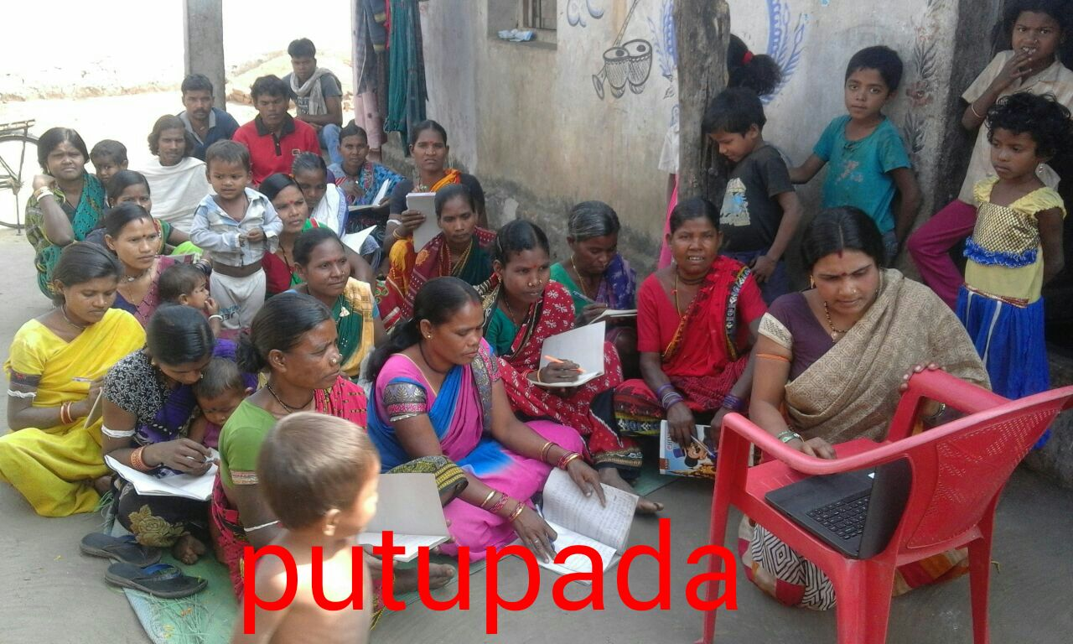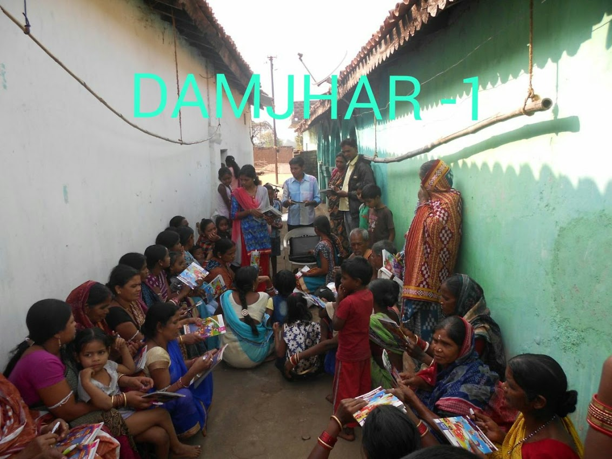

Monitoring and Super vision: KARMI has already started the survey to identify all the illiterate women of the block and make them bathes. Now 5 centers has already been started and other are is in progress. The project coordinator and field staffs are looking in to complete the work within six months. The Secretary KARMI has taken overall responsibility to monitor and supervision the centers properly. The Filed Executives and Supervisors also vividly visit the centers helping the facilitators and learners to ensure quality education in the Centre. The Village Education Committee in each village also took the responsibility to run the centers properly. If any problems rise concerned with the present of learners, selection of site of the centers the committee along with the KARMI staffs resolved it any finally all the centers are continue very well.

