PROGRESS REPORT ON WOMEN LITERACY PROGRAMME BY KARMI FOR JUNE TO SEPTEMBER 2021

Objectives of the programme :
To make literacy and educated the women of the most inaccessible pocket of Kalahandi KARMI start the education programme in Jan 2020 with support of Tata Consultancy and Global Giving. Education is the primary motto of life. Considering to provide total literacy among the women in the age group of 15 to 45 years our organization. The objectives of the project is to make literate of 9600 illiterate women persons with the age group of 15+ years and would be functionally literate through technology based reading, writing and arithmetic skills provided through short duration classes at 10 community centers. As per the project target KARMI will be educated 9600 illiterate persons by studying 50 hours learning schedule to be complete 3 months training period of 5-6 days class in a week through provide computer based functional literacy with a special curriculum developed by the State literacy Mission.
Activities Undertaken in the Literacy Programme : Kalahandi district specially the M.Rampur block o Kalahandi district where only 32% of women are literate and rest are totally illiterate and unable to read or write where the programme is going on. The above mentation motto will be full fill by KARMI and it will be continue until 80 to 90 percentage women become not only literate but also able to functional their literacy. The Computer based Function literacy programme ( CBFL ) programme can be successful by proper understanding of the beneficiaries and the stake holder. Considering to this our organization given special emphasis on community mobilization and ensure total participation of beneficiaries and all the stake holders. We give special emphasis on mobilization of the target women on education the project on village and GP level awareness meeting and ensure total participations of beneficiaries. During the reporting period KARMI organized 12 Village level meeting with participation 2466 people, PRI representatives and Govt. official to make the prograamme successful. Our project staffs given special emphasis on community mobilization through mass meetings village level meetings and meeting with the women organization in village level, women self-help groups and are them on education, social evils eradication and removal of blind believes. But presently due to COVID19 continue the centers were not properly function and the attendance of the learners are less. Even if difficulties our volunteers goes to the learners home and provide necessary support and guide to continue the efforts. Till date the result is not satisfactory due to COVID but the situation has been improving and it will be overcome soon and our achievement will be fulfilled.
KARMI with the head of the project coordinator developed a monitoring team to look after the programme and they frequently visit the centers and organized meetings with the beneficiaries and the committee members of the Centre’s. They also follow up the teaching and learning process and improve the quality of the concerned teachers and provide necessary aid guide and advice. One central committee also formed to look after the problems of the center’s and make the programme more effectives. There are 7 to 9 members of each committees comprised of an educated person like Head master of concerned village school or retired teacher, the PRI members, Anganwadi works, and the word members of the ward or village. The role and responsibility also detail discussed with them and the committees have taken the responsibility of monitoring the programmes as well short out the problems concerned with the Centre and take care of well running of the Centers. During the reporting period about all the centers visited in weekly basic and ensuring progress reports and ensure people contribution to make the Center’s more effective and fruitful.
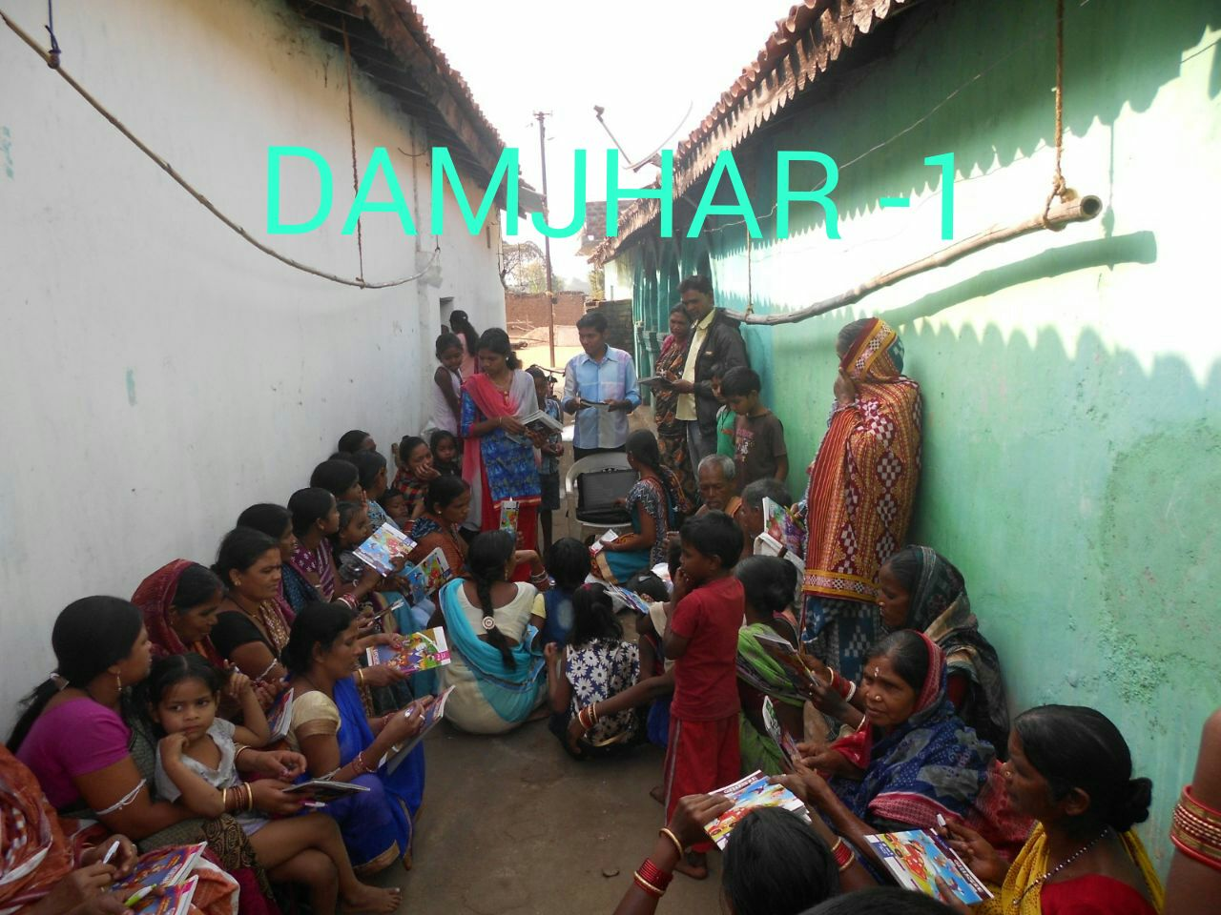
KARMI provide necessary teaching and learning materials with logistic support. The teaching learning materials like Computer, speakers, Primer books, Note books and pens have been supplied to each centers and learners. KARMI mobilize some teaching learning materials and provide to the new learners. There is more demand of TLM but we are unable to supply as per the requirement and also want some support from Global Giving to make the programme more successful.
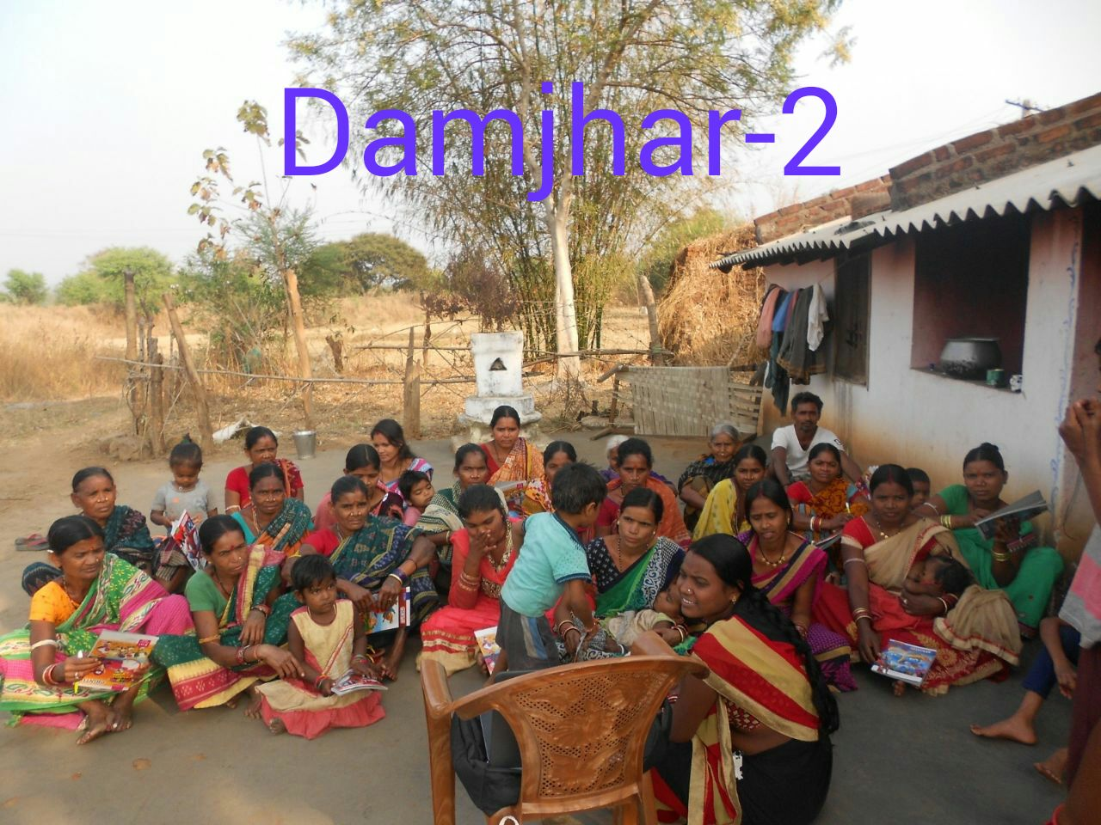
Presently the programme have been decreased and now continuing 15 Education Centers in 12 villages and covering only 632 beneficiaries. But due to our strong effors the programme continue in the same flow and interest of the women or target beneficiaries has been increasing. During the reporting period 322 learners have been completed 3rd primer and able to read, write and arithmetic knowledge. But during the phrase of the programme due to COVID 19 the centers have not been able to continue as before the quality ensure has been decline. Whatever it may be KARMI have make better effort to improve the quality of the centers and fulfil the objective of the programme.
============================================

