PROGRESS REPORT ON WOMEN LITERACY PROGRAMME BY KARMI
- Aim and Objectives of the programme :
Education is the primary motto of life. Considering to provide total literacy among the women in the age groupo of 15 to 45 years our organization KARMI started the Women Literacy programme with support of Global Giving and Tata Consultancy in most enterer pocket of M.Rampur block of Kalahandi district of Odisha in India since Jan 2020. The objectives of the project is to make literate of 9600 illiterate women persons with the age group of 15+ years and would be functionally literate through technology based reading, writing and arithmetic skills provided through short duration classes at 10 community centers. As per the project target KARMI will be educated 9600 illiterate persons by studying 50 hours learning schedule to be complete 3 months training period of 5-6 days class in a week through provide computer based functional literacy with a special curriculum developed by the State literacy Mission.
2. Activities Undertaken in the Literacy Programme.
(a) Awareness on the Women literacy Programme: Any programme can be successful by proper understanding of the beneficiaries and the stake holder. Considering to this our organization given special emphasis on community mobilization and ensure total participation of beneficiaries and all the stake holders. We give special emphasis on mobilization of the target women on education the project on village and GP level awareness meeting and ensure total participations of beneficiaries. During the reporting period KARMI organized 25 Village level meeting with participation 2631 people, PRI representatives and Govt. official to make the prograamme successful. Our project staffs given special emphasis on community mobilization through mass meetings village level meetings and meeting with the women organization in village level, women self-help groups and are them on education, social evils eradication and removal of blind believes.
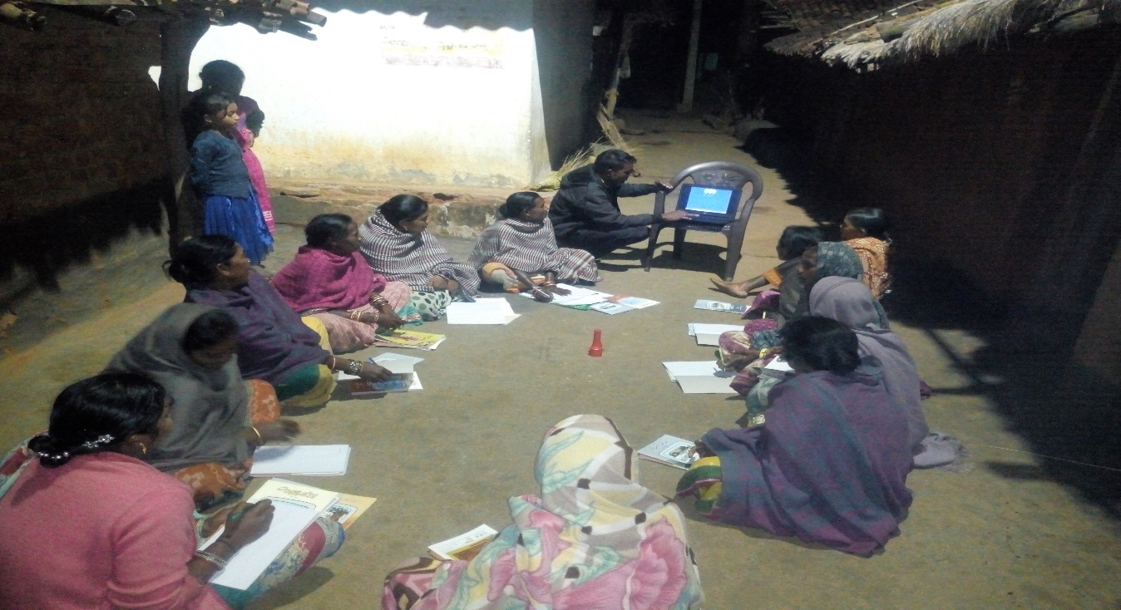
3. Follow up and Monitoring : KARMI with the head of the project coordinator developed a monitoring team to look after the programme and they frequently visit the centers and organized meetings with the beneficiaries and the committee members of the Centre’s. They also follow up the teaching and learning process and improve the quality of the concerned teachers and provide necessary aid guide and advice. One central committee also formed to look after the problems of the center’s and make the programme more effectives. There are 7 to 9 members of each committees comprised of an educated person like Head master of concerned village school or retired teacher, the PRI members, Anganwadi works, and the word members of the ward or village. The role and responsibility also detail discussed with them and the committees have taken the responsibility of monitoring the programmes as well short out the problems concerned with the Centre and take care of well running of the Centers. During the reporting period about all the centers visited in weekly basic and ensuring progress reports and ensure people contribution to make the Center’s more effective and fruitful.
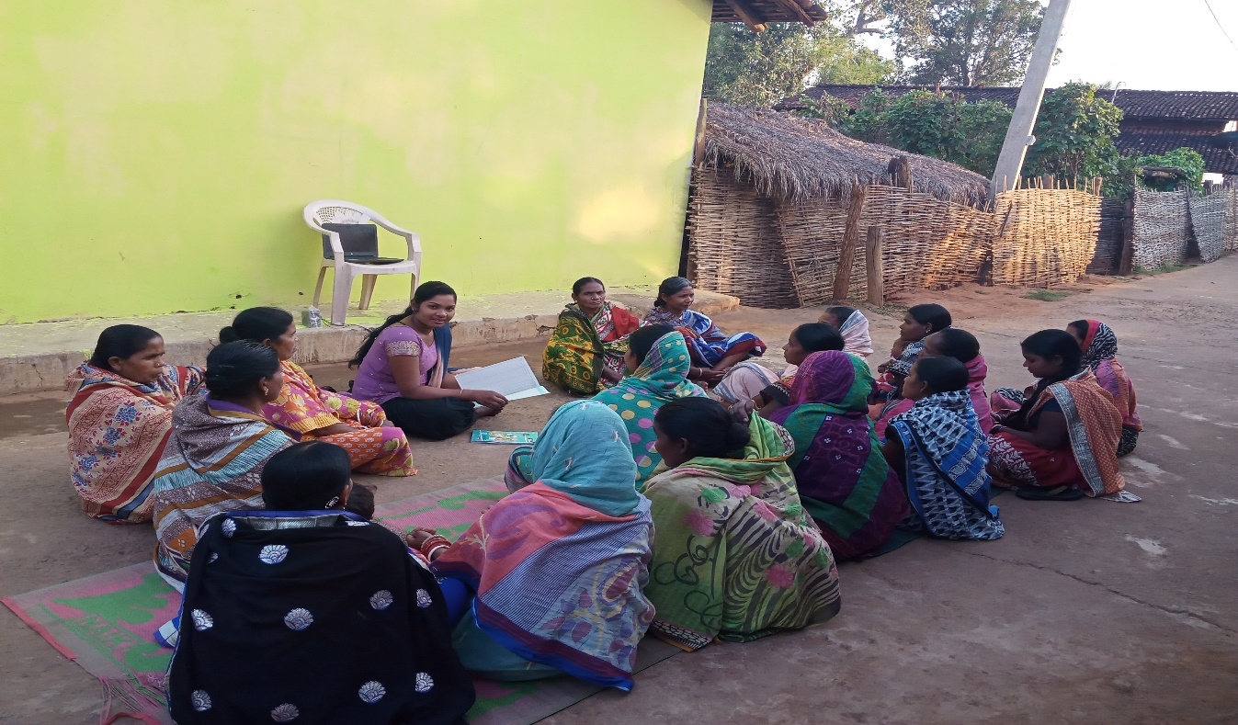
4. Insure Support to the Centre’s: For the qualitative improvement of the center’s KARMI provide necessary teaching and learning materials with logistic support. The teaching learning materials like Computer, speakers, Primer books, Note books and pens have been supplied to each centers and learners. KARMI mobilize some teaching learning materials and provide to the new learners. There is more demand of TLM but we are unable to supply as per the requirement and also want some support from Global Giving to make the programme more successful.

5. Selection of more Volunteers: The quality of education can only possible by the best volunteers. KARMI selected more 12 volunteers to provide quality education. Due to unavailability of more educated volunteers we selected metric and +2 qualified as volunteers of the programme. We also provide necessary training and moral support to make the programme more successful by the volunteers. In near future more volunteers will be requite and provided necessary training.
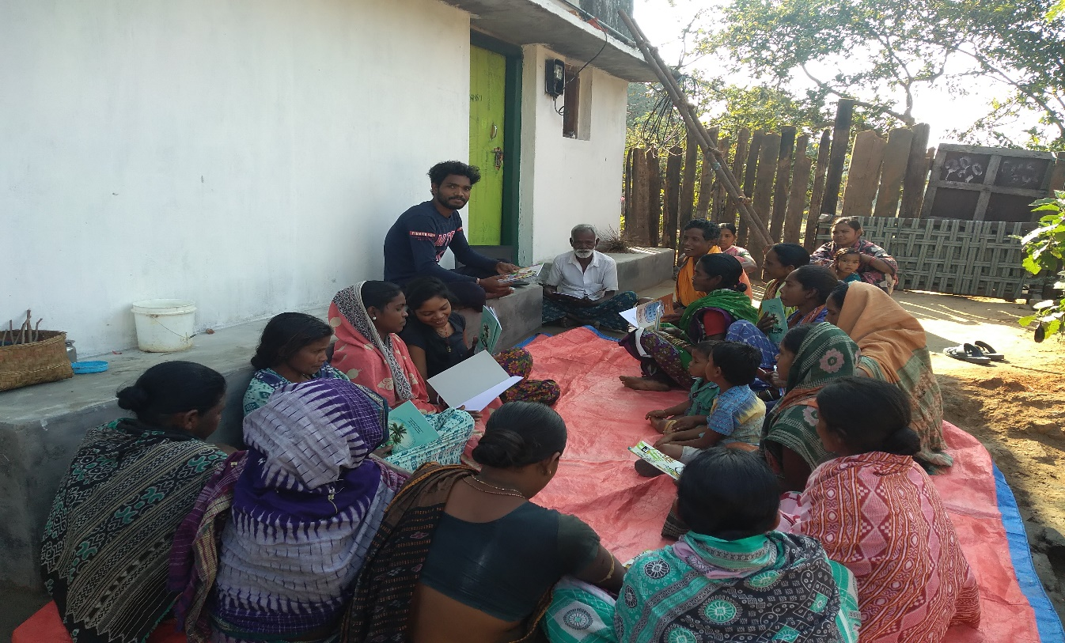
6. KARMI Faced Problems: By this programme we have been continuing 30 Education Centers in 22 villages and the beneficiaries i.e. the women group are more interested to continue the education and want to complete the course in time. As per curriculum the learners will complete the course within 3 months and able to read, write and arithmetic knowledge. But during the phrase of the programme due to COVID 19 the centers have not been able to continue as before the quality ensure has been decline. Whatever it may be KARMI have make better effort to improve the quality of the centers and fulfil the objective of the programme.

