PROGRESS REPORT ON WOMEN LITERACY PROGRAMME IN KALAHANDI
- Project Goal and Objectives :
KARMI our organization start the Women Literacy programme with support of Global Giving and Tata Consultancy in most enterer pocket of M.Rampur block of Kalahandi district of Odisha in India. The objectives of the project is to make literate of 9600 illiterate women persons with the age group of 15+ years and would be functionally literate through technology based reading, writing and arithmetic skills provided through short duration classes at 10 community centers. As per the project target KARMI will be educated 9600 illiterate persons by studying 50 hours learning schedule to be complete 3 months training period of 5-6 days class in a week.
2. Activities Undertaken by the CBFL Programme.
Community Mobilisation: KARMI has given special emphasis on community mobilization as with out the mobilization of the target women on education the project can not be successful. Our project staffs given special emphasis on community mobilization through mass meetings village level meetings and meeting with the women organization in village level, women self help groups and aware them on education, social evils eradication and removal of blind believes. During the last six months we have organized about 22 meetings where about 3605 target illiterate women and 5640 people, women organization members and people representatives attained the meetings. After the community mobilization programme 30% of attendance has been increased in our education center’s.
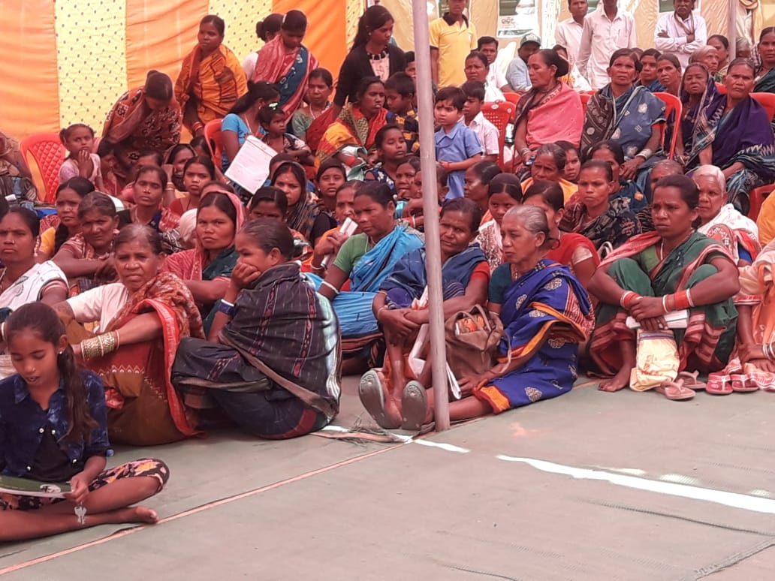

Formation of Committees: Another 22 women literacy Committee has been formed in village level. One central committee also formed to look after the problems of the center’s and make the programme more effectives. There are 7 to 9 members of each committees comprised of an Educated person like Head master of concerned village school or retired teacher, the PRI members, Anganwadi works, and the word members of the ward or village. The role and responsibility also detail discussed with them and the committees have taken the responsibility of monitoring the programmes as well short out the problems concerned with the Centre and take care of well running of the Centers.
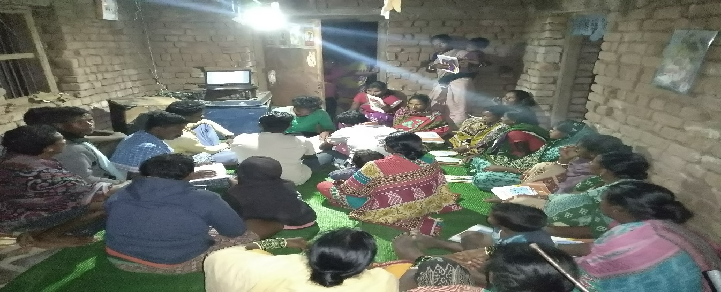
Supply of Teaching Learning Materials: The teaching learning materials like Computer, speakers, Primer books, Note books and pens have been supplied to each centers and learners. But there is one difficulty that among the 35 learners only 30 have got the materials and rest 5 having other materials but without the primer book and it create a difficult situation there. With the collaboration of our other programme KARMI mobilize some teaching learning materials and provide to the new learners. There is more demand of TLM but we are unable to supply as per the requirement.

Continuing the Centers: KARMI has started all 30 ALP Centers in 22 villages the facilitators started the centers well. The TLM has already been provided to each center and the learners as per the provision of the programme. There are 455 women studies in 15 centers and their performance is satisfactory. They have completed the 1st and 2nd primers of Adult literacy course programme prescribed by the Govt. of Odisha. ================================================================================

