Learning Squared Liberia PROJECT Report: SUPPORT RURAL GIRLS EDUCATION IN LIBERIA (33068).

DATE: January 21, 2020

LOCATION: MONROVIA, LIBERIA

Prepared By: LSL-Liberia
Phone: +231(0)886828014
+231(0)776828014
Email: info@learningsquaredlib.org
Website: learningsquaredliberia.org

INTRODUCTION:
This report covers recent activities implemented under the above-mentioned Project covering the month under review (November 2019 –January 2020). Activities were held in Bomi, Cape Mount, Bassa, Margibi, Bong and Montserrado counties in Liberia. This report reflects school monitoring of sponsored children and the selection one new school in Bong county, central Liberia.
2.0 PLANNED ACTIVITIES FOR THE PERIOD UNDER REVIEW:
2.1 Monitoring of sponsored children at the various schools on academy activities;
2.2. Launch and distribution of 300 back packs to sponsored students;
2.3 Organized community and stakeholders meeting in Bong County;
2.4 Phase one payment of sponsored children tuition in Margibi County.
ACHIEVEMENTS FOR THE PERIOD UNDER REVIEW:
School Monitoring: The Support to Rural Girls education project continue its second year of support to students in Margibi County through a regular monitoring at all school activities and students. Schools and students were visited at home and at the schools during the period under reviewed. Parents were encourage to always send their children to school on time and give them time to study their lessons after school, at the school, teachers and other school authorities were also encourage to provide a child friendly space for children to be able to learn with an open mind. Schools visited during the monitoring process included the below listed:

- Jenneh Public School & Kingdom Builders Community School, Bomi County,
- Madina Public School & Konjah Public School, Senjeh, Grand Cape Mount County,
- Fred-Mart Community School and Lowerhardlanderville Community School in Buchannan, Grand Bassa County,
- Minor Community School, Rosoden school system and St. Eafa Community School in Kakata, Margibi County.
- Rebecca J. Wilson Public school in Montserrado County.

Distribution of 300 back pack: Learning Squared Liberia received a donation of 300 back packs and some children cloths for distribution to students in all five project counties. This process officially begin in all five counties with over 300 school going children receiving back pack, used cloths, pens, pencil, and copy books at all 11 project schools in Liberia..
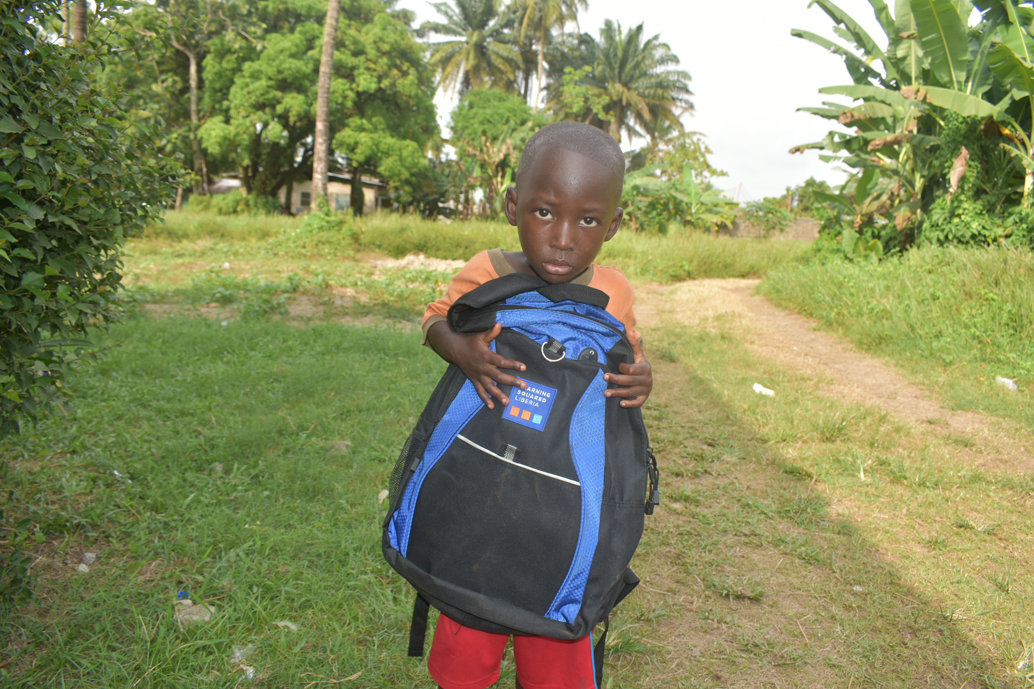
During the distributions, students receive free school supplies, interact with Learning Squared Liberia staff, volunteers and other partners in the field. This year’s school supplies distributions brought significant value in working with children of Liberia. We envision every child having the best learning opportunities possible, beginning with the tools they need to succeed in school.
This distribution process which took place for two weeks in the country was supported by staff, volunteers and other partners of Learning Squared Liberia. The total of three back packs were provided by sponsors in the USA through the effort of the president of the organization LSL.
The back pack distribution provided the underserved students with the supplies they need to succeed while in school. Learning Squared Liberia was able to supply over 200, 1- 6 grade students with backpacks.
Community & Stakeholders Meeting: Learning Squared Liberia facilitated three stakeholders meetings in Bong County our newly selected county. These meeting which included one community members meeting and two stakeholders meeting was well attended by the County Educational Officer CEO, District Educational Officer DEO and other policy makers in the county. During these meetings, Learning Squared Liberia provided full information on its Rural Girls Educational project and how to become a partner to the organization.
These meeting which was very interactive was facilitated by Learning Squared Liberia program team with support from other participants including stakeholder, question and answers were held and the acceptance of the project in the county were highly accepted by the citizens and stakeholders of the community
Phase one scholarship payment: Payment for the 2019/2020 school year begin with the total amount of USD $ 541.00 paid to 35 students in two schools in Margibi County, Liberia. These students are between the ages of 7-17 years and from the 1st to the 6th grade classes in St. Effa community school and the Manor community school located in Kakata, Margibi County.
These students are orphans and less fortunate children living in the communities, these payments represent the full tuition for the first academic semester of this new school year. These amount are presented to schools authorities through its bank account at the school’s account.
The Rural girls Educational project provides support to under privilege school going children living in the community, they also benefits from other school distributions in the county.

4.0 Constraints:
There were few challenges that the project team encounter during the period under review, the lack of vehicle for the official use of the organization is leaving the staff constrain to travel through public vehicle/motorbike which most time delay before reaching the project site. The high demand for the project implementation in the community is also a high challenge. The increased in schools tuition fees at all schools is a major challenge in the community leaving parents with no options but to keep their children away from school.
5.0 Recommendations / conclusion: Thanks and appreciation to our supporters, donors, GlobalGiving, local communities and schools for the level of commitment shown towards the successful implementation of the project. Learning Squared Liberia is open in working with all children of Liberia, mostly the under privilege children in rural Liberia.

