Learning Squared Liberia PROJECT Report: SUPPORT RURAL GIRLS EDUCATION IN LIBERIA (33068).

DATE: September 2020

LOCATION: MONROVIA, LIBERIA

Prepared By: LEARNING SQUARED -Liberia
Phone: +231(0)886828014
+231(0)777171654
Email: info@learningsquaredlib.org
Website: learningsquaredliberia.org

INTRODUCTION:
This report covers recent activities implemented under the project mentioned above, covering the month under review (June–September 2020). Activities implemented in Margibi, Bomi, Cape Mount, Bassa, and Montserrado counties in Liberia. This report reflects school monitoring, distributing protective materials to schools, response to an emergency disaster to a partner school in Grand cape Mount County, Liberia.
2.0 PLANNED ACTIVITIES FOR THE PERIOD UNDER REVIEW:
2.1 Learning Squared received ($1,000.) One Thousand United States Dollars Microgrant from GlobalGiving
2.2 Distribution of personal preventive equipment (PPE) to schools and communities as a response to COVID 19
2.3 Response to a school disaster emergency in Cape Mount county
2.4 Launched a month-long campaign to support children’s education in rural Liberia
2.5 Recommendation, constraints, and conclusion

ACHIEVEMENTS FOR THE PERIOD UNDER REVIEW:
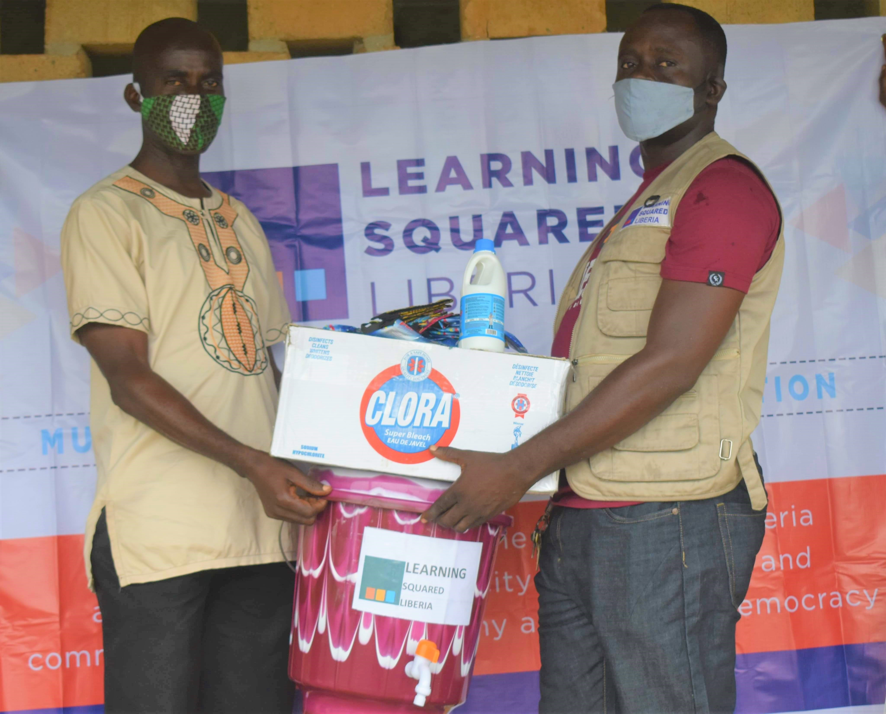
1.0 Learning Squared received ($1,000) One Thousand United States Dollars Microgrant from GlobalGiving. Learning Squared The donation significantly helped the organization respond to the impact of the COVID-19 in communities and schools in rural Liberia. The organization procured personal protective equipment, supplies, masks clora and buckets and distributed over 15 boxes of supplies to schools and communities.
The donated supplies containing personal protective equipment (PPE) and other materials to schools in support and response to COVID-19. The supplies were procured with the hardship grant received from GlobalGiving. We are proud to contribute these supplies to help ensure that they are protected while they do their job and to support the education sector in their response efforts," said Alvin Freeman, Country Manager. On behalf of Learning Squared, we extend our gratitude to GlobalGiving and its partners for the continued support in these critical times. The Microgrant was timely and helped us in response to the fight against COVID-19

2.0 Distribution of personal preventive equipment (PPE) to schools and communities as a response to COVID 19
Learnings Squared donated supplies containing personal protective equipment (PPE) to schools and communities in support and response to COVID-19. The handover ceremony of supplies took place in Bassa, Margibi, Cape mount and Bomi and Bong counties in the presence of students, community leaders’ district and county education authorities and the Ministry of Education. The donation of personal protective equipment will help keep students, teachers, and administrators safe.
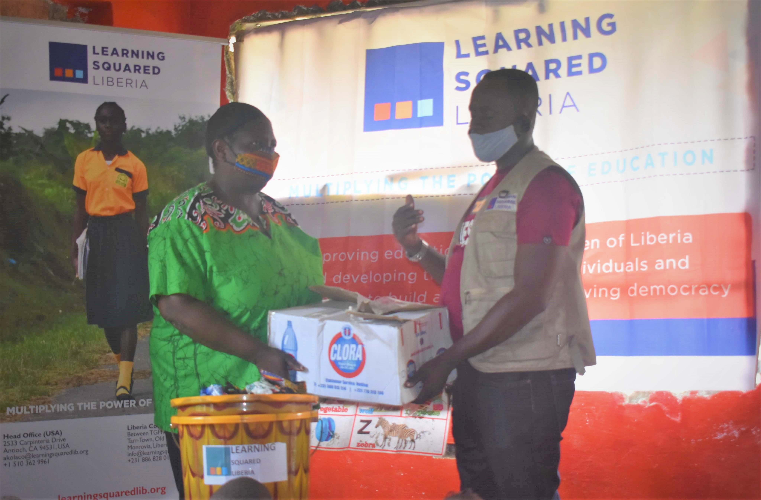
The supplies included masks local produced, cartons of choral, soap, hand sanitizer and buckets. In total, Learning Squared donated US$600.00 six hundred dollars worth of supplies to schools and communities for COVID-19 preparedness and response as schools reopened.
The donation will help to minimize the pandemic risks to children and teachers, Learnings Squared Liberia is also supporting communities and schools to give every child the best start of school opening.

3.0 Response to a school disaster emergency in Cape Mount county
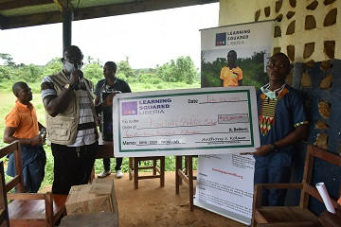
Learning Squared Liberia responded to a disaster emergency to the Konjah Public School to reconstruct its primary school building, damaged due to a massive down pole of rain in June 2020. A donation of $120.00USD one hundred and twenty dollars awarded to the school to help with the reconstruction project. With 698 students. Classes run from the Kindergarten to the 9thgrade and run both morning and afternoon sections.
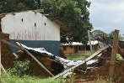
Alvin, Freeman, Program Manager Liberia, Making the presentation through a symbolic check. The admonished school authorities to manage the resources properly. He also applauded school and community leaders to mobilize members to reconstruct the only school building in the community. Receiving the amount on behalf of the school's administration, Mr. Laminu A. Wise, Principal of Konjah Public School, lauded the organization's efforts for their continuous assistance to the school and community at large.
Also, making remarks was the chairperson of the Parents Teachers Association (PTA). Mr. Bashiru K. Mannah. Mr. Bashiru lauded the team for the gesture and promised to lead the workforce to reconstruct the damaged school building.
4.0 Launched a month-long campaign to support children’s education in rural Liberia
Learning Squared Liberia annual fundraising to support education in rural Liberia is begun on Tuesday, September 1, and is expected to continue until the end of September 2020. The theme of this year's campaign is "CHILDREN FIRST," and we are looking to raise funds to support our Rural Scholarship Program in six counties with 300 students in Liberia.
The primary goals of the campaign are to (1) support rural children to explore innovative ideas for tackling educational challenges, (2) provide children with the tools to build a better future and create opportunities to be successful, and (3) support our social microfinance for rural women empowerment (4) provide scholarships, learning materials, and educational support to students.
5.0 Constraints:
There were some constraints and challenges during the period under review. The stay home restriction by the government to respond to the spread of COVID 19 in rural Liberia. Several calls for humanitarian relief to families, lack of technology, and other options to reopen schools during COVID-19. Payments of fees for students during the reopening of schools in the pandemic phase, lack of PPE, and health supplies in rural communities and schools. Official closures of offices and restricted travels.
Recommendations / conclusion:
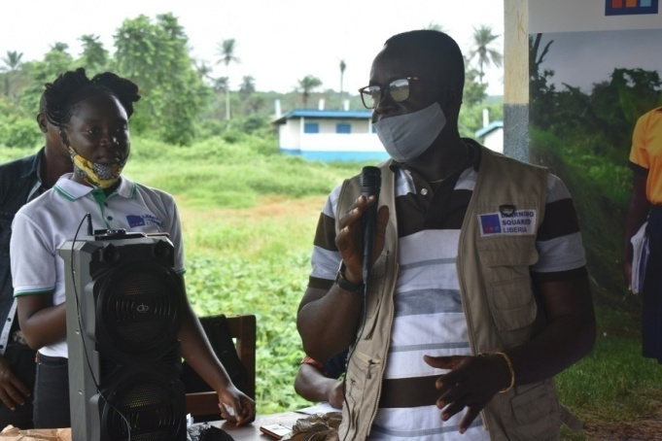
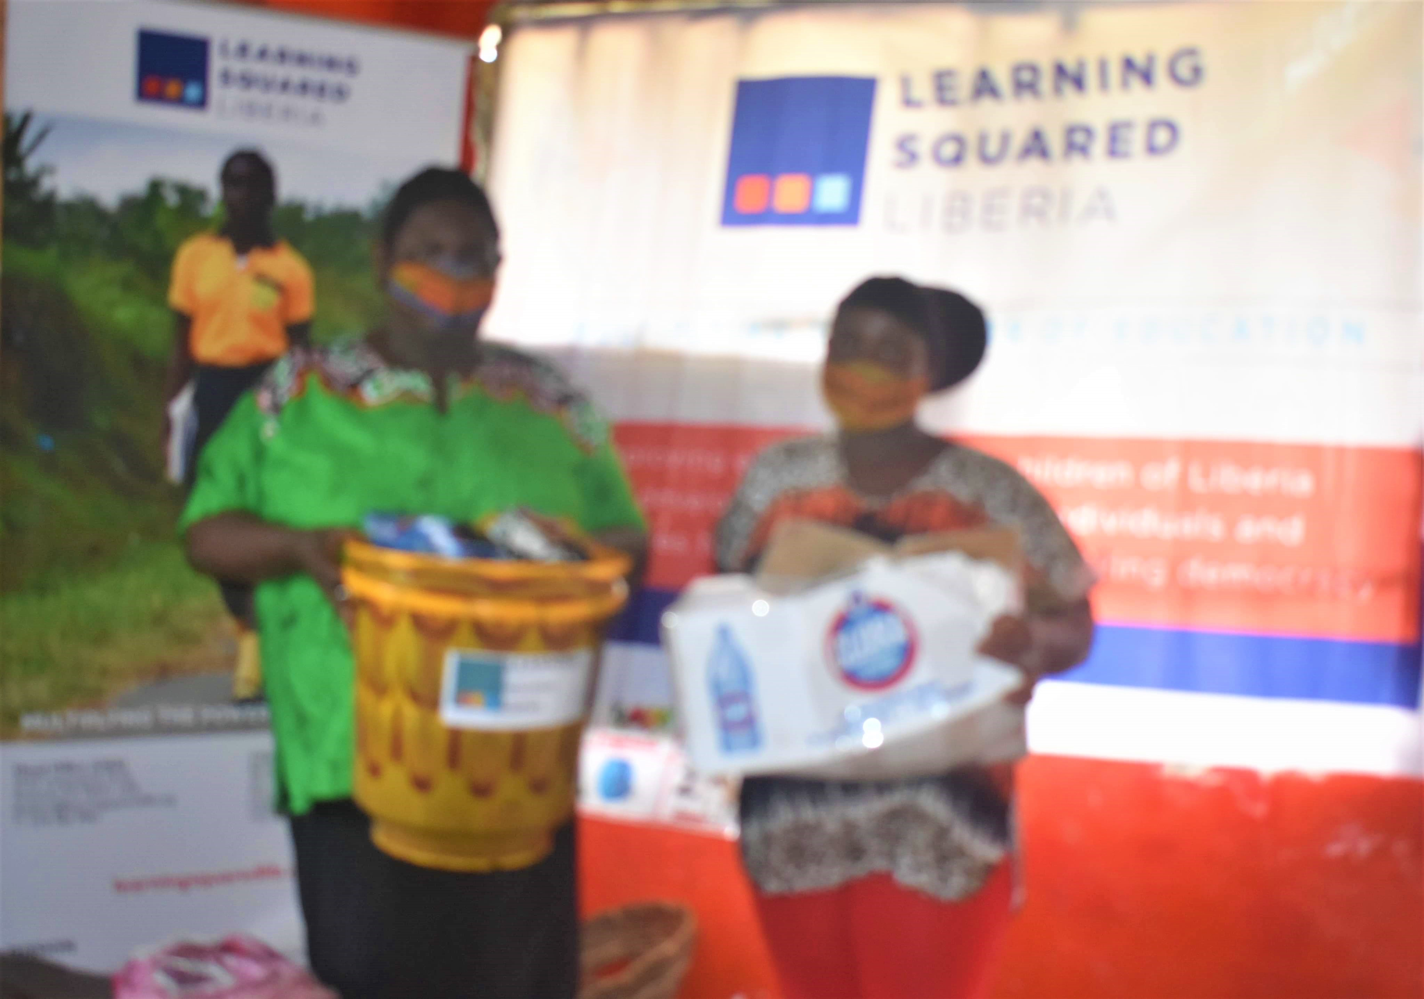
Thanks to GlobalGiving and other partners for the continued support, and especially the Microgrant awarded us. The donation was hugely significant, in that is helped our team reached out to schools and communities with PPE and other health supplies. Thanks to the community leaders, teachers, and volunteers. Including students and parents, for the level of commitment shown towards the fight to stop against COVID 19.

