IDA-LIBERIA PROJECT UPDATE: SUPPORT RURAL GIRLS EDUCATION IN LIBERIA Project - #(#33068)

DATE: JULY 26, 2019

LOCATION: MONTSERRADO, CAPE MOUNT, BASSA, MARGIBI, BOMI COUNTIES, LIBERIA

Prepared By: Learning Squared Liberia
Phone: Liberia +231(0)886828014/ USA +1 510 200 3732
Email: info@learningsquaredlib.org
Website: Www.learnings quaredlib.org

INTRODUCTION:
This update is a highlight of recent activities implemented under the above-mentioned Project covering the month under review (May-July 2019). Activities were held in Bomi, Cape Mount, Bassa, Margibi and Montserrado counties in Liberia. The report reflects the agreement between GlobalGiving and the Learning Squared -Liberia for the implementation of the project.
2.0 PLANNED ACTIVITIES FOR THE MONTH:
2.1 Globalgiving Foundation Field Traveler, Visits Learning Squared Liberia Country office
2.2. Completion of activities for 2018-2019 school year
3.0 ACHIEVEMENTS/ IMPACTS OF THE PROJECT FOR THE PERIOD UNDER REVIEW:
Globalgiving Foundation Field Traveler, Visits Learning Squared Liberia Country office
Learning Squared, formerly IDA-Liberia was excited to receive Globalgiving Foundation’s Field Traveler, Dalila Sumani, from the United States of America in its offices in Monrovia. This visit comes as part of the partnership agreement between GlobalGiving Foundation and Learning Squared Liberia.
The purpose of the visit was to provide our partner the opportunity to monitor project activities, speak with some beneficiaries, and understand the level of impact support from Globalgiving and other donors support have made on the lives of ordinary Liberians, especially women and children through our intervention. The visit will also provide the opportunity to Globalgiving Field Traveler to interact and monitor ongoing projects implemented by Learning Squared in Liberia
Sumani’s visit provided the opportunity to meet staff of Leaning Squared, share experiences, lesson learned, challenges and impacts of Learning Squared Liberia. Making a brief remark at the office Mr. Alvin M. Freeman, Program Manager, welcomed Globalgiving in Liberia and expressed the organization’s unflinching support and commitment to work with her while in Liberia.
Making a brief remark, Sumani expressed thanks to Learning Squared team and praised them for the level of work done in the County and Liberia as a whole. She thanked and encouraged team to keep up the good work and continue to work in the interest of the beneficiaries. She further urged beneficiaries to take Learning Squared Liberia project activities under the support to education and village loan saving projects serious. As it will help provide alternative solutions to some of the challenges, they faced at the community level.
Completion of activities for 2018-2019 school year
Learning Squared Liberia successfully completed its 2018-2019 scholarship program in Liberia. The organization partnered with 11 schools in 5 counties in Liberia. Over 231 students received scholarship assistance, including direct support in the form of tuition payment, notebooks and distribution of assorted books, and learning materials to students. The 2018-2019 school year was full of lesson learned, challenges, impact and success stories. The overall percentage of enrollment according to school administrators and management teams were overwhelming. This was due to support and the willingness of the schools and communities to support the project.
4.0 Constraints:
During the months under review, there were few challenges that we encountered. Transportation and accessibility of rural and remote areas. This is a serious challenge to our work, we had to allocate extra funds to make sure our team travel to project sites. Our team had to used bikes and some instances walk miles to get to our beneficiaries.
5.0 Recommendations / conclusion
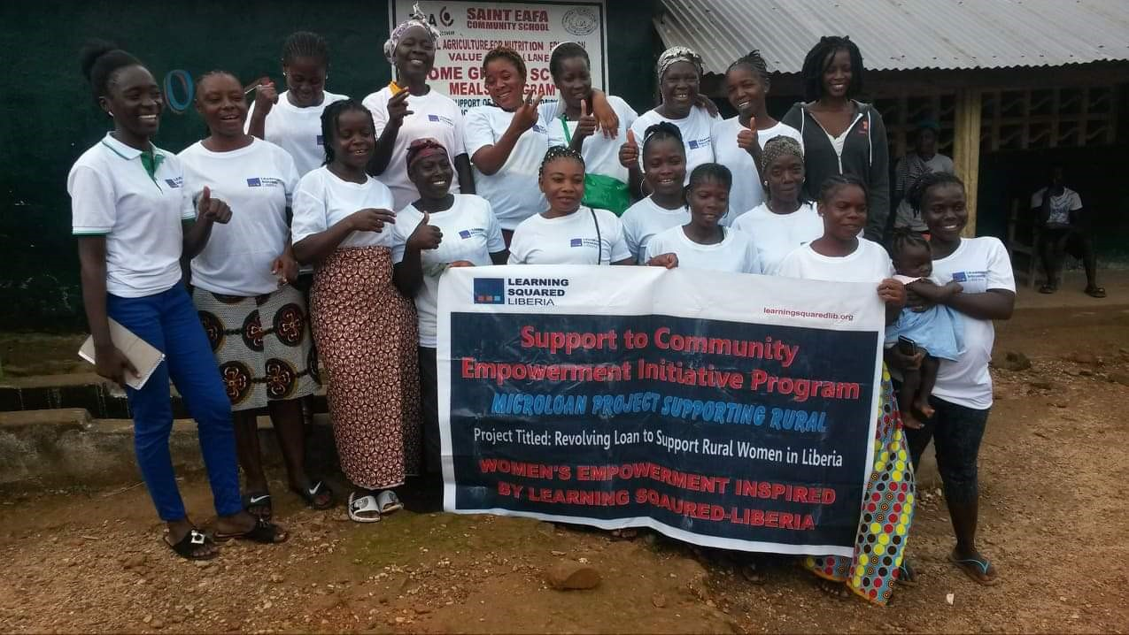
Thanks, and appreciation to our supporters, donors, GlobalGiving, local communities and schools for the level of commitment shown towards the successful implementation of the project. As the team continued to support our beneficiaries. Learning Squared-Liberia is appealing to supporters and donors for more support as the increasing demand for support to rural children education in Liberia is increasingly alarming

