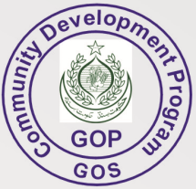
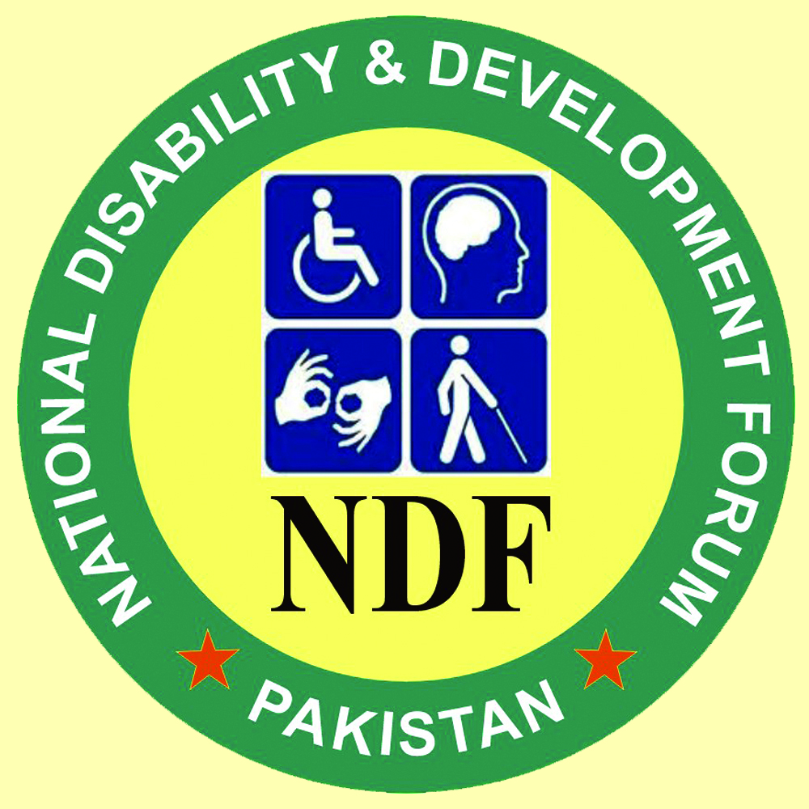

NDF REHAB CENTER, NAWABSHAH DISTRICT SHAHEED BENAZIR ABAD
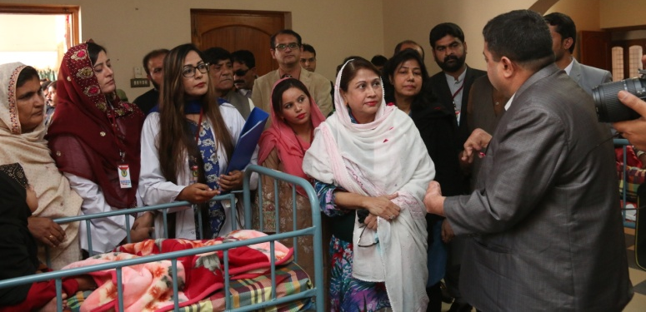

1. Executive Summary
All over the world, mental health is one of the biggest issues to be handled in our society. It seems that the tendency of Intellectual (mental) disability is increasing because the knowledge and awareness is not available in our communities. In rural setups and small town these people with intellectual disabilities are chained and locked in homes or wandering at the streets with dirty and tore clothes or naked. In some cases these people are sent to institutions/mental hospitals for life time.
Keeping in view the big data of Intellectual Disabilities in Sindh, NDF established NDF Rehab Center in Nawabshah The proposed project brings regular services to children with intellectual disabilities, such as life therapies i-e Physiotherapy, Psycho-Therapy, Occupational Therapy, Speech Therapy, & independent living to 100 Children with Intellectual Disabilities. NDF provides residential/boarding services& Day Care services with better care & entertainment to children with intellectual disabilities to bring them out of trauma, entertainment with indoor/outdoor sports with recreations& proper care. The intellectual disabilities need regular care & attention so that center may cater needs of intellectual disability. The parents are poor that they cannot meet the expenses of such therapies. Disability & poverty has close relation, poverty creates disability & disability leads to poverty. Persons with disabilities have limited sources to income, they are under poverty line, and mostly families with disabilities have no sources of income to avail therapy sessions.
The provision of a comprehensive range of facilities for Intellectual disabilities the regular center is only solution, at initial base 100 children will be entertained & rehabilitated.

NDF has identified following problems which may be addressed through this programme.
1. Early Detection: The early detection or prevention of disabilities, to a large extent, is the domain of the medical profession, to diagnose disability at early stage. Early detection brings family attention & intervention that how to deal child with intellectual disabilities. The counselors, psychologists and social workers have its basis in research and training within those disciplines to play their role as well. This would supplement information provided to the families and could improve their knowledge and skills for prevention of disabilities.
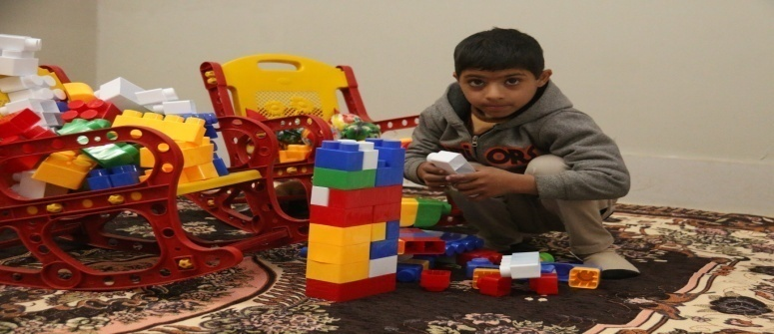
2. Early Intervention: Referral to a multi-professional team at district level will be essential for those children who have moderate or severe levels of impairment. The composition of these teams will reflect a concern for children in relevant developmental and health areas.
3. Social Problem: Stigma in society may be removed through sensitization/mobilization sessions at grass root level to bring understanding that disability does not mean, doing nothing but many ways to work with different style. Through the awareness sessions, seminars, corner meetings it will be realized that disability is blessing in disguise. Children with disabilities are excluded from their communities and live in poverty.
4. Social Inclusion Problem: It is an area which cuts across a number of concerned disciplines such as anthropology, sociology, genetics, psychology, social work, religious instructions etc
5. Economic Problem: Disability & poverty has close relation, poverty creates & disability leads to poverty. Family with disabilities has limited sources to income; they are under poverty line, no sources of income. Due to poverty family can not avail therapies for intellectual disabilities.
According the above mentioned problem NDF seeks support from your organization for the partnership building to seek financial support to keep sustain program activities.
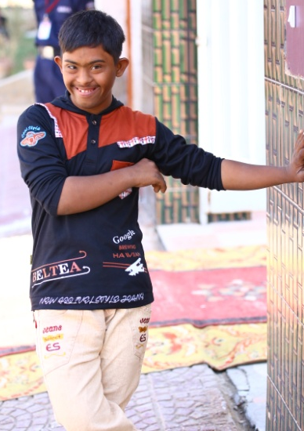
Target
100 (Children with Intellectual disabilities)
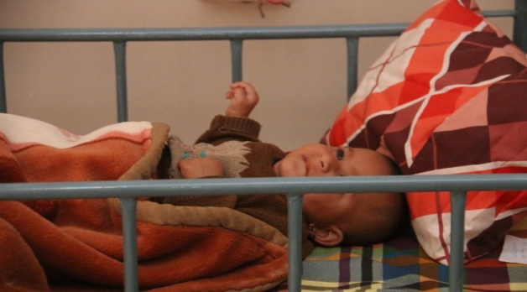

Goal: Socially empowerment of children with Intellectual Disabilities through life therapies to make them self-independent
Objectives
- To provide life therapies at regular base
- To improve living style in different angles such as motor skills, standing, speaking, grip, & others
- To provide nutritional support at routine diet base.
- To maintain health & hygiene of children
- To provide clothes & wearing necessities
- To provide Assistive Devices, CP Wheel Chairs, Wheel Chairs, Tri-Cycles, Hearing Aids & others.
4. Activities
- Awareness/Community Mobilization
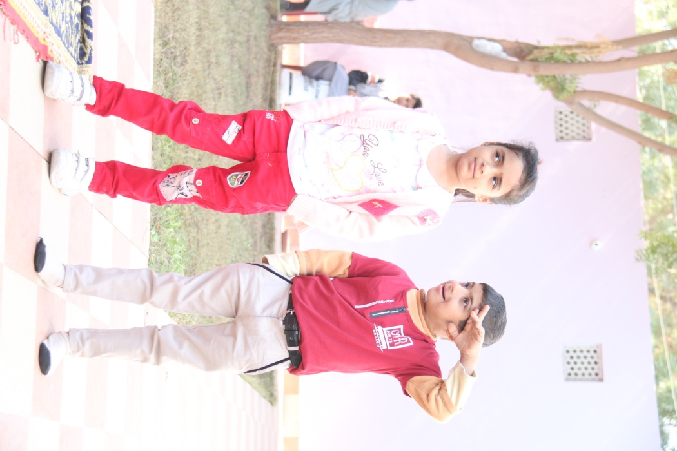
- Life Therapies
- Counseling
- Recreational Activities
- Family Guidance
- Mother Trainings
- Early Detection
- Early Intervention
- Social Inclusion
- Programme Management
- Boarding
- Transportation
- Fund Raising Campaigns
- Food
- Clothing & Shoes
8. Budget Summary

The center is established under seed grant PKR-24 Million funded by CDP-Community Development Programme, UCBPRP, P&D Department Government of Sindh
This center is looking for grants, donations, Zakaat for Fitra for financial sustainability
A/C Title: National Disability & Development Forum, JS Bank: 989439
IBAN: PK29JSBL9023000000989439

Address: House No. C-23, Housing Society Nawabshah, District Shaheed Benazir Abad , 0244366106, 03003211876

