FWA MATERNITY WARD MAY 2024 NARRATIVE REPORT
From the month of January 26, 2024 to May 25, 2024, through the Global Giving Foundation, FWA has received $1788.68, including $198.97 for Ntaseka clinic maternity ward.
Although we still need more medical equipment for the maternity ward,
We are glad we have now started to have both pregnant women for both delivery and hospitalization services.
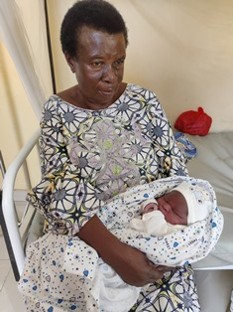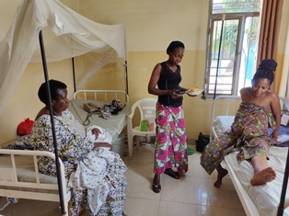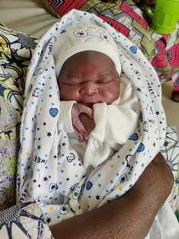
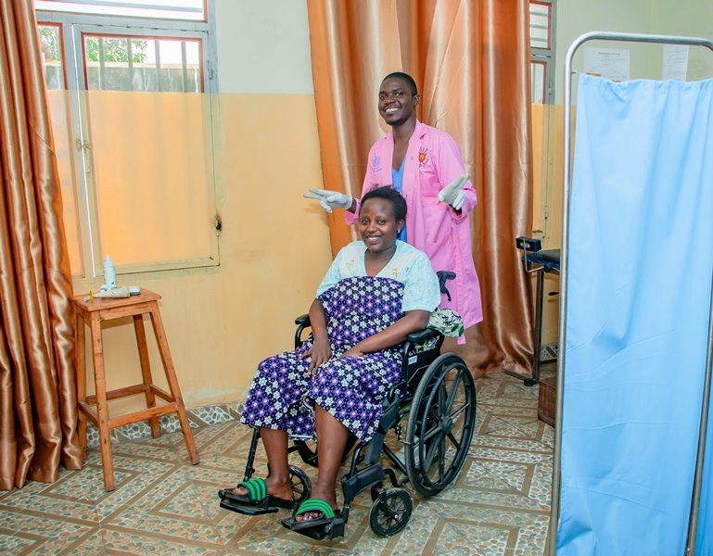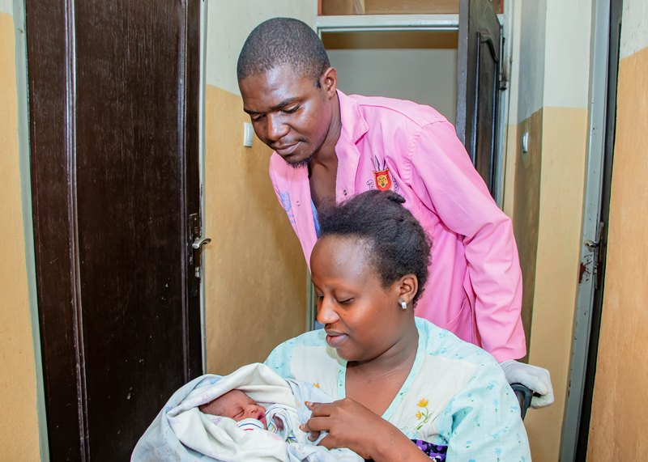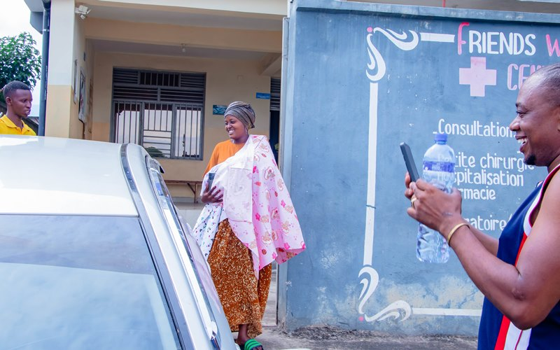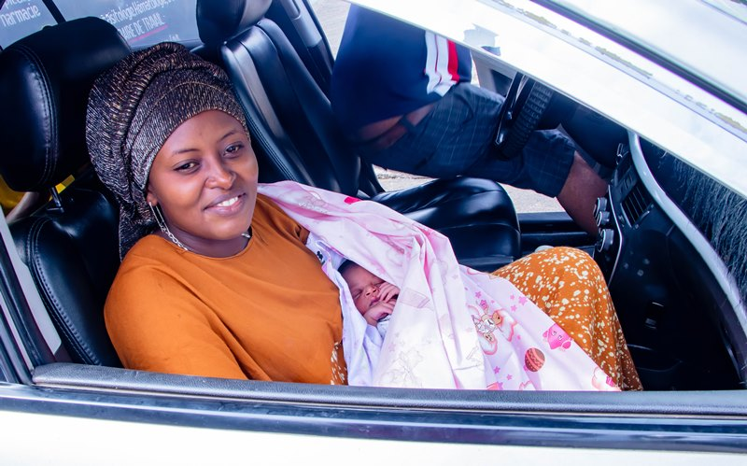
TESTIMONY
My name is X. I’m a sex worker. I was under retro drugs, and I got pregnant. Ntaseka clinic took care of me until I gave birth to a baby girl who is HIV negative. Now one of the FWA staff has taken to initiative to take care of my child because I’m often drunk and forgot my baby. Now my child is healthy and very beautiful. Thank you very much to the FWA.
We are very thankful for those who have made it happen. Therefore, we give our heartfelt thanks all our donors including the Global Giving foundation, the African Great Lakes Initiative (AGLI) of the Friends Peace Teams and the John Gould Family Foundation. We would therefore invite everyone who reads this report to share it with his/her relatives or friends so that they can support this very important work particularly the maternity ward medical equipment.

