FWA MATERNITY WARD MAY 2023 NARRATIVE REPORT
From the month of February 2023 to May 19, 2023, Through the Global Giving Foundation, FWA has received $877, 76, including $18.90 for Ntaseka clinic maternity ward.

Although we still need more medical equipment for the maternity ward,
We are glad we have now started to have both pregnant women and children for both delivery and hospitalization services.
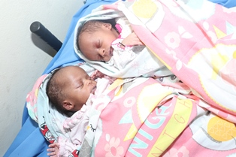
Twins born at Ntaseka clinic
IN the month of March under the support of the Canadian Friends Service Committee (CFSC), some medical equipment were purchased.
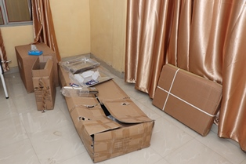
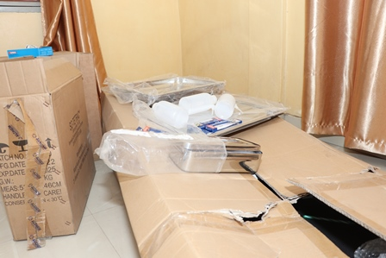
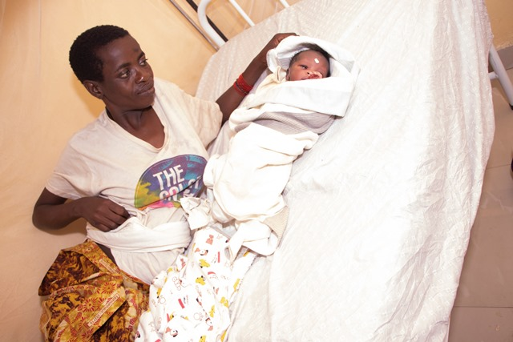
More Babies born at Ntaseka clinic
In the month of April, under the support of the AGLI of the FPT, more medical equipment were purchased
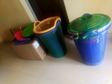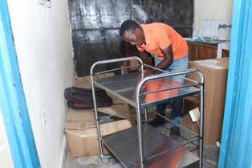

We are very thankful for those who have made it happen. Therefore, we give our heartfelt thanks all our donors including the Global Giving foundation, the African Great Lakes Initiative (AGLI) of the Friends Peace Teams and the Canadian Friends Service Committee (CFSC). We would therefore invite everyone who reads this report to share it with his/her relatives or friends so that they can support this very important work particularly the maternity ward medical equipment.

