FWA MATERNITY WARD JUNE 2022 NARRATIVE REPORT
From the month of February 2022 to May 2022, FWA has done much work for the maternity ward progression. Actually, on December 23rd, 2021, the FWA received a donation of $15,000 from the Global Giving whose memo was “Exceptional”. As the maternity ward was our priority, the funds were used for the maternity ward completion. It was in that way that there was the maternity ward official inauguration on April 8, 2022. Since the beginning of this project, FWA has raised $8470.83 for the maternity ward through the Global Giving. On April 26, 2021, the FWA received $6335.52 from Global Giving. The funds included $3853.62 whose memo was “Organizational level”. The 3853.62 were therefore used for the maternity ward. This means that out of $112360 raised for the maternity ward completion, a total of $27324.45 were raised through the Global Giving Foundation. Many thanks to all those donors who made it happen. The next step is the maternity ward medical equipment and additional staff recruitment. We are very thankful for the great milestone achieved. Therefore, we give our heartfelt thanks all our donors including the Global Giving foundation, the African Great Lakes Initiative (AGLI) of the Friends Peace Teams and the Canadian Friends Service Committee (CFSC). We would therefore invite everyone who reads this report to share it with his/her relatives or friends so that they can continue supporting this very important work.
The pictures below show the progress of the maternity ward from February 2022 to May 2022.
February 2022
In the month of February, under the support of the Global Giving Foundation, wooden doors were put inside the second floor of our maternity ward. More work was done for the maternity ward completion
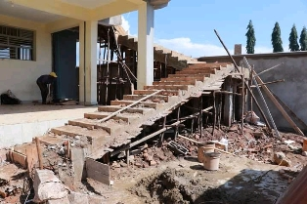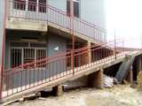

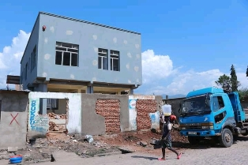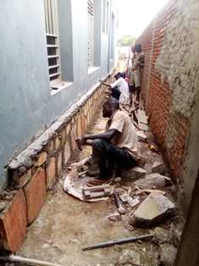.

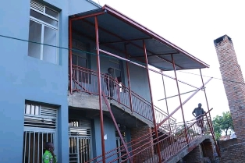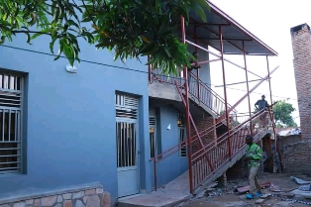
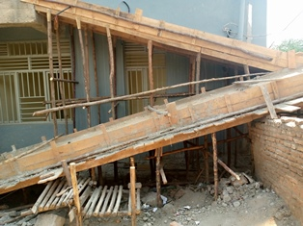
March 2022
In the month of March, under the support of the Global Giving Foundation, More work was done for the maternity ward completion. Windows’ glasses were put on the second floor under the support of the African Great Lakes Initiative (AGLI) of the Friends Peace Teams (FPT)
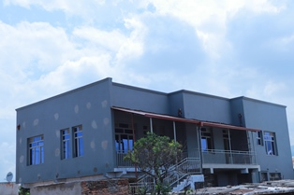
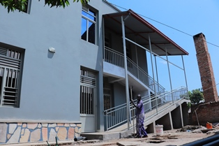

APRIL 2022
In the month of April, the finishing works for Ntaseka clinic maternity ward were completed. On April, 8, 2022, under the high patronage of the Ministry of Solidarity, Social Affairs, Human Rights and Gender, there was official inauguration of the Ntaseka clinic maternity ward. Some participants were present physically, others were there virtually.
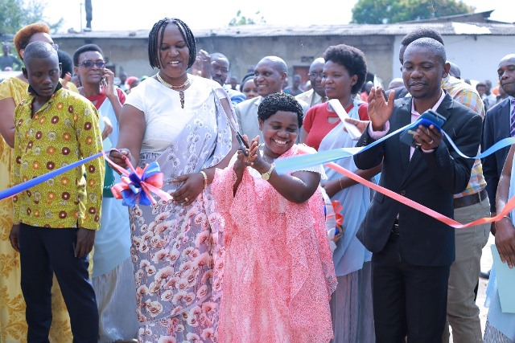
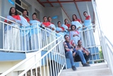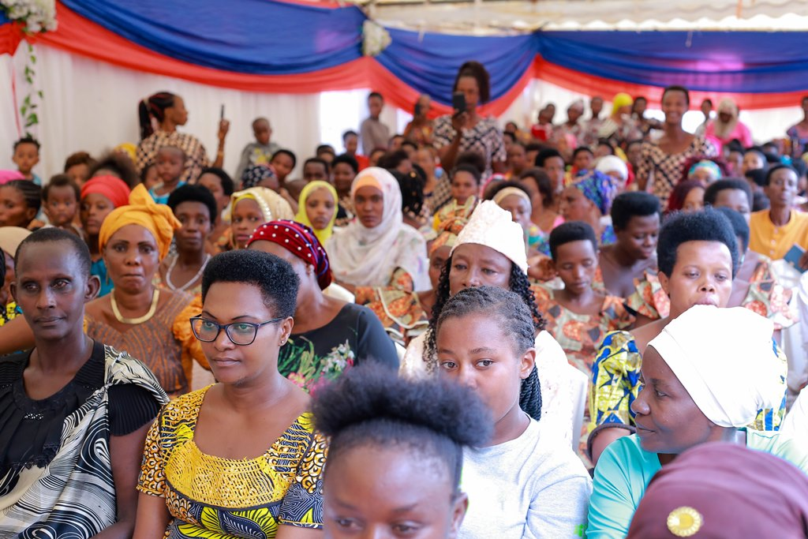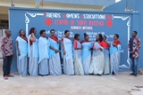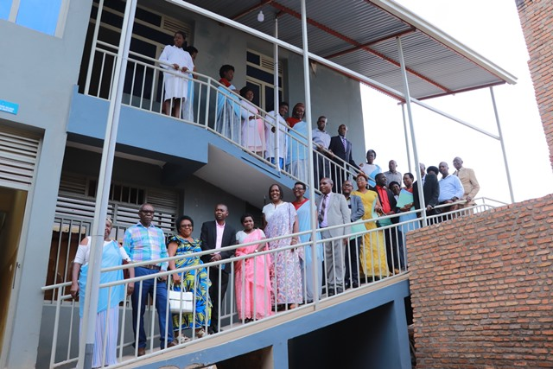
A Group Photo on April 8, 2022
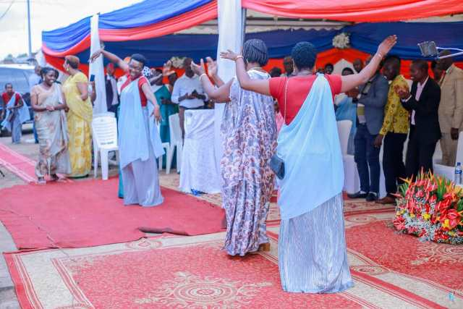
Joy and dancing after the Ntaseka clinic maternity ward official inauguration
https://www.youtube.com/watch?v=RQzgGnDNXr4&authuser=0

