FWA MATERNITY WARD JULY 2021 NARRATIVE REPORT
From the month of April 2021 to June 2021, FWA has received a total of $105, 82 from the Global Giving Foundation for the maternity ward. FWA has also raised some funds through the Canadian Friends Service Committee (CFSC) and the African Great Lakes Initiative (AGLI) of the Friends Peace Teams (FPT).

In the month of April 2021, with the support from the Canadian Friends Service Committee (CFSC), we have continued putting broth on the walls of Ntaseka clinic extension plus the control work.

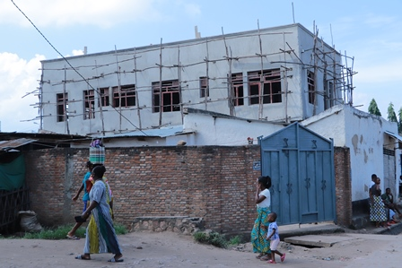
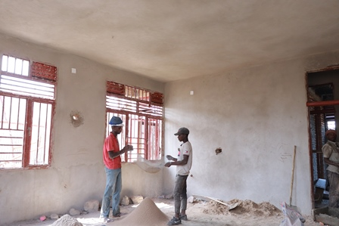

In the month of May 2021, with the support from the Canadian Friends Service Committee (CFSC), we have completed putting broth on the walls of Ntaseka clinic extension plus the control work. Under the support of the Global Giving, we have started painting our maternity ward. Tiles for the first floor were bought under the support of the African Great Lakes Initiative (AGLI).
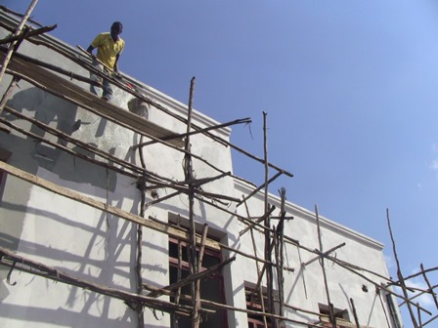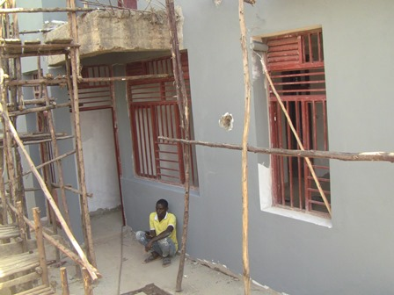
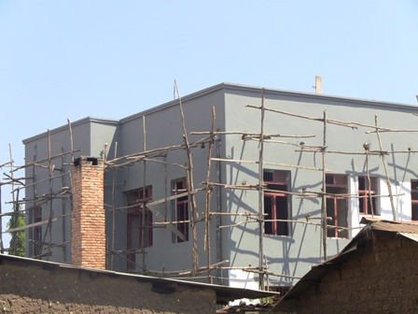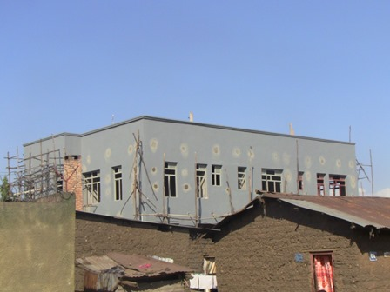m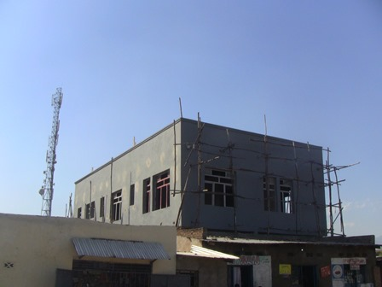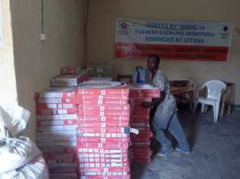
In the month of June 2021, we have started putting tiles on the fisrst floor of FWA maternity ward.
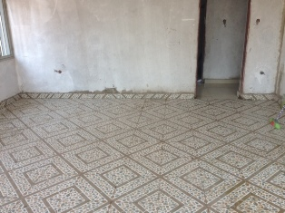
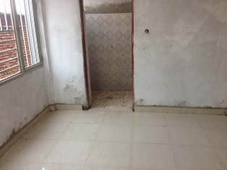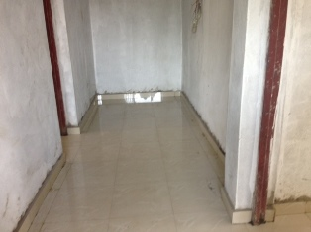

For the moment, we've already raised 80% of the total cost of our building, and now our goal is to raise $15, 000 to complete this project. Our plan is to celebrate the official entrance of this maternity ward by December 1st, 2021. We are very thankful for the great step achieved. Therefore, we give our heartfelt thanks all our donors particularly during this threatening pandemic. We hope to raise more funds through the Global Giving Platform, the African Great Lakes Initiative (AGLI) of the Friends Peace Teams and the Canadian Friends Service Committee (CFSC). We would therefore invite everyone who reads this report to share it with his/her relatives or friends so that they can support this very important work.

