FWA MATERNITY WARD JANUARY 2024 NARRATIVE REPORT
From the month of August 14, 2023 to January 26, 2024m, Through the Global Giving Foundation, FWA has received $3473.53, including $140.4 for Ntaseka clinic maternity ward.
Although we still need more medical equipment for the maternity ward,
We are glad we have now started to have both pregnant women and children for both delivery and hospitalization services.
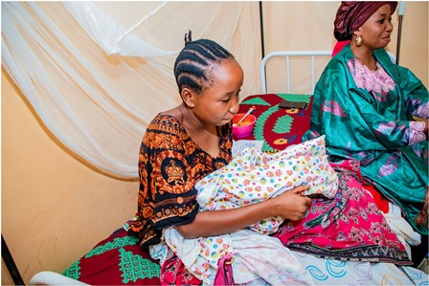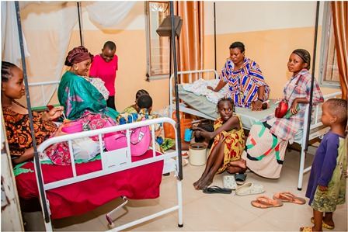
Testimony
I’m one of the Ntaseka clinic HIV positive beneficiaries. I was under retro drugs treatment, and I found myself pregnant. As I was afraid, I came here at Ntaseka clinic for medical consultation. They took care of me and followed up my health until I gave birth. Now, I’m glad because my baby was found HIV negative. They are still doing medical follow up until my baby is 18 months old to make sure my baby is really HIV negative

We are very thankful for those who have made it happen. Therefore, we give our heartfelt thanks all our donors including the Global Giving foundation, the African Great Lakes Initiative (AGLI) of the Friends Peace Teams and the John Gould Family Foundation. We would therefore invite everyone who reads this report to share it with his/her relatives or friends so that they can support this very important work particularly the maternity ward medical equipment.

