FWA MATERNITY WARD JULY 2021 NARRATIVE REPORT
From the month of August 2021 to January 2022, FWA has received a total of $1683, 01 from the Global Giving Foundation for the maternity ward. FWA has also raised some funds through the Canadian Friends Service Committee (CFSC) and the African Great Lakes Initiative (AGLI) of the Friends Peace Teams (FPT) for the maternity ward.
The pictures below show the progress of the maternity ward from August 2021 to January 2022.
AUGUST 2021
In the month of August, with support from the Global Giving Foundation, we built creeping stairs connecting the first floor to the second floor.
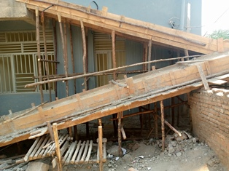
SEPTEMBER 2021
In the month of September, Quakers from both the United States and Canada had donated for the maternity ward completion.

OCTOBER 2021
In the month of October, under the support of the African Great Lakes Initiative (AGLI) of the FPT and the Canadian Friends Service Committee (CFSC), glasses were put on the doors and windows of the first floor. In addition, wooden doors were put inside the first floor. The ceiling of the second floor was put in place as well.
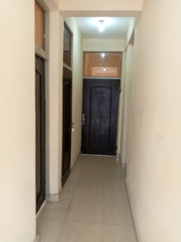
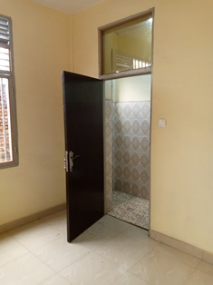

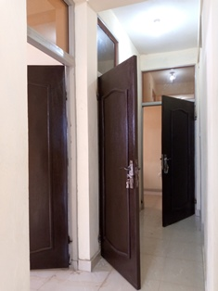
Wooden doors inside the first floor
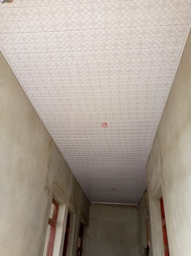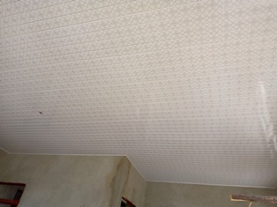
Ceiling of the second floor
NOVEMBER 2021
In the month of November, under the support of the African Great Lakes Initiative (AGLI) of the FPT, tiles for the second floor were purchased.
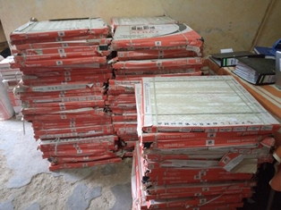
Tiles for the second floor were purchased
DECEMBER 2021
In the month of December, under the support of the African Great Lakes Initiative (AGLI) of the FPT, tiles were implemented on the second floor.

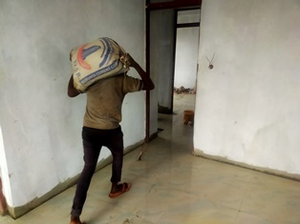
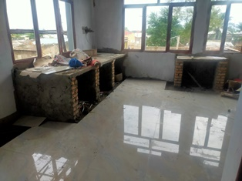
Tiles are being implemented on the second floor
See below how the building looked like at the end of December 2020
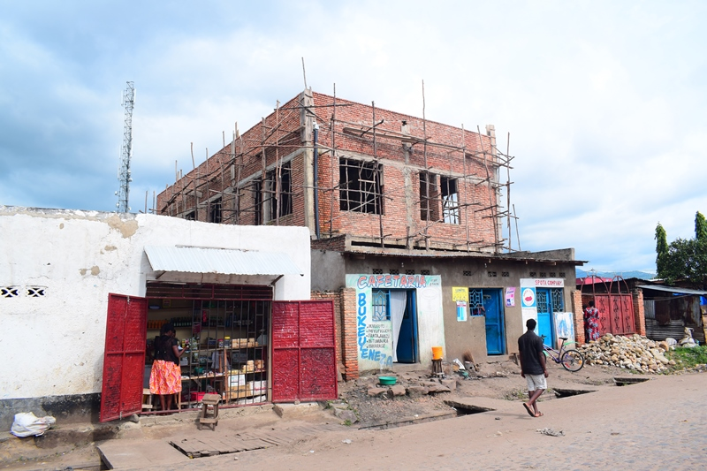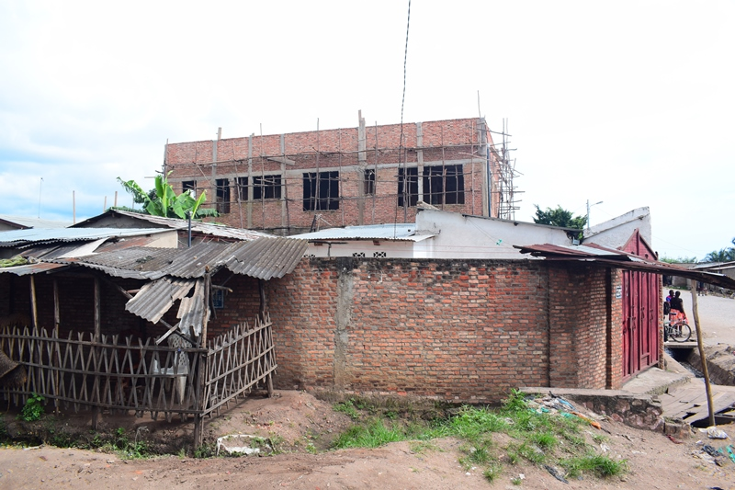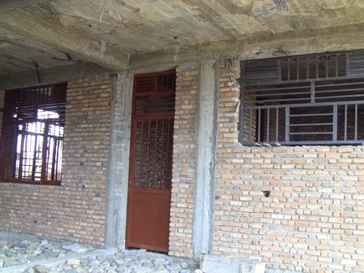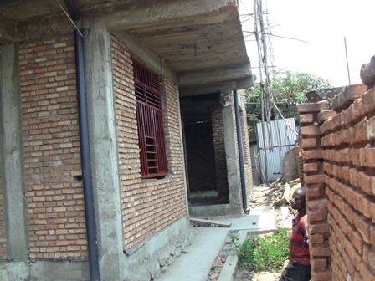

At the end of December 2021
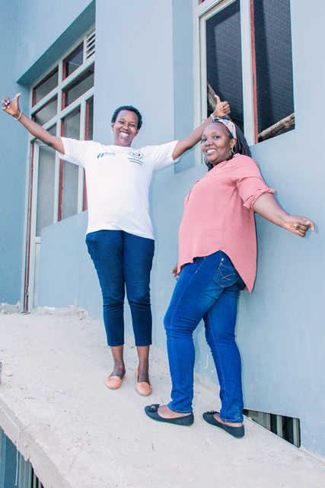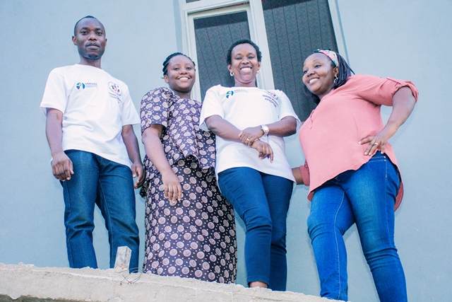
Some of the FWA staff rejoicing because of the new building
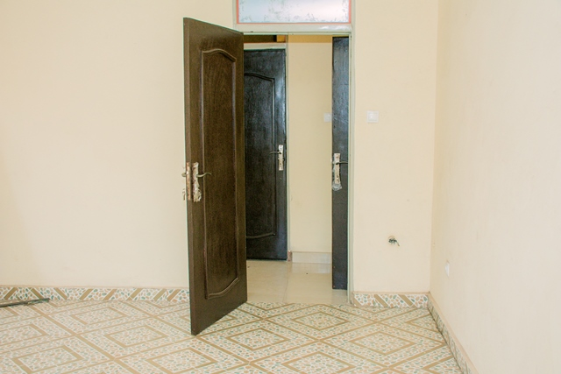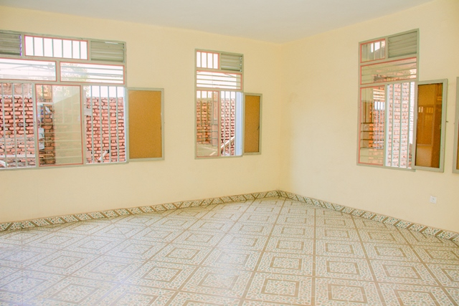

JANUARY 2022
In the month of January 2022, under the support of the Global Giving Foundation, seat toilets, showers and sinks have been installed in our new building. The second staircase was done as well.
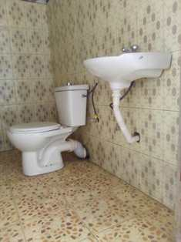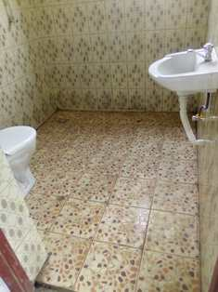
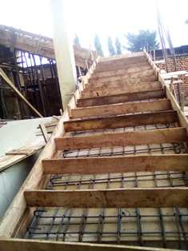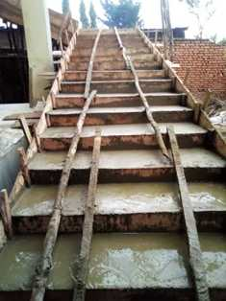
For the moment, we've already raised 95% of the total cost of our building, and now our goal is to raise $20, 000 for our maternity ward equipment and additional staff. This requires one year salary for a full time medical doctor and two nurses. Our plan is to celebrate the official entrance of this maternity ward by March 31st, 2022. We are very thankful for the great step achieved. Therefore, we give our heartfelt thanks all our donors including the Global Giving foundation, the African Great Lakes Initiative (AGLI) of the Friends Peace Teams and the Canadian Friends Service Committee (CFSC). We would therefore invite everyone who reads this report to share it with his/her relatives or friends so that they can support this very important work.

