FWA MATERNITY WARD AUGUST 2023 NARRATIVE REPORT
From the month of May 2023 20, 2023 to August 14, 2023, Through the Global Giving Foundation, FWA has received $1238. 68, including $103.5 for Ntaseka clinic maternity ward.
Although we still need more medical equipment for the maternity ward,
We are glad we have now started to have both pregnant women and children for both delivery and hospitalization services.
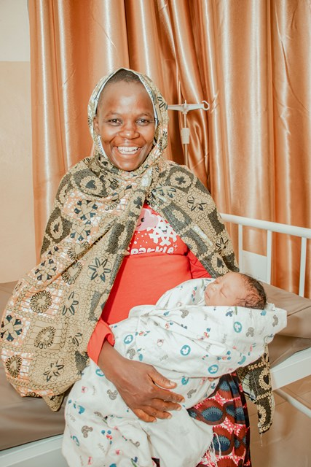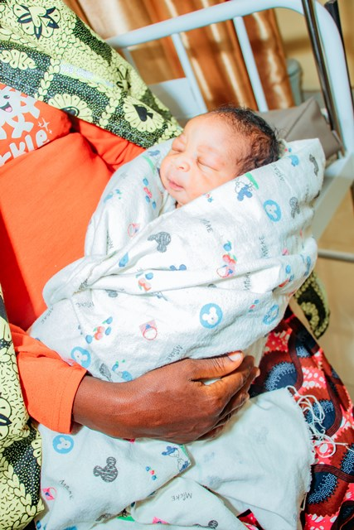
Babies born at Ntaseka clinic
In the month of June 2023, Office tables for the maternity ward were purchased under the support of the Afriican Great Lakes Initiative of the Friends Peace Teams (FPT)
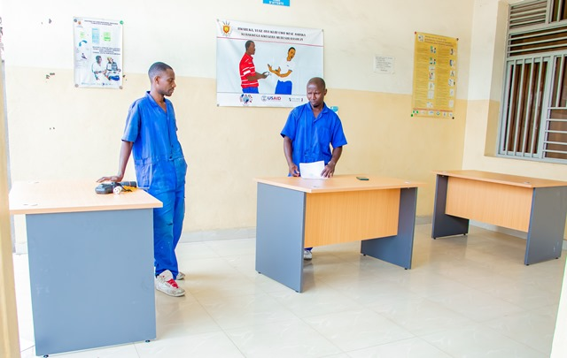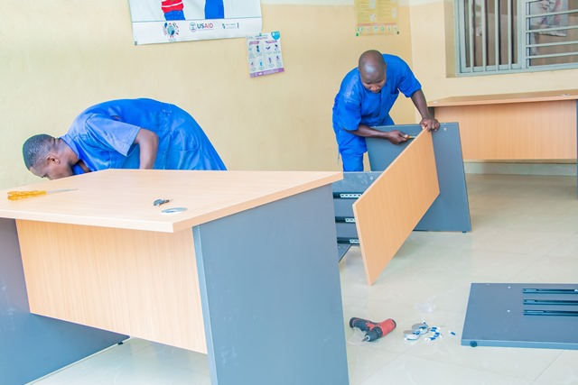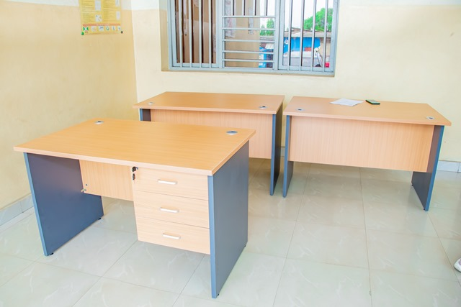
In the month of August 2023, John Gould family Foundation has supported Ntaseka clinic with one SD3 Plus Foetal Doppler and one YX-24LM Dual Fuel Steam
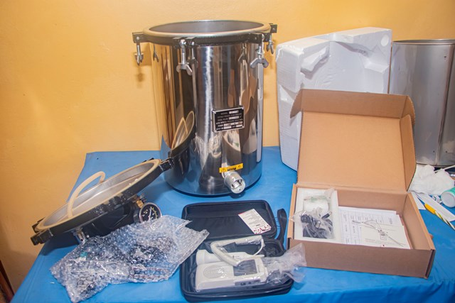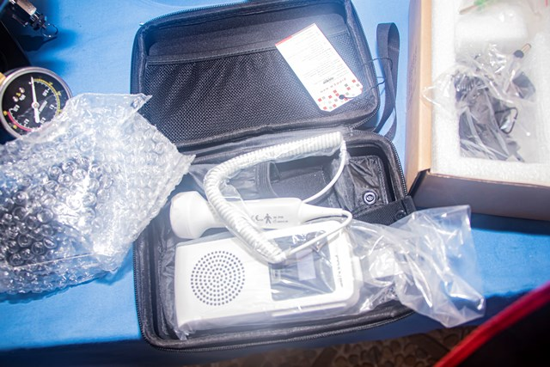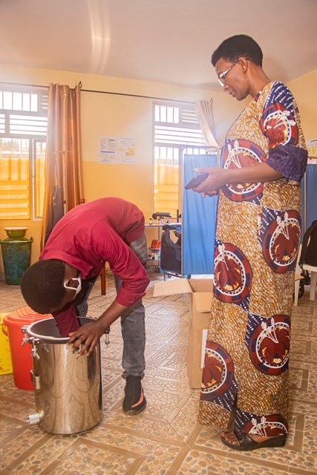

We are very thankful for those who have made it happen. Therefore, we give our heartfelt thanks all our donors including the Global Giving foundation, the African Great Lakes Initiative (AGLI) of the Friends Peace Teams and the John Gould Family Foundation. We would therefore invite everyone who reads this report to share it with his/her relatives or friends so that they can support this very important work particularly the maternity ward medical equipment.

