__________________________________________________
Murders on Mt Elgon
Report from Kenya #491 – March 16, 2018
http://davidzarembka.com/2018/03/08/490-crowdfunding-through-global-giving-march-9-2018/

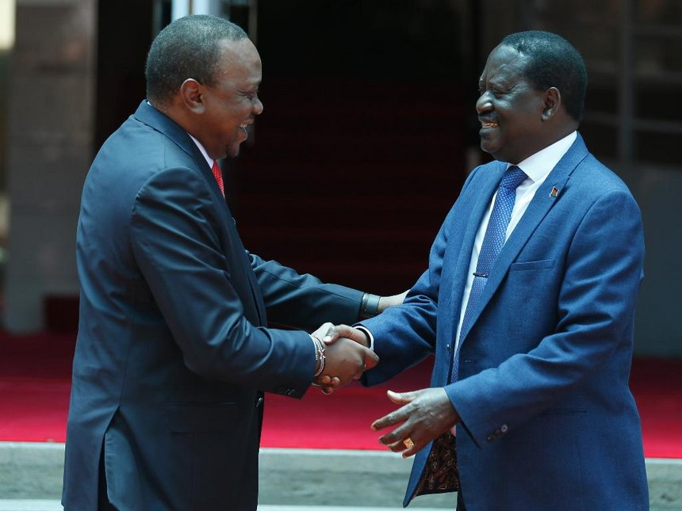

Top of Form

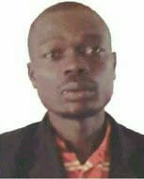

‎Masuti Chemasuet‎ to VOICES OF CHANGE.
11 hrs ·
Much have lately been said about Timothy Kiptanui Kitai a.k.a Cheparkach. Cheparkach has broken all records and he is going to be remembered as the most ruthless criminal of all times.
But do you know Cheparch's home is just a stone throw distance away from the then home of former SLDF commander the late Wycliffe Kirui Matwakei ?
Do you also know that the names "Matwakei" and "Cheparkach" are very unique Sabaot names and that carry unique meanings ?
Now read this :-
-Matwakei - Unmovable.
-Cheparkach - He who strikes
with a spear to
kill.
The above names therefore carry meanings that defines the true characters of their owners.
SLDF's Matwakei led a rebel organization that claimed over two thousand lives in a two year terror period while Cheparkach's less than ten member gang have murdered around twenty people, did several robberies and have over thirty rape cases under their name in a six month period.
,
But the difference between the two is that while Matwakei's SLDF fought for Sabaot land rights and had massive support of locals the reason why it took the government two years to root them out, Cheparkach's group is purely a criminal gang whose agenda is only murdering, robbing and sexually abusing the locals. It will be rembered too that SLDP did not support drunkardness and sexual assaults within their areas of jurisdiction and used to imposse heavy fines on those who raped and cut off ears of those who were found drunk.
Another similarity of the two groups is the effective intelligence gathering which helped them survive government onslaught. Its still an admirable fact that the two groups developed strong intelligence networks that always left security agends wondering.
It should also be remembered that Cheparkach's group had strong connection with motor bike boda boda community who fully supported them in their movements. This support alone contributed more than sixty percent of their ability to dodge government security agents.
Something else that shouldnt be forgotten about the two is their similar family backgrounds. Both families of Matwakei and Cheparkach were firm anti-ndorobo. Cheparkach's father was a strong supporter of SLDF while Matwakei's family created, sustained and led SLDF. But at this juncture, its fair to mention that Matwakei's family did not have criminal under dealings unlike Cheparkach's father who is said to have had criminal networks who supplied him with livestock for his home butchery at Chepkowo and Kubura villages.
Again, the two families had the same strange way of naming their children. Matwakei's father had two wives and named all his children after his clan's great ancestors. No child had was named after their mother's clan. In Cheparkach's family their father had three wives and was more complicsted when it came to naming his children. If he named one new born boy child Cheparkach, he will still give the same name to all male children born in that period by his other wives. For example, there are two sons in the family named Cheparkach and several others named Ngeywo etc.
On matters education, Matwakei was a high school form two drop out but married a form four leaver while Cheparkach is a primary class five graduate who married a class six girl. I was the chairman of Chepkurkur primary school in the year 2012 when I started to fight school going girls early marriages and pregnancies. It was this period when Cheparkach eloped with our pupil. I shut my mouth, ears and eyes knowing the nature of the man I was dealing with.
And Matwakei was more disciplined boy than Cheparkach who seems, to have excessive appetite for other people's wives. At no time was Matwakei accused of misbehaving with his neighbours wives unlike Cheparkach who fathered four children from his immediate neighbours wives. His actions have broken families.
,
But Cheparkach's journey have been cut short by quick response of government. The Kshs.1000,000/- boundy on his head have complicated, matters furthet for it is now obvious that he cant even trust those closed friends who helped him because of fear of a possibility of double dealing. This will drastically reduce his operstions which must have forced him to go to the drawing board once again.
The above stated similarities categorizes these two men as destined by fate to terrorize and die from the bullet of the law.
But listen, the two guys, though enemies to the community, have forced government to come up with beneficial programmes to residents. Matwakei brought Cheptais sub county while Cheparkach brought Kopsiro sub county and degazetement and land title deeds for the remaining Cheoyuk settlement scheme. Its therefore a fact that criminals have always forced government to help Mt Elgon people than elected leaders.
__________________________________________________
To be added to or removed from this listserve, please send your name and email address to davidzarembka@gmail.com.
__________________________________________________
DONATE
Transforming Community for Social Change (TCSC)
For “Ways to Donate” go to https://transformingcommunityforsocialchange.wordpress.com/donate-2/
__________________________________________________
From 1998 to 2016, David Zarembka was the Coordinator of the African Great Lakes Initiative of the Friends Peace Teams. He continues his peacemaking work in East Africa with Transforming Community for Social Change (TCSC) and Friends Church Peace Team (FCPT). He has been involved with East and Central Africa since 1964 when he taught Rwandan refugees in Tanzania. David is married to Gladys Kamonya and lives in western Kenya. David is the author of A Peace of Africa: Reflections on Life in the Great Lakes Region. He is an analyst on eastern Africa issues for TVC News in Lagos, Nigeria.
__________________________________________________
David Zarembka
Transforming Community for Social Change (TCSC)
Phone 254 (0)726 590 783
Reports from Kenya: www.davidzarembka.com/
Email: davidzarembka@gmail.com
Webpages: healingandrebuildingourcommunitiesinternational.wordpress.com/
transformingcommunityforsocialchange.wordpress.com/
__________________________________________________

