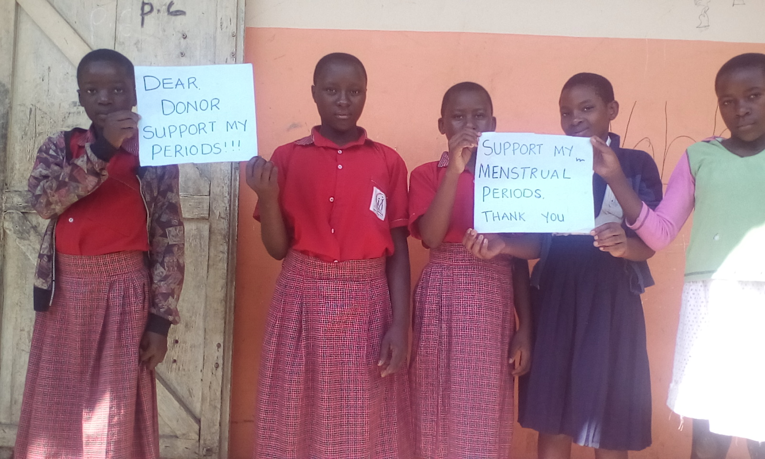
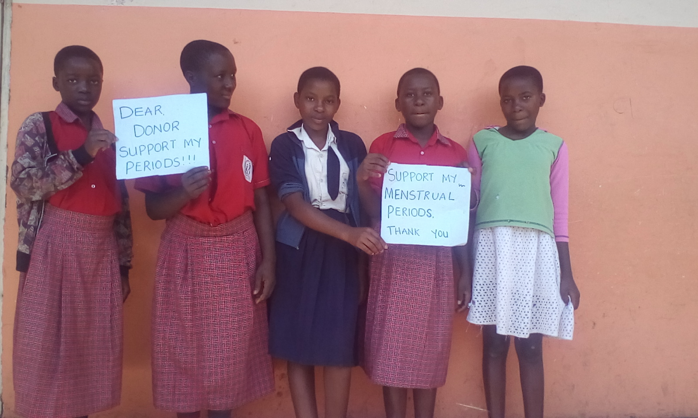

Thank you So Much
Contact us
Mama Dorika’s Island of Happiness-MDIH
Islandofhappiness21@gmail.com
+256788267053

