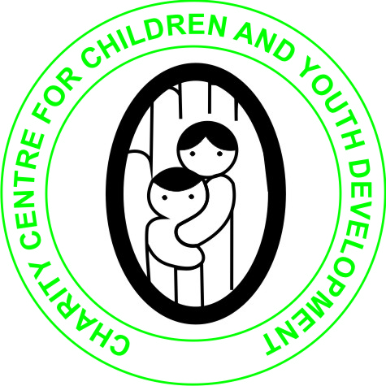
CHARITY CENTRE FOR CHILDREN AND YOUTH DEVELOPMENT

JANUARY 2020 REPORT
ON THE SUPPORT OF ORPHANS AND VULNERABLE CHILDREN UNDER THE PROJECT HELP EDUCATE 300 CHILDREN IN NEED

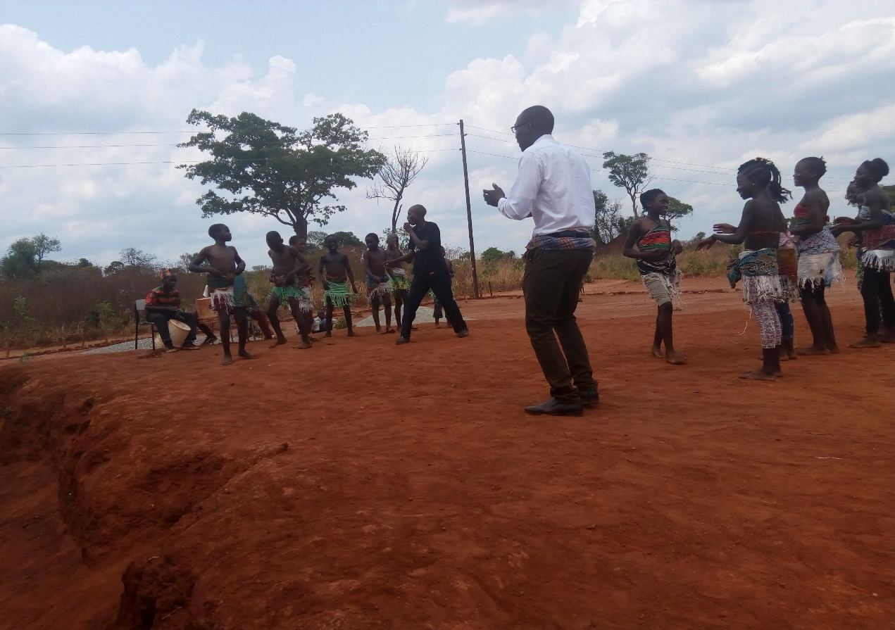
SUBMITTED
TO
GLOBAL GIVING
BY
ALEX BWALUKA
7TH JANUARY 2020

DESCRIPTION OF THE ORGANIZATION
Charity Centre for Children and Youth Development (CCCYD) is a Non-profit, Non-political and Nonreligious Organizations which was established to help Orphans and vulnerable children (OVCs), Youth, women and persons with physical challenges improve their standards of Living through the provision of several life skills, education support, HIV/AIDS awareness and prevention, provision of micro-entrepreneurship skills and soft loans as well as material support.
We envision a society that will work towards eradication of poverty, HIV and AIDS, illiteracy among Orphans and vulnerable children, youths and women in Society.
The Organization's mission is to promote and enhance the capabilities of children, youth and women in North Western Province and beyond to effect positive social change that would necessitate the development of their lives, communities and the nation at large
Many orphans, in most areas of Zambia are dropping out of school due to poverty. This poverty is primarily the result of the HIV/AIDS pandemic which has ravaged the Sub-Sahara region claiming the lives of many adults. Children and the elderly have suffered most as a result of this pandemic. Grandparents and children have become heads of households which they can barely support. This problem has been exacerbated by the harsh economic situation in the country Most of the orphaned children rely on outside help just to meet their basic day to day needs such as food and clothing. The children who have dropped out of school in these communities are unlikely to go back to school particularly children from rural areas and poor families. As a result most children get menace to the community by getting involved in activities such as illegal trading, theft, and vandalizing property and engaging in pre-marital sex. If this problem is not addressed soon the HIV infection rates among vulnerable children will go up!
It is against this background that Charity Centre for Children and Youth Development is raising money on globalgiving under the project HELP EDUCATE 300 CHILDREN IN NEED!
The project is helping educate over 500 orphans and vulnerable children allowing them to remain in school and improve on their life. This will reduce the burden on guardians who have taken up the responsibilities of taking care of orphans left behind by their relatives and this will also reduce poverty and crime in the community which is on increase as a result of children being found on the street.
The fundraising target for this project is $20,000.00 out of which we have raised $1,384.00
This project is helping provide both academic and vocational education to over 300 children in need at Lufunjisha School of Excellence formerly known as Fortune Community School in Solwezi District of Zambia.

Training Small scale farmers in Farmers Business simulation
The organization has partnered with Savings Bank Foundation for International Cooperation from German to provide Farmers Business Simulation which aims at helping small scale farmers improve their quality of farm and quality of life that would in turn provide food security at household level. The trainings will be conducted from October 2019 to March 2020. So far we have trained 334 small scale farmers in 5 districts of Zambia
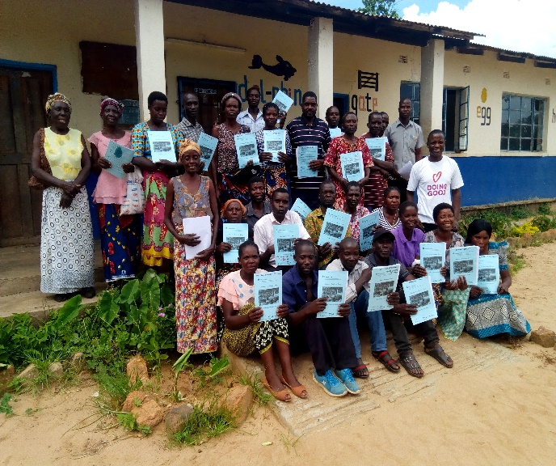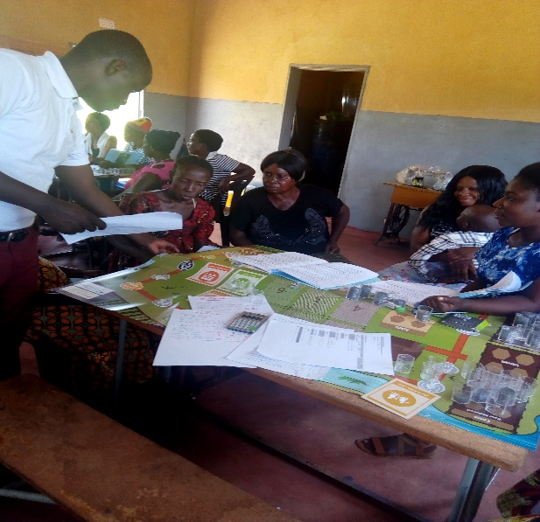
Farmers group photo Farmers Simulation Game training
Teacher’s/ school Expenses for the Month of Novemebr 2019:
SN | NAME OF PAYEE | DESCRIPTION OF PAYMENT | DATE | AMOUNT ZMW
1 | Ms Mercy Kambela | Monthly wages | 21/11/2019 | ZMW 800.00
2 | Ms Chivweta Susan | Monthly wages | 21/11/2019 | ZMW 800.00
3 | Ms Esther Banda | Monthly wages | 21/11/2019 | ZMW 800.00
4 | Mr. Stanley S. Mpande | Monthly Wages | 21/11/2019 | ZMW 800.00
5 | Mr Kanjanja Moses | Monthly Wages | 21/11/2019 | ZMW 800.00
 | TOTAL |  |  | ZMW 4,000

Teacher’s payments total for this report ZMW 4000.00

Challenges:
Though the organization has scored some achievements in the past, we are facing serious challenges that needs urgent attention from well-wishers particularly payment of teachers’ salaries, Classroom furniture, clean water supply and provision of school uniforms. We need adequate funding support if we are to remain supportive to orphans and vulnerable children in Zambia.
However, I wish to express my gratitude to those that have so far donated to our project on global giving and other supporters that have supported this project. I hope you will continue considering this project and request friends and relatives to help us in any way possible.
https://www.globalgiving.org/projects/help-provide-education-to-200-children-in-need/
Our email: info@charitycentreforchildren.org
Mobile (whatsapp) +260 965 737377
Skype: alex.bwaluka14

Report compiled and submitted by
ALEX BWALUKA
7th January 2020

