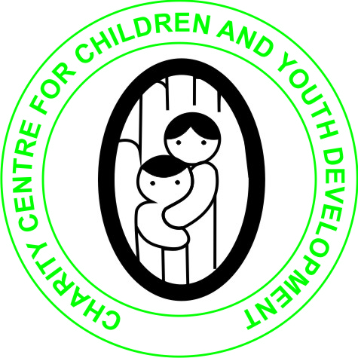

CHARITY CENTRE FOR CHILDREN AND YOUTH DEVELOPMENT

**REPORT**

**ON THE SUPPORT OF ORPHANS AND VULNERABLE CHILDREN UNDER THE PROJECT HELP EDUCATE 200 CHILDREN IN NEED**

**DESCRIPTION OF THE ORGANIZATION**

Charity Centre for Children and Youth Development (CCCYD) is a Non-profit, Non-political and Nonreligious Organizations which was established to help Orphans and vulnerable children (OVCs), Youth, women and persons with physical challenges improve their standards of Living through the provision of several life skills, education support, HIV/AIDS awareness and prevention, provision of micro-entrepreneurship skills and soft loans as well as material support.

We envision a society that will work towards eradication of poverty, HIV and AIDS, illiteracy among Orphans and vulnerable children, youths and women in Society.

The Organization's mission is to promote and enhance the capabilities of children, youth and women in North Western Province and beyond to effect positive social change that would necessitate the development of their lives, communities and the nation at large

Many orphans, in most areas of Zambia are dropping out of school due to poverty. This poverty is primarily the result of the HIV/AIDS pandemic which has ravaged the Sub-Sahara region claiming the lives of many adults. Children and the elderly have suffered most as a result of this pandemic. Grandparents and children have become heads of households which they can barely support. This problem has been exacerbated by the harsh economic situation in the country Most of the orphaned children rely on outside help just to meet their basic day to day needs such as food and clothing. The children who have dropped out of school in these communities are unlikely to go back to school particularly children from rural areas and poor families. As a result most children get menace to the community by getting involved in activities such as illegal trading, theft, and vandalizing property and engaging in pre-marital sex. If this problem is not addressed soon the HIV infection rates among vulnerable children will go up!

It is against this background that Charity Centre for Children and Youth Development is raising money on globalgiving under the project HELP EDUCATE 200 CHILDREN IN NEED!

The project is helping educate over 200 orphans and vulnerable children allowing them to remain in school and improve on their life. This will reduce the burden on guardians who have taken up the responsibilities of taking care of orphans left behind by their relatives and this will also reduce poverty and crime in the community which is on increase as a result of children being found on the street.

The fundraising target for this project is $48,000.00 out of which we have only raised $190.00

This project is helping provide both academic and vocational education to over 200 children in need at Fortune Community School in Solwezi District of Zambia.

**Past achievements**

In 2017, the organization constructed 1x2 classroom block with the support from Edinburgh Global Partnership.

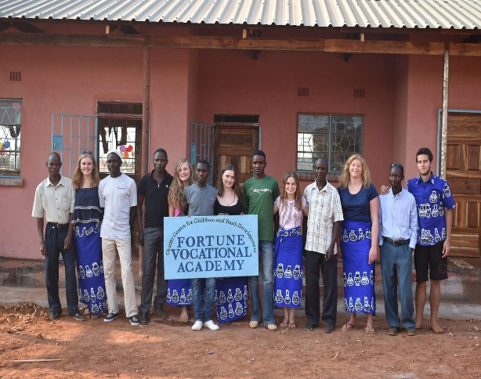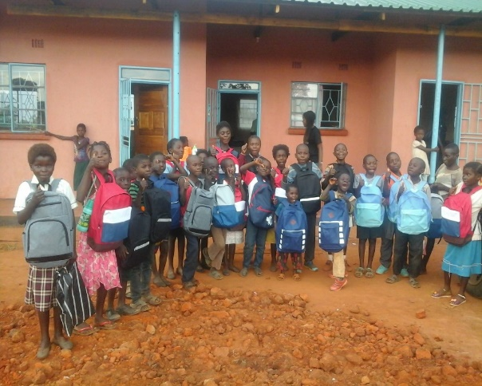

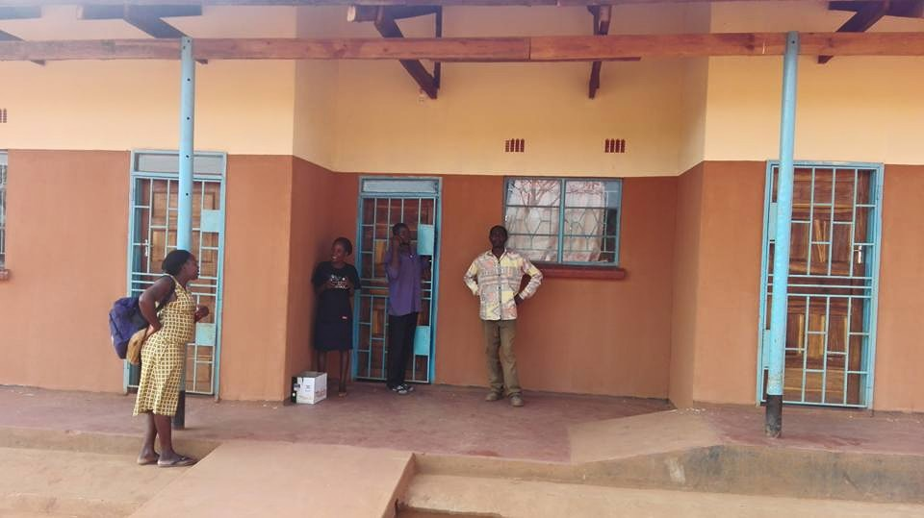

Repainted 1x2 classroom block funded by Edinburgh global Partnership (EGP) from UK.

**ACTIVITIES carried out during the period under review**

1. Provision of Basic education to orphans and vulnerable children in need at fortune community school established by Charity Centre for Children and Youth Development. So far, we have enrolled 295 pupils. Boys 147 and Girls 148.

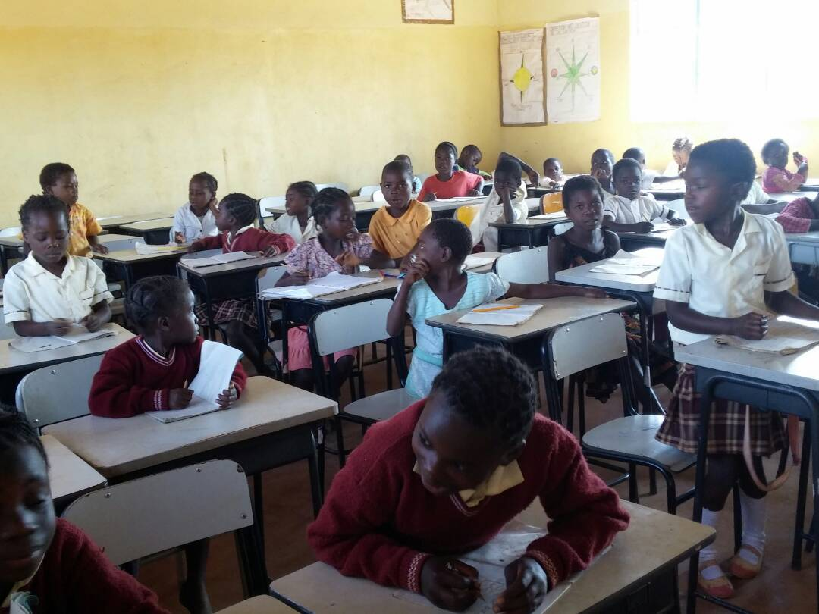

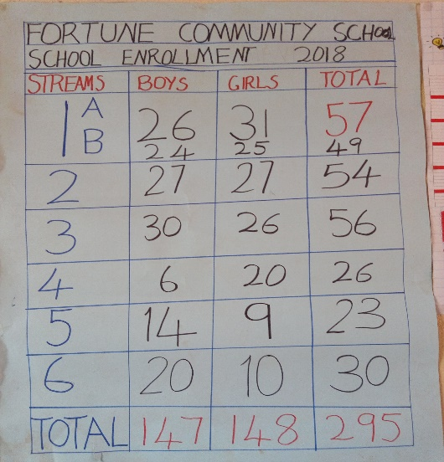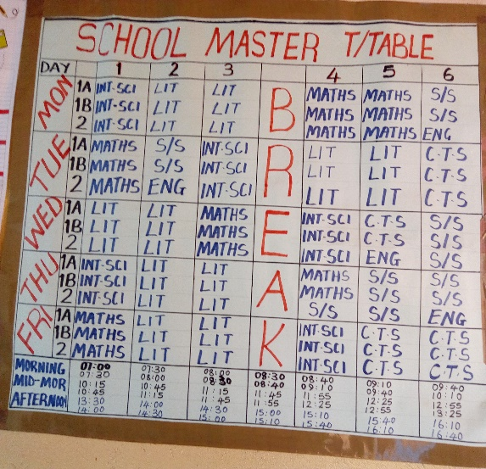

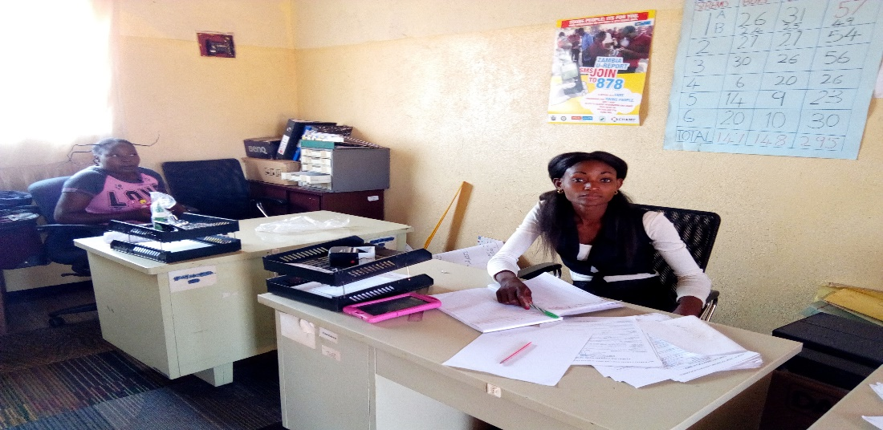

School office

1. **Skills Training:**

The organization has trained 9 youths in knitting skills.

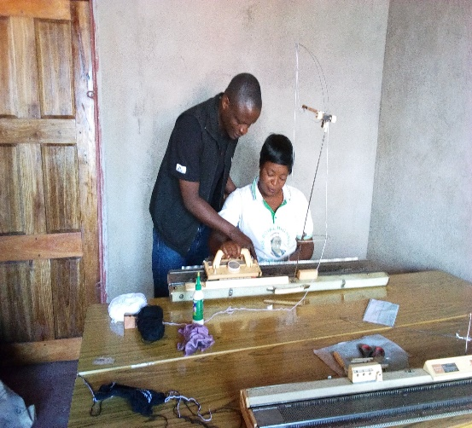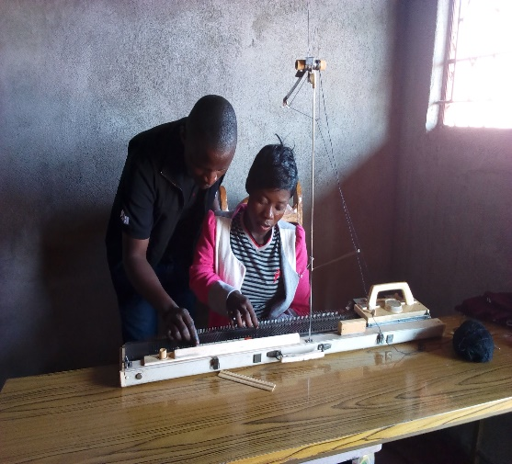

Training Youths in knitting skills.

In February 2018, the organization received second support from the Australian Embassy to construct additional 1x4 classroom block towards the provision of Basic education and skills training in Solwezi District of Zambia.

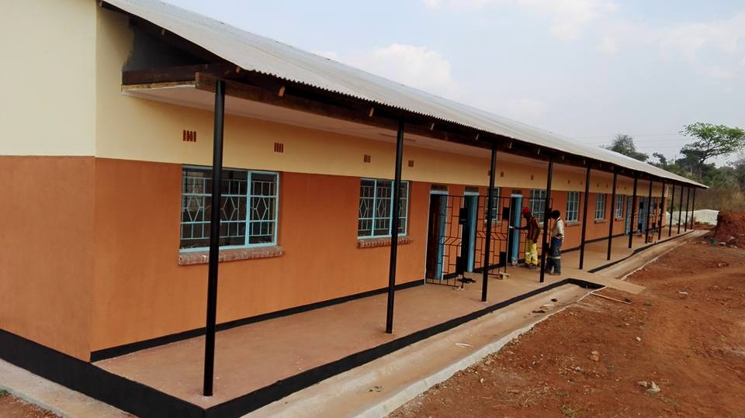

1x4 classroom block funded by Australian Embassy

Above are some of the achievements the organization has scored!

Teachers Expenses:

|  |  |  |  |
| --- | --- | --- | --- |
| Sn | Description of payment | Date | Amount ZMW |
| 1 | Teachers’ Salaries for February | 27/02/2018 | ZMW 1,800.00 |
| 2 | Salary Advance for Teacher Lyakohola Shadrick | 07/03/2018 | ZMW 1,500.00 |
| 4 | Teachers’ Salaries for March 2018 | 29/03/2018 | ZMW 1,400.00 |
| 5 | Teachers’ Salaries for April 2018 | 28/04/2018 | ZMW 1,400.00 |
| 6 | Teachers’ Salaries for May 2018 | 29/05/2018 | ZMW 1,500.00 |
| 7 | Salary Advance for Miss Purity Lumuna | 11/06/2018 | ZMW 400.00 |
| 7 | Teachers’ Salaries for June 2018 | 04/07/2018 | ZMW 3,000.00 |
| 8 | Teachers’ Salaries for July 2018 | 29/07/2018 | ZMW 3,500.00 |
| 9 | Teachers’ Salaries part payment | 10/08/2018 | ZMW 1,200.00 |
|  | **TOTAL** |  | **ZMW 15,700.00** |

SCHOOL UNIFORMS

|  |  |  |  |
| --- | --- | --- | --- |
| SN | DESCRIPTION OF PAYMENT | DATE | AMOUNT |
| 1 | Suiting materials for uniforms | 17/07/2018 | ZMW 250.00 |
| 2 | Down payment for uniforms | 23/07/2018 | ZMW 1,250.00 |
|  | TOTAL |  | ZMW 1,500.00 |

TOTAL EXPENSES **ZMW 17,200.00**

**Challenges:**

Though the organization has scored some achievements in the past, we are facing serious challenges that needs urgent attention from well-wishers particularly payment of teachers’ salaries, Classroom furniture, clean water supply and provision of school uniforms.

However, I wish to express my gratitude to those that have so far donated to our project on global giving and other supporters that have supported this project. I hope you will continue considering this project and request friends and relatives to help us in any way possible.

For those willing to support us can visit this link on globalgiving <https://www.globalgiving.org/projects/help-provide-education-to-200-children-in-need/>

Our email: [info@charitycentreforchildren.org](mailto:info@charitycentreforchildren.org)

Mobile (whatsapp) +260 965 737377

Skype: alex.bwaluka14

Report compiled and submitted by



ALEX BWALUKA

8TH SEPTEMBER 2018