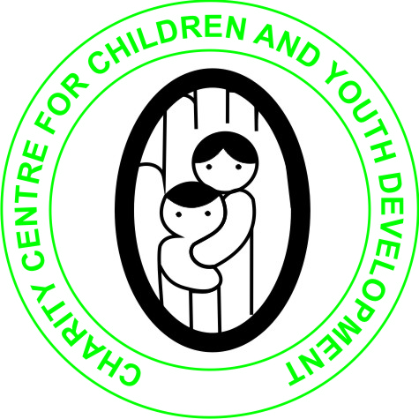
CHARITY CENTRE FOR CHILDREN AND YOUTH DEVELOPMENT

APRIL 2019 REPORT
ON THE SUPPORT OF ORPHANS AND VULNERABLE CHILDREN UNDER THE PROJECT HELP EDUCATE 300 CHILDREN IN NEED

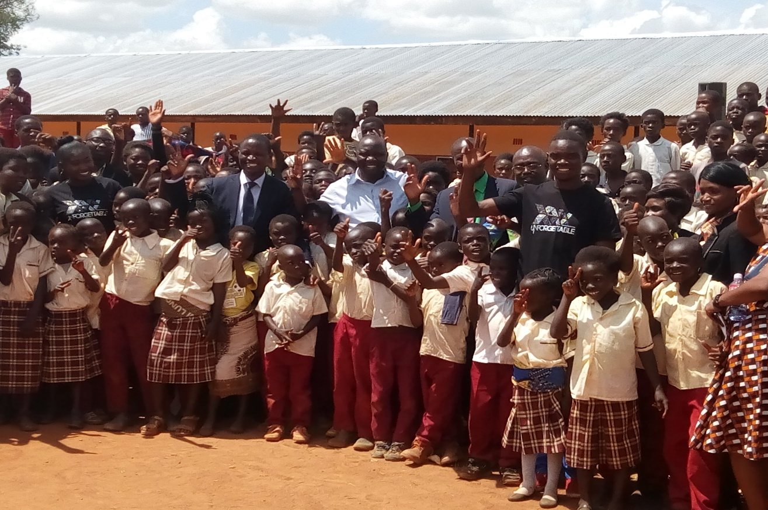
SUBMITTED
TO
GLOBAL GIVING

BY
ALEX BWALUKA
22ND APRIL 2019
DESCRIPTION OF THE ORGANIZATION
Charity Centre for Children and Youth Development (CCCYD) is a Non-profit, Non-political and Nonreligious Organizations which was established to help Orphans and vulnerable children (OVCs), Youth, women and persons with physical challenges improve their standards of Living through the provision of several life skills, education support, HIV/AIDS awareness and prevention, provision of micro-entrepreneurship skills and soft loans as well as material support.
We envision a society that will work towards eradication of poverty, HIV and AIDS, illiteracy among Orphans and vulnerable children, youths and women in Society.
The Organization's mission is to promote and enhance the capabilities of children, youth and women in North Western Province and beyond to effect positive social change that would necessitate the development of their lives, communities and the nation at large
Many orphans, in most areas of Zambia are dropping out of school due to poverty. This poverty is primarily the result of the HIV/AIDS pandemic which has ravaged the Sub-Sahara region claiming the lives of many adults. Children and the elderly have suffered most as a result of this pandemic. Grandparents and children have become heads of households which they can barely support. This problem has been exacerbated by the harsh economic situation in the country Most of the orphaned children rely on outside help just to meet their basic day to day needs such as food and clothing. The children who have dropped out of school in these communities are unlikely to go back to school particularly children from rural areas and poor families. As a result most children get menace to the community by getting involved in activities such as illegal trading, theft, and vandalizing property and engaging in pre-marital sex. If this problem is not addressed soon the HIV infection rates among vulnerable children will go up!
It is against this background that Charity Centre for Children and Youth Development is raising money on globalgiving under the project HELP EDUCATE 300 CHILDREN IN NEED!
The project is helping educate over 400 orphans and vulnerable children allowing them to remain in school and improve on their life. This will reduce the burden on guardians who have taken up the responsibilities of taking care of orphans left behind by their relatives and this will also reduce poverty and crime in the community which is on increase as a result of children being found on the street.
The fundraising target for this project is $48,000.00 out of which we have only raised $721.00
This project is helping provide both academic and vocational education to over 300 children in need at Fortune Community School in Solwezi District of Zambia.
ESTABLISHMENT OF FORTUNE COMMUNITY SCHOOL FOR ORPHANS AND VULNERABLE CHILDREN IN SOLWEZI DISTRICT OF ZAMBIA.
In order to help provide basic education to orphans and vulnerable children in Zambia, our organization in 2017 constructed 1x2 classroom block with the support from Edinburgh Global Partnership.
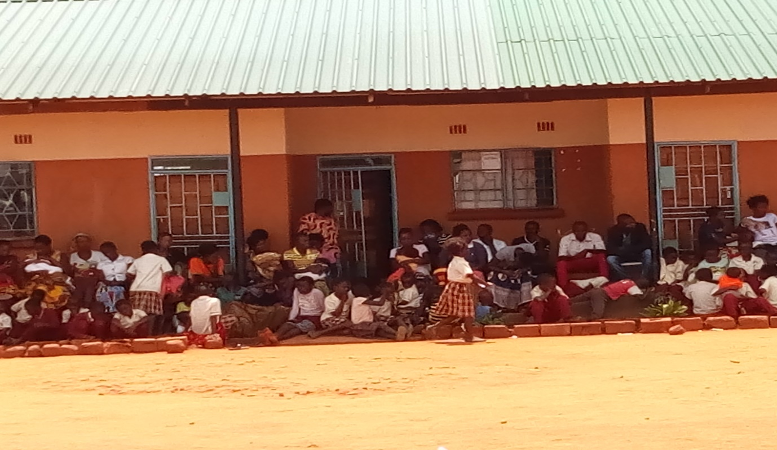
1x2 classroom block funded by Edinburgh global Partnership (EGP) from UK.
In February 2018, the organization received second support from the Australian Embassy to construct additional 1x4 classroom block towards the provision of Basic education and skills training in Solwezi District of Zambia.

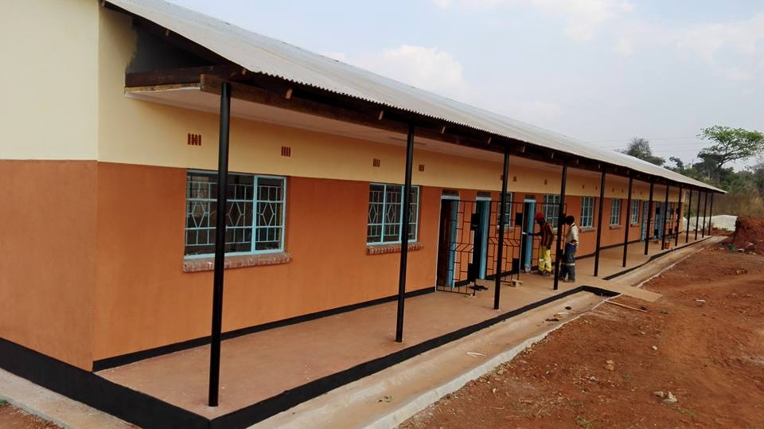
1x4 classroom block funded by Australian Embassy

As at March 2019, we have enrolled Over 400 pupils from Grade one to Grade Seven.

On 5th April 2019, the organization official launched the school.
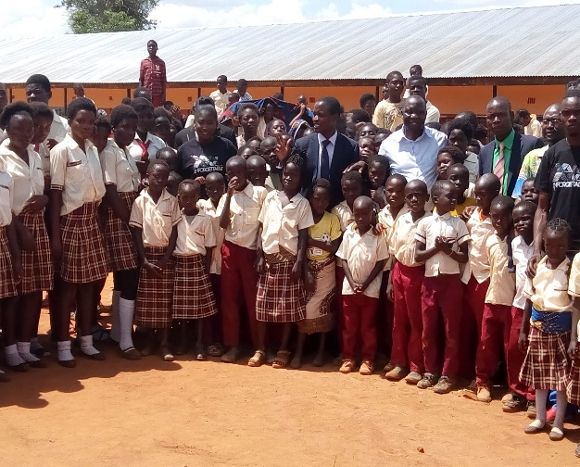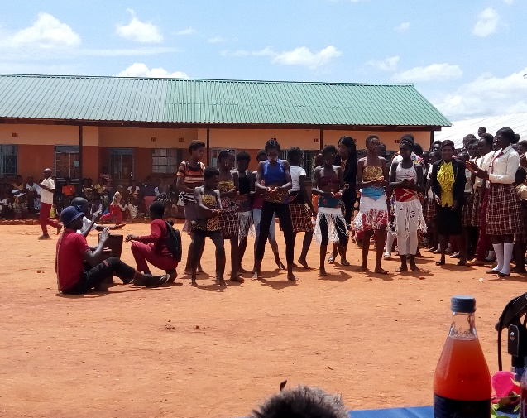
The official Launch of Fortune Community School in Solwezi

Providing sustainable vocational Skills Training for children

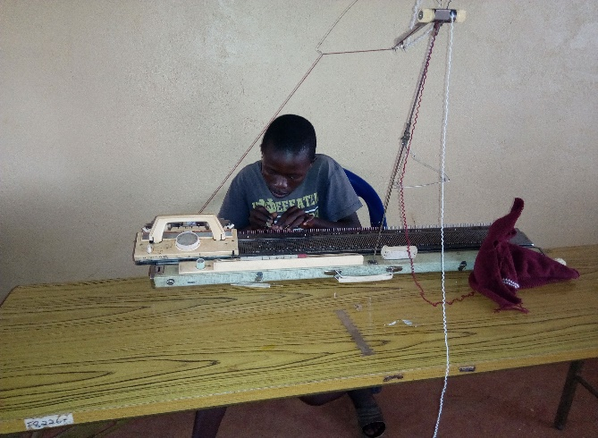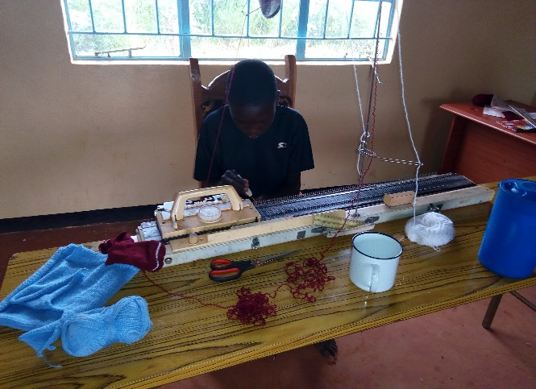
Children being trained in knitting skills

Teacher’s Expenses:
SN | NAME OF PAYEE | DESCRIPTION OF PAYMENT | DATE | AMOUNT ZMW
1 | Mr. Shardrick Lyakohola | Monthly Wages | 01/02/2019 | ZMW 900.00
2 | Miss. Purity Lumuna | Monthly Wages | 01/02/2019 | ZMW 900.00
3 | Miss. Bridget Luwaile | Monthly Wages | 01/02/2019 | ZMW 900.00
4 | Mr. Stanley S. Mpande | Monthly Wages | 01/02/2019 | ZMW 700.00
5 | Mr. Jacob Kalwaji | Monthly Wages | 01/02/2019 | ZMW 700.00
6 | Mr. Peter Mungomba | Monthly wages | 01/02/2019 | ZMW 500.00
7 | Miss. Karen M. Mpande | Monthly wages | 01/02/2019 | ZMW 500.00
 | TOTAL |  |  | ZMW 5,100.00

Challenges:
Though the organization has scored some achievements in the past, we are facing serious challenges that needs urgent attention from well-wishers particularly payment of teachers’ salaries, Classroom furniture, clean water supply and provision of school uniforms. We need adequate funding support if we are to remain supportive to orphans and vulnerable children in Zambia.
However, I wish to express my gratitude to those that have so far donated to our project on global giving and other supporters that have supported this project. I hope you will continue considering this project and request friends and relatives to help us in any way possible.
https://www.globalgiving.org/projects/help-provide-education-to-200-children-in-need/
Our email: info@charitycentreforchildren.org
Mobile (whatsapp) +260 965 737377
Skype: alex.bwaluka14

Report compiled and submitted by
ALEX BWALUKA
22nd April 2019.

