**Summary**

Destitute elderly are marginalized & stigmatized in Ethiopia for lack of care from relatives or extended family. They are also are living in deteriorated economic and social reality due to poverty, physical disability. We planned to provide food items, water, clothing, shelter, medical treatment, sanitary materials, psycho-social support & supportive equipments for 50 destitute elderly, with a special focus on those living with disability and Women

**Challenge**

In countries like Ethiopia, where there is no social service institution elderly are disadvantageous .There is hardly any Center for elderly Services in rural Ethiopia. Ethiopian rural elderly neither get any basic need support from relatives &extended families nor they have access to other forms of support from the government . Because of elderly abandonment by the community they have been found to be hopeless, helpless and lives in dignified manner. Most of them are do not have access to shelter and living in street in extreme poverty .Hence we plan provide basic needs and other necessities for 50 poor destitute elderly. Priorities are going to be given for those elderly who do not have access to other forms of support from the government or others.

**Budget Breakdown**

|  |  |  |  |
| --- | --- | --- | --- |
| **No** | **Activity** | **For each activity** |  |
| 1 | Provision of food and nutrition | 10 |  |
| 2 | Provision of medical care and check up | 15 |  |
| 3 | provision of hygiene and sanitary materials | 25 |  |
| 4 | Provision of clothes and shoes | 50 |  |
| 5 | Support for children and grandchildren of elders: | 100 |  |
| 6 | Providing wheelchair, brail, ramp and other supportive materials | 150 |  |

**Solution**

Elderly will get basic needs like food, shelter; closing and proper medical care .Elderly will live in clean &safe environment and live a healthy life.

**Long-Term Impact**

Confidence of elderly will be built and elderly will be psychologically stable and secured .Quality of life will improve for elderly. Livelihood and welfare for those elderly will be also improved. Elderly will live a happy life for the rest of their life

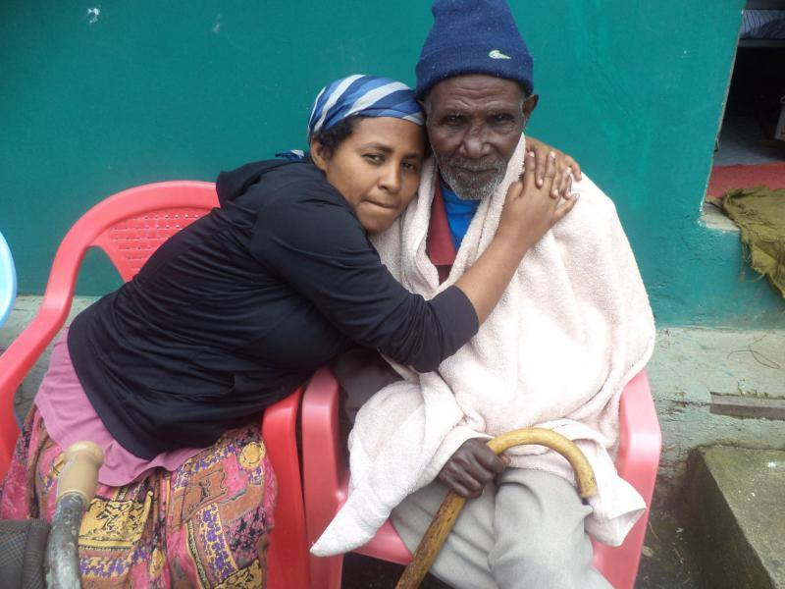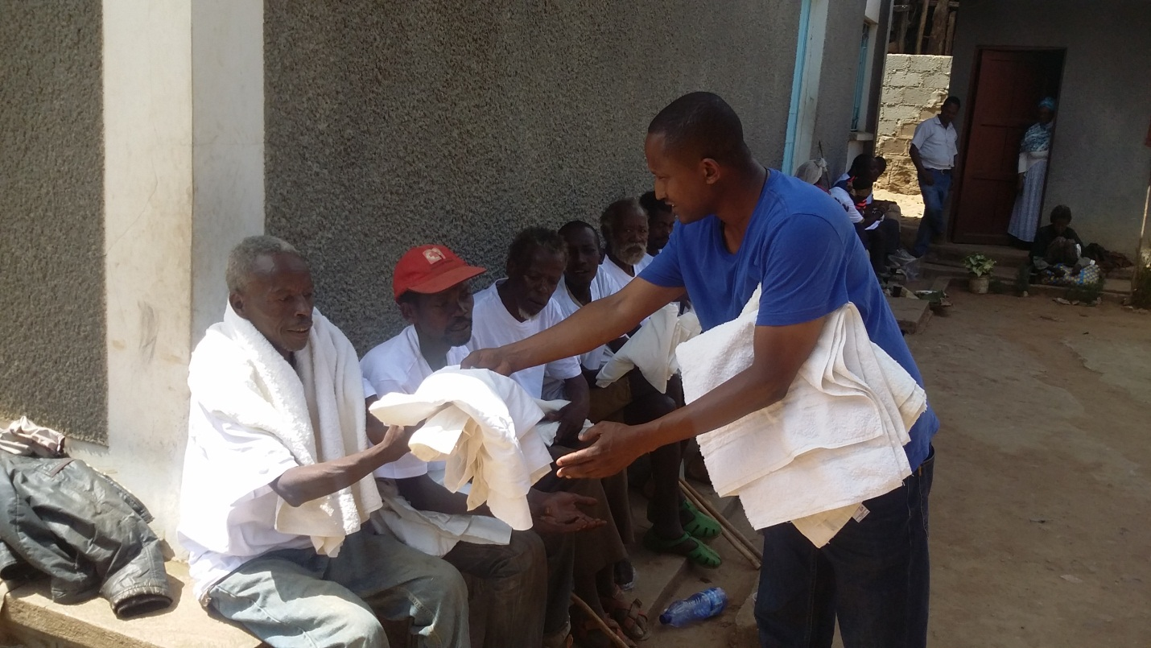

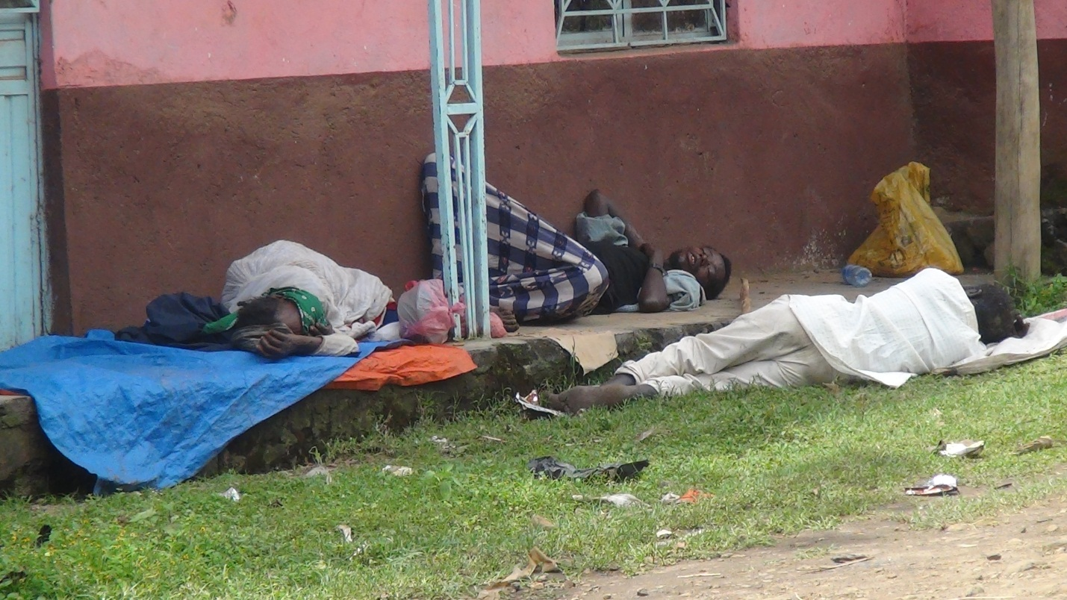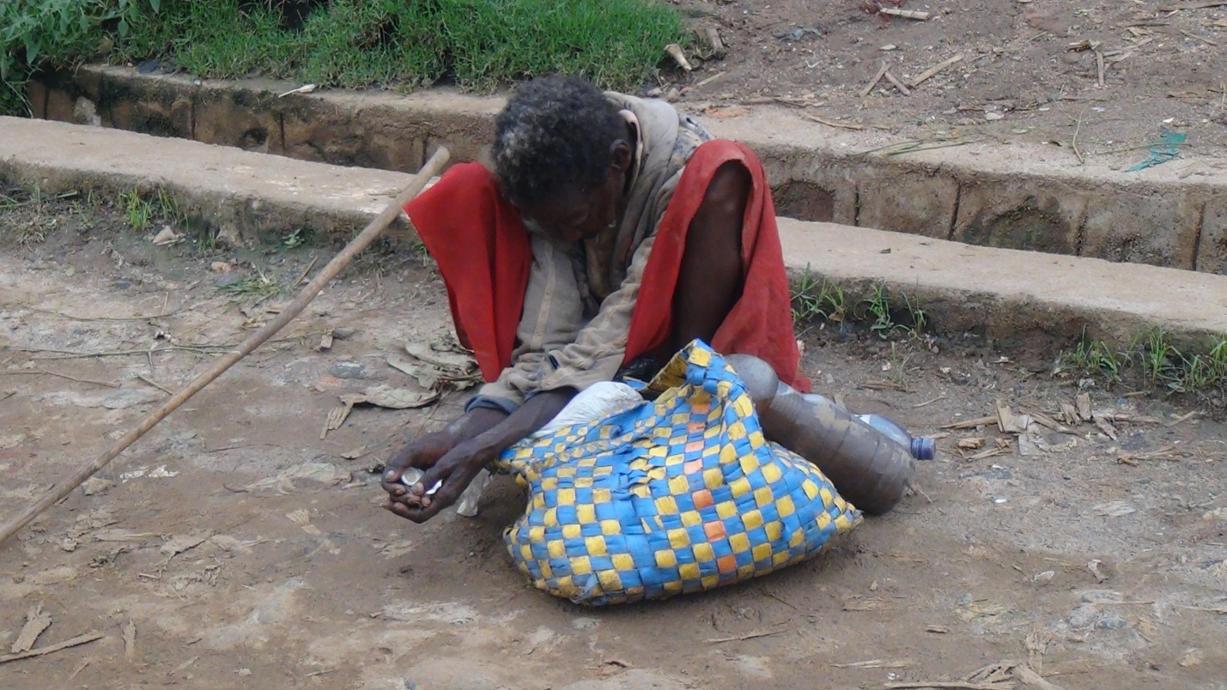

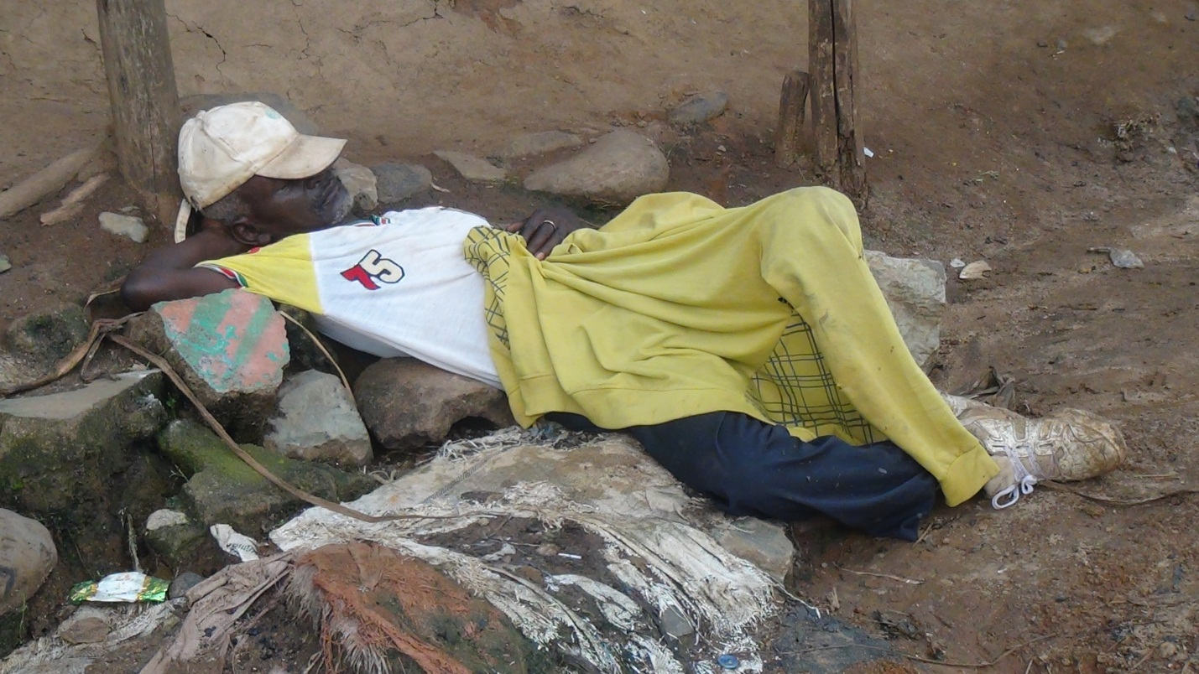

**Before off street**

 **After off street**

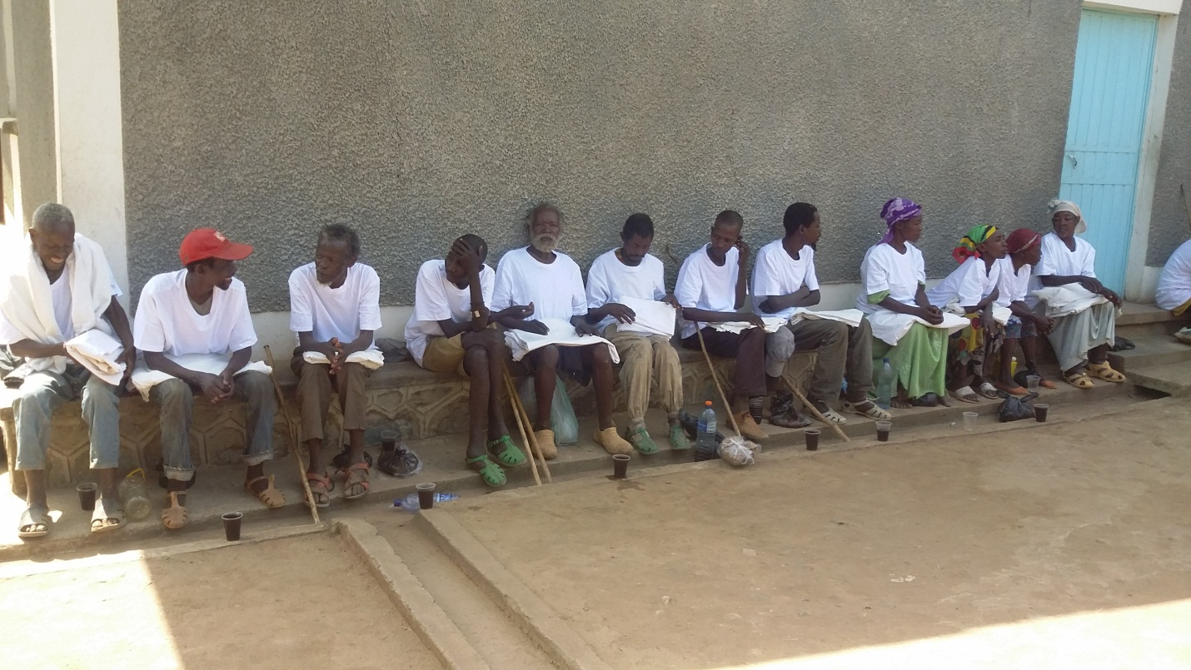

**After off street**

