THANK YOU FOR YOUR SUPPORT
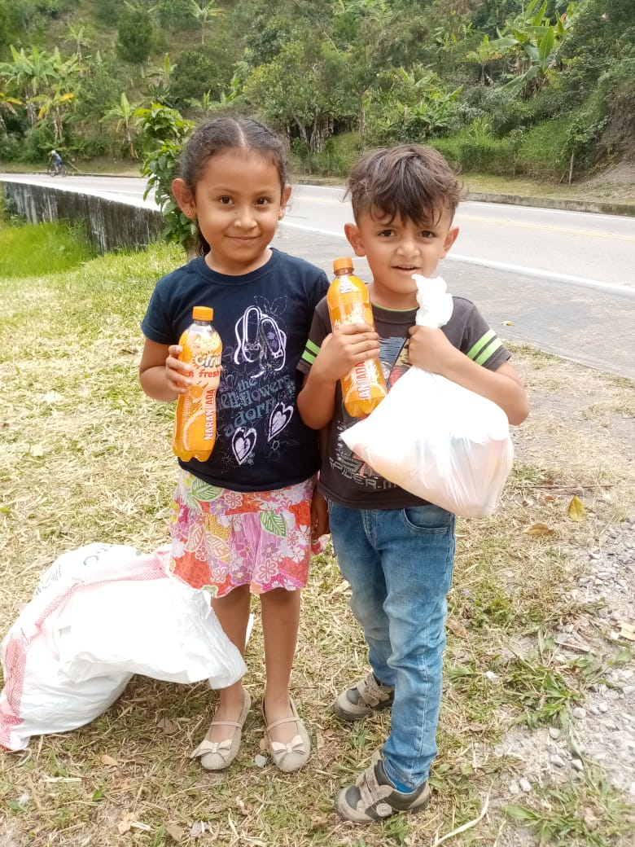
With the project we implement an integral nutrition at the food bank in Bogota, and with its generous donation we are contributing to the normal development and growth of children.
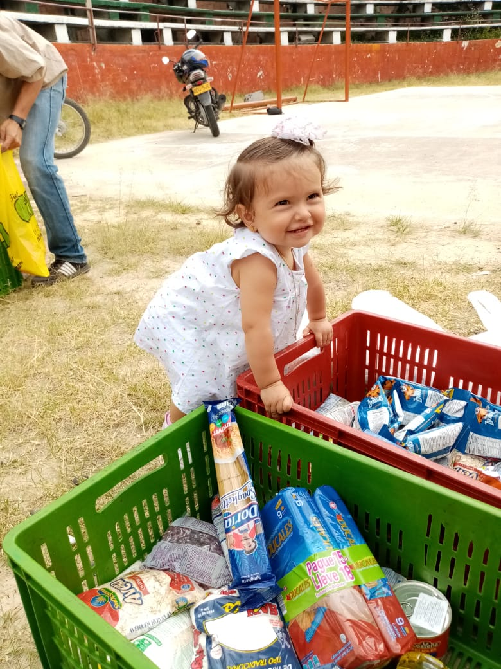
PURE HAPPINESS!
This reaction is what we see every day in the faces of the children benefited from the feeding programs in the bank, you make an important contribution in this process, because if it were not for you, these children would not have their daily food and not They would be in optimal health and wellness conditions.
Thanks to their generosity and kindness, we can see how the children served by the program offered at the food bank of Bogotá are happy, healthy children and willing to learn many things in their daily lives. We could not do this work, if not for the donation from all of you, those who commit to causes for social and non-profit purposes, with the intention of helping those around you and making this a better place to live, with your contribution we can begin a real change in the scourge that these children suffer daily from hunger and other adversities.
Although we have quite satisfactory achievements, our dream is to end hunger in Colombia, so our path is just beginning. We will keep you informed as this project progresses.
“TOGETHER AGAINST HUNGER”

We invite you to donate. With one click you can support the feeding of a child. You can donate from $ 20 or more and share this project with friends and contacts who want to feed hope.

