**ANNUAL REPORT**

2016-2017

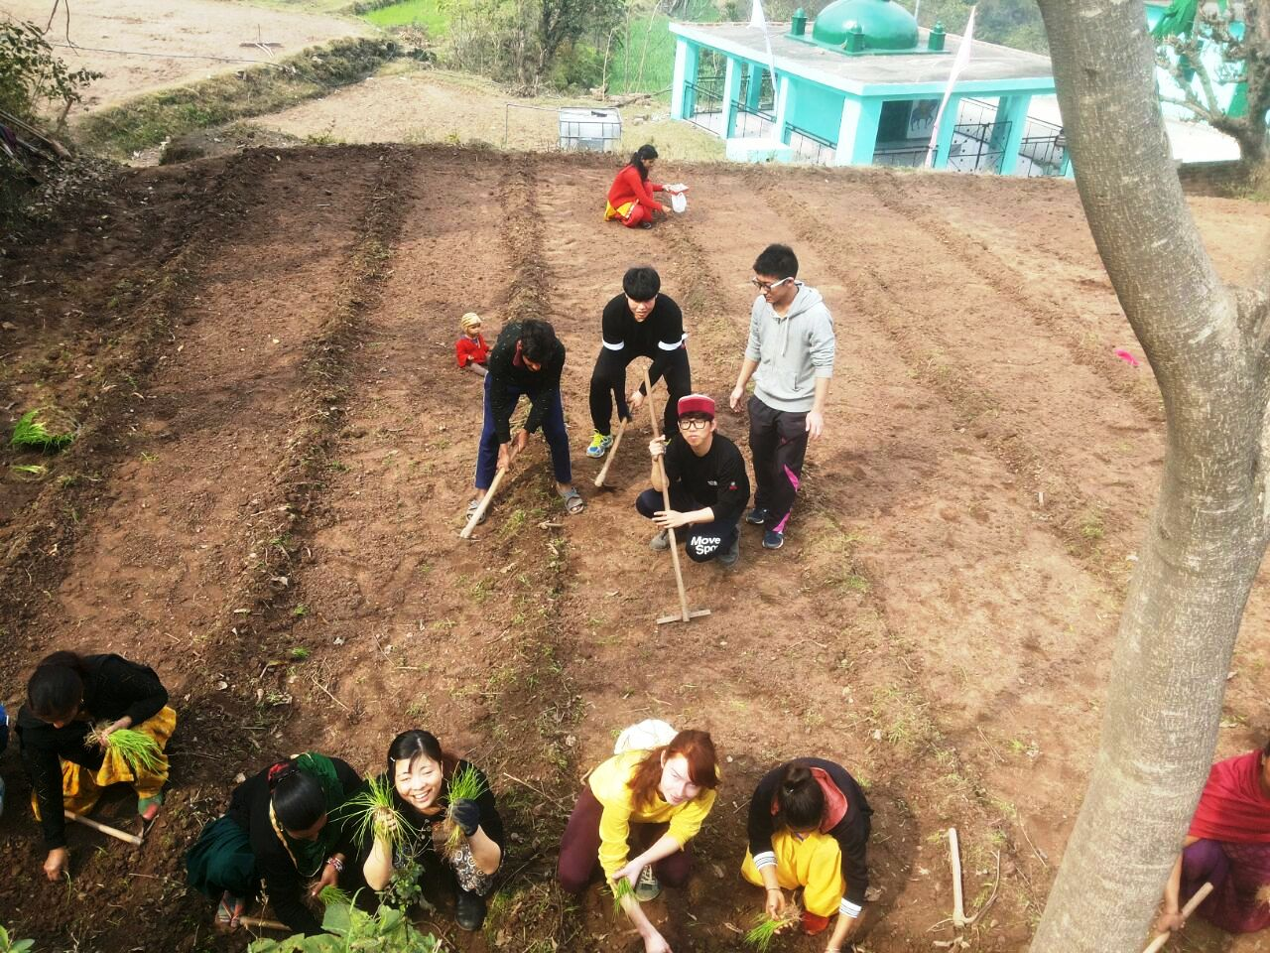

 RUCHI

Rural Centre for Human Interests

Village- Bandh, Bhaguri – 173233

District- Solan, Himachal Pradesh, INDIA

Tel: 91- 8679078500

Email: *info@ruchi.org.in*

Website: [*www.ruchi.org.in*](http://www.ruchi.org.in)

Registered as a society at village Shalana, Rajgarh 173101, Distt. Sirmour, Himachal Pradesh

Contents

1. About the Organisation

1.1. Background…………………………………………………………………………… 3

1.2. Mission Statement …………………………....................................................... 4

1.3. Vision …………………………….…………………………………………… ……. 4

1.4. Belief System 4

1.5 Strategic Objectives 4

**2. Management and Administration**

2.1. Structure 5

2.2. Finance and Accounts 5

3. Projects

3.1. Baddi Integrated Development Water, Health and Agriculture ………..…. 6

3.2. Fight against a Liquor Vend ………………………….………………….……...........7

3.3. CHARGER Project .......... ………….…..:……………………….…………………... .7

3.4. Volun-Tour Project …………………..………………………………….…..………. 8

4 . International Voluntary Service

4.1. International Volunteer Workcamps  8

4.1.1 Raising Peace Campaign………………………………………….……….….8

4.2. Student Placements ……………………………………………………………....... 9

5. Seminars/Conference ……………………………………………………………….… 9

5.1 [Workshop on Water Resource Management …………….…….………………..](#_Toc202241744) 9

5.2. Human Rights Week Celebration ………………….…….…….…………….……..9

5.3. CCIVS GC & GA ... ……………………………………….…………….………...... 9

5.4. Heritage Conference under PATH……………………….……….…..…………… 9

**5.5 Technical Meeting…………………………………………………………………………………………………..………..10**

**6. Audited statement of accounts** …………………………………………….… ..... 12

1. About the Organization

**1. Background**

The Rural Centre for Human Interests (popularly known as RUCHI) has incessantly worked towards uplifting the living conditions of the underprivileged section in selected regions of Himachal Pradesh, India. RUCHI through active grassroots participation and empowerment of the communities in all aspects of their development strives to minimize their dependence on external agencies. RUCHI’s focus on promoting **sustainable anthropocentric development through environmentally, socially and economically integrated activities** ensures the improvement and sustainability of rural communities and their environment.

RUCHI began as a non-profit, voluntary organization in October 1980, set up in the Himalayan foothills of the state of Himachal Pradesh. It was registered as a Society on 16 February 1983 under the Societies Registration Act, 1860.

A new Technology Resource Centre of RUCHI came up in 1994 in a small village of Bandh in Dharampur Block of Solan District which also houses the headquarters of RUCHI. This great achievement was made possible through the Council for Advancement of People’s Action and Rural Technology (CAPART), under the aegis of the Ministry of Rural Development, Government of India.

From the onset, RUCHI realized the importance of providing assistance and technical support to facilitate and aid the process of development by encouraging individual and community participation in the process. Accepting and overcoming the various challenges is the key to RUCHI’s successful progress which today looks back on its past achievements with pride and at the one ahead with hope.

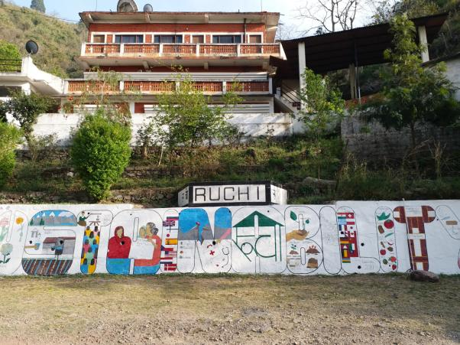

Thirty three years on, the organization is continuing with its commitment to instill an ambience of improved quality of life, a new scenario of social and economic progress and minimal dependence on others on the part of the communities. RUCHI has remained successful in achieving this only through an integrated, multi-disciplinary and participatory sustainable development.

**1.1. Mission Statement**

***RUCHI’s Mission Statement:* Integrated rural development through people-centered, environmentally sustainable action.**

With this in mind (and a view towards social and economic independence), RUCHI introduces technologies deemed appropriate to the conditions, and uses health and resource management education to socially empower and uplift rural communities.

**1.2. Vision**

**A society which is armed with information and knowledge to achieve comfortable living standards; which believe in good governance, equality and respect for each other.**

**1.3. Belief System**

* People have an inherent capacity to achieve - even in the face of adverse conditions - provided they are given with help and guidance.
* Resources, goods, information and technology should be shared amongst and between communities.
* People should be empowered to demand services by virtue of being human and as a basic human right.
* Women play an important catalytic role in development.
* Both development and management should be participatory.
* Social change can occur through economic stability and independence.
* Economic stability and independence can be achieved though optimal and *sustainable* use of local resources.

**1.4. Strategic Objectives**

1. Promote and protect the environment and natural resources, through adoption of appropriate resource management techniques, generally focused at the micro-level of watersheds.
2. Promote education and awareness as a tool to improve the plight of the underprivileged rural poor.
3. Ensure that a participatory approach is used in the conservation and promotion of natural resources.
4. Catalyze the transfer of low-cost agricultural and construction technologies which will aid in environmental protection and community development.
5. Empower women and eradicate gender inequality, namely through micro-credit and self-help groups.
6. Extend our services to the vulnerable section of elderly, and promote independence amongst this section.
7. Develop areas of mutual cooperation amongst Government agencies and NGOs.
8. Improve the community health standard, mainly through preventative measures.
9. Foster an understanding of, and focus on, integrated rural development in the young rural workforce, promoted through non-formal education.

2. Management and Administration

**2.1. Structure**

RUCHI’s daily activities are administered by an executive director. Over and above this, the management of RUCHI rests with the Governing Body, comprised of six members, each of whom is elected for a two-year term.

RUCHI lays great emphasis on ‘people’s power’. The consequence can be noticed in the environment of team spirit, collective experience, hard work and commitment in which and on the basis of which the whole organization runs. Very essentially this is manifested through the 17 full-time staff who proficiently strives to achieve the objectives mentioned above. Now, more than ever before, RUCHI has long- and short-term volunteers participating in the project activities injecting fresh ideas and knowledge into the strong RUCHI team.

**2.2. Finance and Accounts**

The details are outlined in Annexure 1 of the audited statement of accounts.

**Besides project based funding in terms of grants-in-aid, RUCHI generates income from the following sources:**

* Consultation fees.
* Infrastructure usage charges.
* Agricultural activities.
* Public contribution/donations

**At present, RUCHI is receiving funds from the following international funding bodies:**

* RNZWCS-NZAID New Zealand
* Rotary Clubs of New Zealand.
* Lionex GmbH, Germany

**RUCHI’s Indian sources of funding include:**

* Shamdasani Trust

3. Projects 2016-2017

**3.1: Baddi Integrated Development Water, Health and Agriculture.**

In March 2015, RUCHI embarked on this ambitious project with a holistic approach with a focus on improving quality of lives of communities through their overall empowerment, improved farming, health care and environmental sanitation. The project is financially supported by RNZWCS under a New Zealand aid programme.

Land and Water are the two precious resources for farmers for their survival. The scarcity of water for irrigation and drinking is mainly responsible for their low farm production and poor living conditions. Increasing accessibility to water resource to bring more farm land under irrigation is one of the important objectives of the project.

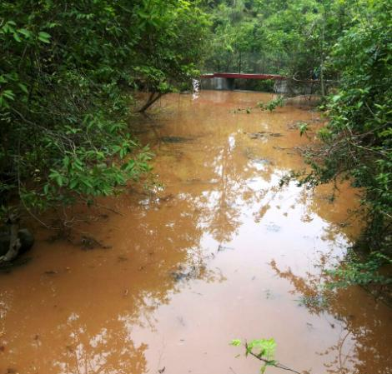

The project deliverables focusing on water development interventions include construction of irrigation tanks, small water storage tanks, percolation tanks and check dams. During the year, 2 check dams, 1 irrigation tank, 5 natural springs and 16 individual water storage tanks of 2500 litre capacity are constructed. The purpose has been to provide safe drinking water to maximum inhabitants. The rejuvenated water bodies now provide water for extended periods.

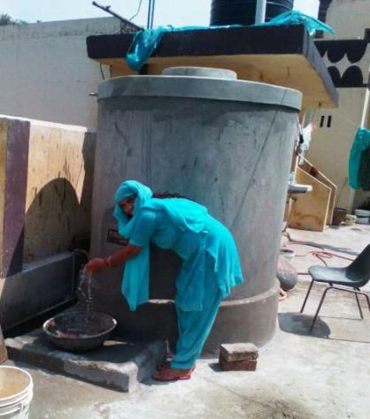

Compared to the previous year figures, there is a marginal increase in farm production of wheat and maize crops and few other vegetables. This can be related to creation of additional irrigation sources and awareness on cash values of the crops and vegetables.

75% of people from villages and slums confirmed that they have better knowledge of known diseases including TB and diabetes. They also informed that educational camps and village level meetings provided them knowledge on health issues, common diseases and their preventions.

All the 23 SHGs formed under the project are involved in saving and inter-loaning among their own members. The activity is running very well with 100% loan returns. The decision to decide purpose, interest rates, paying back period and other terms and conditions completely depends on respective SHGs. The profits are equally shared among members. That is the reason that even the loans approved for consumptions purposes are returned on time. The community educators and SHGs managed by them are quite instrumental in making the project a success

**3.2: Fight against Liquor Vend:**

Last year, the women of Kendol vilage with the support of adjoining 15 other SHGs had kaunched a campaign for shifting of the Liquor vend from their village as it was serving liquors to children below 18 years and causing security issues for the village women. They succeeded in shifting it to another place 3 kms from the village. However, they did not relax with that action and finally succeeded by lobbying with the state government to take a decision that the license of this vend be cancelled and no new license for a new shop in the area be granted to operate from 1st April, 2017.

**3.3 : CHARGER –Fighting Youth Employment by Developing Employability Skills**

**under Erasmus+ Programme of EU:**

This project aims to improve the competences of the youth workers and develop the tools in the area of the employability skills, and finally work on the improvement of the employability skills of young people – NEETS from 6 participating countries.

There will be three main activities –

1. The international training course for young staff trainers and youth workers that will focus on enabling them to work on the development of the employability skills of young people, how to work with NEETs, how to create the educational programme in the framework of NFE etc. The participants of this training will be supporting the phase of the local workshops.

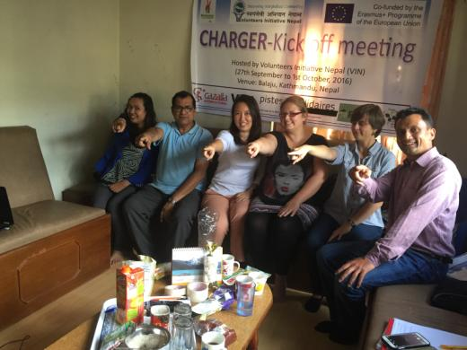

1. The second stage is the prearation of the video tutorials.

3. The third stage is the implementation at the local level, that will aim to empower young people and develop their employability skills. The target of those trainings will be youth, mainly NEETs and young people with fewer opportunities.

The kick off meeting for the project took place in Nepal during 26th September- 2nd October, 2016.

5 international volunteers have also joined RUCHI for six months under the project to work on different projects and one volunteer from RUCHI has gone to one of our partner in Poland for five months as a part of their mobility.

**3.4: Volun-tour Project under Erasmus+ programme of EU:**

The main objective of this project is to develop a new format of international mobilities for young people, fully organized and implemented by NGOs. These mobilities will be defined from now on as “volun-tours”: a mixture of cultural awareness tours and change-making actions organized by NGOs working on the field, with the purpose to offer quality-learning experience to international volunteers through the encounter and interaction with local communities, and to inspire active participation and advocacy in the communities according to a different topic for each country.

By valuing the know-how of the partners involved, the aim of the project is to develop the organisations’

competences to create a new and sustainable entrepreneurial concept arising from non-formal education principles and to promote particular volunteering experiences with common quality standards and changemaking goals.

The goal of “VolunTour” project is to empower local and international NGOs in the management of “volunt-tourists” groups, following an educational path and offering the chance to develop an economically sustainable model to impact local societies through responsible volunteerism.

EVS volunteers in Asia will learn how to develop this aspect through web communication, while European EVS volunteers in Asia will design together with Asian organizations the "volun-tours" journeys. During the study visit of European youth workers in Asia, the tour will be tested with a first group of foreigners participating.

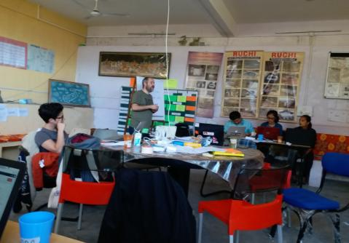Study visits in Europe will involve Asian NGO workers to experience youth mobility, non-formal education projects and change makers’ activities before a final meeting for the production and dissemination of the intellectual output.

The Kick off meeting for the project took place in Nepal during 4-11 November 2016 followed by VolunTour Managers training in Hungary (17-25 February 2017) and the Web Communication Managers’ training at RUCHI, India (21-28 March 2017).

4. International Voluntary Services:

**4.1. International Voluntary Workcamps:**

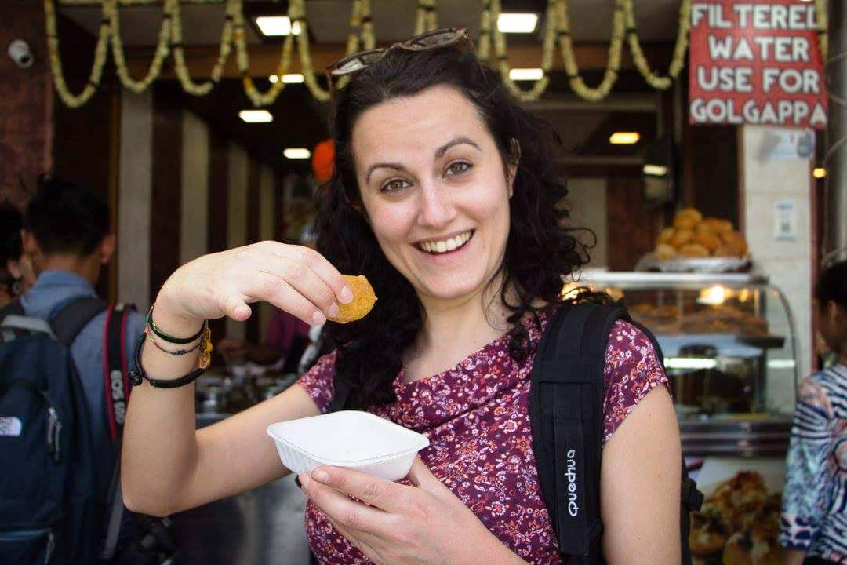RUCHI has been supporting both national and international students for internships as this promotes sharing available information and resources. RUCHI has already joined hands with international networks like CCIVS, NVDA and European alliance and their sub-networks. The volunteers placed through the network members help initiate inter cultural exchange, exposures/experience in community development at grass root level besides academic pursuits.

International volunteers find visiting RUCHI a learning experience. They come on study visit for a short or a long term basis to learn, exchange ideas & perspectives between RUCHI’s staff and other participants and the communities they work with. Their small donations also help the organization to cover its administrative expenses and become independent of agency funding. Depending on funds generated small projects are also taken up with this fund. 63 volunteers visited RUCHI projects in Himachal Pradesh and Rajasthan during the year 2015.

**4.1.1** RUCHI also participated in **Raising Peace Campaign** organized globally by CCIVS. As part of campaign we organized a two weeks voluntary project from 08/08 to 21/08/2016 at Dharamshala with focus on creating cultural awareness, increasing cultural sensitivity, and conducting repair/renovation activity of public infrastructure.

**4.2. Student Placements**

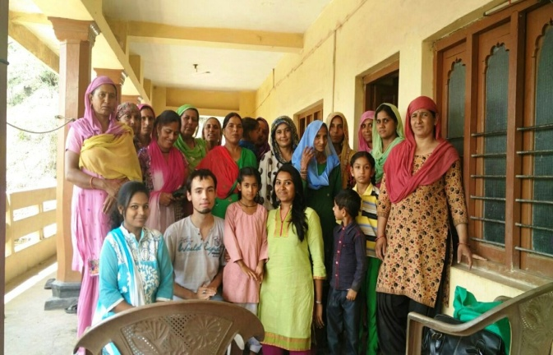Students from various national universities doing their graduation and post-graduation in various disciplines also join RUCHI projects as interns during their university breaks. This extends opportunities to gain first hand knowledge at grass roots level and develop an insight in the practical problems of the rural communities. This broadens their horizons and develops a positive attitude for initiating more innovative humanitarian projects for communities’ sustainable development.

Like the previous years, this year too, 15 PG students of IRMA, Anand (Gujrat), visited RUCHI for two months during October-November 2016 to complete their field work segment placement. They were placed in 5 villages in groups of 3 each. This was meant for their exposure and orientation at grass roots level issues. 2 students from CU Ajmer, 2 from Gujrat and 3 Gandhi Fellow from Udaipur also completed their internship at RUCHI.

5. Seminars/Conferences

**5.1 Workshop on Water Resource Management:**

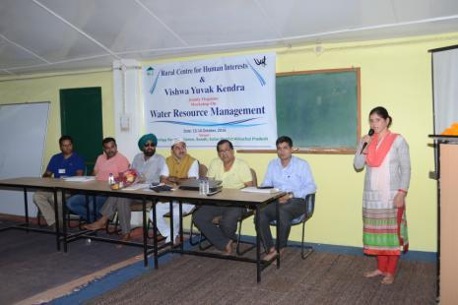

The workshop was organized at RUCHI on 13-14 October, 2016. It was sponsored by Vishwa Yuvak Kendra, New Delhi. 114 participants of NGOs, CBOs, SHGs, Panchayats, Block Samiti members and ordinary citizens participated in the Workshop. Workshop was inaugurated by Shri Ram Kumar Chaudhary, MLA Doon Constituency. Deliberations were made on changing weather, climate change, depleting water sources and the need to save and conserve every drop of water for survival of mankind.

* 1. **Human Rights Week:** RUCHI participated in celebration of International Human Rights Week

During 16-23 October 2016. Two day workshop was organized on 19 – 20/10/2016 at Jharmajri slum to mark the celebration. During the event we reached more than 80 kids and 35 young mothers where we motivated kids to join formal education and provided information to mothers about child nutrition, health, hygiene and sex education.

**5.3** **CCIVS GC and GA** was organized at Bouznika, Morocco and was participated by RUCHI representative from 21/11 – 28/11/2016. During the event Executive committee elections were held, new partnerships with other youth NGO’s were established, previously initiated project were evaluated and future vision for next two years was shared.

**5.4 PATH (Partnership Action, and Tools of Heritage):** RUCHI also joined a Heritage preservation and promotional project coordinated by CCIVS. The project aims to preserve and promote regional and national heritage along with developing capacities of youth leaders to successfully implement actions at local level. A stakeholders forum was organized in Paris from 6-11 Feb 2016. As part of this initiative we are promoting Mountain people culture.

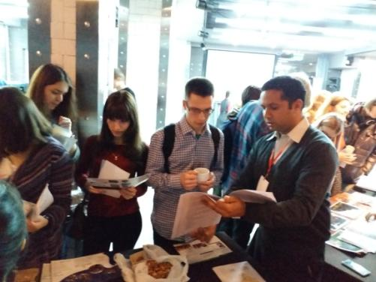**5.5 Technical Meeting:** Two of RUCHI staff attended the Technical Meeting of European Alliance, a European network of NGOs involved in international voluntary services, held in Nizhny Novgorod, Russian Federation during 1-8 March 2017**.**

This is a very important platform of European Alliance to promote community development projects through international volunteers. More than 100 NGOs from all over the world meet during this TM.

This opportunity was also used to participate in CCIVS Day. CCIVS, based in Paris, is the largest network of NGOs promoting IVS. RUCHI is a full member of CCIVS network.