

Profile
Address:
Sanghar Office:
Post Office Kurkali via Jhol
District Sanghar, Sindh
Mobile: 0300 – 3093616
Email: info.induswelfare@gmail.com
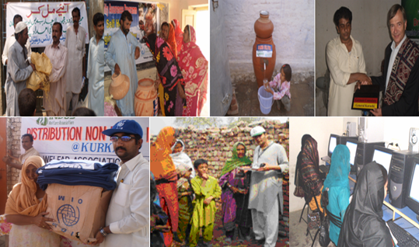
Indus Welfare Association
PROFORMA

Name: Indus Welfare Association

Acronym: IWA

Address: Post Office Kurkali via Jhol, District Sanghar,
Sindh, Pakistán.

Telephone: (92)0300 – 3093616

Website N.A

Email: info.induswelfare@gmail.com

Established In: January 15, 2001.

Registered In: November 5, 2002.

Legal Status: Indus Welfare Association is registered under the Voluntary Social Welfare Agencies (Registration and Control) Ordinance 1961 (XLVI).

Staffing: 25

INTRODUCTION:
Indus Welfare Association(IWA) is a not for profit organization which is registered under Social Voluntary 1961act came into being on January 15, 2001 with a virtual vision to see upcoming a gender ally equal, socio-economical and politically aware community with sound health and literacy.
Indus Welfare Association (IWA) believes in participatory approaches amongst Govt. and all other stakeholders to bring social changes through developments at grass root level by check and balance.
Indus Welfare Association (IWA) works for cultural activities by encouraging people to exchange their cultural skills and heritage amongst them to keep them alive.
The Organization gives Community a major role to play in achieving sustainable development in the protection of Environment and stability in economical conditions by sustain ably managing their natural resources.
The guiding principle remains bottom-up planning for managing all development programs so as to empower community at the grassroots level by involving them in decision-making process. This strategy is not only bearing fruit in terms of direct benefits for the people in improving their socio-economic conditions, but also encouraging their participation in the vital mechanism of community emancipation through participation in self governance.
.
VISION:
To see socio-economically self sustain, politically and culturally enriched and well acquainted literate and healthy rural communities involved in NRM based practices and approaches being friends of environment
MISSION:
Indus Welfare Association (IWA) is committed and devoted in contributing its vision through diverse interventions based on rural context by providing them equal choices and opportunities to both genders so that they can be led towards the road of development

OBJECTIVES OF THE ORGANIZATION:
- Provide quality education and literacy education through formal and non formal schools and work for youth empowerment
- Provide health facilities and health education to most disadvantaged communities
- Reduce poverty through natural resources and small enterprises being friends of environment
- Women empowerment through Advocacy and awareness programs
- To support the human aims expressed in the United Nations Declaration on Human Rights.

ORGANIZATIONAL STRUCTURE:

Executive Body
Executive Officer
Program Manager
Monitoring Officer
Finance officer
Program Officer
Field Officer
Officer Assistant

DEVELOPMENT STRATEGIES:

- Continuous and sustainable motivation campaigns.
- Need assessments through surveys/ workshops.
- Capacity Building of the activists through door step and in-house training programs.
- Establishing community based networks focusing explicit issues.
- Implementation of multi sartorial development approaches for the augmentation of social services and economic growth.

INDUS WELFARE ASSOCIATION’S CURRENT CORE VALUES:
Indus Welfare Association in all its activities will adopt, open and effective communication based on equity of opportunities. Its inspiring principles of action are:
- Strong local ownerships.
- Partnership to overcome capacity constraints.
OUR BASIC VALUES
- Indus Welfare Association respects the rights, culture and dignity of all people and stakeholders working with it.
- Indus Welfare Association believes in equality, irrespective of gender, caste, creed, beliefs, affiliation or political commitment.
- Indus Welfare Association gives top priority to the interests of the vulnerable groups, such as women, child and youth.
- Indus Welfare Association believes in participatory approaches in all work and interventions.
- Indus Welfare Association strongly opposes discrimination of any kind.

ACHIEVEMENTS AND PERFORMANCES

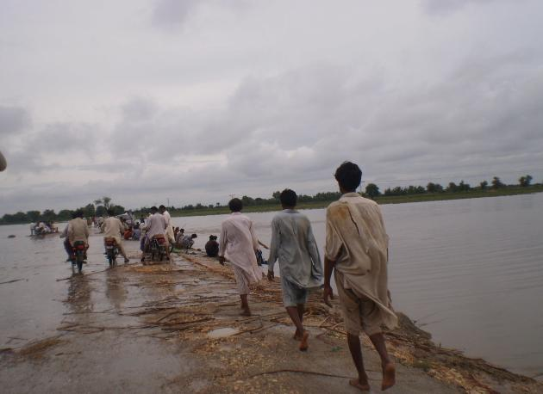
Flood 2011:
There was very critical situation at District Sanghar due to heavy rain. Especially rural areas are 90 percent affected. According to District Govt 1224 villages are underwater and more then 2 lakh 55 thousands homes of District Sanghar are destroyed. In Taluka Sanghar 95 thousands homes, in Taluka Singhoro 80 thousands homes and more then 75 thousands homes are totally destroyed in Taluka Shahdadpur. 65 thousands Acres agricultural land i.e. cotton, sugarcane, vegetables, onions have totally destroyed.. Their homes are under water, their crops have destroyed. Govt announced the district relives but there is still nothing for restoration of the affected peoples. 90% percent of the population is affected and 80% agriculture is underwater. Some village residents are trapped in the water; rain-affected people have taken refuge in higher places and street corners.

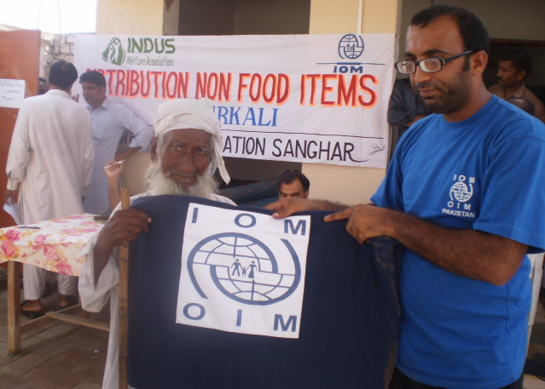
Flood Relief Activities by Indus Welfare Association:
Indus welfare association worked in the most vulnerable location of district Sanghar with the help of its donor partner "International Organization for Migration (IOM)". The project provided Non Food Items (NFI) to the flood victims of various villages in Sanghar.
Distribution:
- 1000 blankets distributed
- 500 kitchen distributed
- 1000 plastic sheeting distributed
- 500 ropes distributed
- 500 toolkits distributed
- 500 Jerry cans distributed
- 1000 sleeping mats distributed

Child Protection and Economic Empowerment of Adolescent
- Women and men community groups organized and strengthened to promote child rights in 50 villages (2 union councils).
- 1000 girls and boys (in equal numbers) develop life skills and actively contributing to child protection initiatives at community level.
- Civil society in the districts set up a child rights monitoring coalition, effectively monitoring child rights and responding to violations of child rights.
- A mechanism for identification, registration and tracking of working children established
- 160 women and adolescent girls and 580 adolescent boys complete vocational education in marketable skills.
- 290 families have an improved and more diverse source of income that is less reliant on cotton production

Adolescent Reproductive Health (ARH):
Adolescents and youth form the largest cohort of Pakistan’s population. Adolescence is defined as the stage in life which lies between childhood and adult life. Adolescence begins before puberty and goes on till the individual is a fully developed and mature adult. It is during this phase of life that individuals go through a host of physical, emotional and social changes. Due to the taboo nature of discussing puberty and related changes, adolescents in Pakistan are usually left in the dark to deal with these changes independently. Similarly, adolescence is the stage when individuals are beginning to shape their values and are extremely vulnerable to peer and external influences. It is crucial to inculcate positive values, provide adolescents with correct knowledge and support them in developing essential skills that will enable them to make better decisions about their lives.
IWA and Aahung develop the capacity of public and private school teachers to integrate quality life skills based education (LSBE) into the school curriculum. Teachers are equipped with accurate knowledge, and effective teaching methodology to be able to discuss ARH issues in the classroom.

Education
Education is the key to better living standards and leads the way-out of poverty. Indus Welfare Association has played a vital part in implementing, well designed interventions to yield desired results in the educational sector. Indus Welfare Association has worked directly with the targeted communities to ensure the relevancy and effectiveness of the educational programs by addressing the needs of the targeted beneficiary groups. All the interventions of Indus Welfare Association are aimed at providing sound educational facilitation to children of vulnerable communities, by providing a safe learning place by focusing on solid school construction, proper schooling facilities to children of outreach communities, encouraging girls technical education as well as primary and secondary levels. Indus Welfare Association facilitated inclusion of PWDs in the formal educational system, strengthening the SMC, holding adult literacy classes and conducting teachers’ training in rural and vulnerable areas of Sindh.
Activities
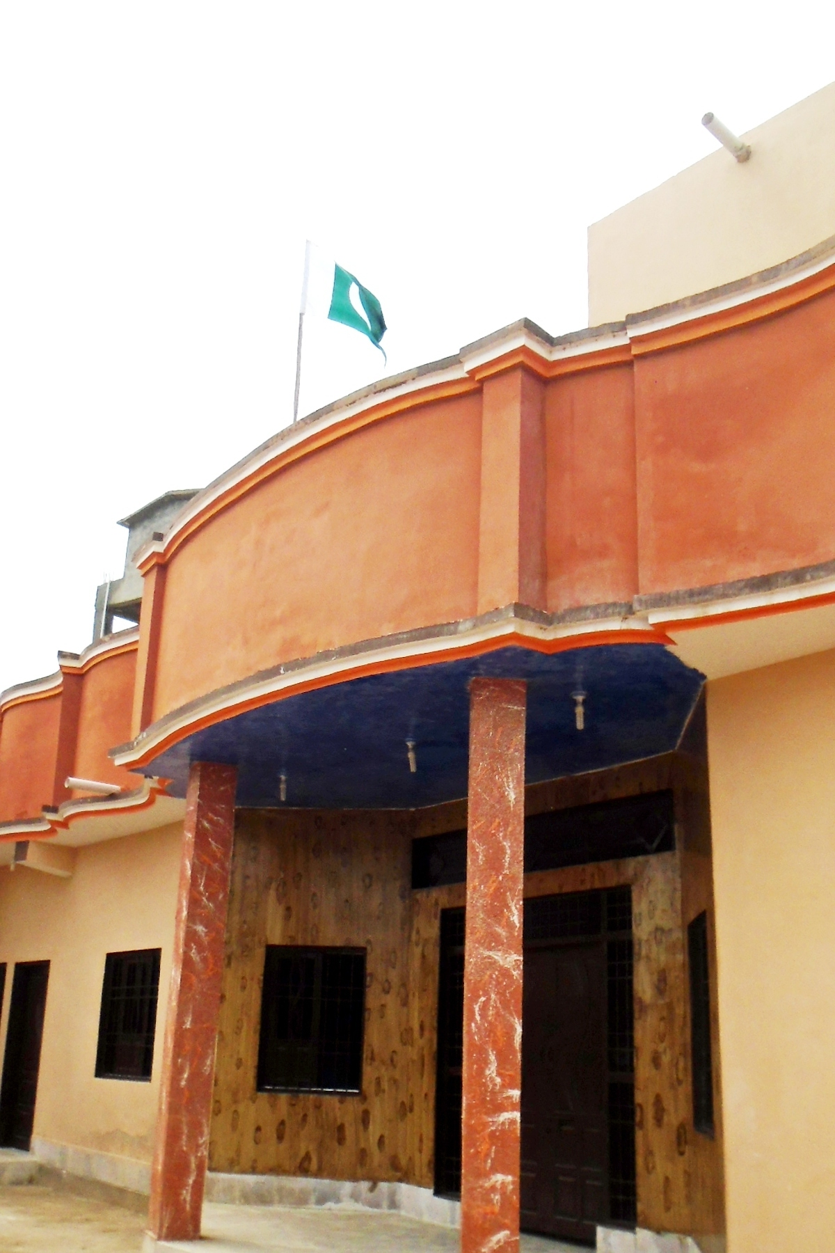
Establishment of Indus Educational Academy:
Kurkali is a Union Council of Sanghar, which is a far flung and less developed Union Council of District Sanghar. Union Council Kurkali has a population of 39,592, education facilities which are unable to cater Schools and Government Teachers are not performing at a satisfactory level. They hardly fulfill their responsibilities; the schools are never able to satisfy the educational needs of the area, and education facilities which are unable to cater to the need of local community.
Keeping in view the unbalanced of female education, a School was established in 2002, by Indus Welfare Association. The prime objective of the school is to provide a standard quality education to the student of rural area but also build the capacity of rural students to face the challenges of modern world and build up their career molded with the requirements of modern age. By doing so, they can compete with the students belonging to metropolitan cities in every walk of life. Present enrollment of student including both boys and girls exceeds 577, who are being benefited with the education staff which comprises 23 teachers, a vice principal and a principal which are running the school in a haphazard manner.

Establishment of 20 Adult Women Literacy Centres:
Indus Welfare Association has established an Adult Women Literacy Center at 10 U.C Kurkali and 10 U.C Manik Thaim. The Community voluntarily provided a one room space. 500 women and young girls have completed various courses.
Establishment of Indus Computer Centre:
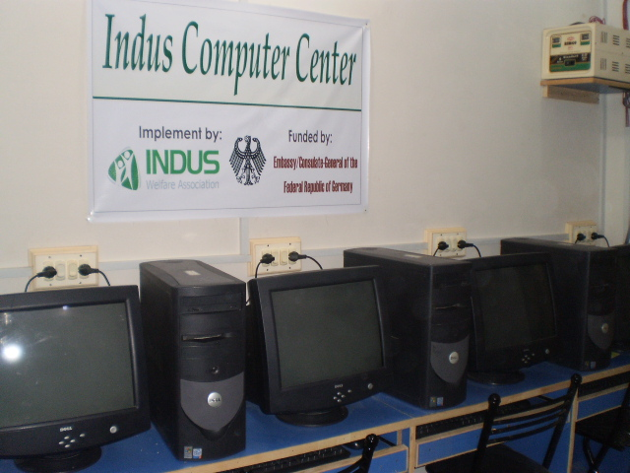
The project is to provide computer training facility for local females of the area, as there is no computer training center within 20 kilometre radius of UC Kurkuli. Through proposed computer training center IT Skills Certificate Course of (03) three month duration will be conducted (04) four times during one year. It is envisaged that a total of (80) eighty females will benefit from this computer certificate course by the end of first year of project.
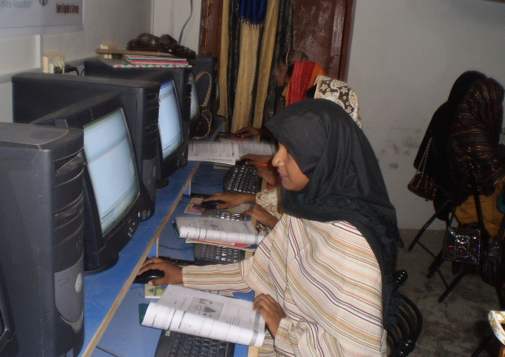
The Computer Training Center will also provide quality IT education to the students of Indus Educational Academy’s secondary class students. Indus Educational Academy is an educational project of Indus Welfare Organization serving local community since 2002.

Total Direct Beneficiaries
- 428 boys & girls
- 880 Youths
- 700 Girls and Women
District:
- Sanghar
Name of Partners
- SEF
- NCE/SSGC
- Consulate General of Germany, Karachi

Achievements
- Increased enrolment rate and improved the quality of education in rural schools
- Made girls education more accessible in the targeted areas
- Improved learning environment through infrastructural development of schools in Sanghar
- Inculcated “Inclusive Learning” in school curriculum
- Ensured friendly learning environment at the ICS and IAWLC’s
- Helped in providing better opportunities to young girls and women of the area for better working and living standards for themselves as well as their families

WASH
Water and environment sanitation is a challenging problems in Pakistan and it is estimated that around 1.5 million children under five years of age die of diarrhea every year around the world due to inadequate and unsafe water, poor sanitation and insufficient attention to hygiene behaviors According to an estimate water, sanitation and hygiene related diseases cost Pakistan’s economy about Rs112 billion per year, over Rs 300 million, a day in terms of health cost and lost earnings. Out of this the cost associated with diarrheal diseases alone is estimated around 55- 80 billon rupees per year. Poor sanitation and hygiene practices are also proving the barrier against tackling polio, as the virus has been found to be transmitted through feces of infected people then passed to others especially in situations of poor hygiene.
Activities
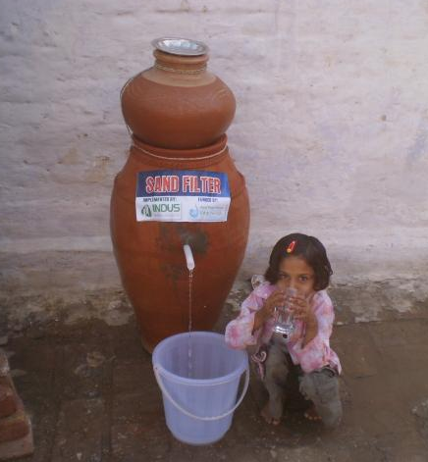
Self Help Biological Sand Filter
Indus Welfare Association the installation of bio-sand filters for 100 families in the area. These innovative filters are based on a simple concept: stable layers of sand can both remove sediments, as well as provide a surface for the growth of microbes that remove harmful bacteria from dirty water. The filters are constructed entirely with local materials, and require little technical expertise for use or maintenance.
The number of direct beneficiaries of your project
- 100 Household
- 743 direct beneficiaries

Achieved outcomes of your projects or activities:
- The rural communities have access to safe drinking water at house hold level
- The prevention from basic water borne diseases e.g. cholera, typhoid, dysentery, hepatitis, gastroenteritis, giardiasis, cryptosporidiosis and guinea worm infections mostly appeared from dirty and polluted water.
- Women and children health is being improved in 100 families and the ratio of the sick patients is decreased up to 50%.

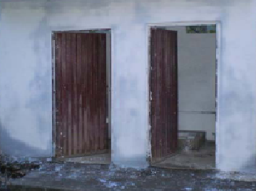
Improve the condition of Water, Sanitation and Hygiene Facilities in 10 Schools.
The project was reconstruct the WASH services in the government schools primary both girls and boys. The WASH interventions focused on reducing the incidences of water and sanitation related diseases by providing safe drinking water, sanitation and hygiene promotion initiatives in the respective 10 schools of UC Kurkali, District Sanghar

Number of direct beneficiaries of project:

1734 students and 26 teachers will be directly benefited this project and also benefited there families.

Impact of project

- Availability of toilets and safe drinking water in 10 schools and increase Health & Hygiene Condition
- Hygienic and clean environment in school.
- Reduced risk for diseases.
- Influencing out of school children.
- Increased enrolment of school

Health & Hygiene
Pakistan’s Maternal and Child Health indicators remain extremely poor every year as 25,000 to 30,000 women die from complications of pregnancy and child birth. Millions more suffer ill health and disability. One million children die before the age of 5 while 16,000 die in the first month after birth.

Activities
- Awareness on RH Problems and HIV/AIDS for youth and women
- Arranged Blood Grouping Camps
- 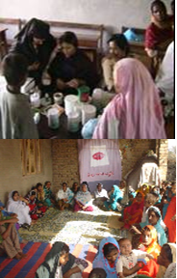Basic Health Care Awareness
- TACMIL Health Project

Country, Province and District
Nationwide
Name of Partners
- Aahung Karachi
- USAID/ Abt Associates
- Distt. Govt. Sanghar
Total Direct Beneficiaries
- 3540

Description
Indus Welfare Association launched these programs to motivate and educate the rural women on health & sanitation. In the first phase of its modus operandi, Indus Welfare Association launched an extensive motivational program in the target villages and conveyed knowledge and information about positive health. In the second phase a mobile team of skilled doctors were led door to door to provide free medical aid and assistance. Family planning was also one of the major components of this program.
Four awareness and consultation meetings were conducted for the youth. Youth Community Theater Group of Indus Welfare Association performed two theaters on RH and HIV/AIDS. 55 youths attended these theatres. 03 One day’s awareness workshops were conducted by Indus Welfare Association for women on Reproductive health and women health problems. Eighty four female and twenty nine male participants attended these workshops.
In 2004, Indus Welfare Association arranged a series of free blood grouping camps in the slum and low-income profile areas of Kurkali. Before starting the camps a small inauguration ceremony with the UC Nazim of the area was conducted. Altogether 491 people (201 women and 290 men) of the area formed a group and lists of people were compiled and handed over to the Committee of the local people to cope in emergency situations.
From 2005 to 2009, 20 health education sessions were arranged in U.C Kurkali on RH, HIV/AIDS personal health and hygiene, gynecology, balanced nutrition and sanitation. Altogether 1000 people (721 female and 279 male) attended these health sessions.

Project: TACMIL Health Project

Location: Sindh: Sukkur, Dadu, Sanghar, Thatta, Larkana, And Ghotki
Balochistan: Jafferabad,

Main Project Features: USAID/ Abt Associates in partnership with AASA Consulting and Indus Welfare Association implemented a two-year health systems strengthening project titled TACMIL in 07 districts of Pakistan. Of the four components, Component 2 was Targeted Health Information, under which AASA Consulting and Indus Welfare Association provided the expertise to carry out a ‘Star Campaign’ study. The purpose of this Campaign is to share comparative health data among districts in order to raise a healthy competition towards improvements. The competition was conceived as a process which encouraged district teams to put extra efforts to their routine program activities in order to improve their health services, and hence the health indicators to gauge the awareness level of MCH issues data was collected from 2000 household from 07 selected districted from all province

Activities:
- Baseline survey
- Awareness Programm MCH issues through Performed Teather Group
- Provide Safe Deliver Kit
Achievements
- Reduce MMR in the rural areas
- Improved women health status in the District
- Educated the rural community on health problems through health awareness sessions
- Overcame a large number of hygienic related health hazards

Community Physical Infrastructure
Activities:
- Construction of 25 community latrines
- Improving Pavements and Sanitation in villages
- Constriction of two Village Community Centers
District
- Sanghar
Total Direct Beneficiaries
1560
Name of Partners
- District Government
- AASA-USAID
- Safwco-PPAF
Description
Over the last five years the CPI section has been emerged as an important sector of the Indus Welfare Association. It has delivered positive impacts on society by instigating meaningful actions to support rural development in the targeted areas. The basic aim is to identify infrastructural problems/needs and mobilize local people in the solution of these problems within a community-based framework.

Achievements
Control the hygienic diseases and improve the living and health standards of the community targeted

Surveys and Third Party Validation Activities
- World Bank Rural Electrification
- Benazir Income Support Program (BISP)
- 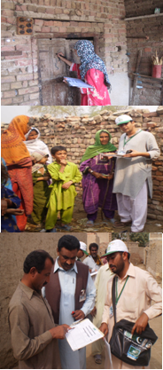PTCL Service Monitoring
- WES UNICEF
Name of Partners
- UNICEF
- The World Bank
- Benazir Income Support Program
- PTCL
- USAID

Description
Indus Welfare has, in partnership with a number of different organisations, conducted many different survey-based research projects. The information gathered in the course of these activities has facilitated better targeting of the funds invested in social development, with the support being directed at the people who need it the most. For example, the Pakistan Poverty Alleviation Fund (PPAF), sponsored by the Government of Pakistan and financed by the World Bank, international, bilateral and private sector donors awarded a contract to AASA Consulting Karachi’s partner Indus Welfare Association to collect data of 120,743 households in the Sanghar district in support of the Benazir Income Support Program (BISP) using the National Poverty Score Card (NPSC).
Third Party Validation - Water Environment and Sanitation (WES)
Our services were rendered for Third Party Validation assignment for UNICEF Water Environment and Sanitation. The scope included collection of baseline data on water and sanitation facilities in girls’ schools in five districts of Sindh. It comprised a sample size of 600 girls’ schools in the districts of Sanghar, MirpurKhas, Umerkot, Thatta and Khairpur. The qualitative aspect of this assignment included in-depth interviews with the government of Sindh

Activities Performed
- Interviews
- Focus group with TMA and SMC
- School Verification
Achievements
Proper and organised data base delivery.

Training Importance to the Workers of Indus Welfare Association
With the help of different NGOs we have made arrangement to impart basic training about the Environment, Livestock, community building and community development, Social forestry and family planning as follows:

- HIV AIDS and Sexual Health
- Livestock care and keeping training
- Tree plantation and Social forestry
- Gender and Development
- Teacher Training
- Effective communication
- Financial Management
- Enterprise Development
- Proposal writing
- Social Mobilization
- Gender and Development
- Teacher Training
- Leader Ship

Name of Partners
- Church World Service
- Aahung Karachi
- Pakistan Dairy Development Board Islamabad
- Institution Development Net work Hyderabad

Achievements
Training cause uplift in the standards and quality in different aspects and sphere of life

EXPEIRIENCE WITH DONORS
No | Year | Projects | Donor | Amount
1 | Ongoing 2011 | IELP,Support for Indus Educational Academy | SEF / Govt: of Sindh | 13,916,850
2 | 2011 | Improve the condition of Water, Sanitation and Hygiene Facilities in 10 Schools | Japan Water Forum Fund, Tokyo Japan | 114,842
3 | 2011 | Non Food Items (NFI) to the flood victims of various villages in Sanghar. | International Organization for Migration (IOM) | 320,0000
4 | 2010 | Self Help Biological Sand Filter | Japan Water Forum Fund, Tokyo Japan | 112,402
5 | 2010 | Indus Computer Center | Consulate-General of Germany, Karachi | 280,000
6 | 2009 | Benzir Income support Program Survey | AASA-PPAF/World Bank | 3,474,555
7 | 2009 | Construction Community Centre in village Muhammad Saeed Aain | Distt: Govt.Sanghar | 556,000
8 | 2009 | Construction one Community Centre in village Kurkali | Distt: Govt.Sanghar | 556,000
9 | 2008 | 20 Adulate women Education Literacy Centre | NCE,LPf/SSGC | 220,000
10 | 2007 | Construction 25 community latrine in 5 villages | Distt: Govt.Sanghar | 445,000
11 | 2005 | 2 Computers | Sindh Social Welfare Council | 30,000
12 | 2004 | Bricks pavements in village Khair Muhammad Brohi. Union Council Kurkali | AASA/USAID | 110,000
13 | 2004 | Bricks pavements and Sanitation in village Muhammad Saeed Aain, Union Council Kurkali | Safwco-PPAF | 266,139

PARTNER ORGANIZATIONS
- Sindh Education Foundation
- Japan Water Forum Fund, Tokyo Japan
- International Organization for Migration (IOM)
- Consulate-General of the Federal Republic of Germany, Karachi
- AASA Consultant
- Distt. Govt. Sanghar
- Church World Service
- Aahung Karachi
- Pakistan Dairy Development Board Islamabad
- Sindh Social Welfare Council
- Literate Pakistan Foundation
Indus Welfare Association is networked with
- Sanghar NGOs Conical
- United Nation Development Program Electoral Process
- Institution Development Net work Hyderabad

Indus Welfare Association Team:
- Mr. Tajammul Hussain, Executive Director :
He has acquired a Master degree in Sociology and Diploma Rural Development Communication. He has more than Ten years experience in project designing, execution, community development, field surveys and report writing.
- Mr. Rashid Hussain, Program Manager:
He has acquired a Master degree in Sociology. He has more than Ten years experience in project planning, designing, execution, social mobilization, community development and field surveys
- Mr.Fahad Arain, Monitoring Officer:
He has acquired a Master degree in Social Science, Graduate in Resource Development Program (RDP) from South Asia Partnership. Eight year experience Rural Development and social sector.
- Ms. Iffat Iqbal, Program Officer:
She has acquired a Master degree in Education He has worked Non Formal Female literacy, and Education Development.
- Mr. Ghulam Rasool, Program Officer:
He has acquired a Master degree in Education He has worked with several national organizations on variety of projects including Education Development.
- Mr. Aleem Akram Program Officer
He has Master in Economic. He has been working in the development sector for the last Five years and has been involved in project management at various levels
- Mr. Anwer Finance officer
He has acquired a Masters degree in Business Administration (MBA) in Finance and a Diploma in Information Technology. He is well experienced in the field of financial accounting procedures.
- Ms Tahira: is social Educational professional. He possesses experience of expensive field work, training in at grass root level.

Contact Details
Sanghar Office:
Post Office Kurkali via Jhol
District Sanghar, Sindh
Mobile: 0300 – 3093616
Email: info.induswelfare@gmail.com

