PROJECT PROPOSAL
FOR
PRIMARY SCHOOL CONSTRUCTION PROJECT

SUBMITTED
BY
AFCOD-Uganda

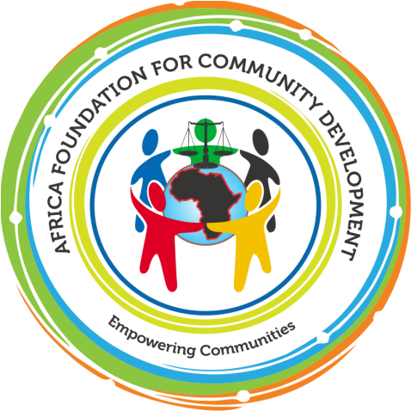

ORGNIZATION NAME: Africa Foundation for Community Development (AFCOD Uganda).
PROJECT TITLE: Primary School Construction Project.
CONTACT PERSON:  Mr. Blair Samuel Musasizi  Mailing Address:  P.O. Box 26780,  Kampala Uganda  +256752498535  Email:blair@afcoduganda.org  blairmusasizi@gmail.com  ORGANIZATION INFORMATION:  NAME: AFCOD-Uganda  Mailing Address:  P.O. Box 26780, Kampala Uganda  Tel:+256772789171  Email: info@afcoduganda.org  afcoduganda@gmail.com  Website:www.afcoduganda.org  LOCATION:  Iganga District in Eastern Uganda  DURATION:  12 Months  AMOUNT REQUESTED:  $ 9,650 US Dollars  FUNDING AGENCY: | NAME OF PROJECT CO-ORDINATOR:  Mr. Wakita Geofrey  Contact Information:  P.O. Box 26780,  Kampala Uganda.  Email: wakitageofrey@gmail.com  Wakita@afcoduganda.org  Tel: +256753927397
Bank Account Information:  9030011326753  Stanbic Bank City Branch Kampala Uganda | Year Founded:  2012
Legal Registration Number:  S.5914/11762  TIN:1009007732 | Annual Budget:  $ 50,000 US Dollars

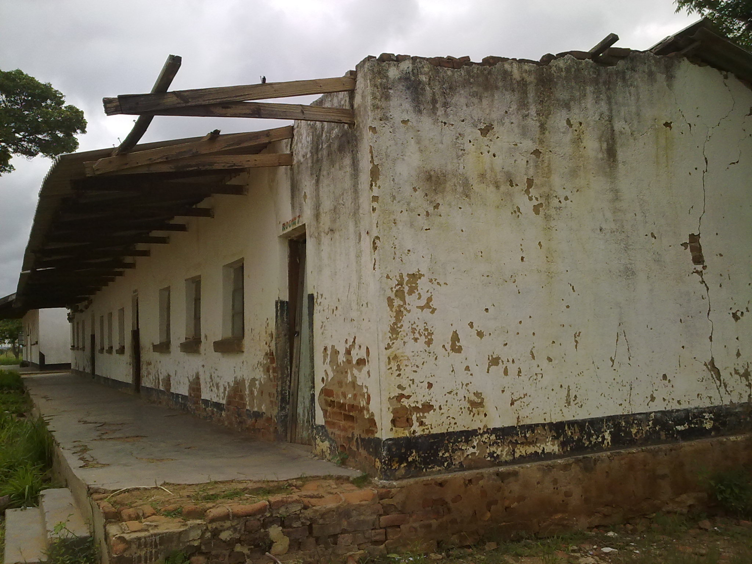
Photos of children attending class. The dilapidated block currently being used by pupils. Clear signs of old age and effects of storm damage are visible. The children urgently require safe learning environment and desire quality education.

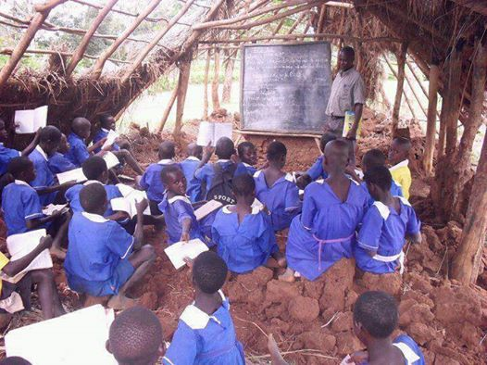

EXECUTIVE SUMMARY
The Education project is to assist the school in construction and rehabilitating infrastructure and learning materials. The main concern is the realization of sustainable development in which the children, teachers and the community are involved in positive activities that will ensure socio-economic welfare in the entire locality and ensure proper learning environment by providing habitable accommodation. It is also in a way assisting Government to attain the Sustainable Development Goal (SDGs) by providing ablution facilities at the school. The major target is to acquire peaceful co-existence and development in which everyone participate equally and effectively in problem and solution identification and where local communities, governments and other developmental bodies facilitate and carry out skills transfer to the younger generation who are not fortunate enough to be afforded or even to go to school. AFCOD-Uganda is an organization founded in 2012 to support innovative community initiatives that promote education, health and entrepreneurship especially among young people in the communities.
PROJECT BACKGROUND
AFCOD-Uganda succeeded to hold various successful meetings with the School Development Committees (SDCs), parents, community leaders, local government and NGOs to forge an understanding of our vision and goals. We made sure that there is community ownership of the project. There is need to involve everyone and have a buy in of the project. The local community and leadership have been very supportive and are doing their part by moulding bricks, providing other materials like river sand, stones and labour.
In order to realize its goals, AFCOD-Uganda has agreed to assist in mobilising resources to build four class rooms to replace the ones which were destroyed by a hail storm and heavy rains. The construction cost will require $ 9,650 US Dollars for labor costs and materials. The work has started although builders are working with the assumption that AFCOD-Uganda will eventually get funding from other development partners.
AFCOD-Uganda’s main objective is to create community capacity to provide education and health infrastructure, and with a particular outreach to the most vulnerable in communities. Since 2012, we have been supporting vulnerable communities and children living with HIV/IDS. Working collaboratively with schools in Iganga District, including at Muira primary school, through which it has a long standing collaboration with the community members and leaders.
THE RATIONALE
Developments do not come to these remote parts of Muira Village in Iganga district easily. As an example since 2014 when the school was destroyed by a storm, the school has been using dilapidated classrooms; the school enrolment has since gone down from 1000 students to about 200 currently. The major constraint for children and parents is that the most nearby primary schools are between the walking distances of 5 and 20 kms or 2 and 5 hours respectively. The school pass rate has been unsatisfactory due various reasons.

AFCOD-Uganda has taken the initiative to change this situation and is now approaching organizations in order to improve the conditions for children who are joining primary schools in the nearby villages.
The AFCOD-Uganda’s strategy is to construct a Block consisting four classes for the primary School in Muira for boys and girls respectively. Implementation will include construction, provision of teaching materials, such as text books for all subjects, and clean and safe drinking water and there will be two phases of the project.
In phase (1) of the project, AFCOD-Uganda will construct 4 classrooms which will have 4 doors and eight windows each and will be 27 metres long and six metres wide. The walls and the floor will be made from locally baked bricks; the doors and windows of metal and the roof of iron sheets. There will also be need to construct staff houses comprising of head master’s, her deputy and a staff rooms, six toilets and two staff houses. Once construction work is completed, classrooms will be fitted with chairs in phase two of the project to prepare the school to start operating learning and teaching activities in 2017. The classrooms will be used to teach the pupils in the morning and avoid hot sitting which inconveniences both school children and teachers. The AFCOD-Uganda mobilized parents and local community members to make bricks for the buildings and contribute other locally available materials towards this project.
PROBLEM STATEMENT
The school is located 110km from Kampala city and 15km from Iganga Town along Iganga-Kaliro highway. There is a good gravel road linking it to the main road, the problem is the economic problems bedevilling the community which has not been spared the scourge of the HIV/AIDS. There are orphans learning at the school and small percentage get assistance from the Universal Primary Education (UPE) an education program under the Ministry of Education and Sports (MES) but it is poorly funded and facilitated. UNICEF has been supporting 500,000 disadvantaged primary school pupils in Uganda for the past five years and indications are that it is pulling out thereby exposing the pupils .The community which is predominantly peasantry therefore, finds it extremely difficult to afford the school levy and materials per term. In essence, it means the little facilities provided cannot sustain capital projects as even Government is failing to give infrastructure grants due to liquidity problems in the economy.
THE OBJECTIVES
To construct one block for primary school for Muira Primary school in Iganga district in Busoga region in Eastern Uganda with a population of about 1,000 primary school going children to provide quality education in 12 months.
STRATEGIES OF IMPLEMENTATION
The project was proposed by a series of discussion with the leaders, parents, local communities and review of baseline data.
At the initial start of the school project, AFCOD-Uganda will construct 4- class rooms, 12- toilets, and staff houses, and also equip the school gradually with electricity, teaching materials, such as text books and the supply of water.

Phase 1

Construction of 4 classrooms has started but staff houses will start as soon as funds are availed. This will be followed by construction of storage tanks for rainwater collection. At the end of the project, the last act will be the buying of desks as Government has provided almost all the essential text books.

Phase 2

Installation of a 10,000 litres borehole water collection plastic tank is at an advanced stage and purchase of desks will be done to enable the school to start operating in the second budget of phase two of the project. The school will admit 2,000 students over four classes
AFCOD-Uganda has engaged the expertise of local builders and other labourers to carry out the actual work. The material donated by our development partners was delivered and is at the school, well secured. The technical staff will prepare all the necessary reports including the financial reports and submit them to the donors and partners as agreed upon.

After the project, AFCOD-Uganda will invite the donor representatives, government and community members to carry out their own independent evaluation after the completion of the project. Continuous monitoring of the project will be conducted by the AFCOD-Uganda technical staff and representatives from the funding agencies to ensure that the project achieves its goals and objectives as set out in this proposal.
EXPECTED RESULTS
Quality education for 1,000 students delivered through creation of students friendly
learning spaces:

- Improved standards of life among teaching staff at Muira primary School.
- Increased enrolments up to 2,000 students and enhancement of habitable classrooms.
Deliverable
AFCOD-Uganda will deliver both technical and financial reports each month to the funding agencies. This will include details of the class attendance by learners and teachers, lessons taught, materials purchased, challenges faced, achievements realized, money spent and the community support.
PROJECT BENEFICIARIES
The school facilities aim to give services to 1,000 primary school students from Muira and surrounding sub-counties such as; Namungalwe, Nawandala, Nabitende, Nambale and others.
MONITORING AND EVALUATION
A variety of formal and informal Monitoring and Evaluation mechanisms will be central to ensuring the appropriate delivery of effective and sustainable services. These will include: Multi Indicator Cluster Surveys, class performance surveys, class attendance data, girl-boy retention data and exit surveys.

PROJECT SUSTAINABILITY
AFCOD-Uganda will continue to work with the partners, donors, district local government and Ministry of education and sports on this capacity while also working closely with local NGOs working on education programs in the region. AFCOD-Uganda will develop a Memorandum of Understanding (MOU) with the Ministry of Education which will clarify each partners’ roles and responsibilities both short and long term. The Ministry of education will be encouraged to provide staff for the facilities, facilitate the UNICEF supported school supply and AFCOD-Uganda will invest heavily in staff training at all levels. In this way sustainable structures for primary school education delivery will be developed in Muira Village Iganga District in Eastern Uganda.
AFCOD-Uganda will work with local communities to develop the capacity of individuals to play an active role in governance and delivery of education in primary school. Parents Teachers Association (PTAs) will be formed to ensure the school’s future sustainability. AFCOD-Uganda’s annual sustainability assessment will be used to review the capacity of both local communities and school to take on further aspects of supporting the school after the donor phase. AFCOD-Uganda will also continue to provide its technical support and facilitation.
COLLABORATION
AFCOD-Uganda will collaborate and network with the local community, community leaders, Development partners and Government of Uganda.
COMMUNITY CONTRIBUTION
The local Community will contribute labour and local materials such as water and sand that will be used to construct the four classrooms and provide security for the materials.
CAPACITY TO IMPLEMENT THE PROJECT
AFCOD-Uganda has the required capacity necessary to design interventions and at the same time give impetus to the program’s management. The organization constantly plans before engaging in project activities and other interventions. It’s recognition by the local communities and School authorities have further placed us in a strategic footing to replicate ourselves in the affairs of the school. We have a policy of non interference in the school administration and our role is to assist where possible. AFCOD-Uganda has a rare unity of purpose amongst its members and the feeling of serving community schools bonds us further. This has in turn ensured solidarity and hence stability and community development. There is high potential that this achievement will be replicated in the community and Iganga district as a whole.
BUDGET PROPOSAL
Our budget proposal is 13,450 based on contributions and materials donated by our partners and cash donations from members and well-wishers. However, there is a budget deficit of $ 9,650 US Dollars which we need to cover. And AFCOD-Uganda has an existing bank account and details are available on request. With a system in place for efficient governance and financial accountability.

BUDGET

PROJECT TITLE: Primary School Construction Project.
ITEMS |  | Income
Donations |  | $ 1,950
Project levies |  | $ 800
Contributions |  | $ 1,050
Total |  | 3,800
 |  | Expenses
Building Materials
Bags of Cement |  | $ 1,500
Door Frames |  | $ 1,450
Window Frames |  | $ 1,200
Iron Sheets |  | $ 1,450
Roof Traces |  | $ 1,100
Paint |  | $ 1,500
Security |  | $ 450
Labour |  | $ 1,000
Total Cost |  | $ 9,650 US Dollars

CONCLUSION
AFCOD-Uganda will adopt the policy of corporate good governance throughout the implementation process of this project. This will ensure accountability and transparency in the management of resources allocated.

