Support an Athlete- Develop Football in Pakistan

Quarterly Report

Karachi United and Kiran Foundation

Karachi United and Kiran Foundation collaborated to provide players a unique opportunity: English language and football training. Through a total of 15 sessions, this program aimed to enhance their sports skills while also improving verbal communication, boosting confidence, and honing the life skills of Academy Players. The initiative empowered players to excel on the field and in personal growth by combining sports and language education, shaping well-rounded individuals with better communication abilities. Through this dynamic initiative, Karachi United and Kiran Foundation were not just fostering athletes; they were building well-rounded, empowered individuals ready to excel in all facets of life.

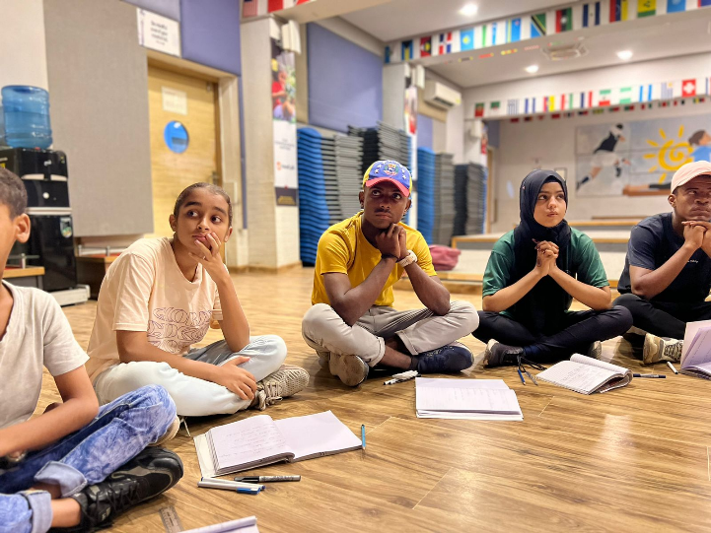

All Karachi SBB Yadgari Football Tournament 2023

Karachi United Academy Players participated in The All Karachi SBB Yadgari Football Tournament 2023 which featured 14 engaging sessions. These sessions focused on refining players' skills, fostering teamwork, and enhancing communication. As teams competed on the field, they also benefited from these special sessions, which left a lasting impact on all participants, making the event an unforgettable experience for everyone involved.

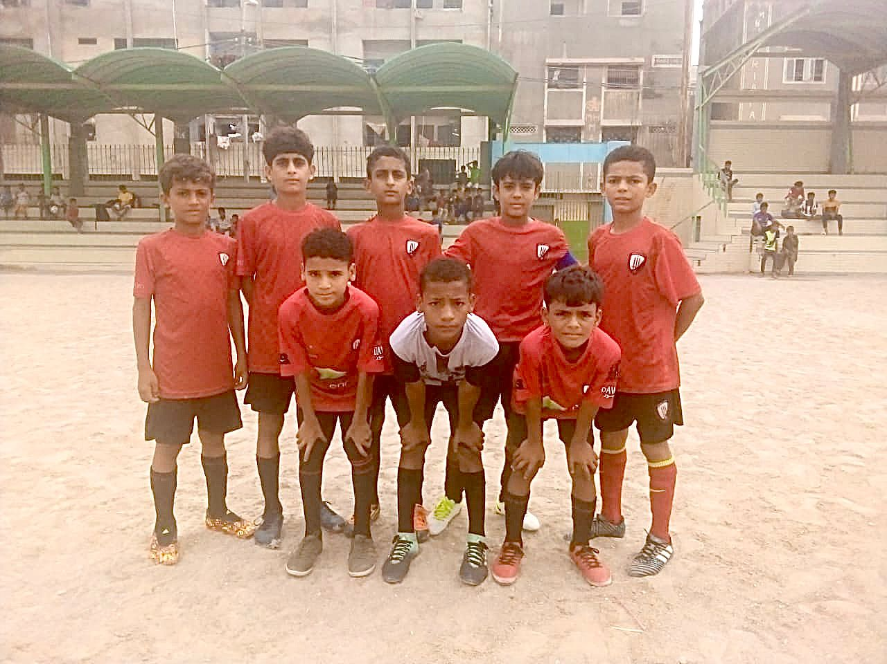

Annual Physical Test Day

The Karachi United Academy recently held its annual physical test day, assessing the
development of players through various data points such as sprint speed. Academy Participants ranged from the youngest born in 2013 to the eldest in 2007. Initial analysis indicates an interesting trend, with participants from Malir generally outperforming their counterparts from Lyari of the same age group. Further analysis will provide valuable insights into player growth and inform future training programs.

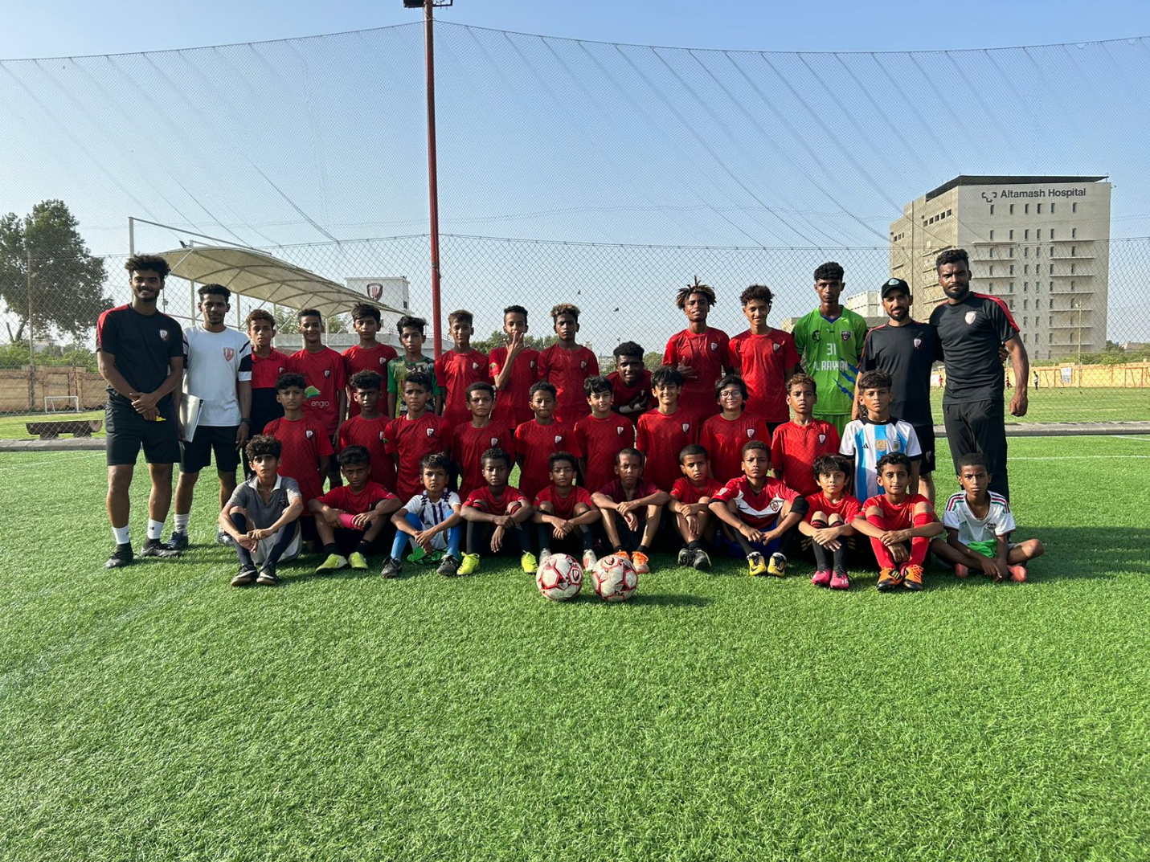

Karachi United and Life Skills Training Sessions

Karachi United actively offers its Academy players weekly sessions for football and life skill training. The football training aims to build the players' confidence and polish their untapped talent, preparing them for success in various football tournaments organized by local clubs, as well as domestic and international competitions. Meanwhile, the life skill sessions actively instill essential values in the players and motivate them to become exemplary human beings. These sessions also encourage them to face life's difficulties with confidence and determination, empowering them to excel both in sports and in life.

