Support an Athlete- Develop Football in Pakistan
Quarterly Report
Education Facility for young Footballer:

Young boys from the ages of 9-15, mainly from Lyari, are exceptional football players attending the Academy at KU. However, many of them do not attend formal schooling or if they do, are losing interest in their studies and have a high dropout rate. This would lead them to struggle in the long run. KU’s Board of Directors and their passionate mentors are extremely worried about the future of these boys and are in need of a solution to help with the future of these children.

KU approached Kiran Foundation to provide a holistic program inclusive of grooming, life skills and academic help for these footballers. KF and KU both came together and brainstormed the idea of “The Footballer’s School”. This school would run four days a week in the afternoon, with one day for mothers, enhancing the boys’ academic aptitude and skills by adopting KF’s holistic approach. KU will be identifying 40 footballers that are attending KU Academy, mainly from Lyari.

This group will be divided into two categories that will include the following classes and skills-building schedule:

- Life Skills Group: for those footballers going to school but lack grooming
  - Soft Skills that will include (1 hour)
    - Leadership Skills: public speaking, debating,
    - Personality Grooming: values; manners; hygiene; table manners; how to dress, walk, talk, greet; how to present oneself; conversational skills,
  - Spoken English/Spoken Urdu (30 minutes)
  - World vision that includes social studies, general knowledge (30 minutes)
  - Intellectual skills: technology skills, CV building for older students, how to research, reading and writing in both languages, and story writing for younger students (30 minutes)
  - Mindfulness sessions
- Fast Track Group: for those footballers not attending school at all and require more of an academic focus that will include English, Maths, Science, Urdu classes; alongside soft skills training
  - English, Maths, Science, Urdu classes (30 minutes)
  - We may facilitate Quran Nazra if needed.

There will be 2 ½ hours of classes a day, divided into four 30-minute classes, 3 days a week with a break. Life Skill and Fast Track Group classes will be happening concurrently. We will have more ambitious goals for younger footballers (age bracket 9-12), for instance, getting admission into mainstream schools. With the older age bracket (12-15), we will work on skills building and securing/supporting them into vocational centers. However, the groups will not necessarily be age-specific as some older children may be in the Fast-Track group if they have not gone through formal schooling.

The Footballers' School will take place during the afternoon, from 3-5.30 PM, at KF DCTO Campus. To ensure attendance, it will be mandatory to attend The Footballer’s school, if boys want to continue to train at the KU Academy. Selected footballers and their parents will attend an orientation at KF and learn about Dos and Don'ts on campus, the KF’s Behavioural Management System (BMS), and must follow KF’s Student Handbook.

It is important to have parent involvement. Hence, mothers will come in one day a week. We will adopt KF’s compassionate approach, the mother-child-teacher partnership triangle, by interviewing parents and children for the screening and selection process of this project, as well as having one day of classes for the footballers’ mothers. These classes may include Quran classes, fitness, skills development, positive parenting, and entrepreneurship to empower the mothers.

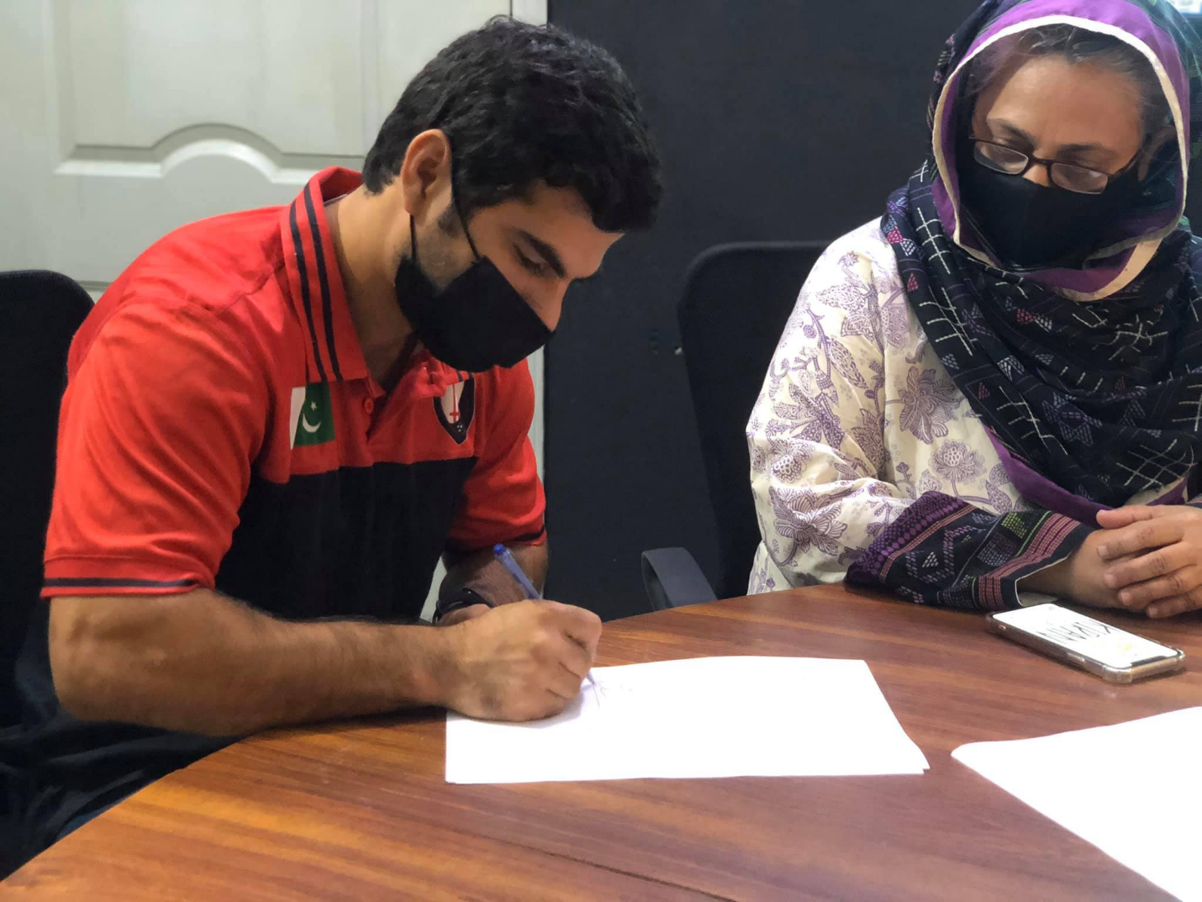
Figure 1 MoU is being signed between Karachi United and Kiran Foundation
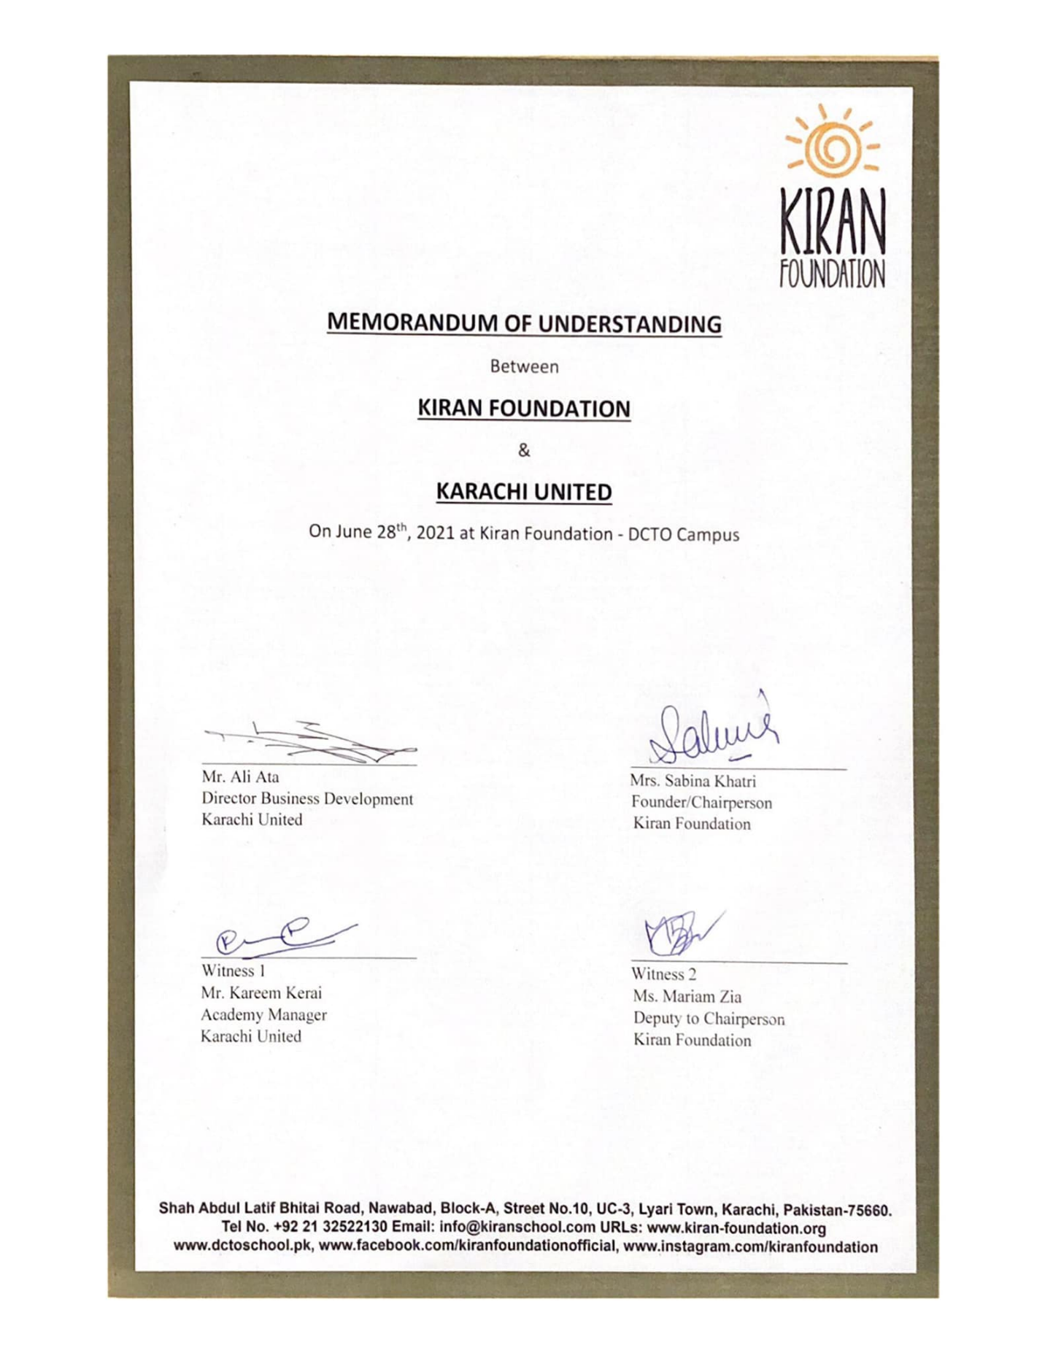
Figure 2 MoU between KU and Kiran Foundation

