Support an Athlete- Develop Football in Pakistan
Quarterly Report

Football and life skill Training Session:
Karachi United conducted weekly football and life skill sessions during the period. These sessions revolved around strengthening the motor skills, improving physical strength, and teaching leadership and team-building qualities amongst players belong to marginalized area, rarely get opportunities to line these essential skills at home and in their neighborhood.

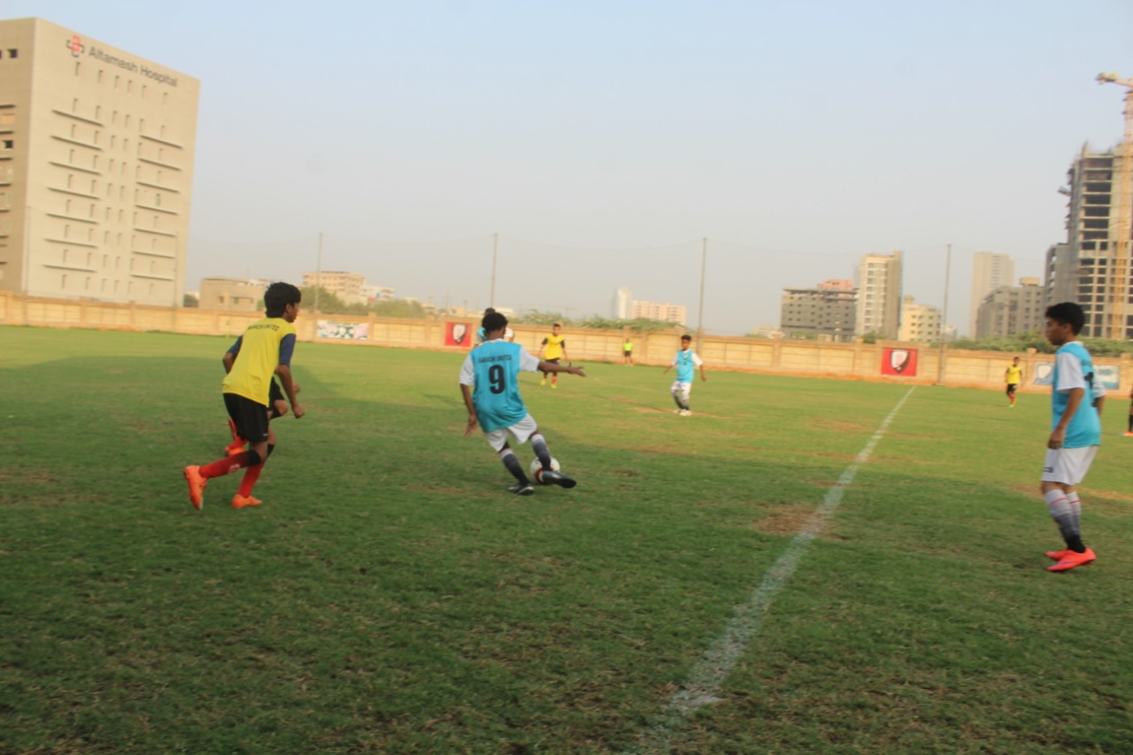
Figure 1 Football training session at Karachi United Stadium

Friendly Matches:
Karachi United and Kiran foundation are making collective efforts to educate the young players of KU Academy. In order to motivate the players, both organizations conducted a mixed friendly match together. Players got the chance to interact with the student of Kiran Foundation who belong to diverse background. These friendly matches also promoted the peace and harmony amongst the different communities. The friendly match was followed by an Awards ceremony for the outstanding Kiran Foundation students and their mentors.
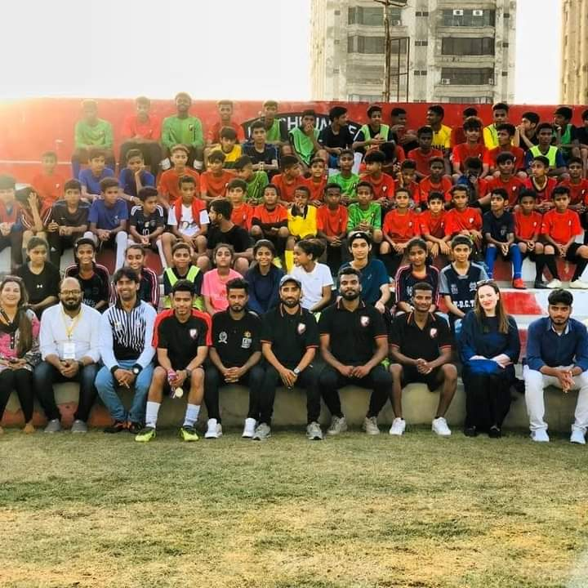

Figure 2 Participants and staff members of Kiran Foundation & KU pose for group photo at Karachi United Stadium

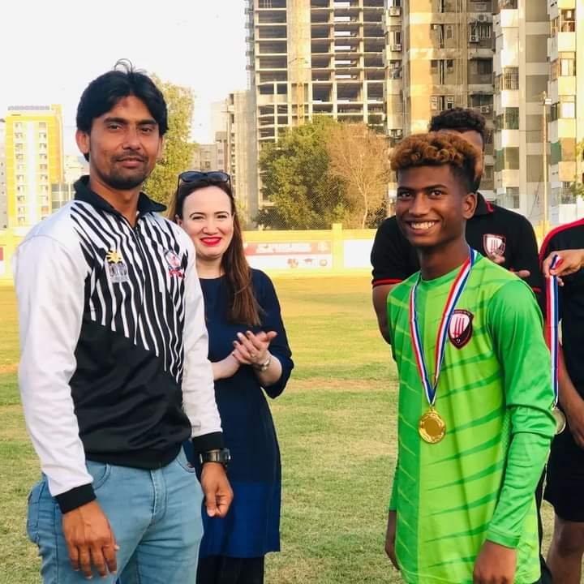
Figure 3 Medals are distributed amonsgt the players after the friendly match

Train The Trainer Program:

Karachi United conducted a two full-day coaching course titled ‘Train the Trainer (TTT) Program’ in March 2022. The TTT course is modeled on the training that KU has received from, inter alia, Liverpool FC, with the objective of raising the standard of football in Pakistan. After this course, coaches got the valuable knowledge of the coaching and now they are able to train the players better. We believe that one of the key ways to do so is through coaching education.
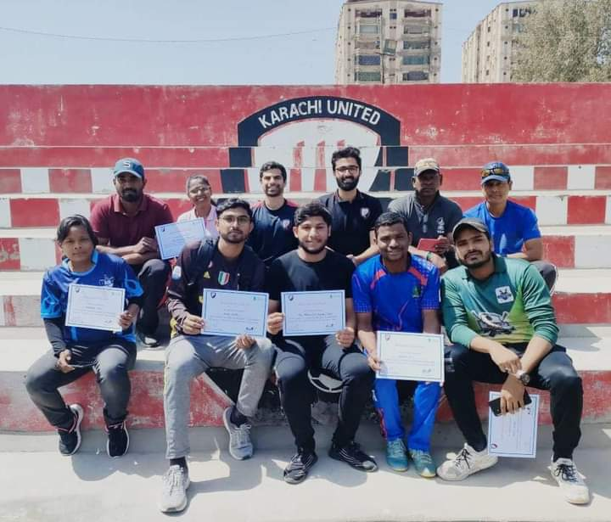
Figure 4 Coaches pose for group photo after receiving the certificate

