**Support an Athlete- Develop Football in Pakistan**

**Quarterly Report**

**Standard Chartered Karachi United Youth League 2021:**

Karachi United in collaboration with Standard Chartered Bank launched 4th Youth League on 19th, March 2021. With the remarkable success and very positive feedback Karachi United has been organizing this league in collaboration with Standard Chartered from the last three years. The opening ceremony of the league was held on 19th, March at Karachi United Stadium. This league provides a platform for Youth football teams from across the under-served areas of Karachi to come together, break barriers and inculcate the spirit of competition.This youth league offers an array of benefits but the benefits extends well beyond the field. They start learning to communicate with peers, can build strength and speed that will aid their overall physical development as they grow. It also encourages the young players to embrace the diversity. Karachi United has booked three football grounds for group matches and Karachi United is also providing the transportation facility to community center players. A total of 5 football matches have been played as of writing date of this report. Total of 62 teams are participating in this league and these teams were divided into following four categories:

|  |  |
| --- | --- |
| **Categories** | **Number of Teams** |
| Under-10 | 8 |
| Under-12 | 12 |
| Under-14 | 12 |
| Under-16 | 12 |
| Girls | 10 |
| School | 8 |

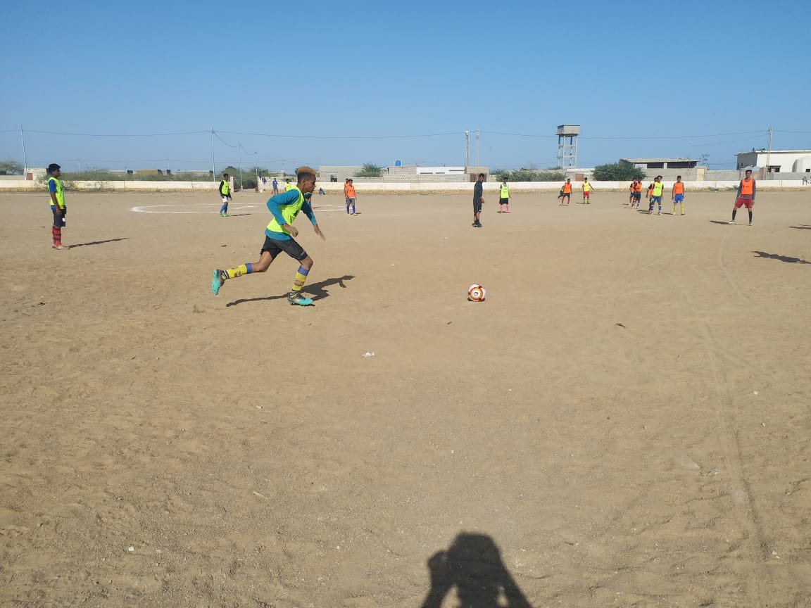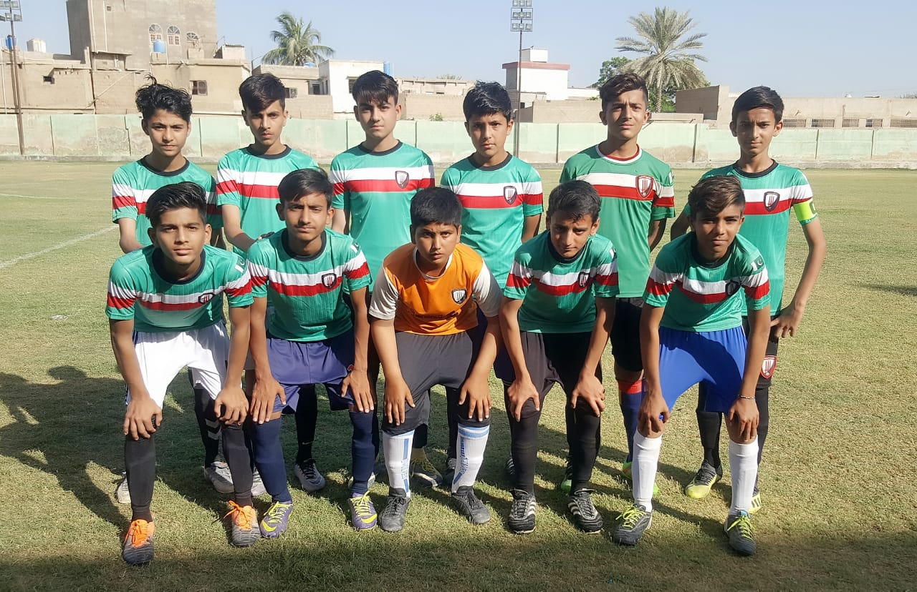

Figure Players are in action during the match

Figure Team Baldia pose for group photo before the match

**Coaches Development Program (CDP)**

Karachi United conducted 10 days long workshop with 20 community coaches during this period. Karachi United is providing professional football training to the community coaches to raise the football standard in their respective communities. The coaches receive training from Karachi United professional coaches who are certified courses and received training from renowned football clubs such as LPC. The training is not only enhancing their coaching skills but also improved ideas and improvisation which now help them to coach the kids in advanced and better way. These coaches conduct video training for the better understanding of players along with field training.

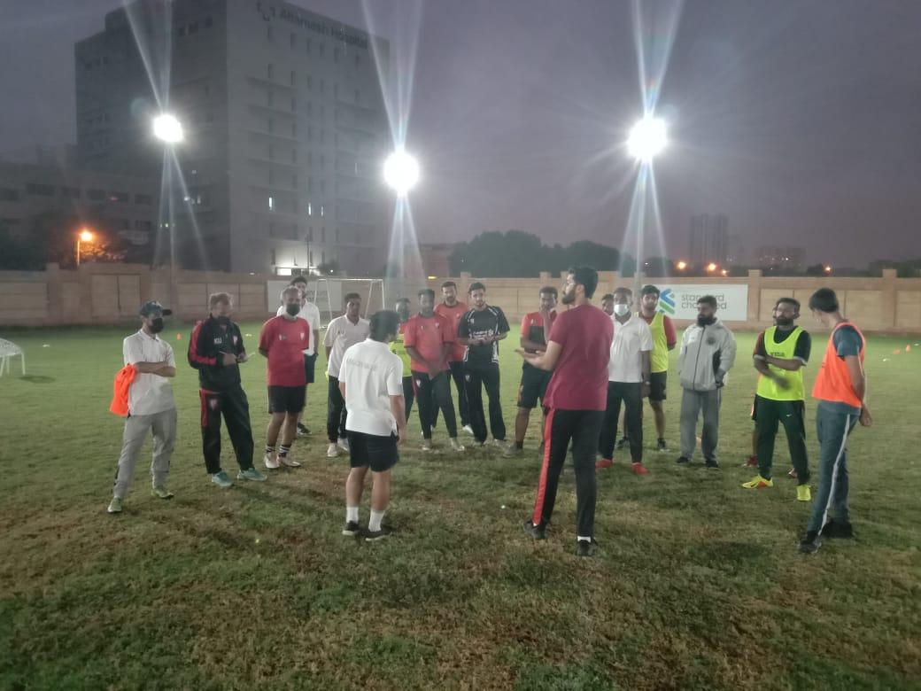

Figure 1 KU coaches are briefing to community coaches during CDP session