Support an Athlete- Develop Football in Pakistan
Quarterly Report
Karachi United Education Program:

Karachi United believes that education is important for the players. In order to provide free education to young players, KU Academy has partnered with Kiran Foundation to aid the life-skills and education development of the children. A total of 35 boys are enrolled in the 10 months program, attending classes 3 times a week at the DCTO campus in Lyari. This program is enabling the players to learn etiquettes and other skills. Before the commencement of the classes, a baseline test was conducted by Kiran Foundation. The purpose of this test was to evaluate the academic level of the players.

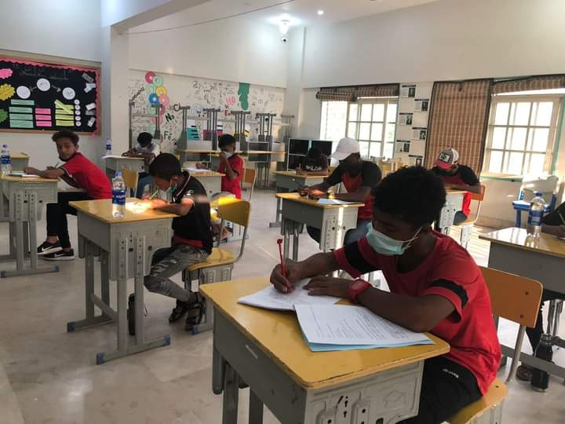
Figure 1 Players are giving baseline test

Standard Chartered- Karachi United League 2021:
Karachi United partnered with KU Academy and run football league every year. This league aims to provide the boys a platform where they can showcase their football talent and boost their confidence. The final match of this league was held between KU Academy and Baldia team. Both teams played their hearts out until the las whistle. KU Academy won the final of the SCB KU Youth League, winning 1-0 against KU Baldia.

After the success of KU- SCB league in Karachi, KU and SCB has launched the league in Islamabad. More than 350 boys and girls, belong to diverse communities of the region will come together to play 70 matches.

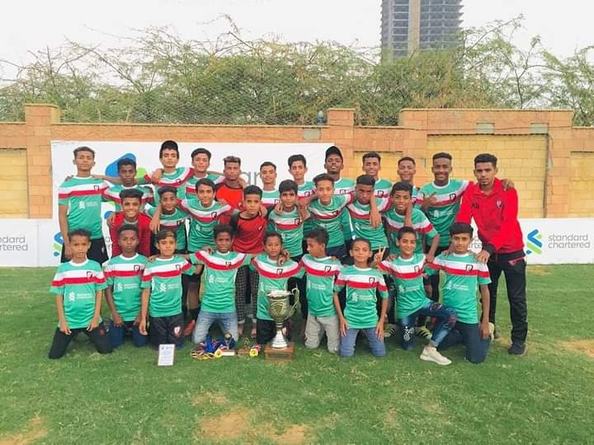
Figure 2 Players are celebrating the victory with trophy

