**Support an Athlete- Develop Football in Pakistan**

**Quarterly Report**

**Swindon Town Tour**

This month, Karachi United Academy took its players to Swindon Town Football Club in the UK, where the academy players received coaching, and mentoring, and participated in friendly matches with Swindon Town Academy. This exposure was very important because emerging players do not often have the opportunity to travel overseas, explore other cultures, and compete in friendly football competitions with players from other academies. The experience enhanced the players' tactical knowledge, and they also had insightful classroom sessions and mentoring on sports psychology, which helped them learn about mental toughness and peak psychology. These new concepts and interactive sessions, along with the football exposure, will be a major asset to the development of these young footballers.

These opportunities are incredibly significant for emerging football players, primarily because such experiences are usually not accessible to many. Traveling to the Swindon Town Football Club in the UK provided the Karachi United Academy players not only with a chance to train and play in a different environment but also permitted an invaluable exchange of cultures and techniques with the Swindon Town Academy. This kind of international exposure is crucial for young athletes, as it broadens their understanding of the game beyond their local context, introducing them to a diversity of playing styles, strategies, and levels of competition.

Moreover, the chance to engage in friendly matches with their counterparts from another country allowed these players to gauge their skills and tactics against a broader spectrum of talent. Such experiences can be eye-opening and immensely beneficial in highlighting areas of strength and aspects needing improvement, accelerating personal and team development.

Furthermore, the coaching and mentoring sessions, specifically tailored around sports psychology and mental toughness, address an often overlooked but vital component of athletic performance. Learning how to maintain focus, manage stress, and navigate the ups and downs of competitive sports can profoundly impact a player's growth and resilience on and off the field.

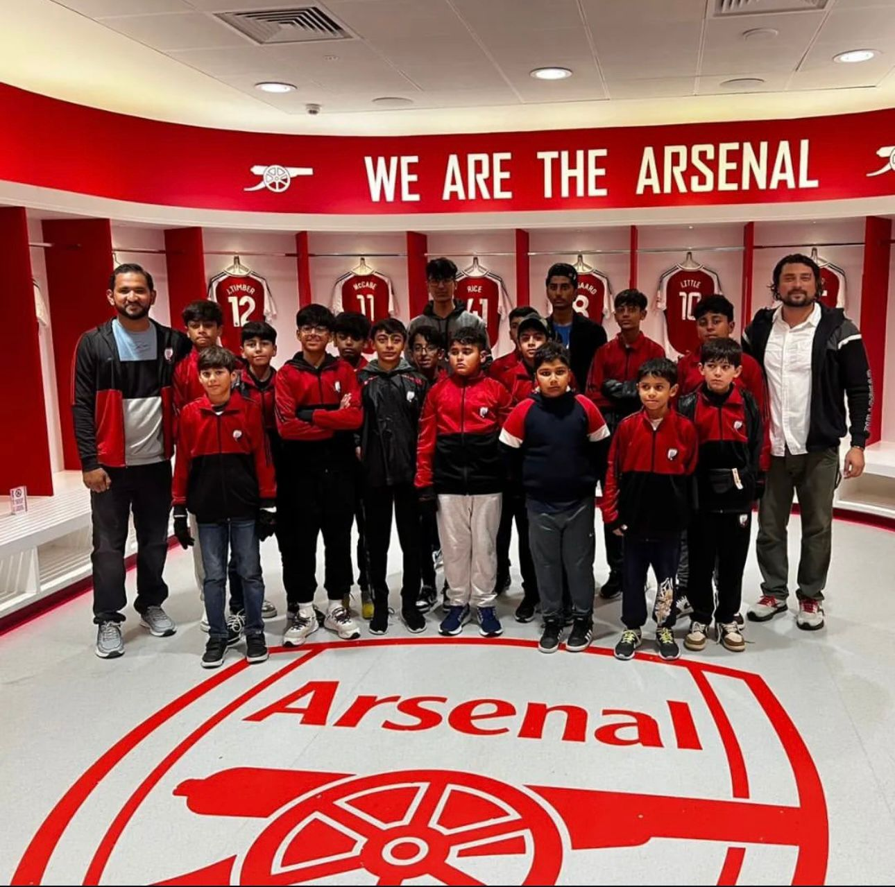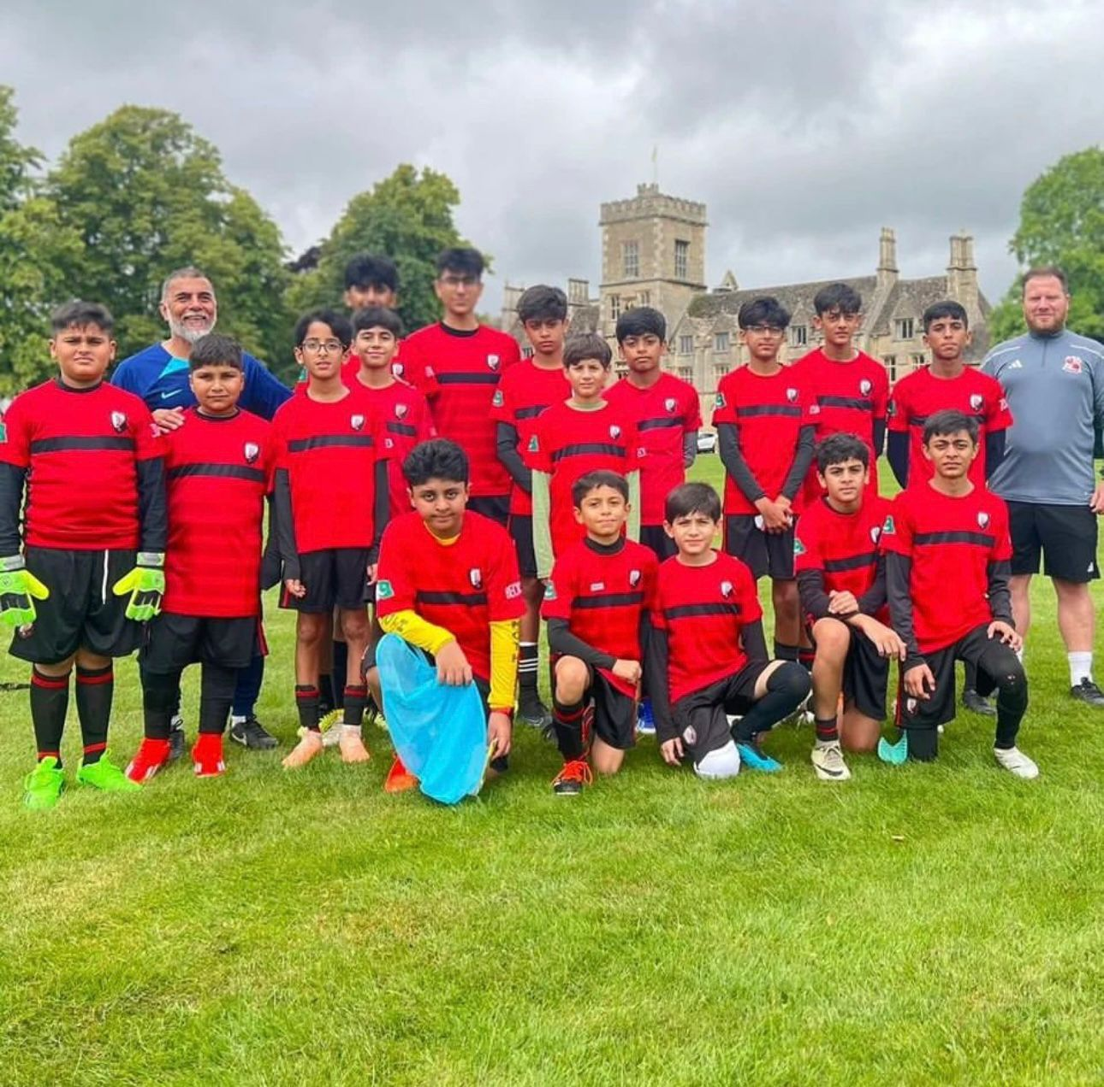

**Summer Camp**

Karachi United has launched its eagerly awaited annual two-month summer camp program, scheduled every year for June and July. This program, held annually, stands as the most anticipated event for players seeking professional sports coaching during their leisure time, especially for children on school breaks. It serves as an exceptional opportunity for participants from diverse backgrounds to come together, participate, and enhance their football skills. More than just a chance to hone sports abilities, this program offers a significant platform for players and parents to network, gain broader exposure, and deepen their understanding of the myriad careers and the overall sports ecosystem in Pakistan.

Reflecting a carefully tailored approach, the summer camp offers a variety of activities and training sessions designed to accommodate children across different age groups and skill levels. The inclusivity of the program is evident through its daily practice sessions, friendly matches, and meticulously planned workshops on sports psychology, football careers, nutrition, and fitness. It emphasizes the importance of building a strong foundation not only in sports but also in the principles of healthy living and psychological well-being.

At the heart of Karachi United's summer camp is the core aim to provide a safe and inclusive environment where children can learn, grow, and thoroughly enjoy themselves. It's an initiative that seeks to imbue participants with a sense of joy, camaraderie, and a positive outlook on their lives. Moreover, in a season where children take a hiatus from their academic responsibilities, this program stands out as a wonderful outlet for physical activity, helping them to stay active, engaged, and mentally stimulated during their vacations. It's a unique blend of learning and fun, designed to leave a lasting, positive impact on their lives.

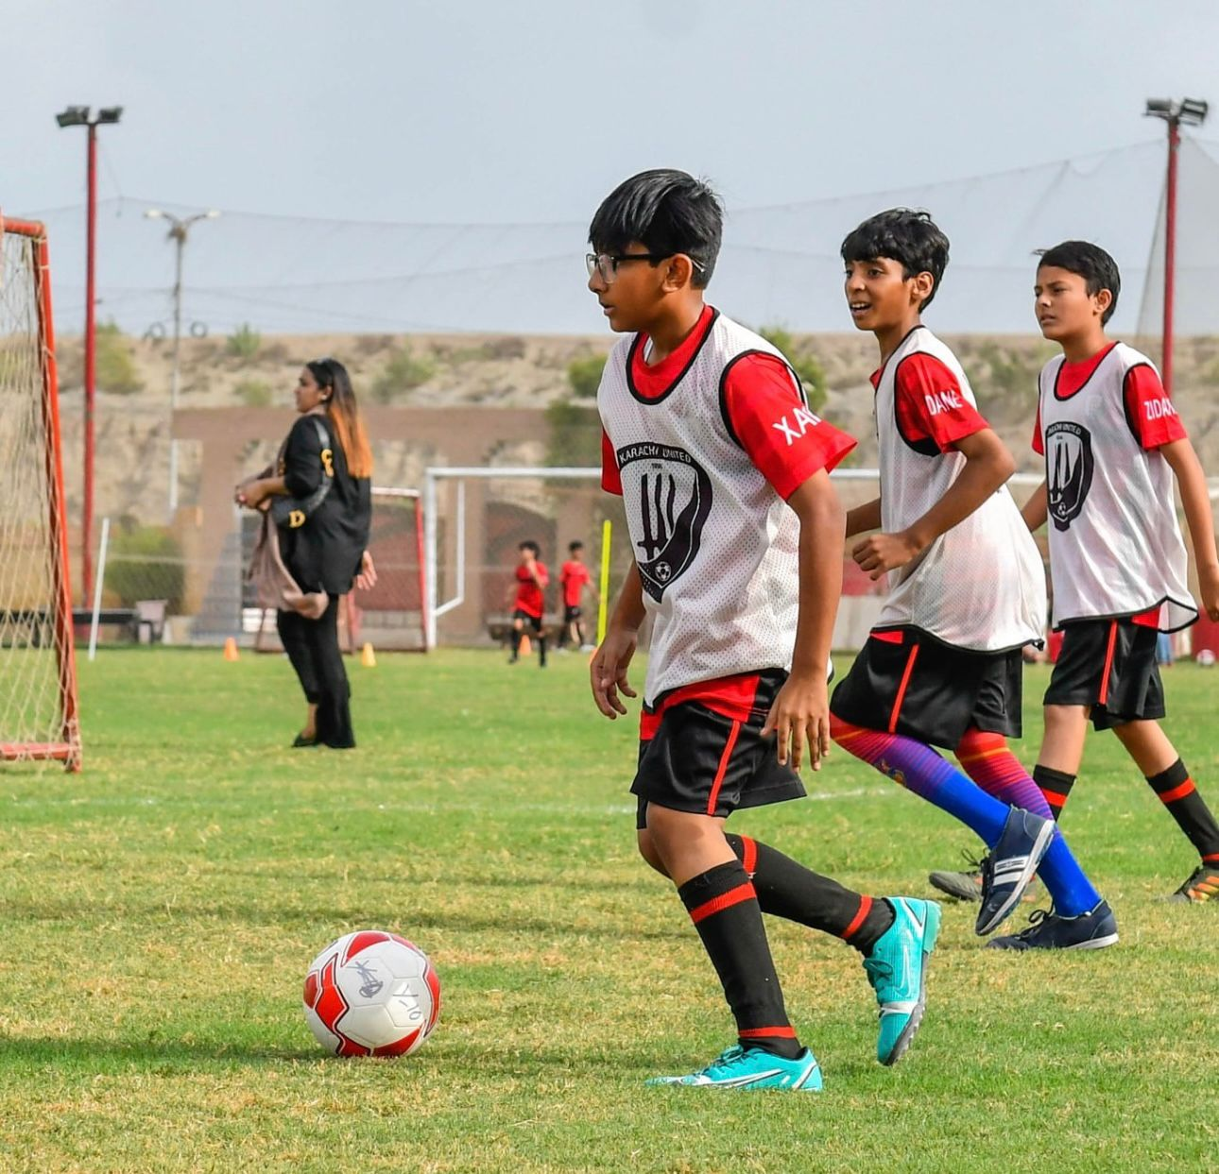 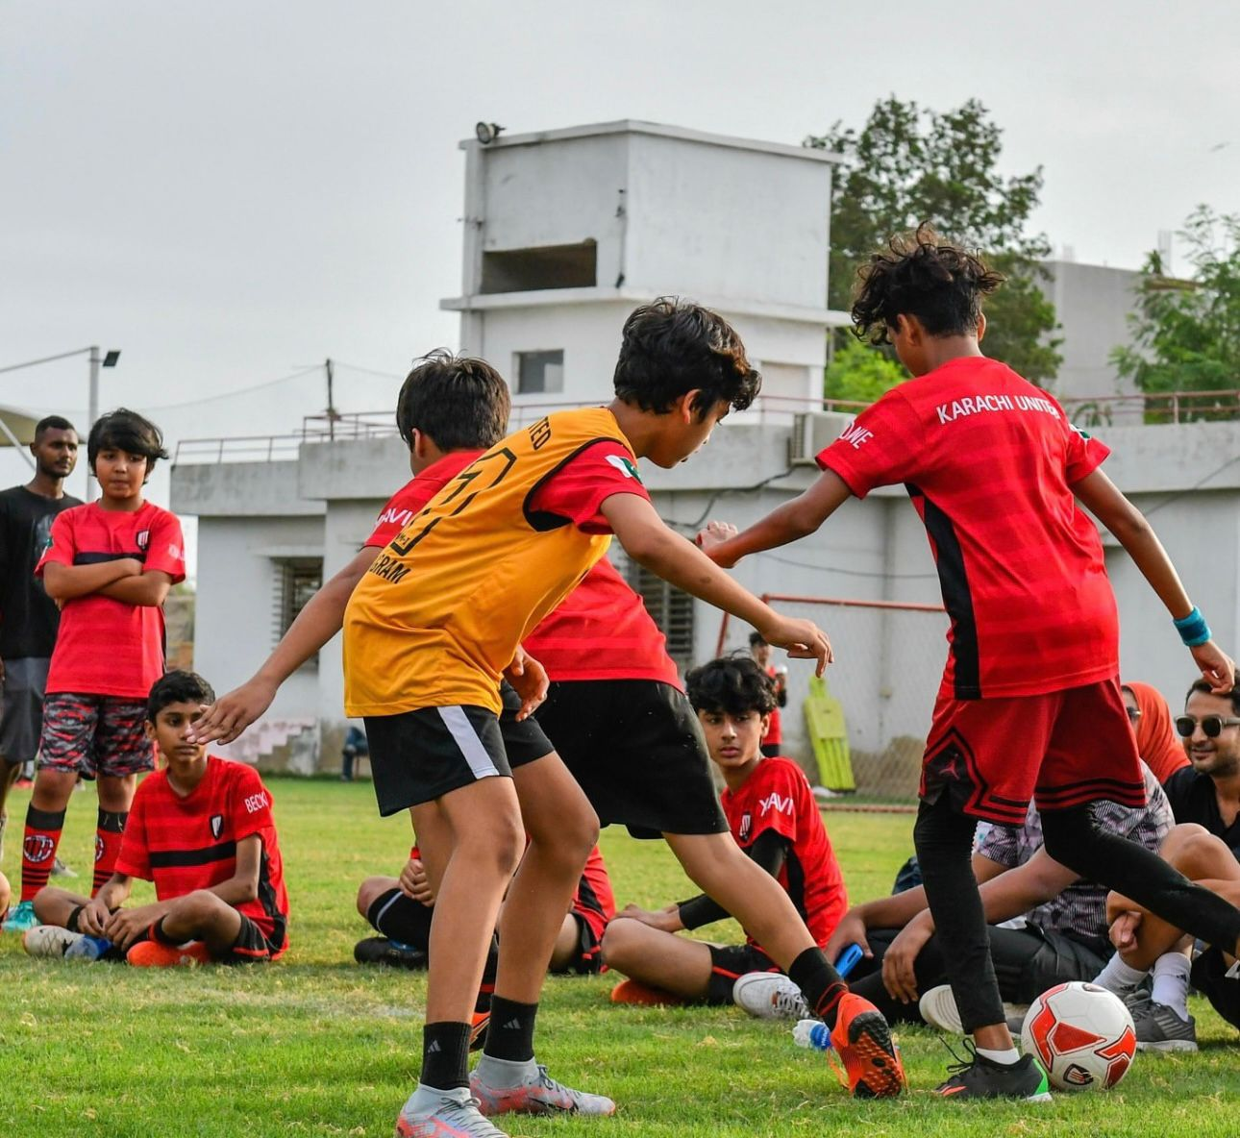

**Ramazan Futsal League**

Karachi United organized the annual three-day event during Ramazan, the Ramazan Futsal Cup. The tournament attracts 250+ players from various backgrounds and professions who engage in healthy and conducive events. The majority of the teams that participated in the event belonged to the corporate sector, providing them with an excellent opportunity to engage in football and enhance their working experience with their teams. In addition to the football tournament, the Ramazan Futsal Cup also included a variety of other activities and entertainment options for participants and spectators alike. These included food stalls and other fun-filled events that create a festive atmosphere. The league is an excellent opportunity for people to come together and celebrate the spirit of Ramazan while engaging in physical activity and promoting team building and camaraderie. Karachi Uniteed Under 16 were crowned champions of the All Karachi Ramazan Futsal League.

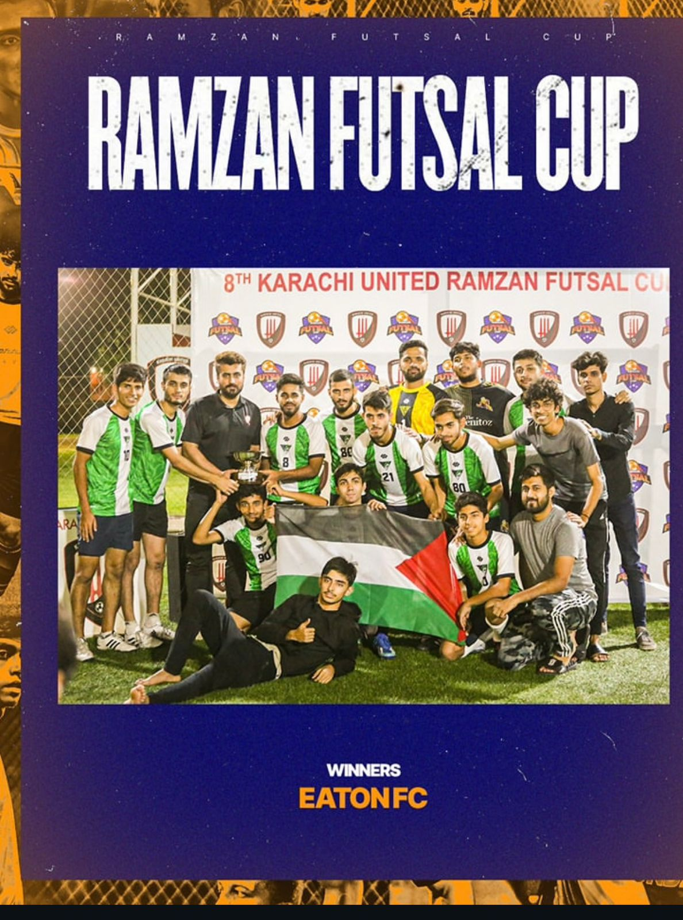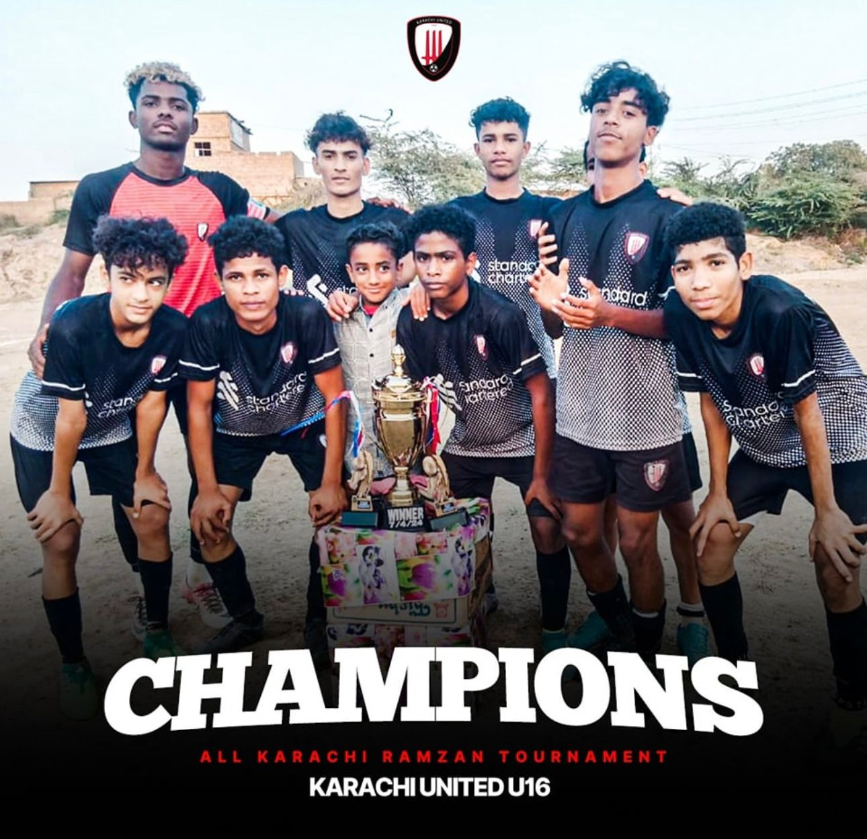

**28h Open Youth Tournamen**

Karachi United successfully organized the 28th edition of the Open Youth Tournament, engaging over 50+ teams. The three-day quarterly event allows young footballers to showcase their skills and passion for the sport. The tournament is open to all youngsters from different academic institutions, football organizations, and community organizations to participate and engage in friendly competitions. With age-specific categories catering to players under 11, under 14, under 17, and under 20, the tournament ensures accessibility for all young individuals between 8 and 20 years old. This inclusivity fosters a nurturing environment where talent knows no bounds, allowing every participant to shine regardless of age. At its core, the tournament's primary objective is to ignite and nurture youth involvement in football while striving to cultivate a more conducive and supportive football culture within Pakistan.

