Support an Athlete- Develop Football in Pakistan
Quarterly Report

KHI Awards

Karachi United won the KHI Awards hosted by K-Electric in the women empowerment category for their "WE, Women Empowerment" project. The project aims to empower women in football by addressing the gender gap, stereotypes, and underrepresentation of women in football through training, tournaments, and building sustainable platforms. Through this project, Karachi United will further leverage existing Lyari, Monghopir, and Orangi community centers, providing weekly football training to aspiring female athletes. The project will also select talented females from these communities for specialized training and football mentorship at the KU Academy, along with transport and facilitating communication with families. The award seeks to provide yearly support to make this project more sustainable and achieve its milestones for this year.

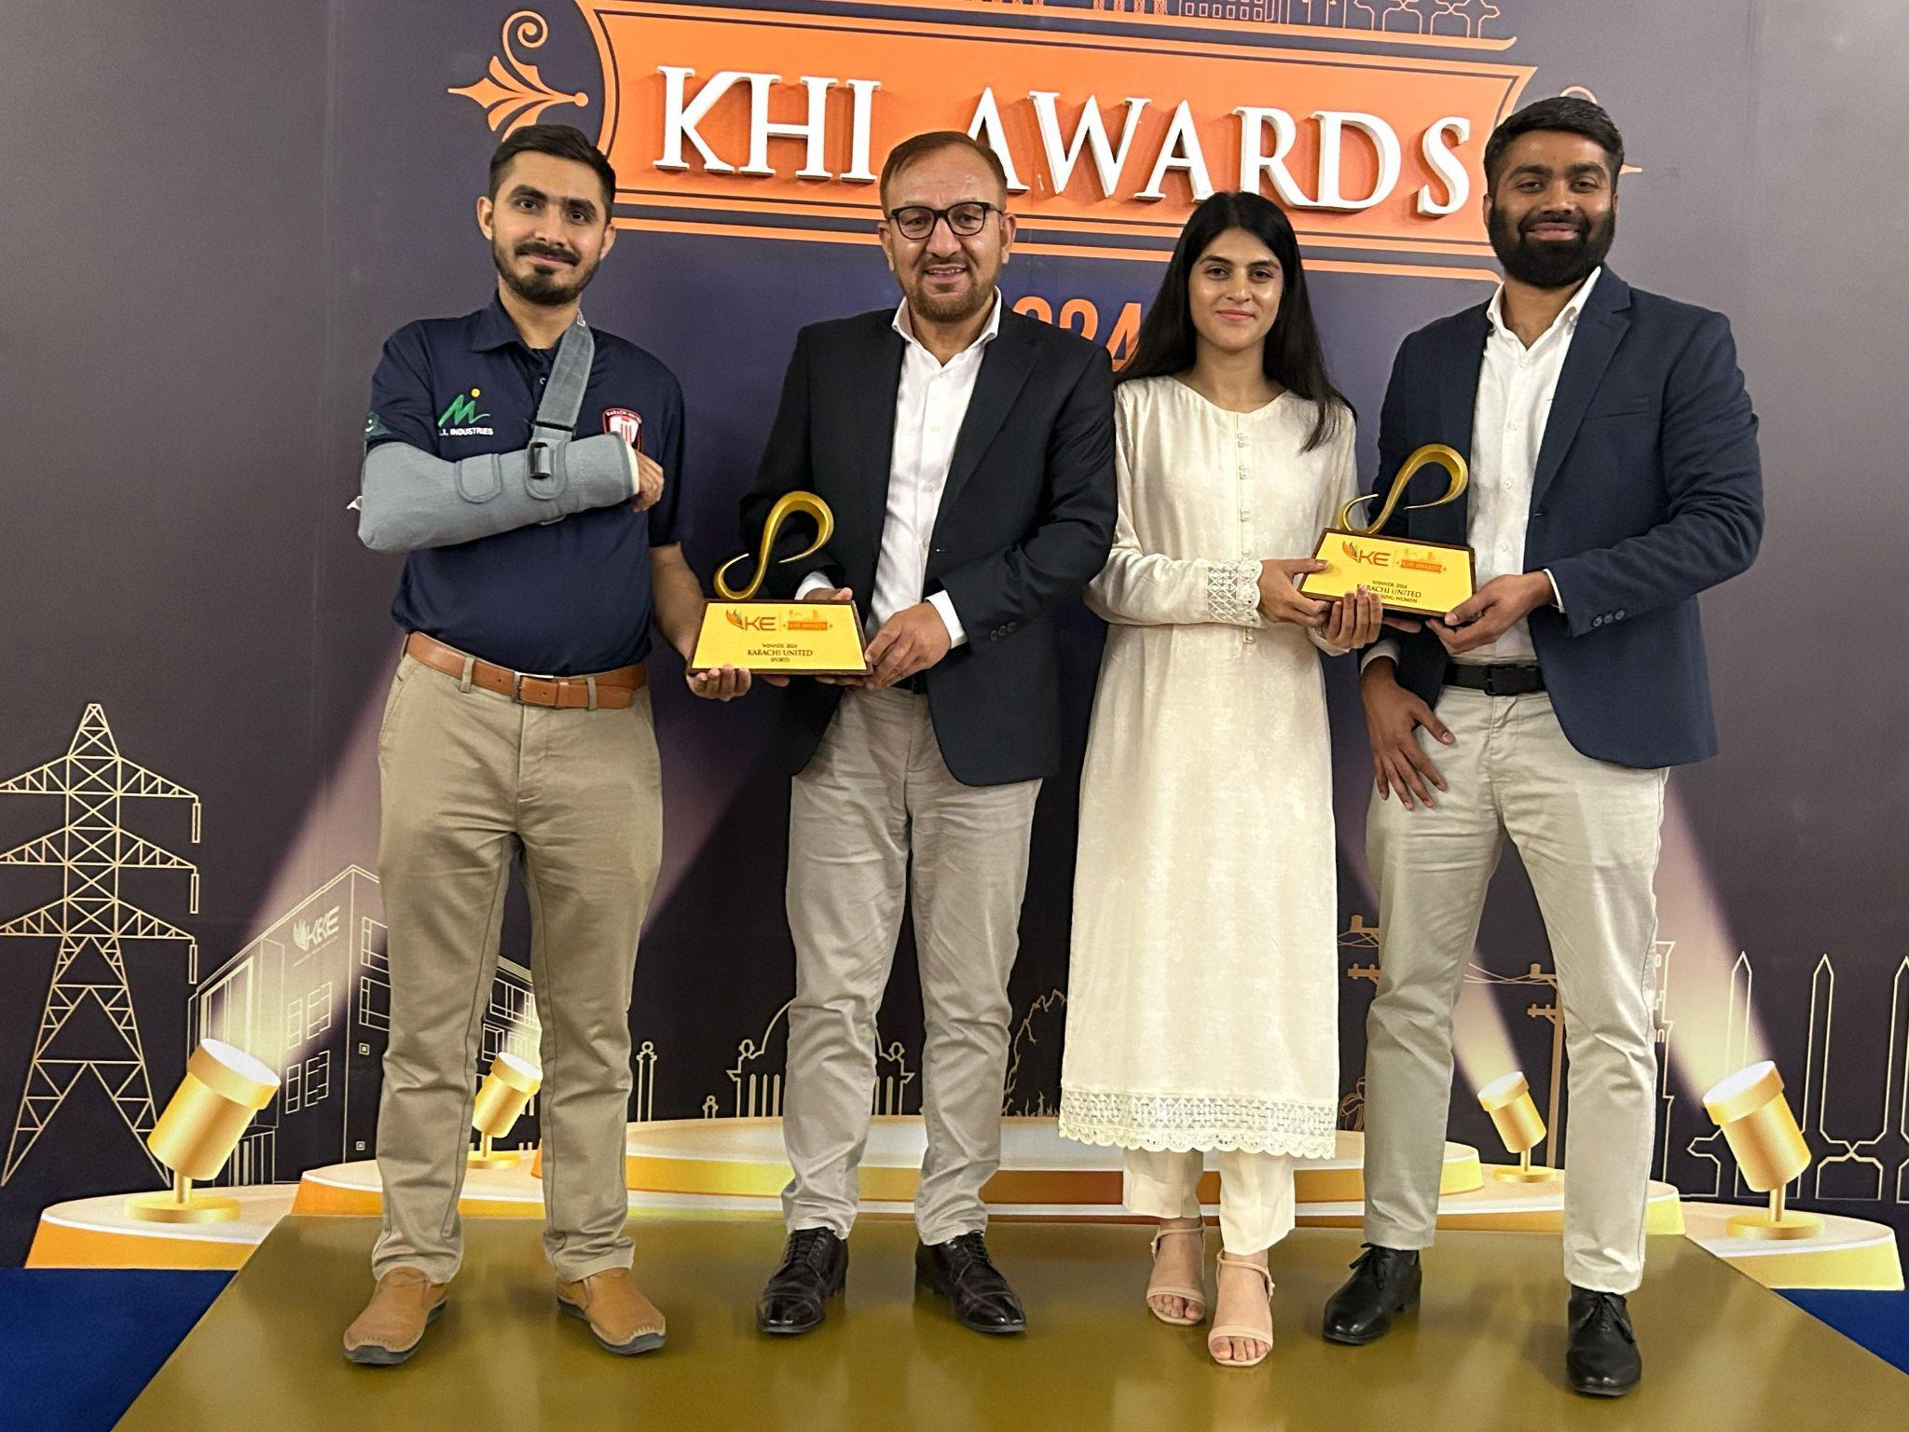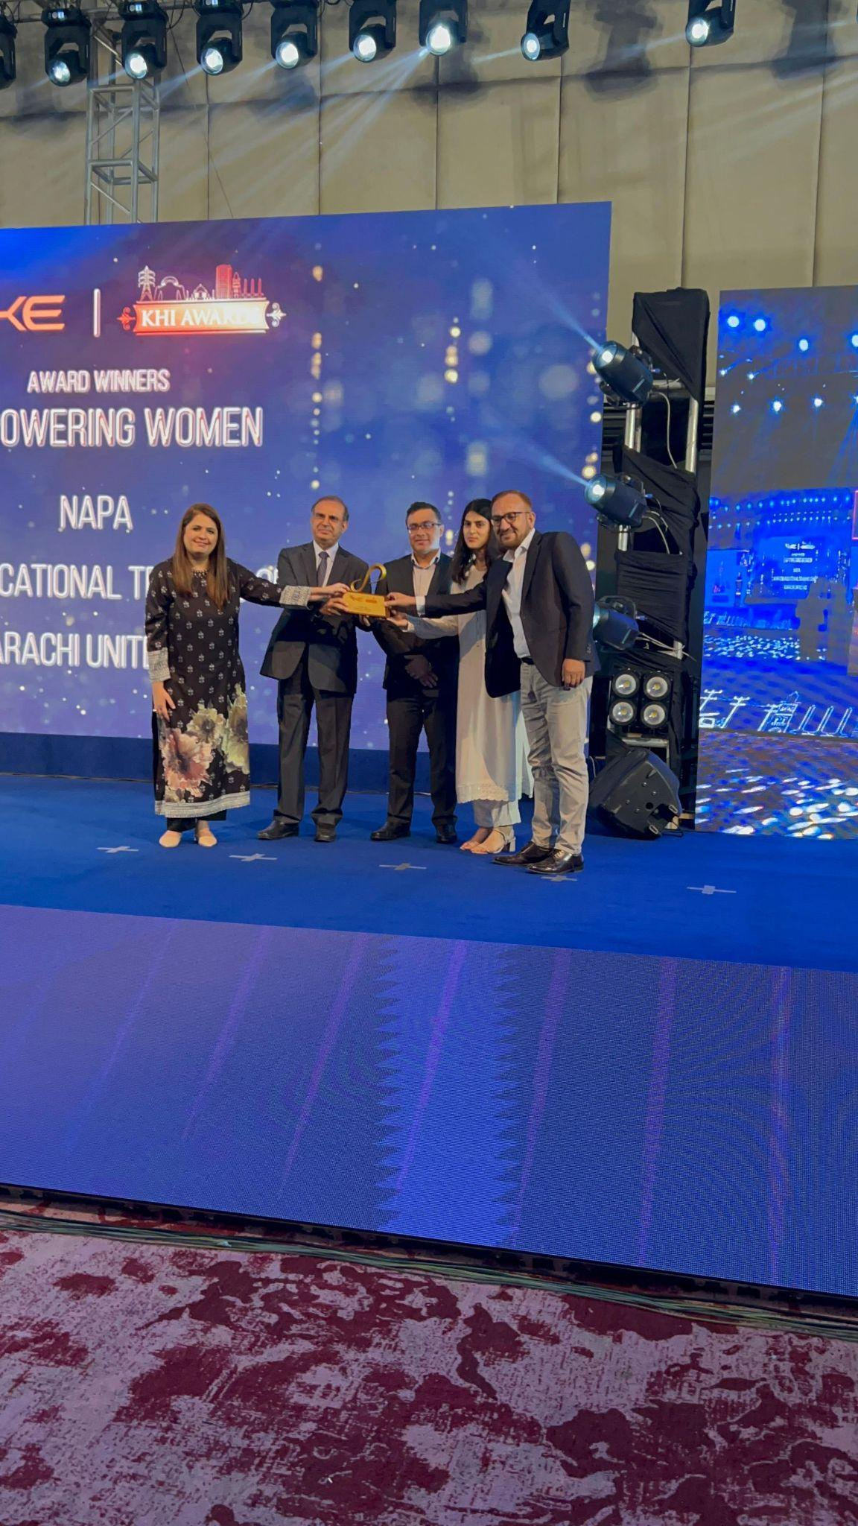

Standard Chartered Karachi United Youth League
Karachi United has successfully concluded its sixth Standard Chartered Karachi United Youth League, a collaboration between Standard Chartered Pakistan and Karachi United. This year, 72 teams participated in the league, comprising 1280 young male and female players from categories under 10-16. The victorious squad in the girls' competition was the Karachi United girls' team, while the winning team in the under-14 boys' competition was Karachi United Baldia Center.
The tournament inspired enthusiastic participation by children hailing from different football clubs and academies in Karachi United. The league allowed young Karachi United players to engage in friendly football competitions, promote player development, and bridge the gender gap through football.
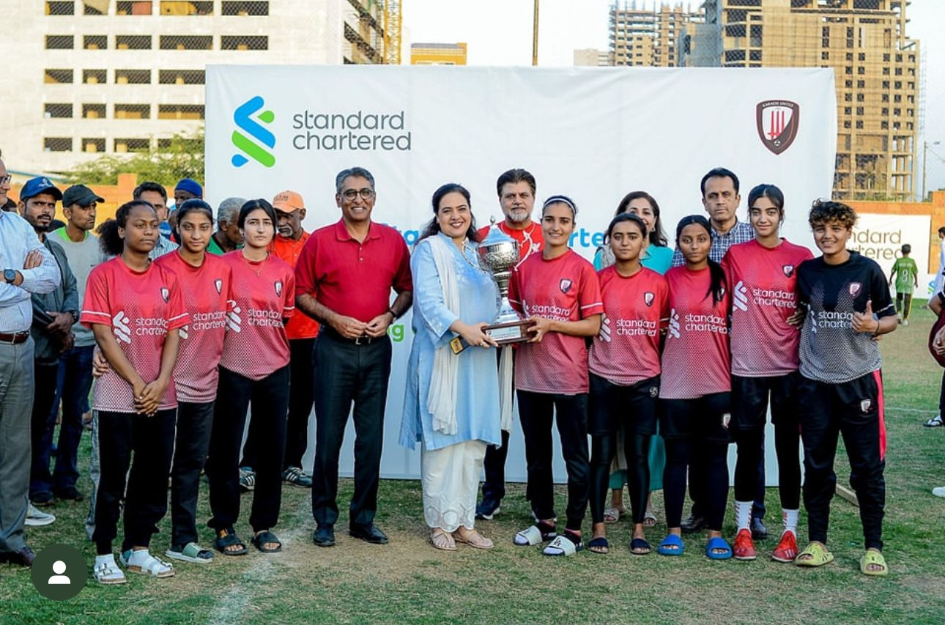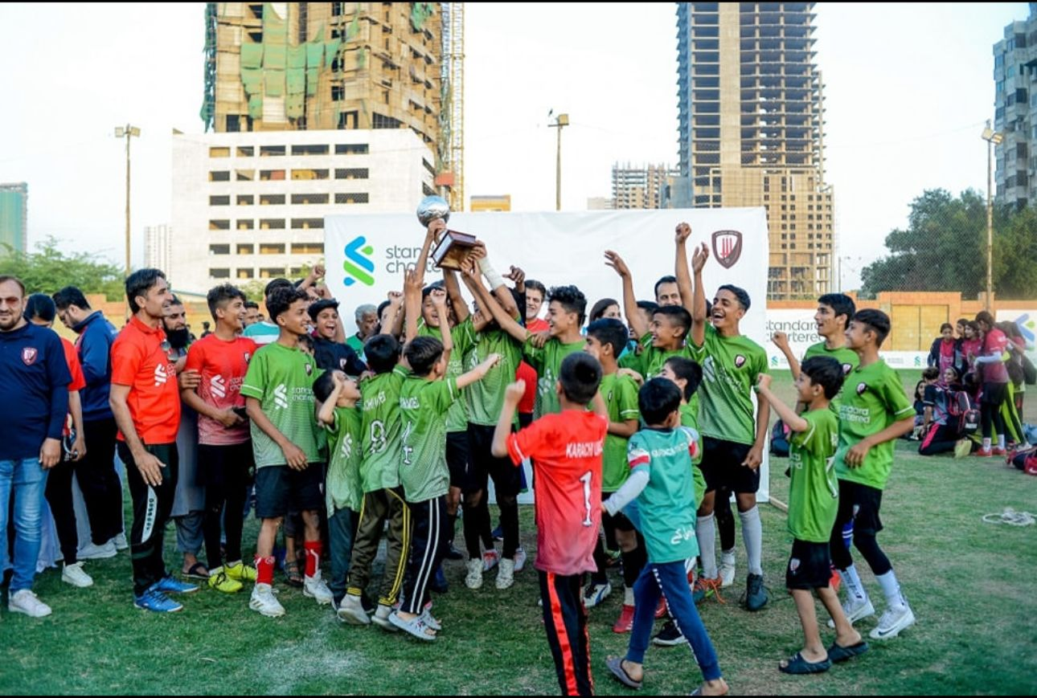

Islamabad Super League
Karachi United sent 17 athletes to participate in Islamabad Super League. The league, known for its competitive environment and high standards, provided KU athletes with a valuable opportunity to showcase their football skills, gain exposure, and experience top-level competition.
Before the event, our athletes underwent rigorous training sessions conducted by experienced coaches, focusing on enhancing their physical conditioning, tactical understanding, and mental resilience. These preparations aimed to equip them with the necessary tools to perform at their best and face the challenges of elite competition.
The Islamabad Super League also provided KU athletes with invaluable exposure to scouts, coaches, and officials from various organizations. This exposure opened doors for potential opportunities in professional sports leagues, scholarships, and further development pathways. Additionally, these young participants gained insights into their strengths and areas for improvement, which will guide their football development journey and career moving forward.

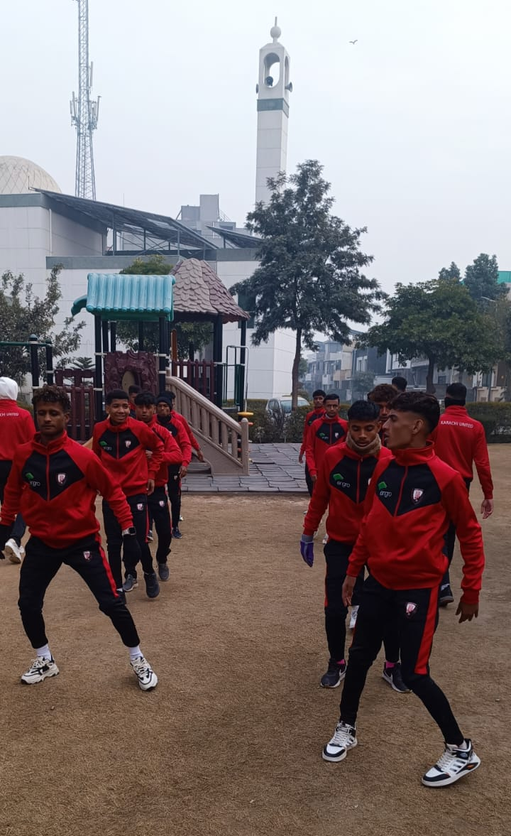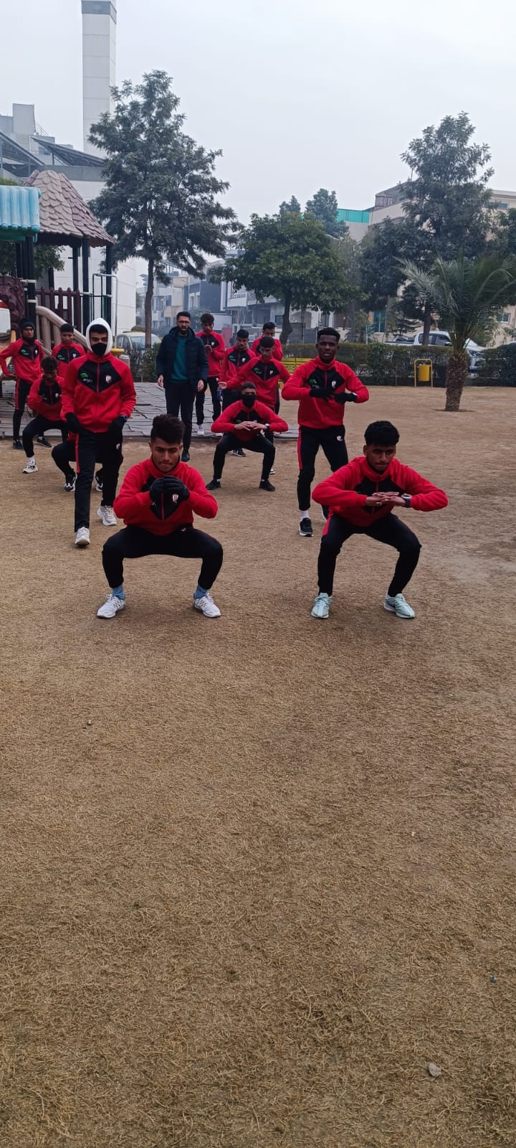

Women’s Day campaign

Karachi United Celebrated Women's Day on March 8 through an impactful online campaign aimed at recognizing and honoring the achievements of its female athletes. Through various digital platforms, KU highlighted the remarkable success stories of our female athletes, showcasing their dedication, resilience, and accomplishments in their respective sports. The campaign served as a platform to amplify their voices and contributions, inspiring others and breaking stereotypes surrounding women in sports. By spotlighting their successes, Karachi United reaffirmed its commitment to empowering women in sports and creating a supportive environment where they can thrive and excel.

