Sponsor A Star
Quarterly Report

Karachi United's Sponsor a Star Program: Empowering Future Champions
In September 2024, Karachi United (KU) launched the Sponsor a Star program, a transformative initiative designed to nurture young talent from underprivileged communities in Karachi. This program aims to empower promising young athletes by addressing their football training needs and their nutritional, educational, and personal development.
Since its inception, Sponsor a Star has enrolled 14 emerging athletes under the age of 12, all selected on merit for their exceptional potential. These children hail from communities where families earn an average of $40 to $100 per month, often struggling to meet basic necessities like food, education, and healthcare. Despite these challenges, these children have shown remarkable talent and resilience, earning their place in KU’s Academy.
Through the Sponsor a Star program, these players receive international-standard football training tailored to develop their skills to a global level. Beyond the field, the program ensures their holistic growth by providing access to balanced nutrition and quality education. Currently, all 14 athletes are enrolled at Al-Furqan School, where they are thriving academically, laying the foundation for a brighter future both as athletes and individuals.
The initiative aims to break the cycle of poverty and empower young athletes to make careers in sports and other fields, learn leadership skills, and unlock their true potential.
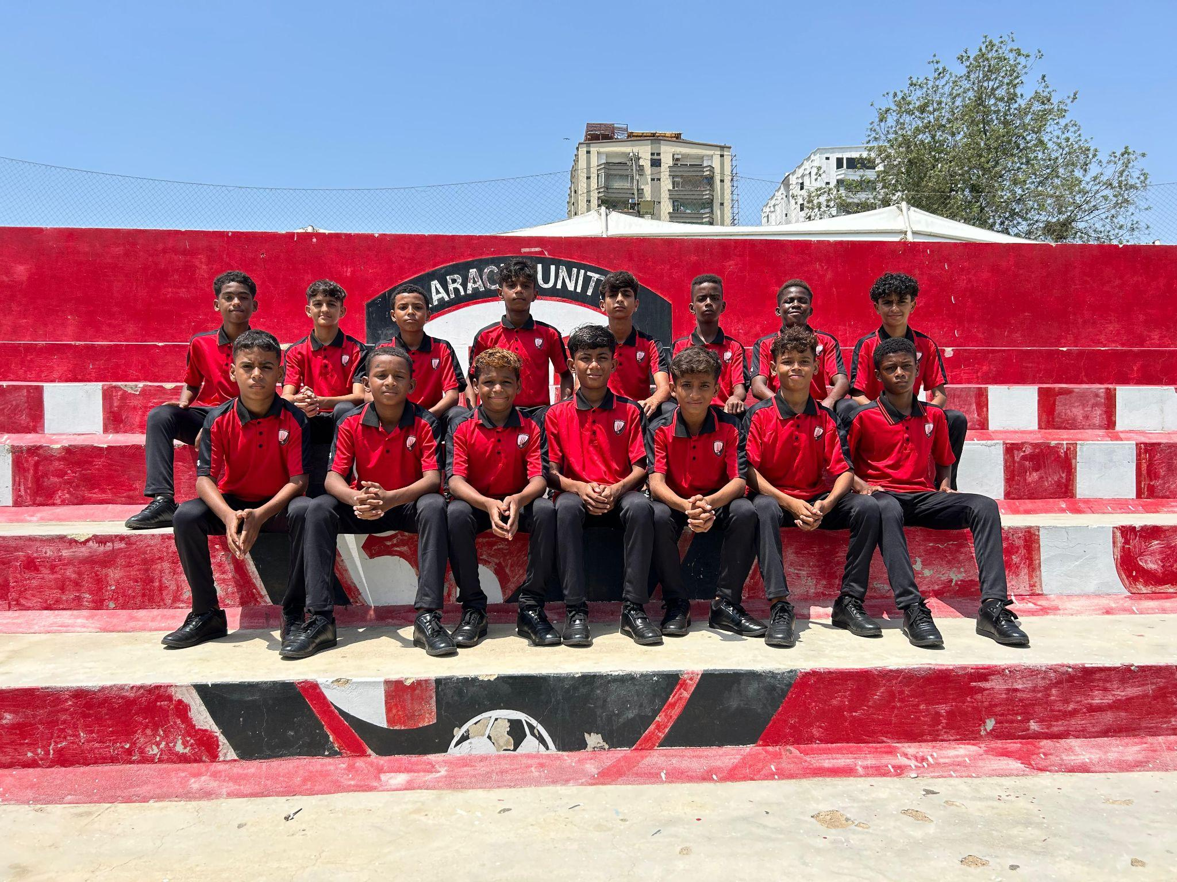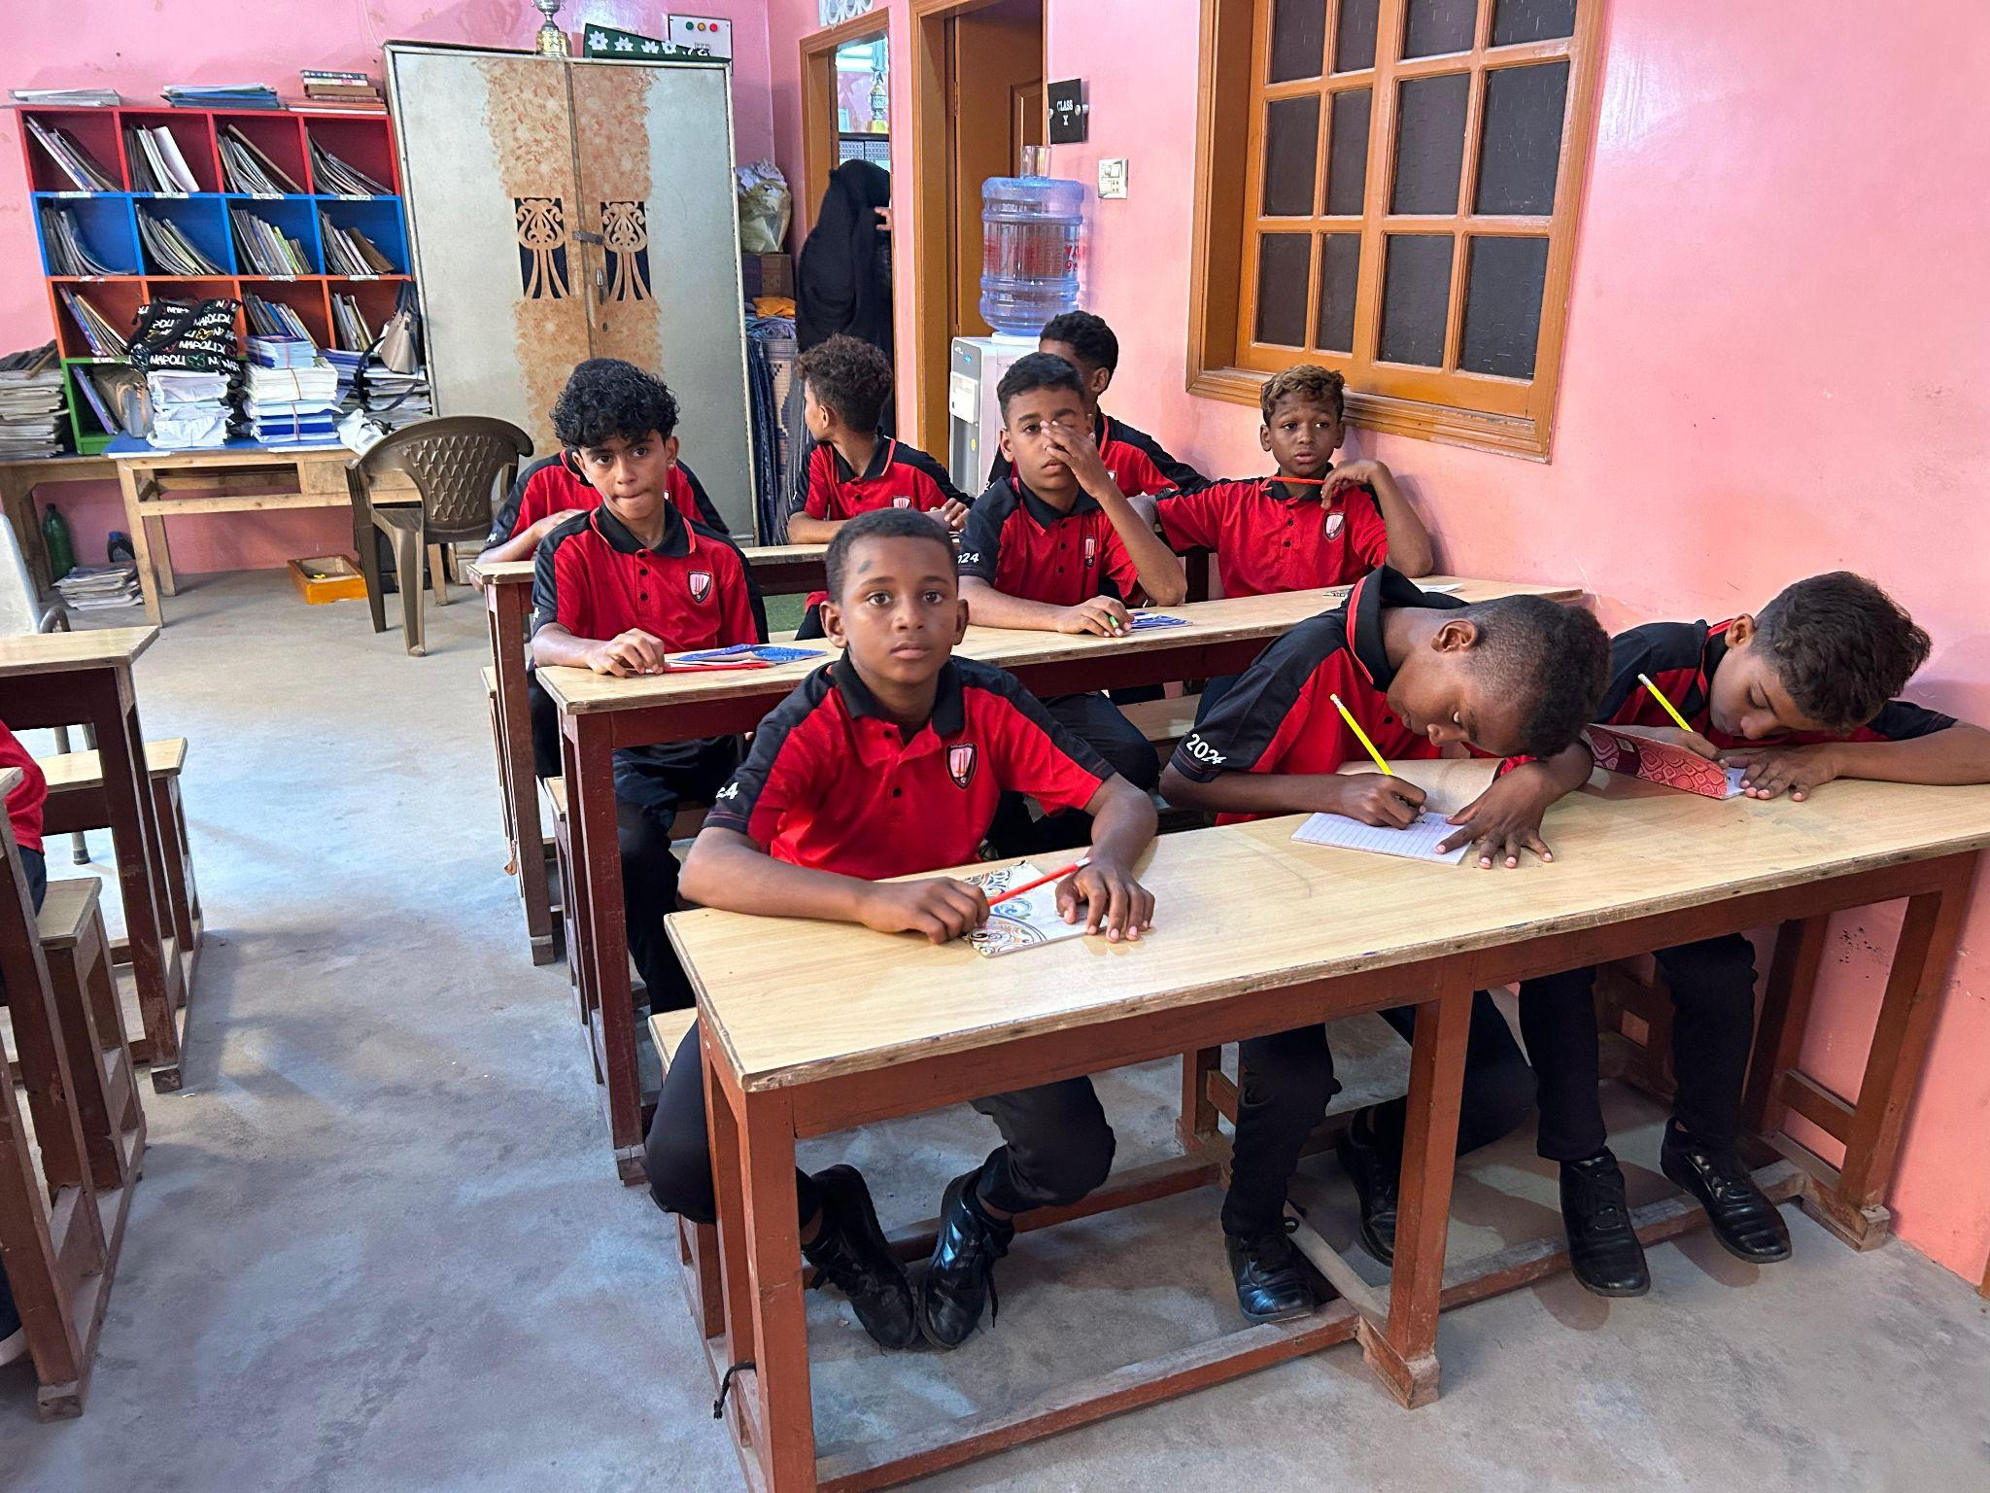

Standard Chartered Karachi United Youth League 2023
In September 2023, Karachi United launched the 7th edition of the Standard Chartered Karachi United Youth League, continuing its mission to promote sports and community development across Karachi. Since its inception in 2017, the league has provided a platform for over 6,000 boys and girls from underserved areas to engage in football, promoting teamwork, breaking social barriers, and instilling a culture of healthy competition.
This year’s league features participation from 1,360 players, including 180 girls, across multiple communities and educational backgrounds. Over 200 matches are being held across six iconic locations: Khyber Muslim Ground (Baldia Town), Old Golimar Football Ground, Jam Eleven Ground (Malir), Karachi United Clifton, and Kakari Ground (Lyari).
With 3,000+ indirect beneficiaries, 250+ hours of football engagement, and growing participation, the Standard Chartered Karachi United Youth League continues to be a flagship initiative in empowering communities and nurturing future talent in Pakistan.

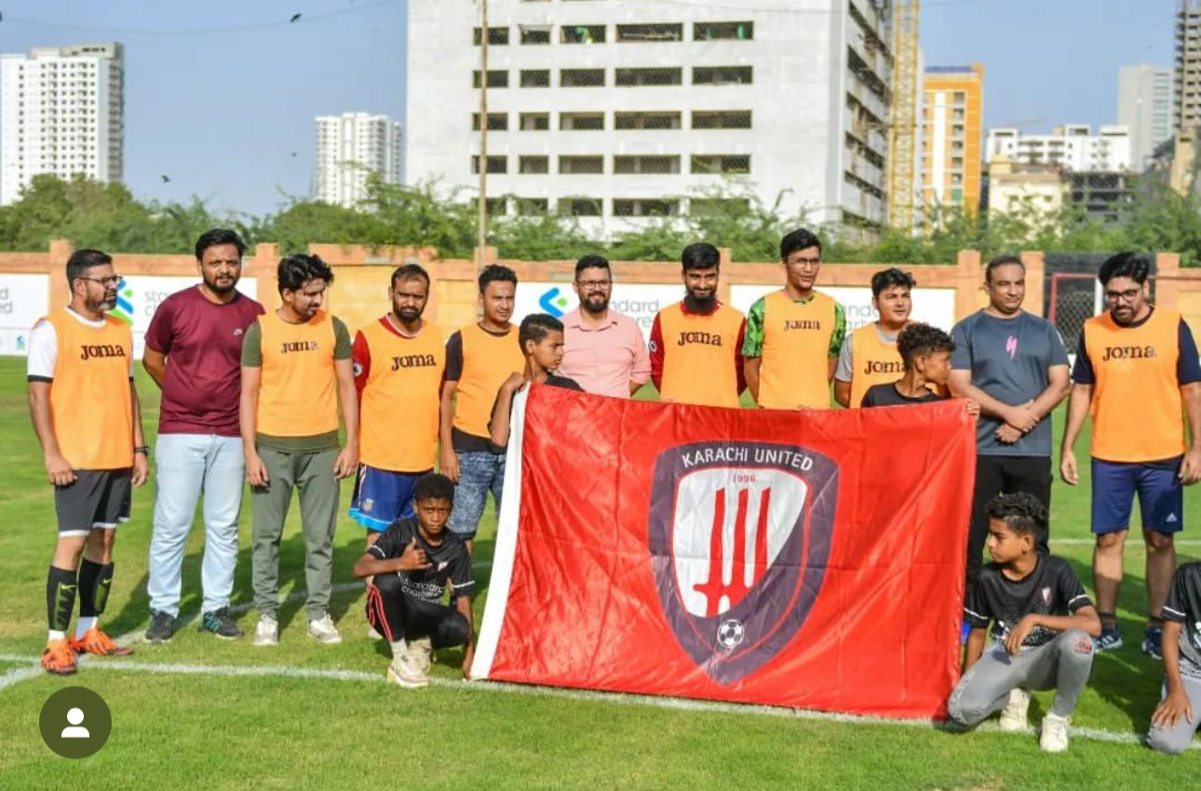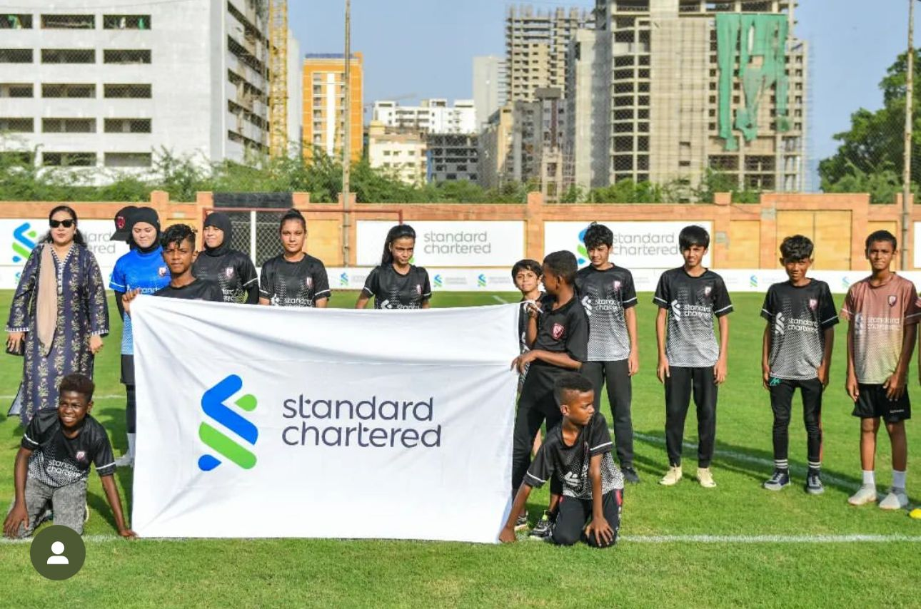

Karachi United Open Youth Tournament 2024: A Celebration of Young Talent

On Sunday, October 13th, 2024, Karachi United hosted the 27th edition of its Open Youth Tournament, continuing its mission to provide a vibrant platform for young footballers aged 8 to 20 to showcase their skills and passion.
The tournament brought together aspiring players across age-specific categories—U11, U14, U17, and U20—creating an inclusive space for budding talents and seasoned competitors alike. Teams from academic institutions, football clubs, and community groups participated in friendly matches, embodying sportsmanship and team spirit.
This year’s event saw overwhelming support from players and their families, who contributed to the tournament’s electrifying atmosphere. The day was filled with exciting football, camaraderie, and unforgettable moments, reflecting the tournament’s core objective: promoting youth involvement in football and cultivating a thriving football culture in Pakistan.

