Support an Athlete- Develop Football in Pakistan
Quarterly Report: November to January 2020
Qatar Tour:
Football has remained a truly global sport for decades. It has the capacity of uniting whole world, even it is played for only 90 minutes. Karachi United aims to promote football standard in Pakistan by top quality international competitions as international tours provide competitive environment to the players. In order to gain the international exposure, Karachi United academy team visited Qatar in November.
In order to select top players for the upcoming competition, 3 trial sessions were conducted in Karachi United stadium. Karachi United team provided the transportation to all players who participated in trial session. Total 14 and 13 players were selected for U12 and U11 teams respectively. Karachi United U12 and U11 teams played 3 competitive matches against Turkish first division club Fenerbahce and Aspire Academy from 17th November to 21st November, 2019. Both the age group managed to win the tournament. The result of the tournament is given below:
- Karachi United Under-12 VS Aspire Under-12 (4-2)
- Karachi United Under-12 VS Fenerbache Under-12 (5-2)
- Karachi United Under-11 VS Aspire Under-11 (8-1)
- Karachi United Under-11 VS Fenerbache Under-11 (3-1)
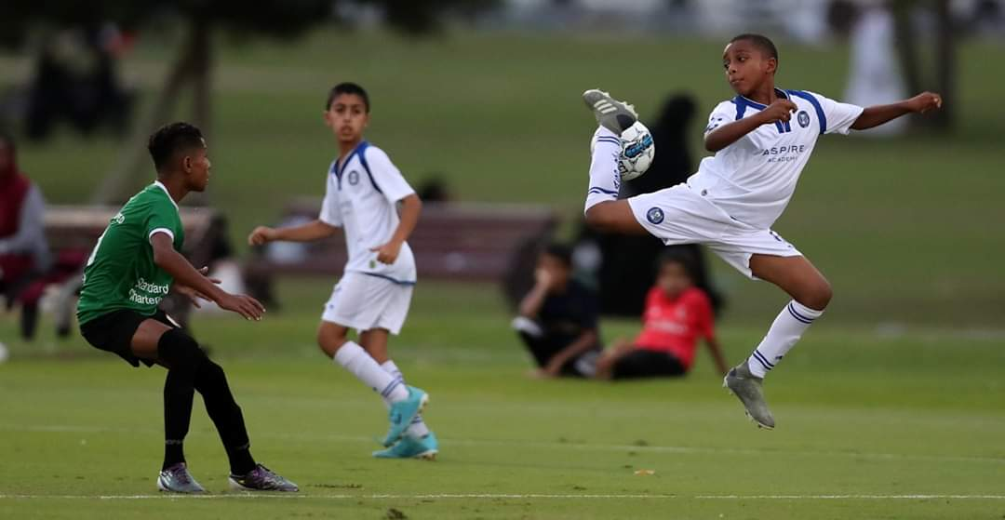
Figure 1 Karachi United Academy and Aspire Academy are in action

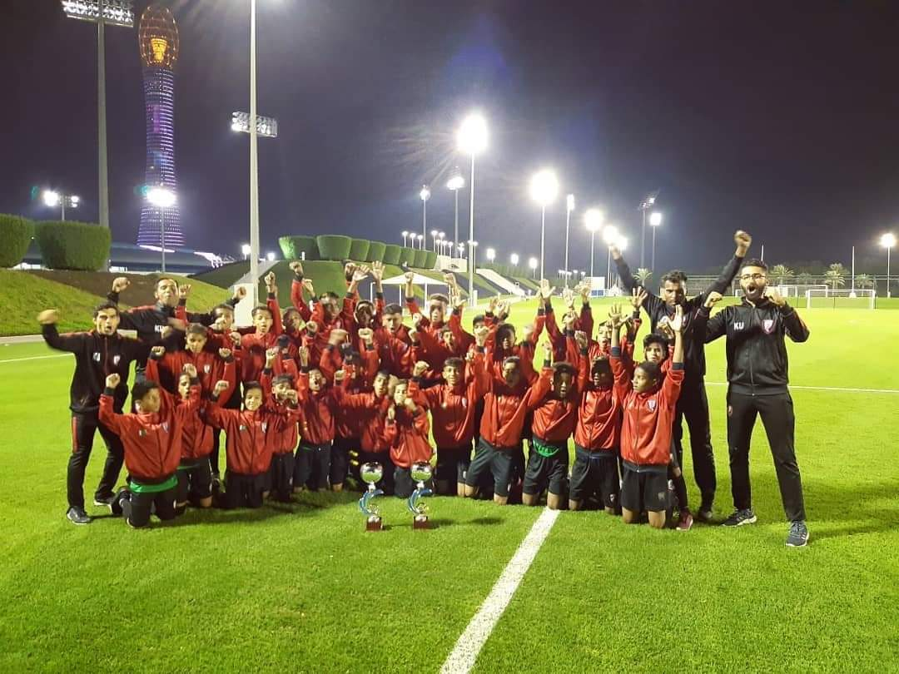
Figure 2 Karachi United Academy celebrating victory along with their coaches

Coach Development Program:
In order to improve the quality of football coaching, Karachi United launched CDP (Coaches Development Program) for community centers coaches during this quarter. Karachi United professional coaches are training community center coaches three times a week. These classes are conducted at certain location within the community.
The CDP course is not only based on class room lectures but also football techniques are demonstrated at the ground. This certification has been designed in 6 levels and duration of each course is 2 months long (twice a week sessions for 2 hours each). Course for KU Youth Coaches and CoE Coaches is free of cost (Internal Candidates) and Validity of Certificate will be for 3 years. A total of 30 coaches have enrolled for this course who attend the classes twice a week at Karachi United football stadium. After completion of the course 2 assessment were conducted. Only three coaches were able to clear the first assessment whereas, 10 out 12 coaches cleared the 2nd assessment.
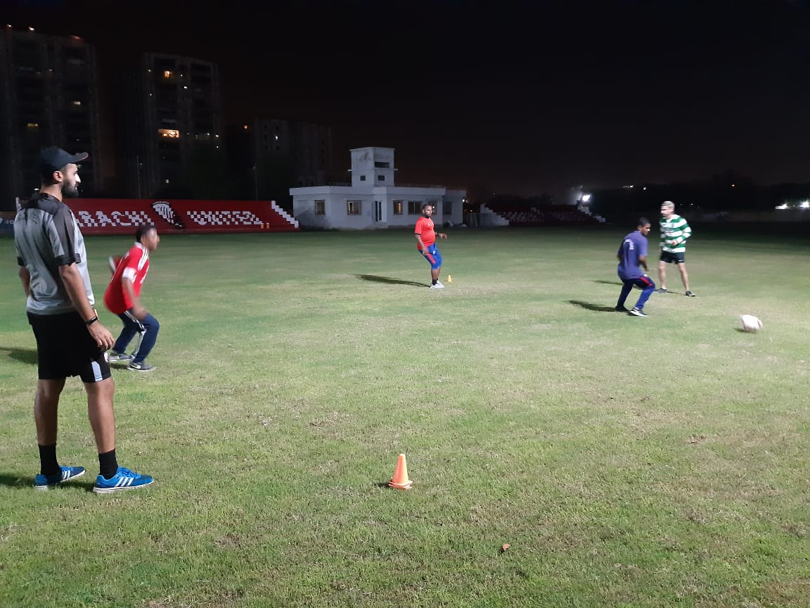

Figure 3 Coaches are practicing football techniques at Karachi United football ground

Standard Chartered – Karachi United Youth League 2019:
Karachi United Academy Under-10, Under-12 and Under-14 participated in Standard Chartered- Youth League. This league aims at promoting sports amongst children, and pulled them out of destructive activities such as kite flying, marbles, card, drug abuse which are very common in under developing areas of Karachi. The league will end on 15th January. The real motive of this league is to give these players who usually do not get the chance to play high level competitions, a chance to get the feel of international professional events. In order to increase the standard of the league, official referees and match commissioners were appointed for every match. Karachi United Under-10 has reached in the final whereas, Under-12 and Under-14 were knocked in quarter final.
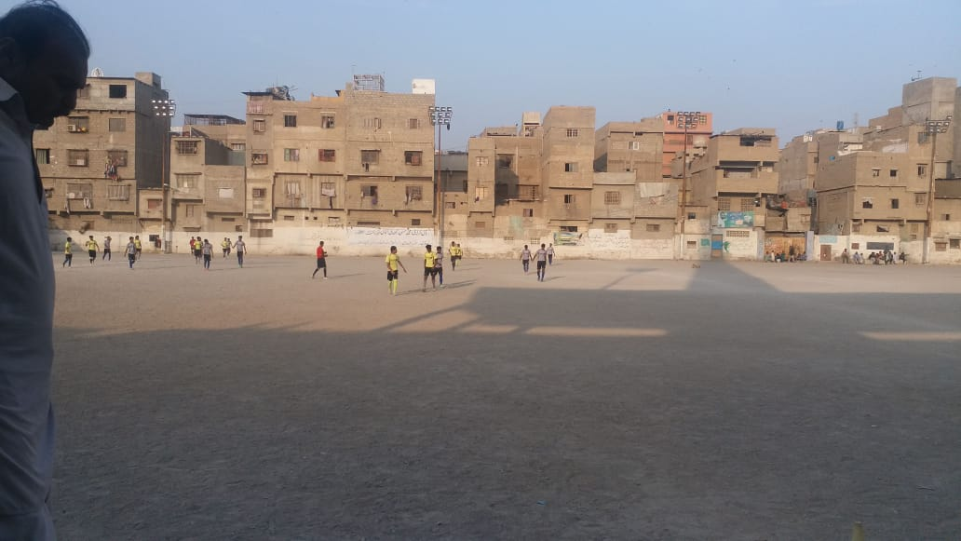
Figure 1 Team Chakra Goht vs CEFA are in action during SCB youth league 2019

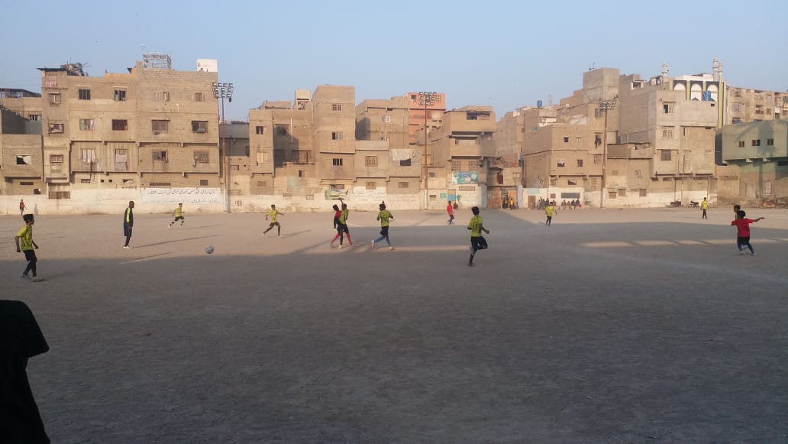
Figure 2 Players are in action during match

